***1.WRITE A C++ PROGRAM FOR CALCULATE THE AREA OF THE RECTANGLE AND VOLUME OF THE RECTANGLE.CREATE A CLASS AREA AND DERIVE THE CLASS VOLUME AND USE THE SAME MEMBER FUNCTION WITH THE SAME PARAMETER FOR THE ABOVE CLASSES.***

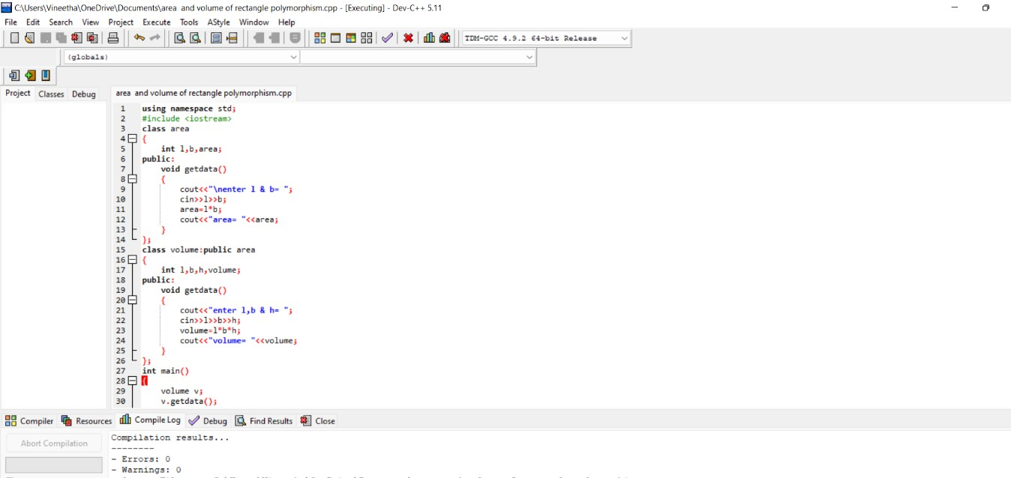

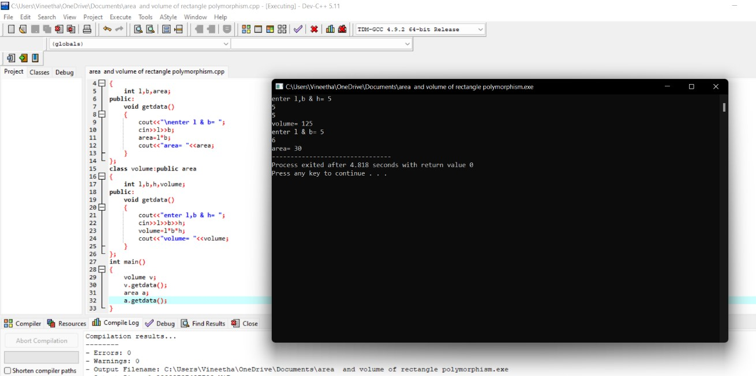

**2.WRITE A C++ PROGRAM TO DISPLAY AN OBJECT USING POLYMORPHISM .**

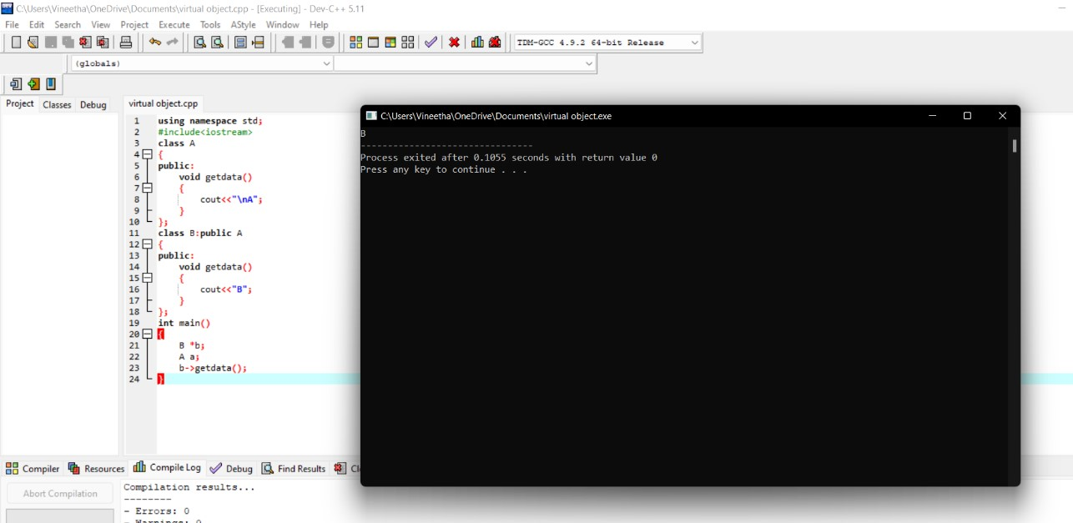

**3.WRITE DOWN A CODE FOR THE FOLLOWING INHERITANCE**

**BANK**

**SBI**

**ICICI**

**AXIS**

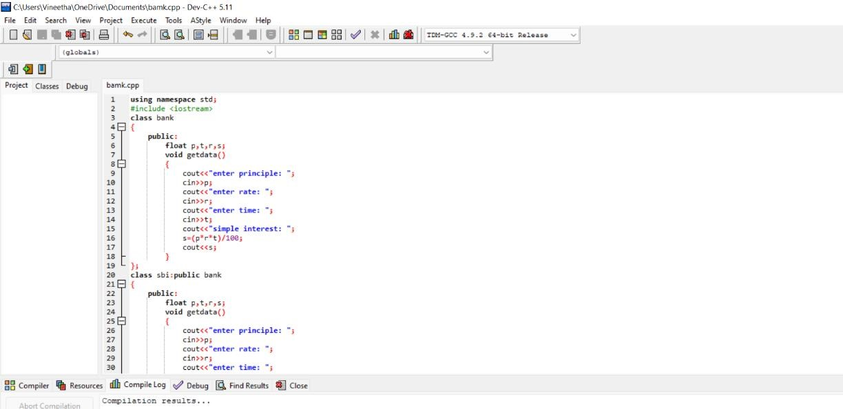

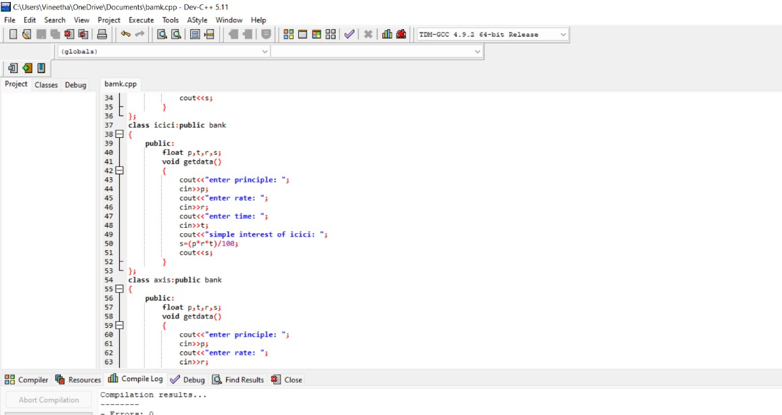

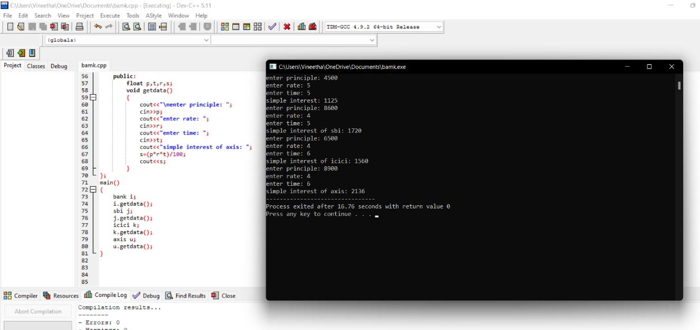

**4.WRITE A C++ PROGRAM FOR DIVISOR BY ZERO**

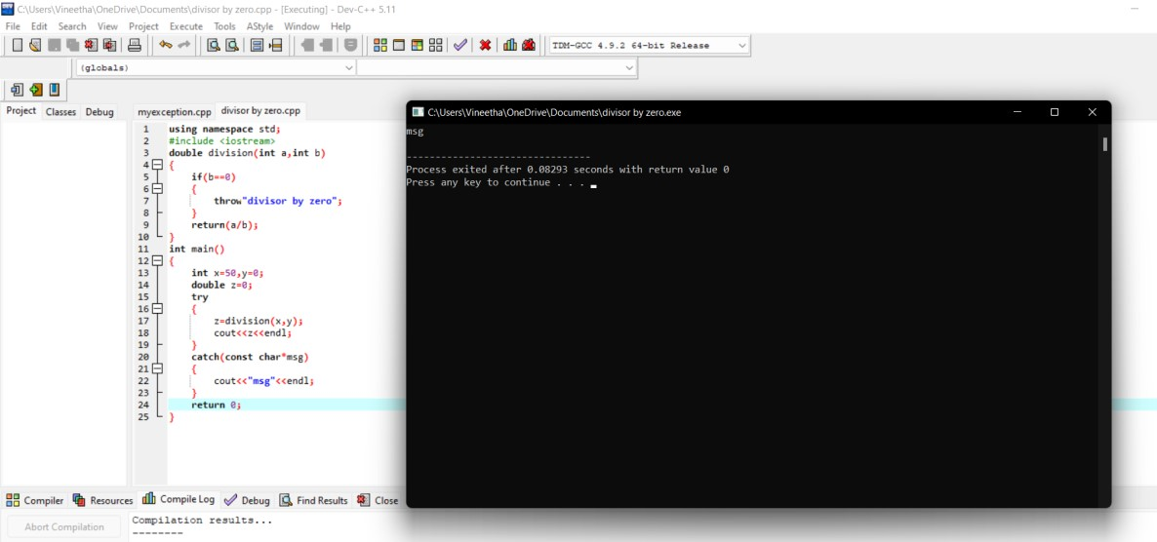

**5.WRITE A C++ PROGRAM FOR MYEXCEPTIONS**

