DATE:29-08-2022 DSA0136-OOPS WITH C++ PROGRAMMING

1.write a c++ program to find the person is eligible for voting or not?

Program:-

using namespace std;

#include<iostream>

main()

{

int age;

cout<<"enter age";

cin>>age;

if (age>0 && int(age))

{

if(age>=18)

{

cout<<"eligible";

}

else

{

cout<<"not eligible";

}

}

else

{

cout<<"not valid";

}

}

Output:_

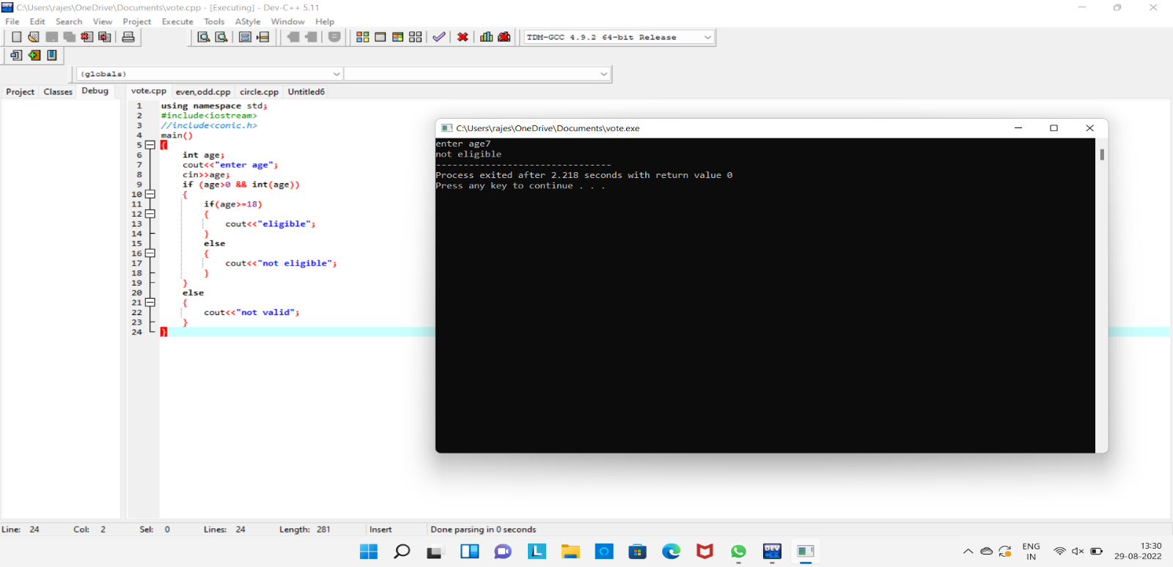

2.write a c++ program to find the given number is even or odd?

Program:-

using namespace std;

#include<iostream>

int main()

{

int num;

cout<<"enter the number";

cin>>num;

if(int(num))

{

if(num%2==0)

{

cout<<"even number";

}

else

{

cout<<"odd number";

}

}

else

{

cout<<"not valid";

}

}

Output:-

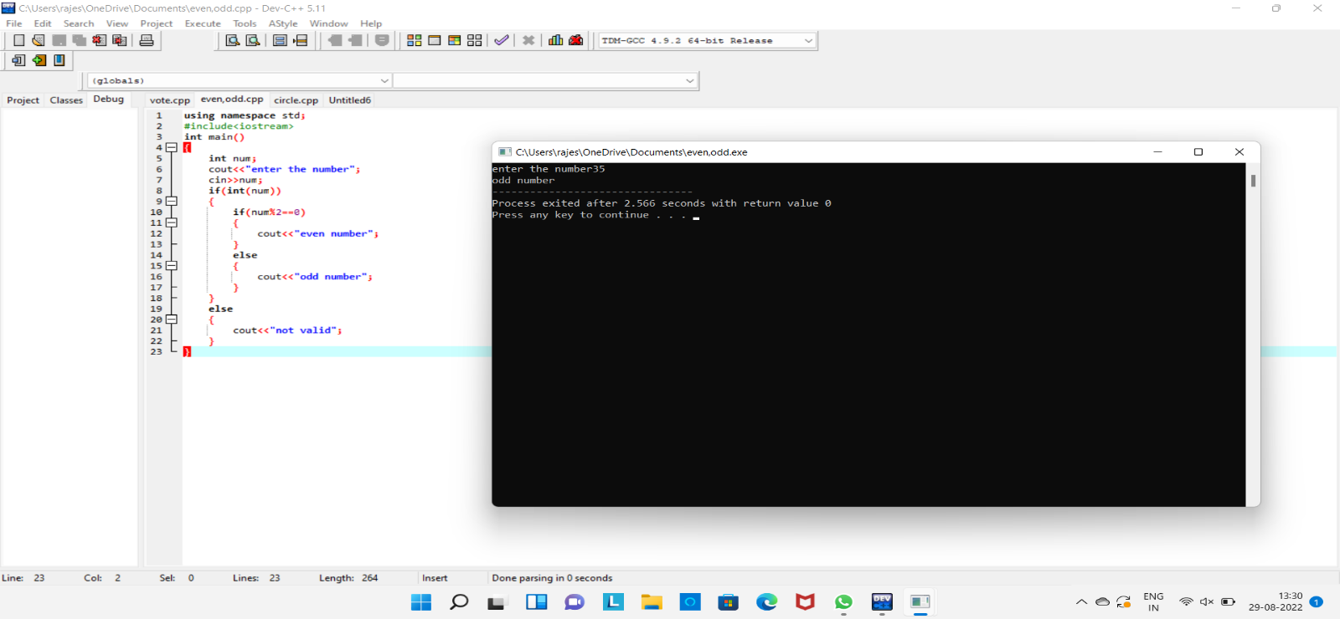

3.write a c++ program to find the area of circle and circumference?

Program:-

using namespace std;

#include<iostream>

int main()

{

float r,PI=3.14;

int exp;

cout<<"enter the radius";

cin>>r;

cout<<"enter the choice";

cin>>exp;

switch(exp)

{

case 1:

{

cout<<"area"<<3.14*r*r;

break;

}

case 2:

{

cout<<"circumference"<<2*3.14*r;

break;

}

default:

{

cout<<"enter the correct choice";

}

}

}

Output:-

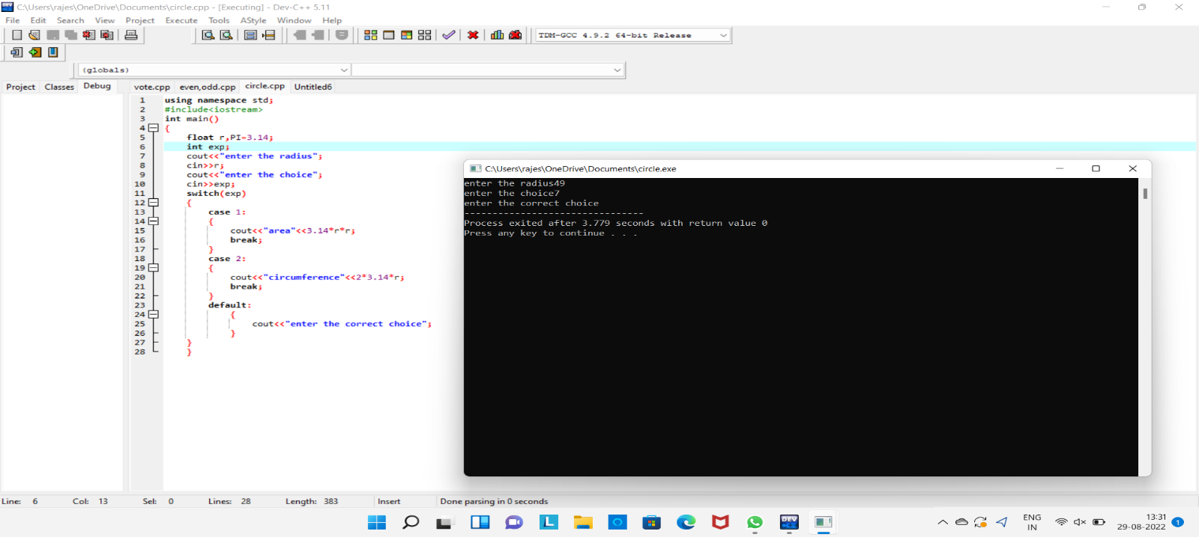

4.write a c++ program to find the addition of two numbers?

Program:-

**using namespace std;**

**#include<iostream>**

**main()**

**{**

**int a,b;**

**cout<<"enter a and b values";**

**cin>>a>>b;**

**if(int(a) && int(b))**

**{**

**cout<<a+b;**

**}**

**else**

**{**

**cout<<"not valid";**

**}**

**}**

**Output:-**

