DATE:29-08-2022 DSA0136-OOPS WITH C++ PROGRAMMING

1.write a c++ program to find the person is eligible for voting or not?

Program:-

using namespace std;

#include<iostream>

main()

{

int age;

cout<<"enter age";

cin>>age;

if (age>0 && int(age))

{

if(age>=18)

{

cout<<"eligible";

}

else

{

cout<<"not eligible";

}

}

else

{

cout<<"not valid";

}

}

Output:_

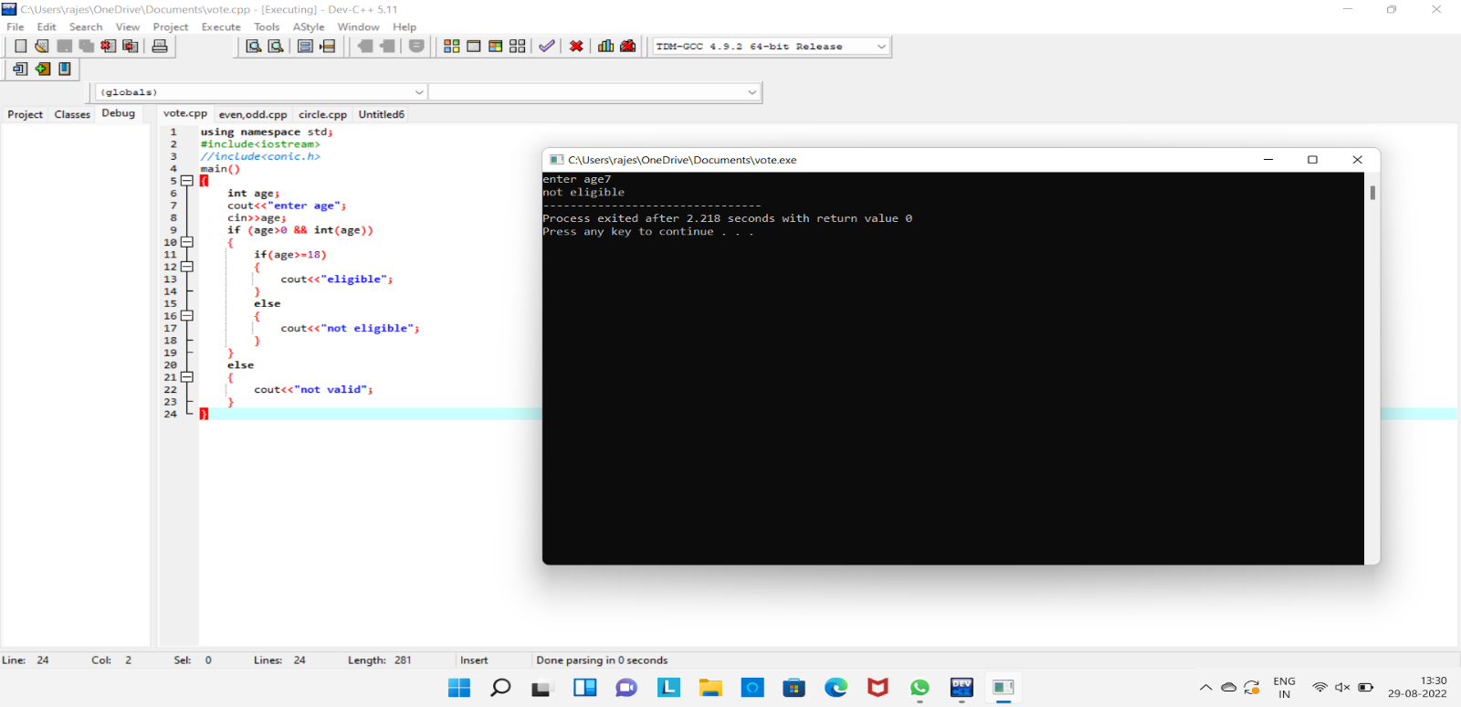

2.write a c++ program to find the given number is even or odd?

Program:-

using namespace std;

#include<iostream>

int main()

{

int num;

cout<<"enter the number";

cin>>num;

if(int(num))

{

if(num%2==0)

{

cout<<"even number";

}

else

{

cout<<"odd number";

}

}

else

{

cout<<"not valid";

}

}

Output:-

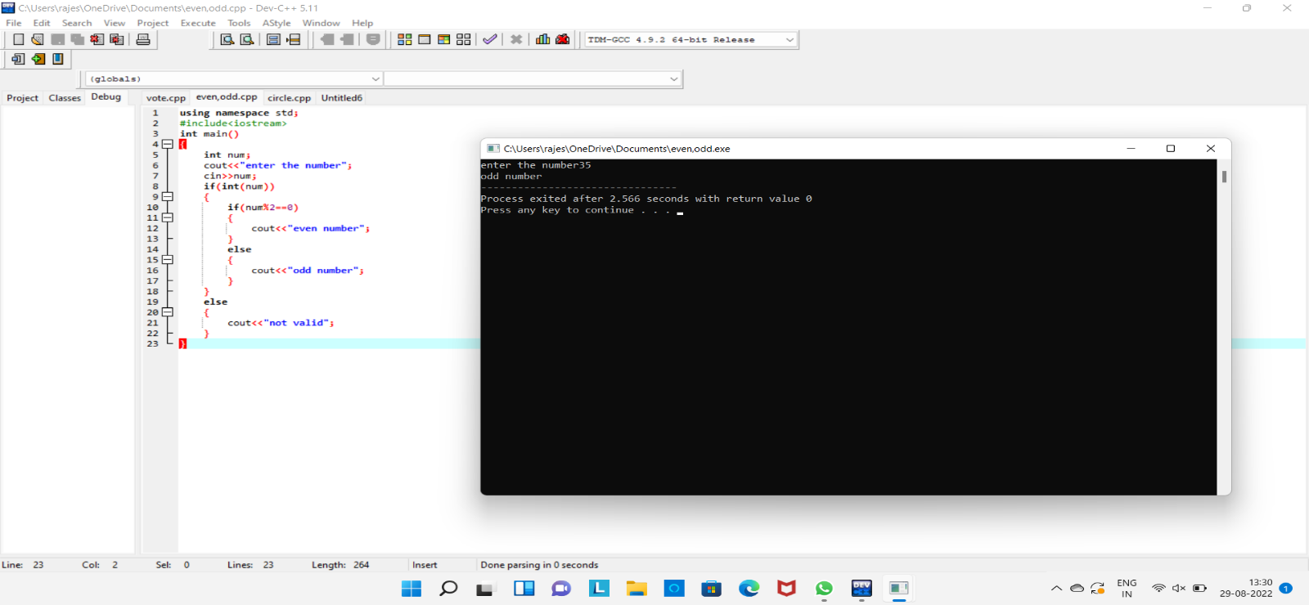

3.write a c++ program to find the area of circle and circumference?

Program:-

using namespace std;

#include<iostream>

int main()

{

float r,PI=3.14;

int exp;

cout<<"enter the radius";

cin>>r;

cout<<"enter the choice";

cin>>exp;

switch(exp)

{

case 1:

{

cout<<"area"<<3.14*r*r;

break;

}

case 2:

{

cout<<"circumference"<<2*3.14*r;

break;

}

default:

{

cout<<"enter the correct choice";

}

}

}

Output:-

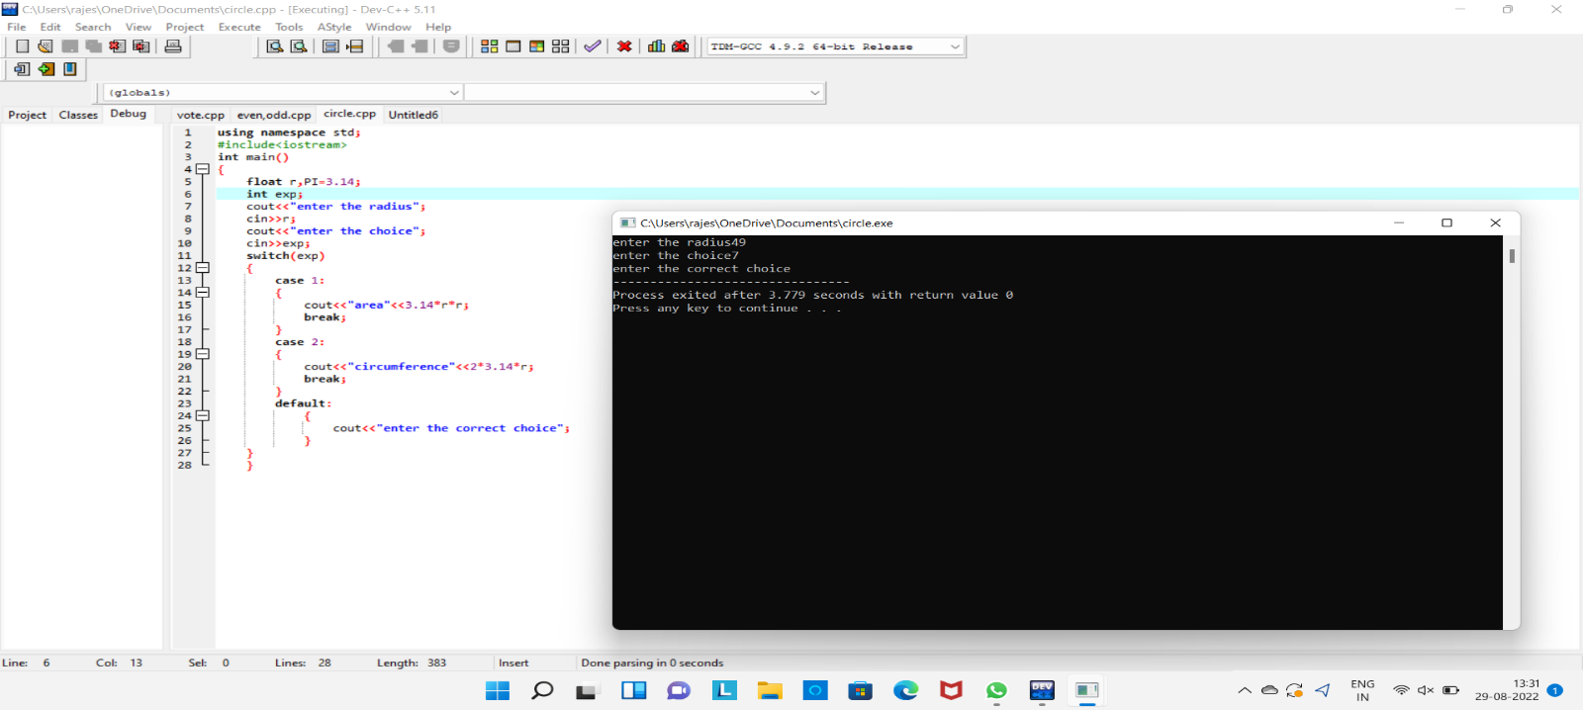

4.write a c++ program to find the addition of two numbers?

Program:-

**using namespace std;**

**#include<iostream>**

**main()**

**{**

**int a,b;**

**cout<<"enter a and b values";**

**cin>>a>>b;**

**if(int(a) && int(b))**

**{**

**cout<<a+b;**

**}**

**else**

**{**

**cout<<"not valid";**

**}**

**}**

**Output:-**

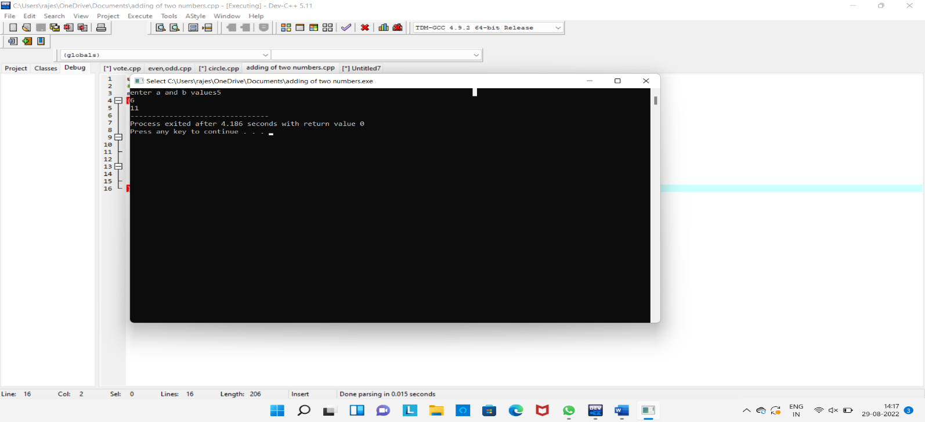

**5.write a c++ program to find the biggest among 3 numbers**

**Program:-**

**using namespace std;**

**#include<iostream>**

**main()**

**{**

**float a,b,c;**

**cout<<"enter a,b and c values ";**

**cin>>a>>b>>c;**

**if(float(a) && float(b) && float(c))**

**{**

**if(a>b && a>c)**

**{**

**cout<<"a is greatest";**

**}**

**else if(b>c && b>a)**

**{**

**cout<<"b is greatest";**

**}**

**else**

**{**

**cout<<"c is greatest";**

**}**

**}**

**else**

**{**

**cout<<"not valid";**

**}**

**}**

**Test cases:**

**1. .a=x,b=y,c=x**

**2.a=-5,b=-7,c=-9**

**3.a=5,b=7,c=-9**

**4.a=0.01,b=0.09,c=-0.03**

**Output:-**

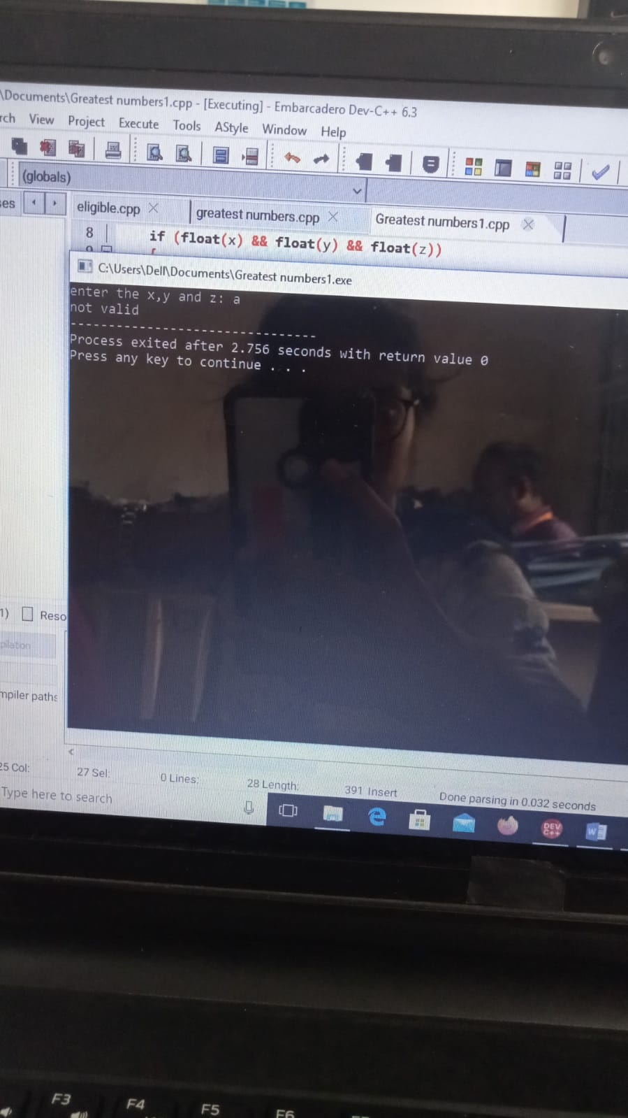

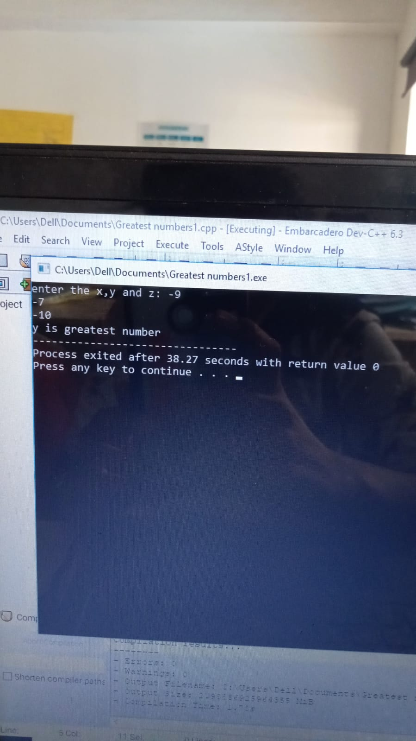

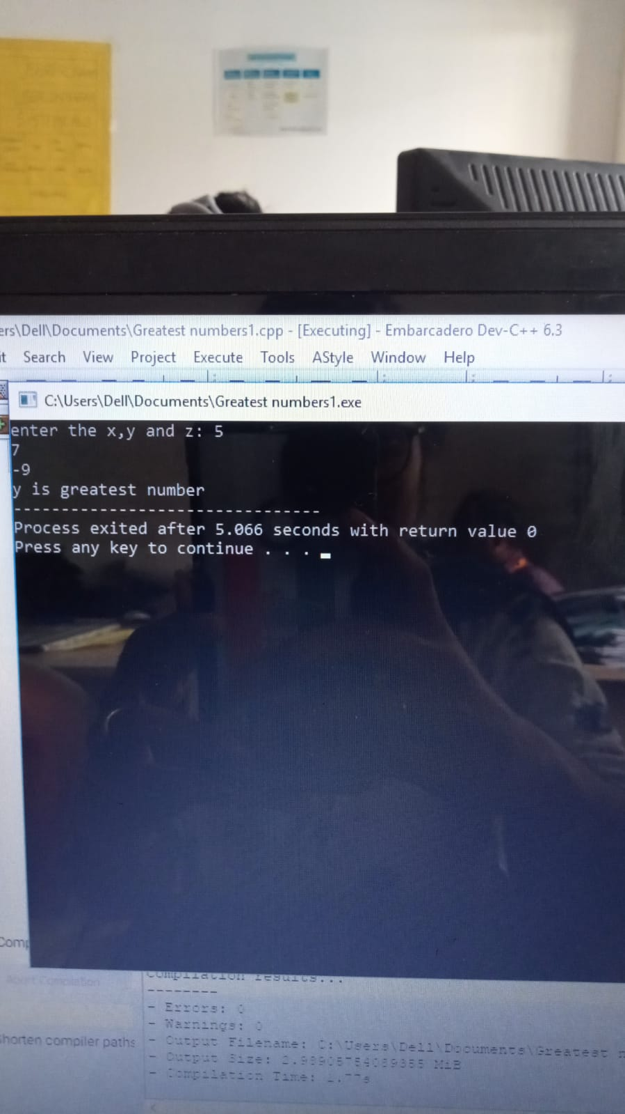

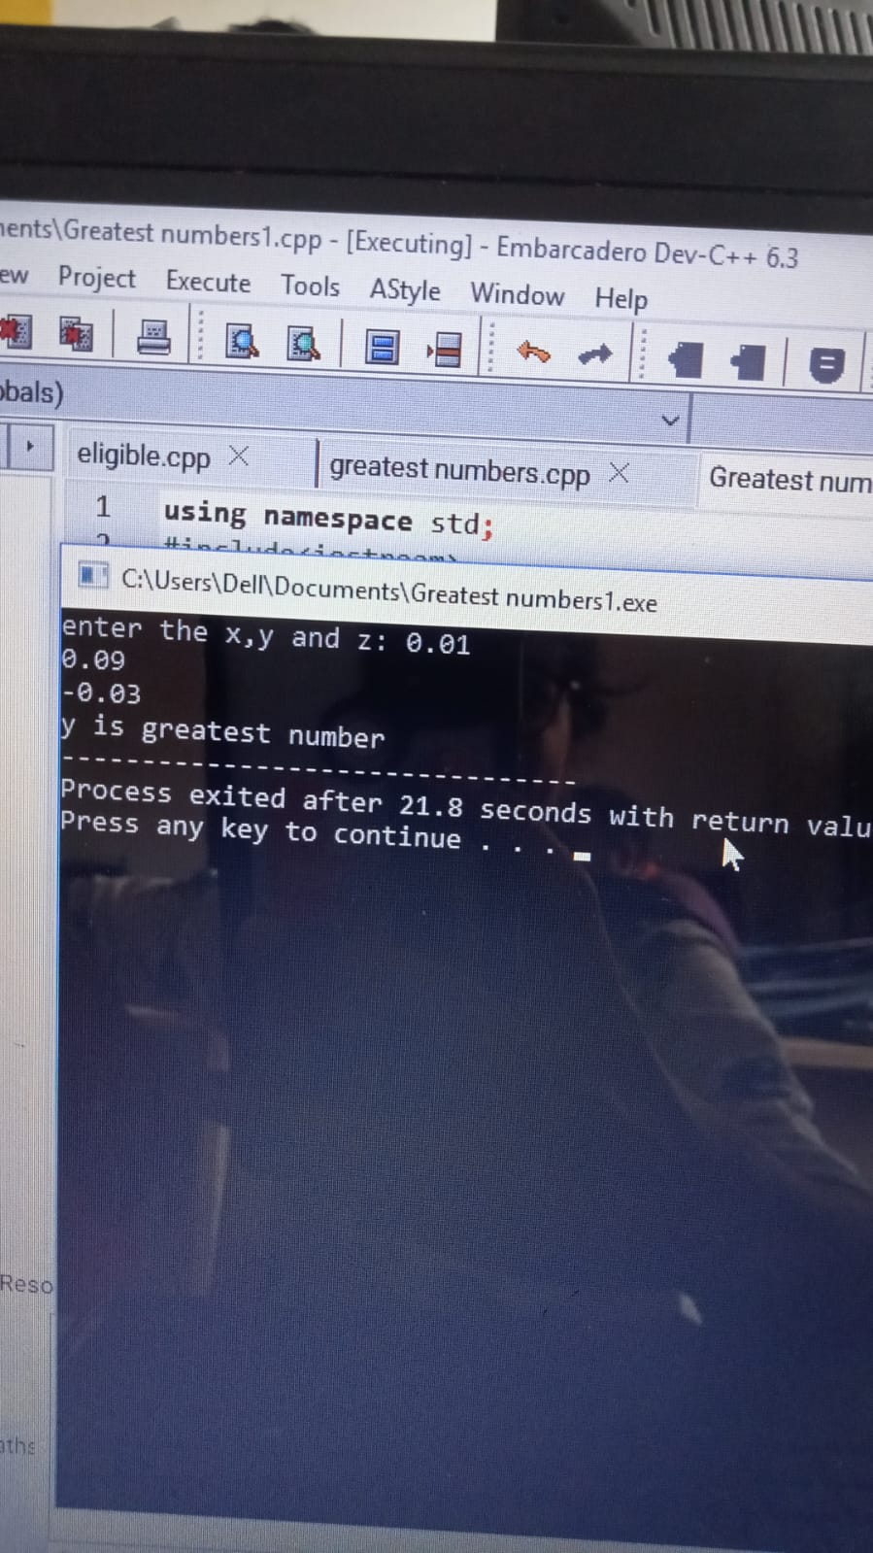

**6.write a c++ program to find the volume of the cone using class and object?**

**Program:-**

**using namespace std;**

**#include<iostream>**

**class volume**

**{**

**float r,h,v;**

**public:**

**void gatdata();**

**void display();**

**};**

**void volume::gatdata()**

**{**

**cout<<"enter r and h values";**

**cin>>r>>h;**

**}**

**void volume::display()**

**{**

**cout<<"volume of the cone";**

**v=0.33*3.14*r*r*h;**

**cout<<v;**

**}**

**int main()**

**{**

**volume z;**

**z.gatdata();**

**z.display();**

**}**

**Output:-**

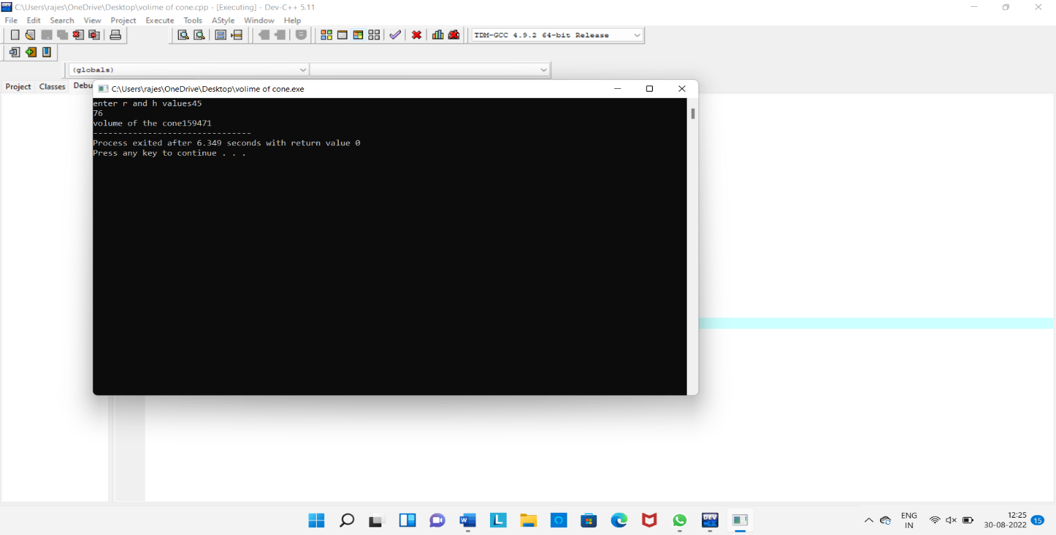

**7.write a program to find the simple intrest and compound intrest using class and object?**

**Program:-**

**using namespace std;**

**#include<iostream>**

**#include<math.h>**

**class intrest**

**{**

**double p,t,r;**

**double a,n,m;**

**public:**

**void gatdata();**

**void display();**

**};**

**void intrest::gatdata()**

**{**

**cout<<"enter p,r and t values";**

**cin>>p>>t>>r;**

**}**

**void intrest::display()**

**{**

**cout<<"simple intrest";**

**n=p*t*r/100;**

**cout<<n;**

**cout<<"coumpound intrest";**

**a=p*(pow((1+r/100),t));**

**m=a-p;**

**cout<<m;**

**}**

**int main()**

**{**

**intrest K;**

**K.gatdata();**

**K.display();**

**}**

**Output:-**

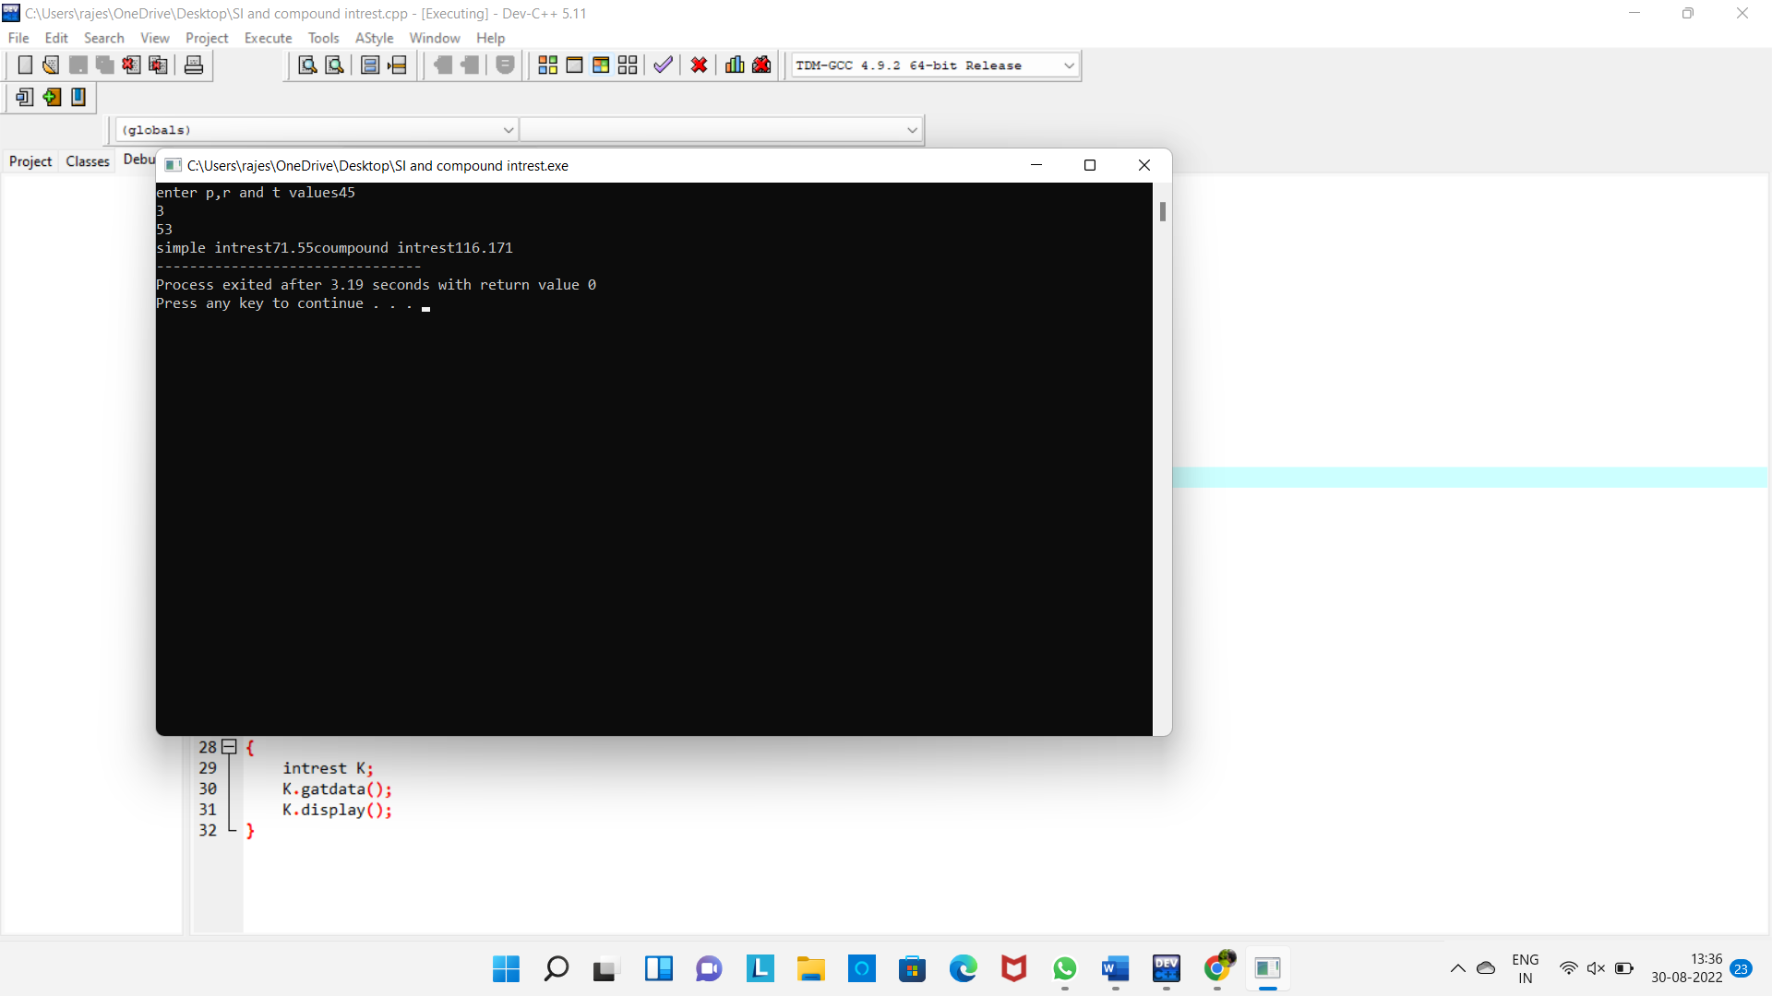

**8.write a c++program to find the biggest of 3 numbers using class and object?**

**Program:-**

**using namespace std;**

**#include<iostream>**

**class greatest**

**{**

**int a,b,c;**

**public:**

**void getdata();**

**void display();**

**};**

**void greatest::getdata()**

**{**

**cout<<"enter the a,b and c values: ";**

**cin>>a>>b>>c;**

**}**

**void greatest::display()**

**{**

**cout<<"greatest of three numbers is:\n";**

**if(a>b && a>c)**

**{**

**cout<<"a is greatest number";**

**}**

**else if(b>a && b>c)**

**{**

**cout<<"b is greatest number";**

**}**

**else if(c>a && c>b)**

**{**

**cout<<"c is greatest number";**

**}**

**else**

**{**

**cout<<"enter the correct values";**

**}**

**}**

**int main()**

**{**

**greatest h;**

**h.getdata();**

**h.display();**

**}**

**Output:-**

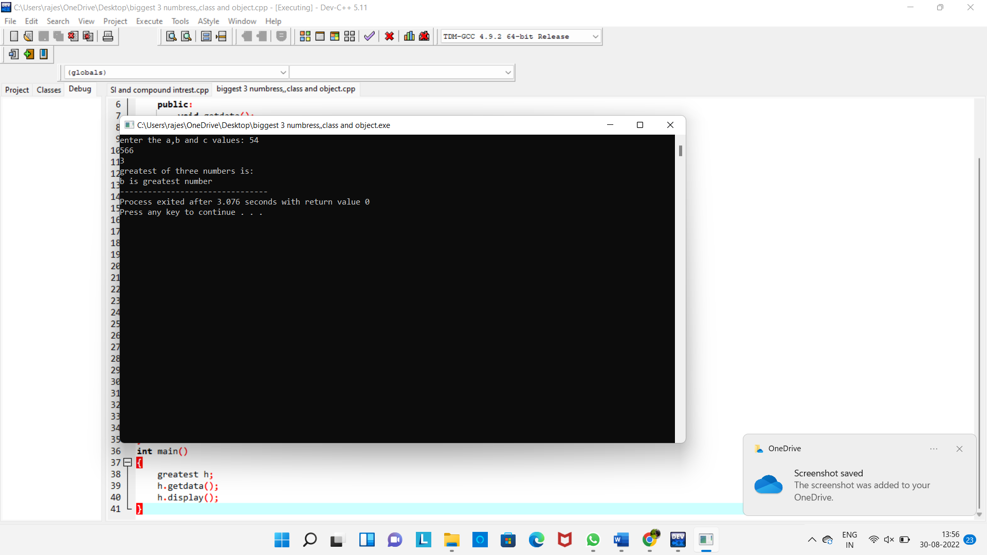

**9.write a c++ program to find the student marks of total and average?**

**Program:-**

**using namespace std;**

**#include<iostream>**

**int main()**

**{**

**int m1,m2,m3,regno;**

**float total,avg;**

**cout<<"enter the regno";**

**cin>>regno;**

**cout<<"enter the three subject marks";**

**cin>>m1>>m2>>m3;**

**total=m1+m2+m3;**

**if (m1>=50 && m1<=100)**

**{**

**avg=total/3;**

**if(avg>=90)**

**{**

**cout<<"grade A";**

**}**

**else if(avg>=80 && avg<90)**

**{**

**cout<<"grase B";**

**}**

**else if(avg>=70 && avg<80)**

**{**

**cout<<"grade C";**

**}**

**else if(avg>=60 && avg<70)**

**{**

**cout<<"grade D";**

**}**

**else**

**{**

**cout<<"fail";**

**}**

**}**

**else**

**{**

**cout<<"enter the correct marks";**

**}**

**}**

**Output:-**

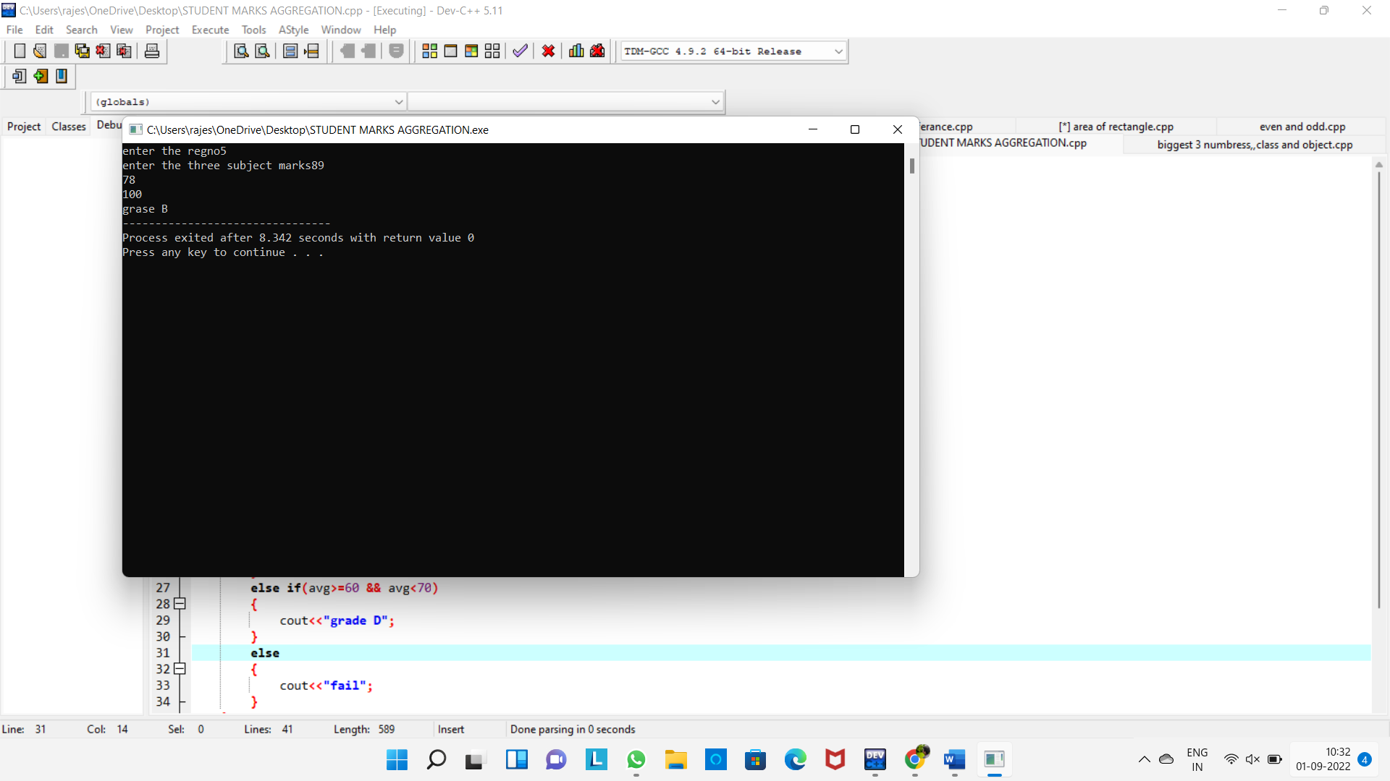

**10.write a c++ program for to find the arthemetic operations?**

**Program:-**

**using namespace std;**

**#include<iostream>**

**#include<math.h>**

**int main()**

**{**

**int a,b;**

**int exp;**

**cout<<"enter a and b values: ";**

**cin>>a>>b;**

**cout<<"enter the choice: ";**

**cin>>exp;**

**switch(exp)**

**{**

**case 1:**

**{**

**cout<<a+b;**

**break;**

**}**

**case 2:**

**{**

**cout<<a-b;**

**break;**

**}**

**case 3:**

**{**

**cout<<a*b;**

**break;**

**}**

**case 4:**

**{**

**cout<<a/b;**

**break;**

**}**

**case 5:**

**{**

**cout<<a%b;**

**break;**

**}**

**default:**

**{**

**cout<<"enter the correct choice";**

**}**

**}**

**}**

**Output:-**

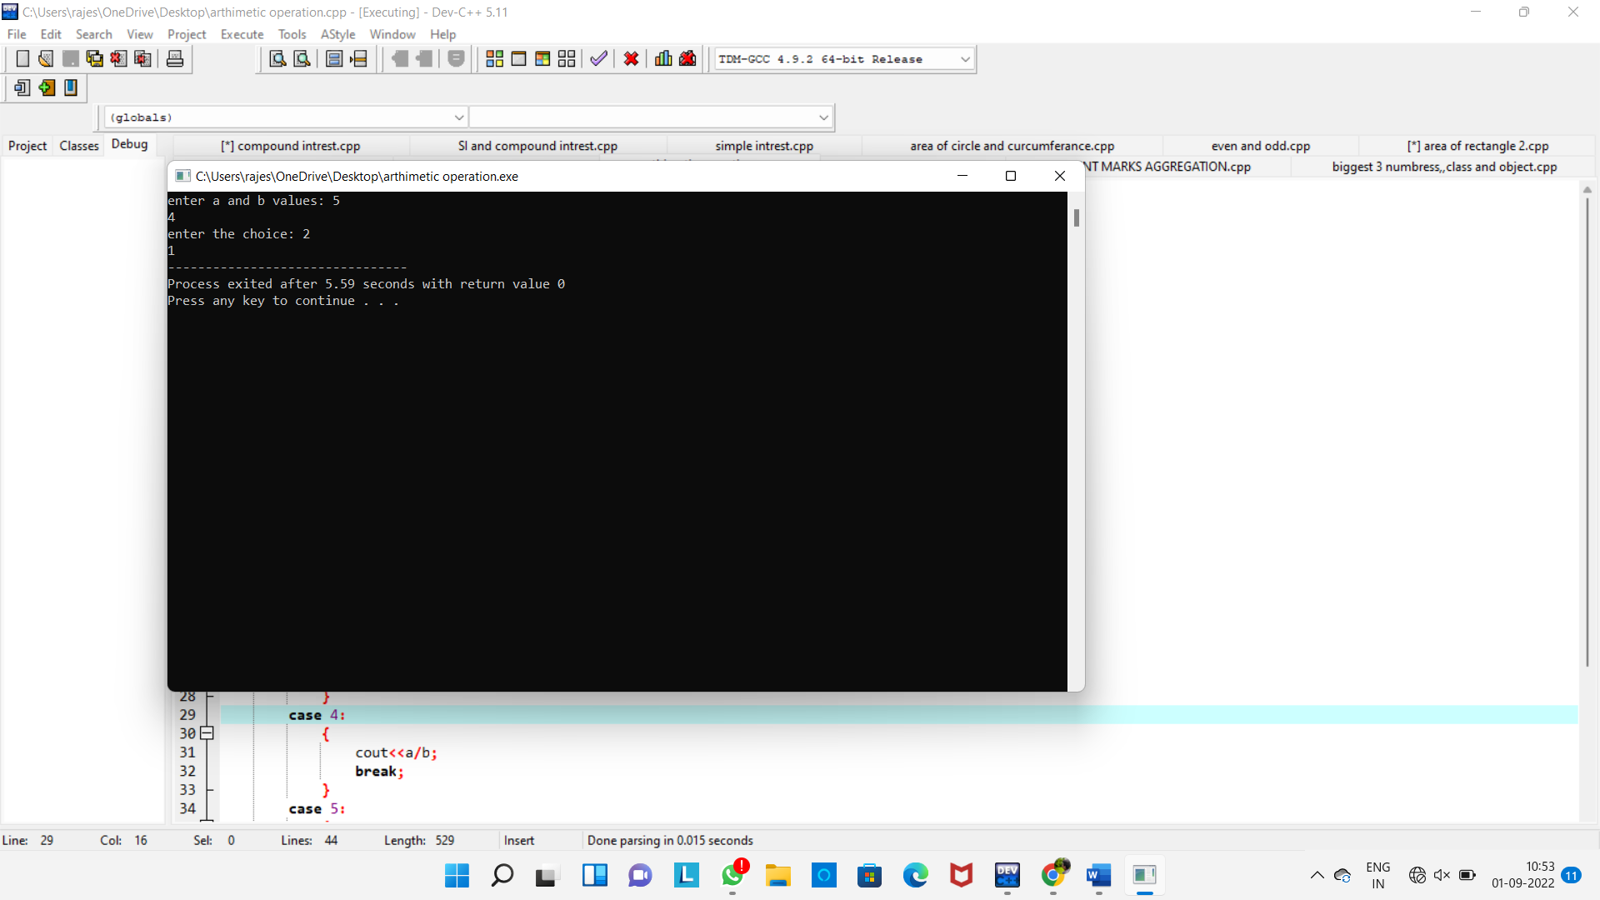

**11.write a c++ program to find the area of the rectangle?**

**Program:-**

**using namespace std;**

**#include<iostream>**

**class rectangle**

**{**

**int l,b,x;**

**public:**

**rectangle();**

**rectangle(int,int);**

**};**

**rectangle::rectangle()**

**{**

**}**

**rectangle::rectangle(int l,int b)**

**{**

**cout<<"area of rectangle";**

**x=l*b;**

**cout<<x;**

**}**

**int main()**

**{**

**rectangle myarea(10,20);**

**return 0;**

**}**

**Output:-**

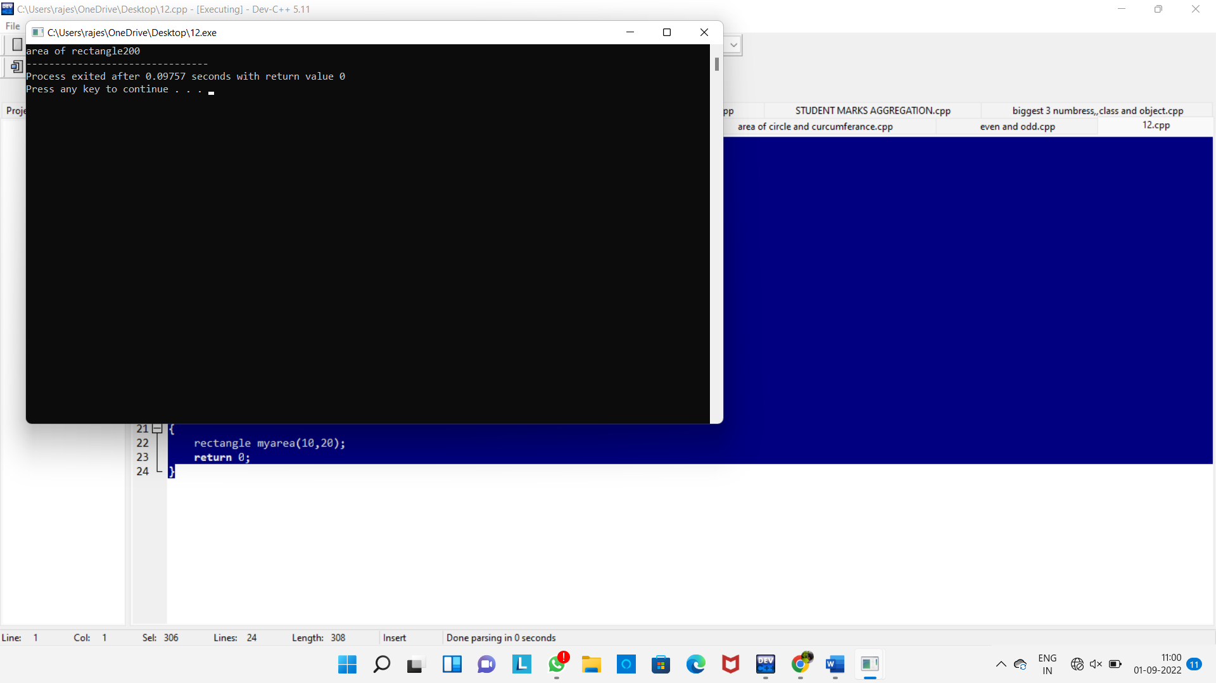

**12.write a c++ program to find the sum of two numbers using class and object?**

**Program:-**

**using namespace std;**

**#include<iostream>**

**class add**

**{**

**int x,y,z;**

**public:**

**void getdata();**

**void display();**

**};**

**void add::getdata()**

**{**

**cout<<"enter x and y values ";**

**cin>>x>>y;**

**}**

**void add::display()**

**{**

**cout<<"sum of a and b numbers ";**

**z=x+y;**

**cout<<z;**

**}**

**int main()**

**{**

**add a;**

**a.getdata();**

**a.display();**

**}**

**Output:-**

