UNIVERSITY INSTITUTE OF COMPUTING

PROJECT REPORT
ON
Project name here
Subject Name
SUBJECT CODE_HERE

SUBMITED BY:

Name:Taranjot Singh UID : 25BCD10103

Branch :UIC Group: BCD-2

Section :B Semester:1st

SUBMITED TO:

Name :Dr.Rajat Patail D.O.SUBMITION : _________________

Desigination: ____________________
Sign:____________________

Project Report: Project Title

Title
“Role of Data Science in Healthcare: Enhancing Decision Support and Patient Care through Predictive Analytics, Diagnosis, and Disease Tracking”

Aim / Introduction of the Project
The aim of this project is to explore how Data Science is transforming the healthcare industry by improving decision-making, diagnosis accuracy, and disease management. Hospitals generate massive amounts of data daily — from patient records to medical imaging — and Data Science techniques help analyze this data to deliver better patient outcomes.
By applying predictive analytics, healthcare institutions can anticipate potential health risks, while machine learning algorithms assist doctors in early diagnosis. Furthermore, disease tracking systems allow real-time monitoring of outbreaks, helping in timely prevention and control.
This project highlights how Data Science enhances patient care, supports clinical decisions, and drives innovation in healthcare systems.

Objective
The main objectives of this project are:
- To study how hospitals apply Data Science techniques to improve patient care and decision-making.
- To understand the role of predictive analytics in identifying high-risk patients and preventing diseases.
- To explore how machine learning models assist in accurate and faster diagnosis.
- To analyze how data tracking systems help in monitoring and controlling disease outbreaks.
- To highlight the overall impact of Data Science on improving efficiency, accuracy, and quality in healthcare services.

Overview of E-Commerce Concept Used
In this project, the core concept revolves around the application of Data Science in the healthcare industry. Data Science combines statistical analysis, artificial intelligence (AI), and machine learning (ML) to extract meaningful insights from large volumes of healthcare data.
Hospitals collect data from patient records, laboratory results, medical imaging, and wearable devices. Using data analytics tools, this information is processed to identify trends, predict diseases, and assist doctors in making informed clinical decisions.
Key concepts include:
- Predictive Analytics: Anticipates patient risks and helps prevent diseases before they occur.
- Machine Learning Models: Assist in diagnosis by recognizing patterns in medical images or lab reports.
- Data Visualization: Dashboards and visual reports help healthcare professionals monitor patient health in real time.
- Big Data Platforms: Enable storage and analysis of massive healthcare datasets efficiently.
Through these technologies, Data Science ensures faster diagnosis, reduced human error, and improved patient outcomes.

Working Model / Process Flow
The working model of Data Science in Healthcare follows a systematic process that transforms raw medical data into useful insights for improving patient care and hospital decision-making. The process can be explained in five main stages:

Step 1: Data Collection
Hospitals collect data from multiple sources — electronic health records (EHRs), lab results, imaging systems, wearable devices, and patient feedback. This forms the foundation for all analytical work.

Step 2: Data Preprocessing
The collected data is often unstructured or incomplete. Data scientists clean, filter, and organize it to ensure accuracy. This includes removing duplicates, handling missing values, and converting data into usable formats.

Step 3: Data Analysis & Modeling
Advanced algorithms such as machine learning and predictive models are applied to analyze the data. These models can predict disease risks, suggest treatments, or identify unusual medical patterns.

Step 4: Visualization & Interpretation
The analyzed data is presented using dashboards, graphs, and reports to help doctors and hospital administrators easily understand patterns and make informed decisions.

Step 5: Decision Support & Implementation
Finally, hospitals use these insights for real-time patient monitoring, preventive care, and resource optimization. The system continuously learns from new data, improving accuracy over time.

6. Benefits and Limitations
A. Benefits of Data Science in Healthcare
- Improved Diagnosis Accuracy:
Machine learning models help detect diseases like cancer or heart disorders at early stages, improving survival rates.
- Predictive Healthcare:
Predictive analytics identifies patients at risk of developing chronic diseases, enabling preventive care and timely treatment.
- Personalized Treatment Plans:
Data-driven insights allow doctors to design treatment plans based on individual patient data, medical history, and genetic factors.
- Efficient Hospital Management:
Data analytics optimizes resource allocation, staff scheduling, and equipment usage, reducing operational costs.
- Disease Tracking and Prevention:
Real-time data tracking helps control outbreaks and manage pandemics like COVID-19 effectively.
- Enhanced Patient Experience:
Faster decision-making, accurate diagnosis, and personalized care lead to greater patient satisfaction and trust.
B. Limitations of Data Science in Healthcare
- Data Privacy and Security Risks:
Sensitive patient information is vulnerable to cyberattacks and data breaches.
- High Implementation Cost:
Setting up advanced data systems and hiring skilled professionals can be expensive for many hospitals.
- Data Quality Issues:
Incomplete or inconsistent data may lead to incorrect predictions or diagnoses.
- Need for Skilled Professionals:
Effective use of data science tools requires trained data scientists and medical experts.
- Ethical and Legal Concerns:
Using patient data for AI modeling raises questions about consent and ethical data usage.

7.Technology and Payment System Used
A. Technology Used
Hospitals and healthcare organizations use a combination of Data Science tools, Artificial Intelligence (AI), and Big Data technologies to collect, process, and analyze patient data effectively.
The key technologies include:
- Programming Languages:
  - Python and R for data analysis, visualization, and predictive modeling.
- Machine Learning & AI Frameworks:
  - TensorFlow, Scikit-learn, and PyTorch for building diagnostic and predictive models.
- Big Data Platforms:
  - Apache Hadoop and Apache Spark for managing and processing large-scale healthcare datasets.
- Data Visualization Tools:
  - Tableau and Power BI for creating dashboards and real-time health monitoring systems.
- Database Management Systems:
  - SQL, MongoDB, and Oracle for storing and managing patient records securely.
- Cloud Computing:
  - Platforms like AWS, Google Cloud, and Microsoft Azure for secure data storage and scalability.

B. Payment System Used
While Data Science primarily focuses on analytics, healthcare institutions integrate digital payment systems for better patient convenience and operational transparency.
- Online Payment Gateways:
  - Hospitals use gateways such as Razorpay, Paytm, and Stripe for secure online bill payments.
- Cashless Insurance Integration:
  - Data systems are linked with insurance APIs for automatic verification and cashless transactions.
- Hospital Billing Software:
  - Built-in billing modules process payments, generate invoices, and maintain digital transaction records.
- UPI and Mobile Payments:
  - UPI-based apps (like Google Pay, PhonePe, and BHIM) are widely used for quick and contactless payments.

- Risk and Security Measures
The use of Data Science in healthcare brings immense benefits but also introduces several risks related to data privacy, misuse, and system vulnerabilities. Hospitals must implement strong security measures to ensure patient data remains safe and confidential.

A. Risks Involved
- Data Breaches:
Unauthorized access or hacking of hospital databases can expose sensitive patient information such as medical history, ID numbers, and financial data.
- Data Misuse:
Improper handling or sharing of medical data without patient consent can lead to ethical and legal violations.
- Inaccurate Predictions:
Poor-quality data or biased machine learning models may lead to wrong diagnoses or treatment recommendations.
- System Vulnerabilities:
Weak network security or outdated software can make hospital systems prone to cyberattacks or malware.
- Human Error:
Lack of awareness or negligence by staff can lead to accidental data leaks or security lapses.

B. Security Measures
- Data Encryption:
Encrypting all patient data before storage or transfer ensures protection against unauthorized access.
- Access Control:
Role-based access allows only authorized healthcare professionals to view or edit sensitive data.
- Regular Security Audits:
Hospitals conduct routine audits to identify and fix system weaknesses.
- Firewall and Antivirus Protection:
Strong firewalls and updated antivirus software prevent malware and cyber intrusions.
- Data Backup and Recovery:
Maintaining regular data backups ensures that information can be restored in case of system failures.
- Compliance with Data Protection Laws:
Following standards like HIPAA (Health Insurance Portability and Accountability Act) ensures legal protection of patient data.
- Staff Training:
Conducting cybersecurity awareness programs for employees reduces human error and strengthens data protection.

Findings / Analysis
After studying the role of Data Science in Healthcare, several important findings were observed. These findings highlight how hospitals are leveraging technology to enhance medical care, efficiency, and safety.

A. Findings
- Improved Patient Outcomes:
Predictive analytics helps in identifying high-risk patients early, allowing timely treatment and reducing mortality rates.
- Enhanced Diagnostic Accuracy:
Machine learning models can analyze medical images, lab reports, and patient data faster and more accurately than traditional methods.
- Data-Driven Decision Making:
Doctors and hospital administrators rely on dashboards and AI-powered systems for evidence-based decisions rather than intuition alone.
- Efficient Resource Management:
Data science tools help hospitals allocate beds, staff, and medical equipment more effectively, minimizing delays and costs.
- Real-Time Disease Tracking:
During health crises (like COVID-19), data visualization tools enabled real-time tracking of infection rates and resource needs.
- Integration Challenges:
Hospitals face issues combining different data sources (EHR, lab data, imaging, etc.), affecting overall analysis quality.
- Privacy Concerns:
Despite technological advancement, maintaining strict data privacy and ethical usage remains a top challenge.

B. Analysis
The analysis shows that Data Science has become essential for modern healthcare systems. Predictive analytics not only helps in prevention and early diagnosis but also reduces the overall healthcare cost. However, to achieve maximum benefits, hospitals must ensure high-quality data, strong security protocols, and skilled professionals for data interpretation.
In summary, the integration of Data Science in healthcare is transforming the industry from reactive care to proactive, data-driven healthcare delivery.

Conclusion
Data Science has emerged as a revolutionary force in the healthcare sector, enabling hospitals and medical professionals to make smarter, faster, and more accurate decisions. Through the use of predictive analytics, machine learning, and data visualization, healthcare providers can identify potential risks, diagnose diseases early, and offer personalized treatment to patients.
The integration of data-driven tools has not only improved patient outcomes but also enhanced hospital management, cost efficiency, and disease control. However, with these advancements come challenges — including data privacy, ethical concerns, and technical limitations — which must be addressed through strong policies, staff training, and robust security measures.
In conclusion, Data Science is transforming healthcare into a proactive, efficient, and patient-centered system, shaping the future of medical innovation and global health improvement.

11.Learning Outcomes
After completing this case study on the Role of Data Science in Healthcare, the following key learning outcomes were achieved:
- Understanding of Data Science Applications:
Gained insight into how Data Science is used in hospitals for diagnosis, prediction, and disease monitoring.
- Knowledge of Predictive Analytics:
Learned how predictive models help identify health risks and improve preventive care.
- Awareness of Technological Tools:
Understood the role of technologies like AI, machine learning, big data platforms, and visualization tools in healthcare.
- Appreciation of Data-Driven Decision Making:
Recognized how data insights support better medical and administrative decisions.
- Understanding of Risks and Security Needs:
Learned about the importance of data privacy, encryption, and compliance with healthcare data laws.
- Critical Thinking and Analysis:
Developed the ability to evaluate both the benefits and limitations of using Data Science in real-world healthcare systems.

12.References
- IBM Watson Health Reports – Applications of AI and Data Science in Healthcare
- World Health Organization (WHO) – Digital Health and Data Analytics Reports
- Analytics Vidhya – Role of Data Science in the Healthcare Industry
- ResearchGate – A Study on Predictive Analytics for Disease Detection
- Towards Data Science – Machine Learning Applications in Healthcare
- Kaggle Healthcare Datasets – Real-world Medical Data for Analysis
- National Institutes of Health (NIH) – Healthcare Big Data and AI Initiatives

13.Screenshots

[screenshot for upload in any blog (linkedin/medium)

https://www.linkedin.com/in/taran-deol-9b98a5397/overlay/1762496800322/single-media-viewer/?profileId=ACoAAGF8YV0B0br9zPTplSOYxnFt_mFCj-BR2y4

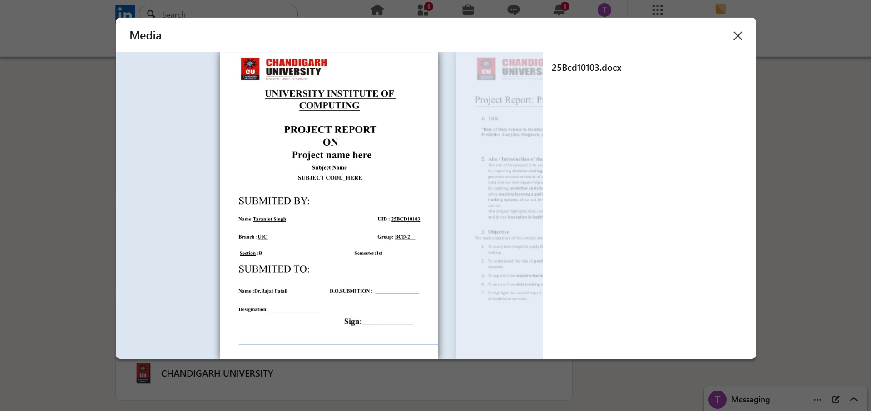

]

[screenshots for upload in github]

14. Evaluation Grid (To be created as per the SOP and Assessment guidelines by the faculty):
Sr. No. | Parameters | Marks Obtained | Maximum Marks
1. | PROJECT TITLE |  | 2 Marks
2. | CASE STUDY |  | 5 Marks
3. | Github Upload Link |  | 1 Marks
4. | Blog Upload Link |  | 1 Marks
5. | Follow Format |  | 1 Marks
 | TOTAL |  | 10 Marks
 | AVG |  | 6 Marks

Teacher Signature

