NAME – Tarandeep Singh

ROLL NO – 102317261

GROUP – 2Q25

# COGNITIVE COMPUTING

**ASSIGNMENT NO. 11**

Writeup Describing the Project:

This project is an emotion detection model built using Landing AI to identify different emotions —Angry , Sad , Happy . Trained on labeled datasets, the model accurately predicts emotions from new images, demonstrating AI's potential.

Step 1

–

Project Creation Page

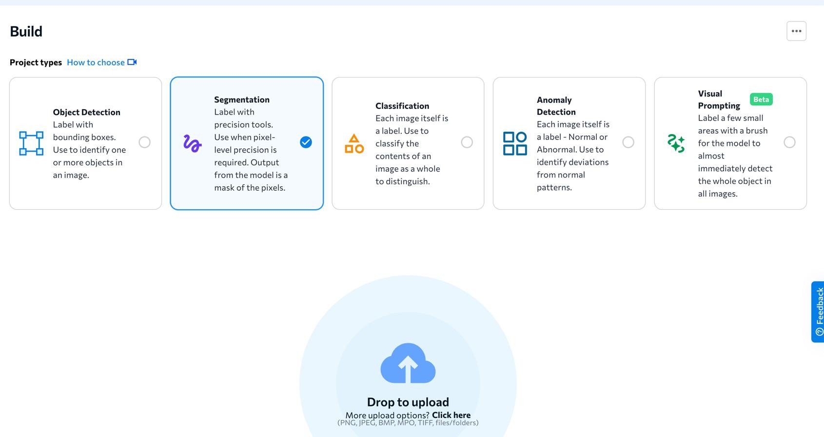

Step 2 - Uploading images

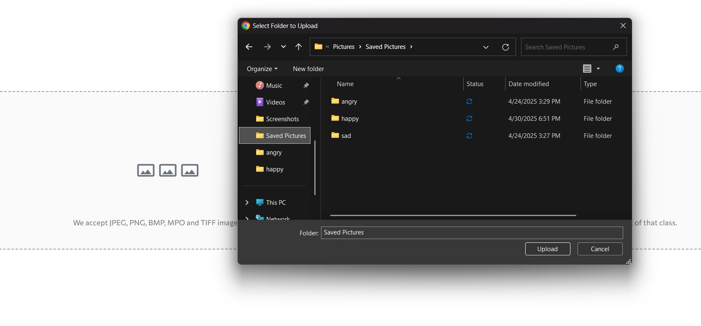

Step 3 – Labelling Classes

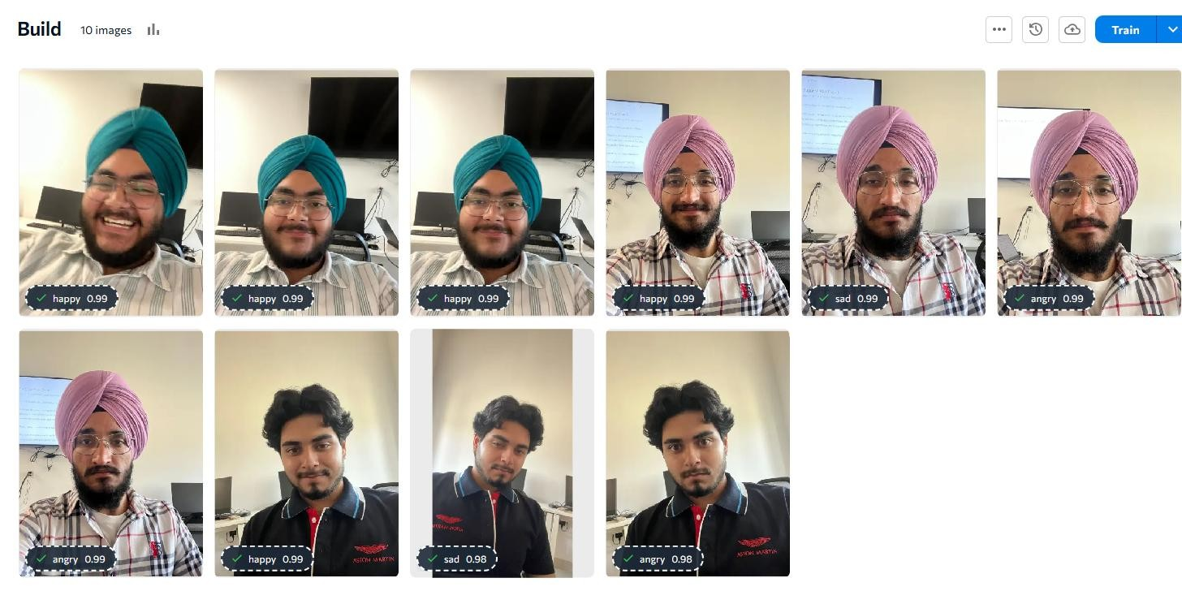

Step 4 – Confusion Matrix

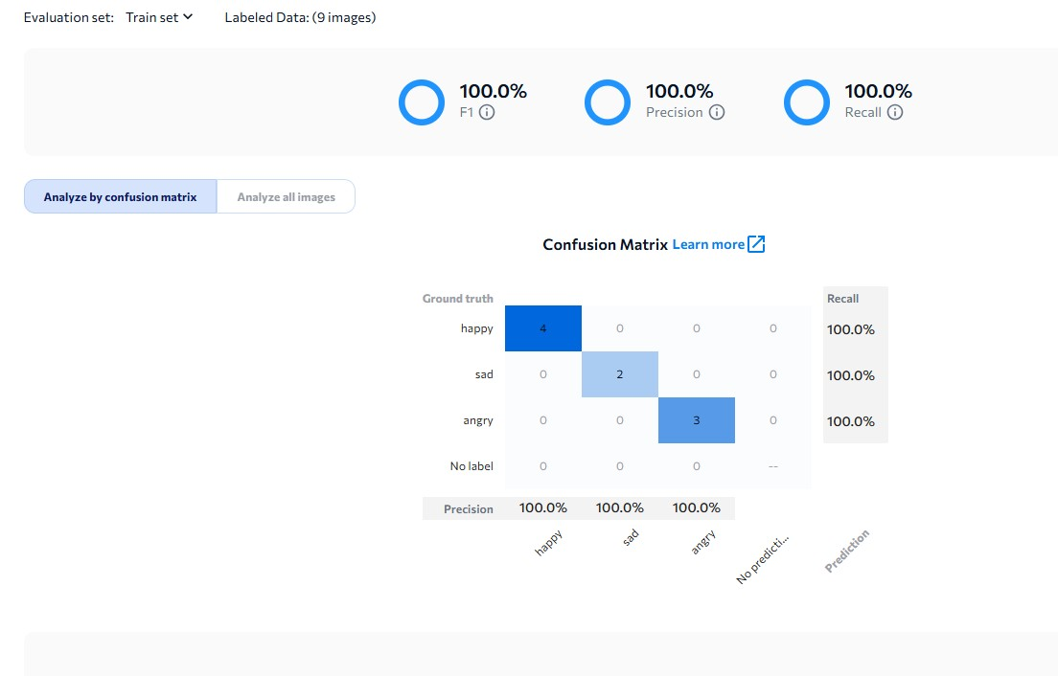

Step 5 – Training Model

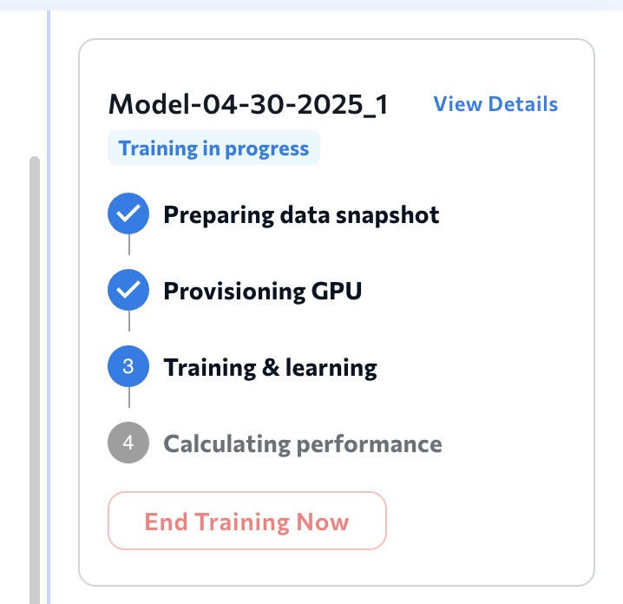

Step 6 – Testing the Model

