DATA SCIENCE PROJECT REPORT
Predictive Modeling of Productivity Based on Sleep Patterns, Screen Exposure, and Stress Levels

Tarandeep Singh
Roll No: 61
Section : 324PB
Lovely Professional University

Certificate
This is to certify that Tarandeep Singh has completed the project titled ' Predictive Modeling of Productivity Based on Sleep Patterns, Screen Exposure, and Stress level using Machine Learning' under my guidance.

Declaration

I, Tarandeep Singh, a student of B.Tech Computer Science and Engineering at Lovely
Professional University, Punjab, hereby declare that the project titled “Predictive Modeling of Productivity Based on Sleep Patterns, Screen Exposure, and Stress Levels” submitted in partial fulfillment of the requirements for the award of the degree is a record of original work carried out by me under the guidance and supervision of the concerned faculty.
I further declare that the work presented in this project report is based on my own efforts, research, and understanding. All the data analysis, visualizations, and interpretations have been performed by me using appropriate tools and techniques in the field of Data Science. Wherever references have been made to the work of others, due acknowledgment has been given in accordance with standard academic practices.
I confirm that this project report has not been submitted, either in part or in full, to any other university or institution for the award of any degree, diploma, or certification. The results and findings presented in this report are genuine and have not been fabricated or manipulated in any form.
I also take full responsibility for maintaining the integrity and authenticity of the work. I understand that any form of plagiarism or academic misconduct will lead to disciplinary action as per the rules and regulations of the university.
This project has enhanced my understanding of data analysis, visualization techniques, and machine learning concepts. It has provided me with practical exposure to real-world data and strengthened my problem-solving and analytical skills.
I hereby declare that the information provided in this report is true to the best of my knowledge and belief.

Acknowledgement
I would like to express my sincere gratitude to all those who have supported and guided me throughout the completion of this project titled “Predictive Modeling of Productivity Based on Sleep Patterns, Screen Exposure, and Stress Levels.”
I am especially thankful to my project guide and faculty members for their valuable guidance, continuous encouragement, and constructive suggestions, which helped me successfully complete this work.
I would also like to thank Lovely Professional University for providing me with the necessary resources, infrastructure, and learning environment to carry out this project effectively.
I extend my heartfelt thanks to my friends and peers for their support, cooperation, and helpful discussions during the course of this project.
Lastly, I am deeply grateful to my family for their constant motivation, understanding, and encouragement, which enabled me to complete this project successfully.

Table of Contents
- Introduction ........................................................................
  - Background of the Study .............................................
  - Objectives of the Project ............................................
  - Importance of Data Analysis .......................................
- Scope of the Analysis ................................................
  - Scope and Limitations ...............................................
  - Applications of the Study ............................................
- Existing System ..........................................................
  - Overview of Existing System ......................................
  - Drawbacks or Limitations of Existing System ..............
- Source of Dataset ......................................................
  - Dataset Description ..................................................
  - Dataset Features and Attributes ................................
- ETL Process .................................................................
  - Extract ........................................................................
  - Transform ...............................................................
  - Load ............................................................................
- Analysis on Dataset ...................................................
  - Introduction to Analysis ............................................
  - General Description of Dataset .................................
  - Data Preprocessing ..................................................
  - Specific Requirements, Functions and Formulas .........
  - Analysis Results ......................................................
  - Visualization (Dashboard) ........................................
- List of Analysis with Results .....................................
  - Correlation Heatmap Analysis ..................................
  - Pair Plot Analysis ...................................................
  - Sleep Hours vs GPA Analysis .................................
  - Social Media Usage vs GPA ..................................
  - Phone Usage vs GPA ............................................
  - Weekly Study Sessions vs GPA ............................
  - Extracurricular Activities vs GPA ..........................
  - Average Lifestyle of Top Students .........................
  - Parental Education vs GPA ..................................
  - Hostel vs Non-Hostel Distribution .......................
  - Hostel vs GPA Analysis .....................................
  - Feature Importance Analysis ...............................
  - Confusion Matrix ................................................
  - Model Comparison ..............................................
- Future Scope .............................................................
- References ...............................................................
- Bibliography .........................................................

Introduction
In today’s data-driven world, understanding the impact of lifestyle habits on individual productivity has become increasingly important. With the widespread use of digital devices and evolving work environments, factors such as sleep patterns, screen exposure, stress levels, and daily routines play a significant role in influencing human performance. Analyzing such data can provide valuable insights into behavioral patterns and help in improving productivity and well-being.
The project titled “Exploratory Data Analysis of Productivity Based on Sleep Patterns, Screen Exposure, and Stress Levels” focuses on examining how various lifestyle and demographic factors affect productivity. The primary objective of this study is to identify meaningful patterns, trends, and relationships within the dataset that can help in understanding how daily habits influence performance levels. By applying data preprocessing, exploratory data analysis (EDA), and visualization techniques, the project aims to transform raw data into meaningful insights.
This study utilizes tools such as Python and its libraries like pandas, NumPy, matplotlib, and seaborn to clean, process, and visualize the dataset effectively. Various graphical representations such as bar charts, box plots, scatter plots, and heatmaps are used to highlight important relationships between variables.
Furthermore, this analysis helps in identifying key factors that influence productivity, such as sleep duration, stress levels, screen time, and work modes. The insights derived from this project can be useful for individuals, organizations, and researchers in understanding how lifestyle choices affect performance and in making informed decisions to improve productivity and overall well-being.
In conclusion, this project demonstrates the importance of data analysis in understanding human behavior and showcases how data-driven approaches can be used to uncover meaningful insights and optimize productivity in modern environments.

Scope of the Analysis
The scope of this project is centered around the analysis of lifestyle and behavioral data to extract meaningful insights related to individual productivity. The analysis primarily focuses on understanding how factors such as sleep duration, screen exposure, stress levels, work mode, and demographic attributes influence productivity outcomes.
This project involves data preprocessing steps including handling missing values, data cleaning, and feature selection to ensure the dataset is suitable for analysis. Exploratory Data Analysis (EDA) is performed to identify trends, patterns, and relationships among various lifestyle and productivity-related attributes. Visualization techniques such as bar charts, box plots, scatter plots, and heatmaps are used to present the findings in a clear and interpretable manner.
The scope of this analysis is limited to descriptive and exploratory methods using statistical and visualization techniques. It does not include advanced predictive modeling or deployment of machine learning models, as the primary focus is on understanding relationships and patterns within the data rather than making future predictions.
Additionally, the project aims to provide insights into how daily habits and environmental factors impact productivity, which can be useful for individuals, organizations, and researchers in improving performance and well-being. However, the conclusions drawn are specific to the dataset used and may vary with different datasets or real-world conditions.
In summary, this project emphasizes a data-driven approach to understanding productivity through lifestyle factors within a defined dataset, focusing on analysis, interpretation, and visualization rather than real-time implementation or large-scale predictive systems.

Existing System
In the current environment, analysis of productivity and lifestyle-related data is often performed using basic and traditional methods such as spreadsheets, manual observations, or simple reporting tools. While these methods allow individuals and organizations to record data related to sleep patterns, screen usage, stress levels, and work habits, they are limited in their ability to extract meaningful insights efficiently.
Existing systems primarily focus on data collection and storage rather than in-depth analysis. For instance, many applications and tools track metrics like screen time, sleep duration, or stress levels individually, but they do not effectively analyze the relationships between these factors and overall productivity. As a result, users must rely on manual interpretation, which can be time-consuming and may not reveal hidden patterns or correlations.
Moreover, traditional approaches do not fully utilize modern data analysis techniques such as exploratory data analysis (EDA), statistical visualization, and pattern identification. This limits the ability to understand how multiple lifestyle factors interact with each other and influence productivity. Without proper analytical tools, it becomes difficult to identify trends such as the impact of sleep on performance or the effect of stress on productivity levels.
Another limitation of existing systems is the lack of effective visual representation. Data is often presented in tabular or numerical formats, making it challenging to interpret complex relationships quickly. Additionally, these systems may not handle missing, inconsistent, or noisy data efficiently, which can lead to inaccurate or incomplete analysis.
In summary, while existing systems are useful for tracking and storing lifestyle-related data, they lack advanced analytical capabilities required to uncover meaningful insights. This creates a need for a more efficient, data-driven approach that leverages modern data analysis and visualization techniques to better understand and improve productivity

Drawbacks of Existing System
The existing systems used for tracking and analyzing lifestyle and productivity-related data have several limitations that reduce their effectiveness in generating meaningful insights. Some of the major drawbacks are as follows:
• Lack of Advanced Analysis:
Traditional tools mainly focus on recording individual metrics such as sleep duration or screen time. They do not support advanced analytical techniques like exploratory data analysis, correlation analysis, or pattern recognition across multiple factors.
• Manual Effort and Time-Consuming:
Users often need to manually interpret data from different sources, making the process slow and inefficient. This delays understanding and decision-making regarding productivity improvement.
• Limited Data Visualization:
Data is commonly presented in simple tables or basic summaries, which makes it difficult to quickly identify trends, relationships, or patterns among lifestyle variables.
• Higher Chances of Errors:
Manual analysis and interpretation increase the likelihood of human errors, which can lead to incorrect conclusions about productivity and influencing factors.
• Poor Integration of Multiple Factors:
Existing systems typically analyze factors like sleep, stress, or screen time separately rather than together, limiting the ability to understand their combined impact on productivity.
• Lack of Insightful Relationships:
Without proper analytical tools, it is difficult to identify how different variables interact, such as how stress and sleep together affect performance.
• Data Inconsistency Issues:
Missing, incomplete, or inconsistent data is often not handled effectively, reducing the accuracy and reliability of analysis.
• Limited Decision Support:
These systems do not provide meaningful insights or interpretations, making it harder for individuals or organizations to take informed actions to improve productivity.

Source of Dataset
The dataset used in this project has been sourced from Kaggle, an online platform that provides a wide range of publicly available datasets for data science, machine learning, and research purposes.
Kaggle datasets are widely recognized for their quality, diversity, and real-world relevance. The dataset used in this project contains information related to lifestyle and behavioral factors such as sleep duration, screen time, stress levels, work mode, and productivity scores, making it suitable for analyzing the impact of daily habits on productivity.
Before performing the analysis, the dataset was downloaded from Kaggle and preprocessed to ensure accuracy and consistency. Data cleaning steps such as handling missing values, removing duplicates, and formatting were carried out to prepare the dataset for further analysis.
The dataset is used strictly for academic and educational purposes, and no sensitive or personal information has been misused. Proper care has been taken to maintain the integrity and reliability of the data throughout the project.

ETL Process
The ETL (Extract, Transform, Load) process is a fundamental step in data analysis that involves collecting data from sources, preparing it for analysis, and storing it in a structured format. In this project, the ETL process was implemented as follows:

4.1 Extract
The first step involved extracting the dataset from Kaggle, a reliable online data repository. The dataset was downloaded in a structured format (such as Excel/CSV) and imported into the Python environment using libraries like pandas. This step ensured that the raw data was readily available for further processing.

4.2 Transform
The transformation phase focused on cleaning and preparing the data to make it suitable for analysis. The following operations were performed:
• Handling missing or null values using appropriate techniques (removal or imputation)1
• Removing duplicate records to maintain data integrity
• Converting data types into appropriate formats
• Filtering irrelevant or inconsistent data
• Creating new features such as productivity levels (Low, Medium, High)
• Structuring the dataset for better readability and analysis
Additionally, exploratory data analysis (EDA) techniques were applied to understand the distribution and relationships within the data using visualization tools.

4.3 Load
After transformation, the cleaned and processed dataset was loaded into the Python environment for analysis and visualization. The data was used to generate insights through various graphical representations such as bar charts, box plots, scatter plots, and heatmaps.
The processed data can also be stored in structured formats for future use or further analysis if required.

In conclusion, the ETL process ensured that the raw dataset was converted into a clean, structured, and analysis-ready format, enabling accurate and meaningful insights into the relationship between lifestyle factors and productivity.

Analysis on Dataset

6.1The analysis of the dataset is a crucial part of this project, as it helps in understanding the underlying patterns, relationships, and trends present in lifestyle and productivity data. The primary objective of this analysis is to explore how different behavioral and environmental factors influence individual productivity levels.
The dataset used in this project contains multiple variables such as sleep duration, screen time, stress levels, work mode, physical activity, and mental wellness indicators. Each of these factors plays a significant role in determining productivity outcomes. By applying data analysis techniques, meaningful insights can be derived to better understand how daily habits affect performance and efficiency.

6.2 General Description of Dataset
The dataset consists of structured data where each row represents an individual, and each column represents a specific feature or attribute. The dataset includes both numerical and categorical variables, making it suitable for comprehensive analysis.
Key attributes in the dataset include:
• Lifestyle factors (e.g., sleep hours, screen time, exercise levels)
• Psychological factors (e.g., stress levels, mental wellness index)
• Work-related variables (e.g., work mode, occupation)
• Demographic attributes (e.g., age, gender)
• Productivity indicator (e.g., productivity score from 0–100)
The dataset provides a holistic view of an individual’s daily habits and environment, enabling the analysis of both direct and indirect factors influencing productivity.

6.3 Data Preprocessing
Before performing the analysis, the dataset was preprocessed to ensure accuracy and consistency. Data preprocessing is an essential step as raw data may contain missing values, inconsistencies, or irrelevant information.
The following preprocessing steps were carried out:
• Handling Missing Values: Missing or null values were identified and treated using appropriate techniques such as removal or imputation
• Removing Duplicates: Duplicate records were eliminated to maintain data integrity
• Data Cleaning: Inconsistent or irrelevant data entries were filtered out
• Data Transformation: Certain variables were transformed into meaningful formats, such as categorizing productivity into levels (Low, Medium, High)
• Feature Selection: Relevant features were selected for focused analysis
These steps ensured that the dataset was clean, reliable, and ready for meaningful analysis.

6.4 Specific Requirements, Functions and Techniques
Various data analysis techniques and functions were used to perform the analysis. Python libraries such as pandas, NumPy, matplotlib, and seaborn were utilized extensively.
Some of the key operations performed include:
• Descriptive Statistics: Used to summarize data using measures such as mean, median, and standard deviation
• Correlation Analysis: Used to identify relationships between variables using correlation coefficients
• Data Visualization: Graphical representations such as heatmaps, scatter plots, bar charts, and box plots were used to interpret data
• Categorization Functions: Continuous variables were grouped into categories (e.g., productivity levels)
These techniques helped in simplifying complex data and extracting meaningful insights.

6.5 Analysis Results
The analysis revealed several important patterns and relationships within the dataset:
• A positive relationship was observed between sleep duration and productivity, indicating that adequate rest improves performance
• Stress levels showed a negative impact on productivity, suggesting that higher stress reduces efficiency
• Screen time demonstrated a negative correlation with productivity, highlighting the impact of excessive digital exposure
• Work mode (remote, hybrid, in-person) showed variations in productivity, indicating the influence of work environment
• Lifestyle and behavioral factors collectively contribute to productivity, rather than a single factor alone
These results demonstrate that productivity is influenced by a combination of lifestyle habits, psychological conditions, and environmental factors.

6.6 Visualization (Dashboard)
Visualization played a vital role in this project by converting raw data into meaningful graphical representations. Various plots such as heatmaps, scatter plots, bar charts, box plots, and pair plots were used to analyze and interpret the data.
The visualizations helped in:
- Identifying trends and patterns easily
- Understanding relationships between variables
- Detecting outliers and inconsistencies
- Presenting findings in a clear and intuitive manner
For example, heatmaps were used to show correlations, scatter plots to analyze relationships, and bar charts to compare different categories. These visual tools made it easier to communicate the results effectively.

6.7 Summary
Overall, the dataset analysis provided valuable insights into the factors affecting student performance. It highlighted the importance of maintaining a balance between academic efforts and lifestyle habits. The use of data preprocessing, statistical analysis, and visualization techniques ensured that the results were accurate and meaningful.
This section forms the foundation for further analysis and machine learning implementation, ultimately contributing to a better understanding of student behavior and performance.

Productivity Score Distribution Analysis

The productivity score distribution was analyzed using a histogram to understand how productivity values are spread across individuals.The histogram shows that most individuals fall within the medium productivity range (around 40–60), indicating that the majority of people maintain an average level of productivity. There are fewer individuals in the very low (below 30) and very high (above 80) productivity ranges, which suggests that extreme productivity levels are less common.This distribution indicates that productivity is generally balanced among individuals, with only a small portion achieving exceptionally high or low performance. It also highlights the need to understand what factors push individuals from average to high productivity.
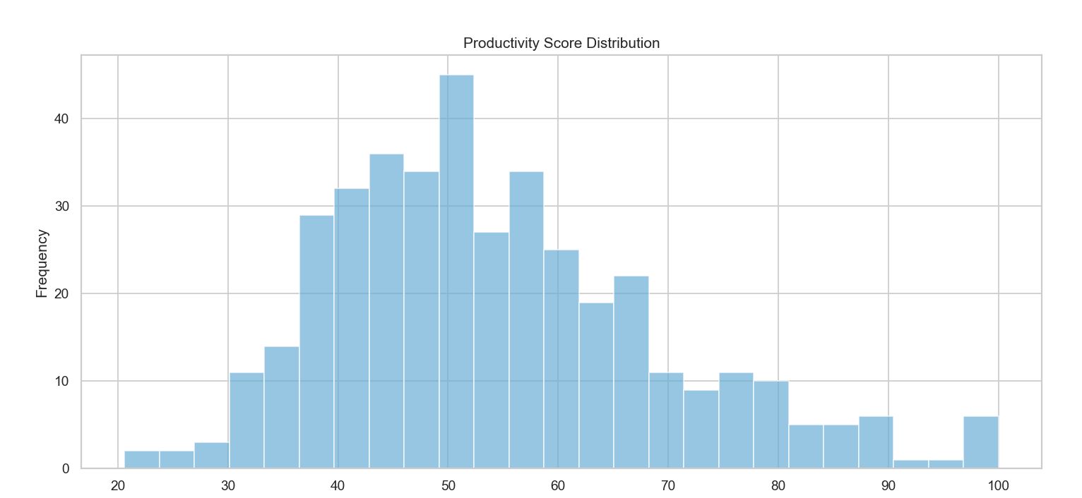

Average Productivity by Occupation
This analysis examines the relationship between occupation type and average productivity using a horizontal bar chart.
The results show that unemployed and retired individuals exhibit relatively higher productivity scores, followed by self-employed and employed individuals, while students show comparatively lower productivity.
This trend may indicate that individuals with fewer structured obligations or flexible schedules may have better control over their time, leading to higher productivity. On the other hand, students may experience academic pressure, stress, or inconsistent routines, which can impact their productivity levels.
Overall, this graph highlights that occupation and daily responsibilities play a significant role in influencing productivity.

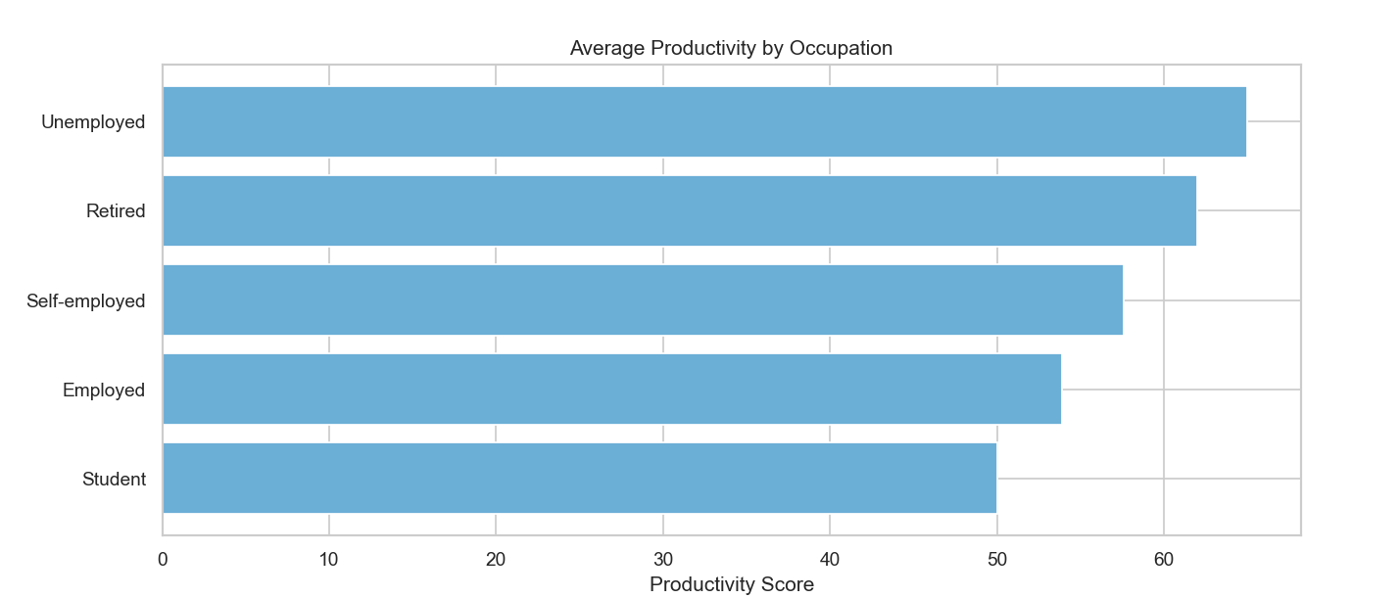

Productivity by Age Group Analysis
A bar chart was used to analyze how productivity varies across different age groups.
The analysis shows that individuals in the 18–24 age group have slightly higher average productivity, followed by those in the 25–30 group, while other age groups show slightly lower values.
This suggests that younger individuals may have higher energy levels, adaptability, and motivation, contributing to better productivity. However, the differences are not extremely large, indicating that productivity is not solely dependent on age but also influenced by other lifestyle factors.

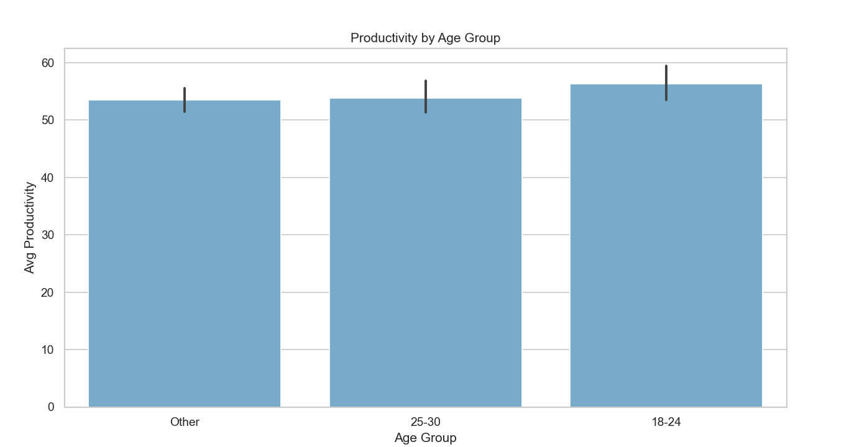

Productivity by Work Mode Analysics
A box plot was used to compare productivity across different work modes: Remote, Inperson, and Hybrid.
The visualization shows that in-person and hybrid work modes tend to have slightly higher median productivity compared to remote work. Additionally, hybrid work shows a wider distribution, indicating variability in performance.
This suggests that structured work environments or a combination of flexibility and discipline may enhance productivity. Remote work, while flexible, may sometimes lead to distractions or lack of routine for certain individuals.
Overall, the graph highlights that work environment plays an important role in influencing productivity levels.
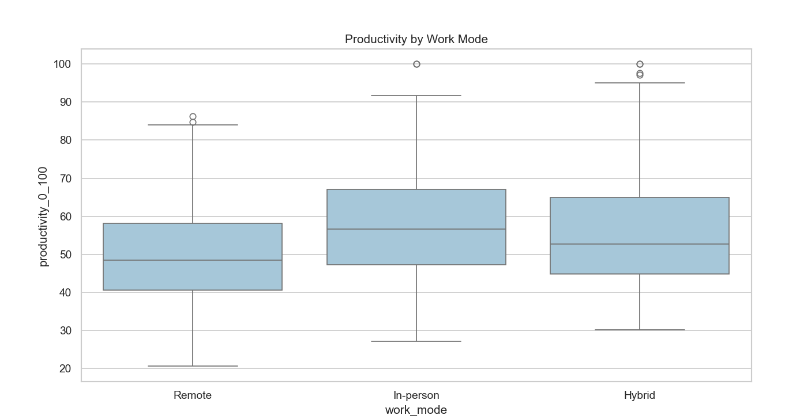

Sleep vs Productivity Level
This relationship was analyzed using a box plot comparing sleep hours across productivity levels (Low, Medium, High).
The results clearly show that individuals with high productivity tend to have higher sleep hours, while those with low productivity generally have lower sleep durations.
This indicates a positive relationship between sleep and productivity, emphasizing that adequate rest improves cognitive function, focus, and efficiency. The distribution also shows that insufficient sleep is associated with lower productivity levels.
This analysis highlights the importance of maintaining proper sleep habits for better performance.

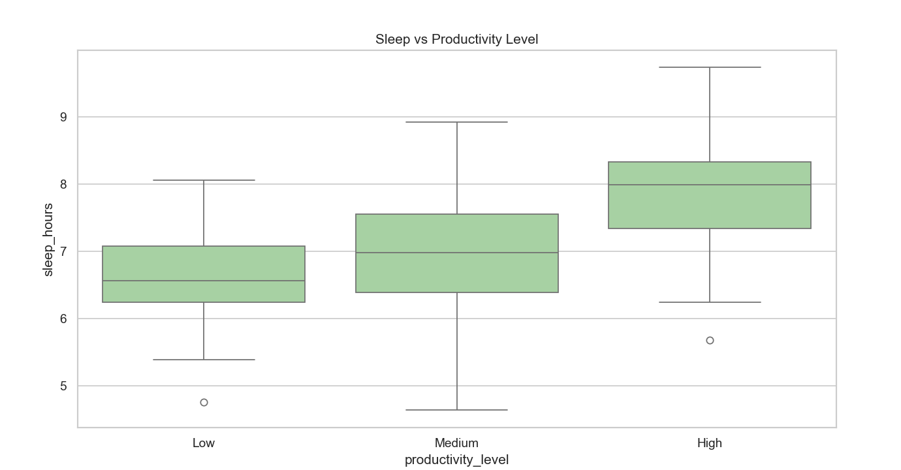

Sleep vs Productivity (Scatter Plot)
A scatter plot was used to examine the relationship between sleep hours and productivity, with stress level represented using color intensity.
The plot shows a positive trend, where productivity increases with sleep hours. Additionally, darker color shades (higher stress levels) are associated with lower productivity values.
This indicates that:
More sleep → higher productivity
Higher stress → lower productivity
The combination of these factors demonstrates that both physical (sleep) and psychological (stress) conditions significantly affect productivity.
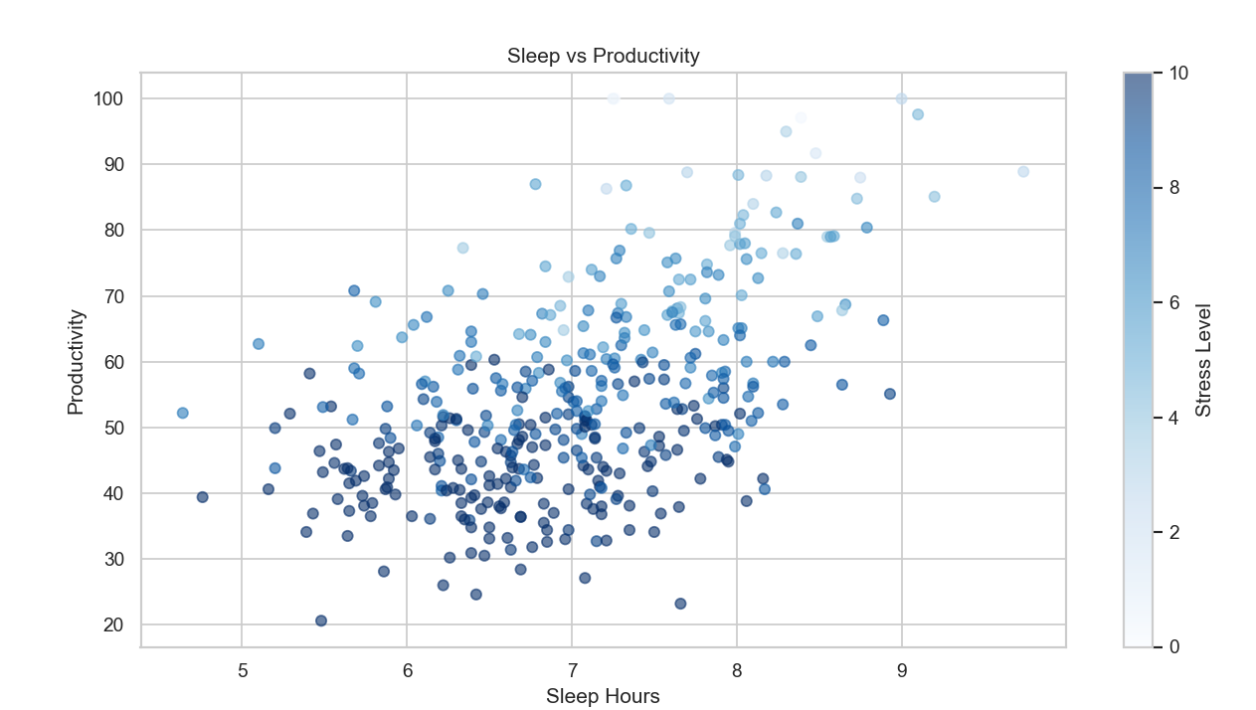

Productivity by Gender
A box plot was used to compare productivity distribution across different genders.
The results show that productivity levels are relatively similar across genders, with only slight variations in median values and distribution.
This suggests that gender does not have a major direct impact on productivity. Instead, productivity is more strongly influenced by lifestyle, behavioral, and environmental factors rather than demographic attributes.
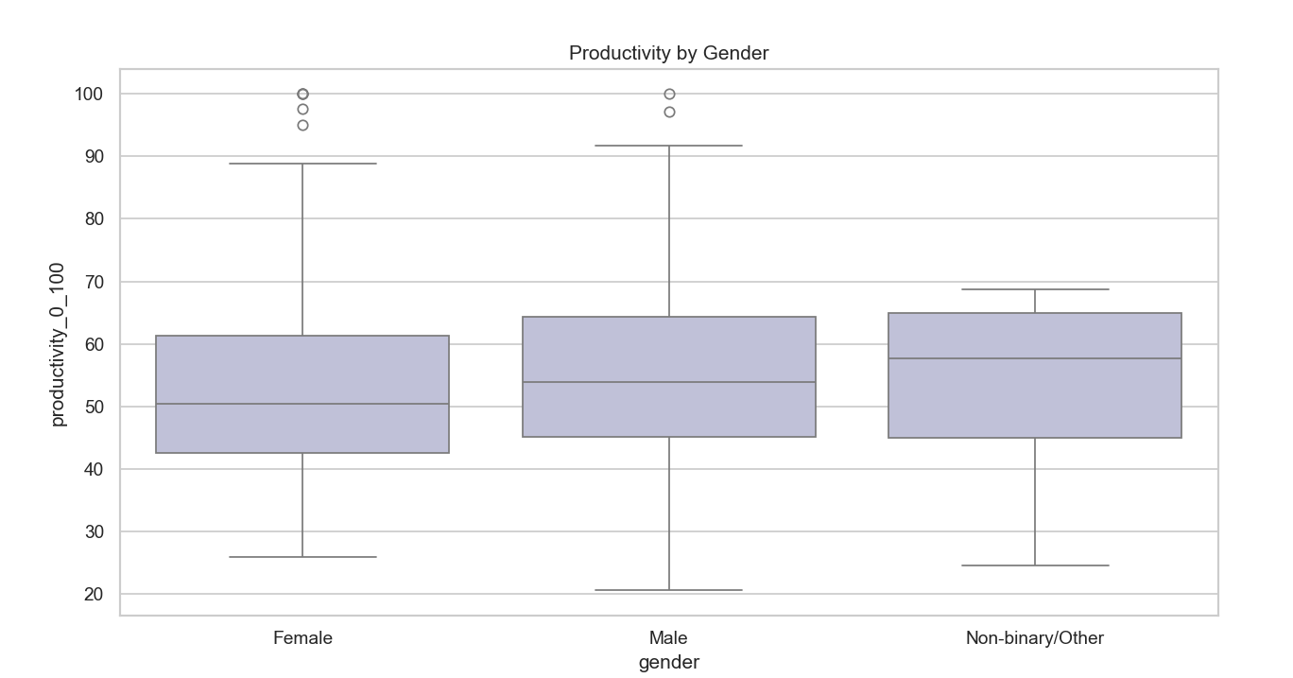

Correlation Between All Features (Heatmap)

The correlation heatmap is one of the most important visualizations in this project, as it provides a comprehensive overview of relationships between all variables.
From the heatmap:
• Sleep hours show a positive correlation with productivity, indicating that better sleep improves performance
• Stress level shows a strong negative correlation with productivity, highlighting that increased stress reduces efficiency
• Screen time shows a negative relationship with productivity, suggesting excessive digital usage impacts performance
• Mental wellness index shows a strong positive correlation with productivity, indicating overall well-being is crucial
This confirms that productivity is influenced by a combination of lifestyle, behavioral, and psychological factors.
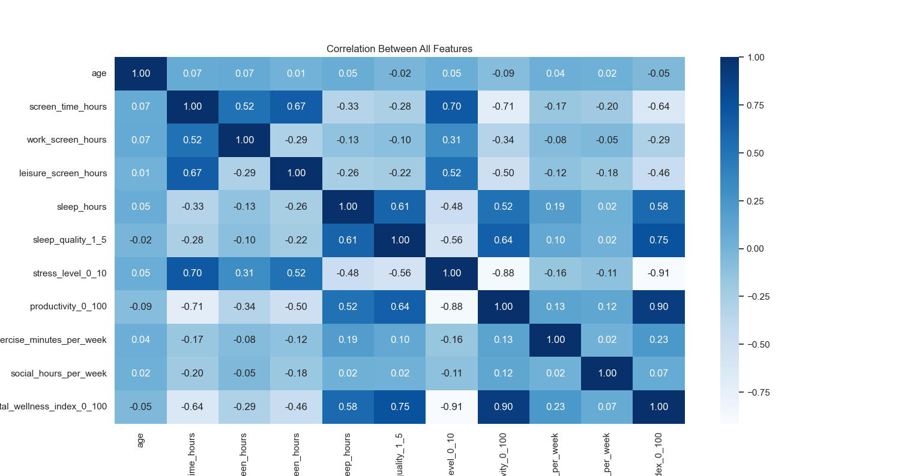

List of Analysis with Results
The following analyses were performed on the lifestyle and productivity dataset to extract meaningful insights:

5.1 Productivity Distribution Analysis
• Analysis: Examined the distribution of productivity scores using a histogram.
• Result: Most individuals fall within the average productivity range (40–60), with fewer individuals in very high or very low ranges.

5.2 Sleep vs Productivity Analysis
• Analysis: Studied the relationship between sleep hours and productivity using scatter plots and box plots.
• Result: Individuals with higher sleep duration tend to have better productivity, indicating a positive relationship.

5.3 Stress Level Impact
• Analysis: Analyzed how stress levels affect productivity.
• Result: Higher stress levels show a negative impact on productivity, reducing performance efficiency.

5.4 Screen Time Impact
• Analysis: Examined the relationship between screen time and productivity.
• Result: Increased screen time generally leads to lower productivity, suggesting that excessive digital usage can act as a distraction.

5.5 Work Mode Analysis
• Analysis: Compared productivity across different work modes (Remote, In-person, Hybrid).
• Result: In-person and hybrid work modes show slightly higher productivity, while remote work shows more variability.

5.6 Gender-Based Analysis
• Analysis: Compared productivity levels across different genders.
• Result: Productivity differences between genders are minimal, indicating balanced performance across groups.

5.7 Occupation-Based Analysis
• Analysis: Evaluated productivity across different occupations.
• Result: Productivity varies across occupations, suggesting that work responsibilities and lifestyle influence performance.

5.8 Age Group Analysis
• Analysis: Studied productivity variations across different age groups.
• Result: Younger individuals (18–24) show slightly higher productivity, though differences are not very large.

5.9 Correlation Analysis
• Analysis: Identified relationships between variables using a correlation heatmap.
• Result: Strong relationships were observed:
- Sleep → Positive correlation with productivity
- Stress → Negative correlation
- Mental wellness → Strong positive impact

5.10 Data Quality Analysis
• Analysis: Checked for missing values, duplicates, and inconsistencies.
• Result: Data cleaning improved accuracy and ensured reliable and meaningful analysis

Future Scope
The current project focuses on exploratory data analysis (EDA) of lifestyle and productivity data to derive meaningful insights. However, there is significant scope for further enhancement and expansion of this work.
In the future, advanced machine learning techniques can be applied to build predictive models that forecast productivity levels based on factors such as sleep patterns, screen exposure, stress levels, and work habits. This would enable individuals and organizations to proactively identify factors that impact performance and take corrective actions.
The project can also be extended by incorporating larger and more diverse datasets from different regions, professions, and age groups. This would improve the accuracy, reliability, and generalizability of the analysis across different populations.
Additionally, integrating real-time data sources such as wearable devices, mobile applications, or productivity tracking tools can provide live monitoring and dynamic analysis. This would allow users to track their habits and receive real-time insights for improving productivity and well-being.
Another important enhancement would be the development of an interactive dashboard using tools like Power BI or Tableau. Such dashboards would make the analysis more user-friendly by enabling interactive exploration of data and easier interpretation of results.
Furthermore, additional variables such as mental health indicators, diet patterns, work-life balance, and environmental factors can be included to provide a more comprehensive understanding of productivity.
The system can also be extended into a web-based or mobile application that allows users to input their daily habits and receive personalized recommendations to improve productivity. This would make the project more practical and applicable in real-world scenarios.
In conclusion, the project has strong potential for growth by integrating advanced analytics, expanding datasets, and developing user-friendly applications, ultimately contributing to better productivity management and data-driven decision-making.

References
[1] Kaggle, “Lifestyle and Productivity Dataset” [Online]. Available:
https://www.kaggle.com/
[Accessed: Apr. 2026].
[2] W. McKinney, Python for Data Analysis: Data Wrangling with Pandas, NumPy, and IPython, 2nd ed. Sebastopol, CA, USA: O’Reilly Media, 2017.
[3] J. VanderPlas, Python Data Science Handbook: Essential Tools for Working with Data. Sebastopol, CA, USA: O’Reilly Media, 2016.
[4] T. Hastie, R. Tibshirani, and J. Friedman, The Elements of Statistical Learning, 2nd ed. New York, NY, USA: Springer, 2009.
[5] F. Chollet, Deep Learning with Python. Manning Publications, 2018.
[6] Pandas Documentation, “Pandas User Guide,” [Online]. Available:
https://pandas.pydata.org/docs/
[Accessed: Apr. 2026].
[7] NumPy Documentation, “NumPy Reference,” [Online]. Available:
https://numpy.org/doc/
[Accessed: Apr. 2026].
[8] Matplotlib Documentation, “Visualization with Python,” [Online]. Available:
https://matplotlib.org/stable/contents.html
[Accessed: Apr. 2026].
[9] Seaborn Documentation, “Statistical Data Visualization,” [Online]. Available:
https://seaborn.pydata.org/
[Accessed: Apr. 2026].

Bibliography
Detailed explanation of Bibliography.
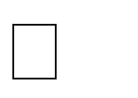
- Kaggle, “Lifestyle and Productivity Dataset”” Available: https://www.kaggle.com/

- McKinney, W., Python for Data Analysis. O’Reilly Media, 2017.

- VanderPlas, J., Python Data Science Handbook. O’Reilly Media, 2016.

- Chollet, F., Deep Learning with Python. Manning Publications, 2018.

- Hastie, T., Tibshirani, R., and Friedman, J., The Elements of Statistical Learning. Springer, 2009.

- Pandas Documentation. Available: https://pandas.pydata.org/docs/

- NumPy Documentation. Available: https://numpy.org/doc/

- Matplotlib Documentation. Available: https://matplotlib.org/

- Seaborn Documentation. Available: https://seaborn.pydata.org/

Github(project) :-
LinkedIn Post: MYPROJECT

