5-13:

* cycle time for both customer type :

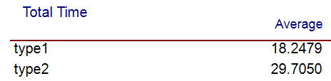 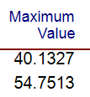

5-14:

* cycle time for both customer type :

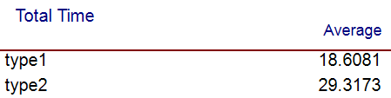 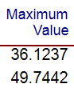

5-15:

* cycle time for both customer type :

