AWS RDS (MySQL) Database Creation Structural Operational Procedure
Purpose:
This SOP provides a complete step-by-step guide to create an Amazon RDS MySQL database using the AWS Console. It is designed for revision, interview preparation, and practical implementation.

Step 1: Open AWS Console
Login to AWS Console. Verify the region (Mumbai ap-south-1) and navigate to Aurora and RDS.
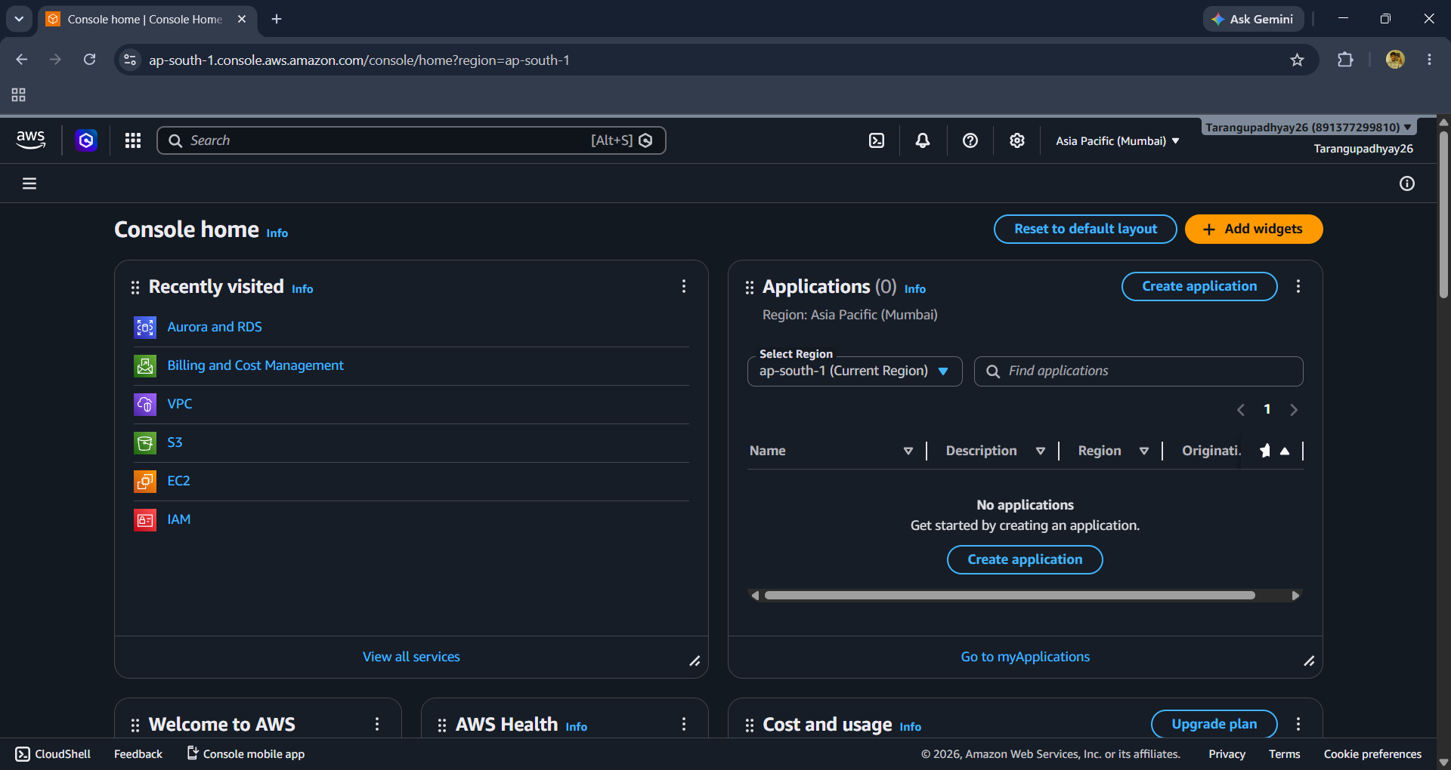

Step 2: Open RDS Dashboard
From the RDS dashboard click Create Database.
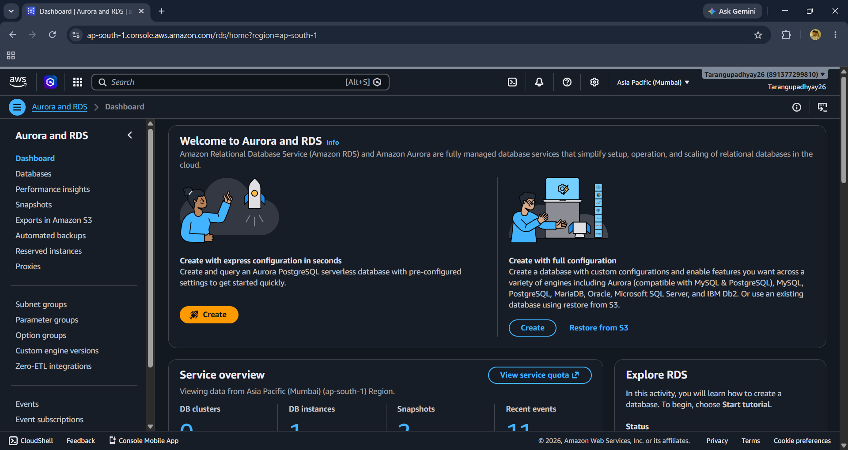

Step 3: Select Engine

Choose MySQL as the database engine.
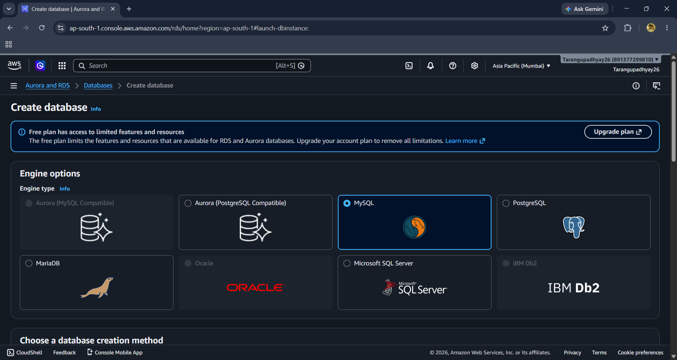

Step 4: Creation Method

Select Full Configuration for complete control over settings.
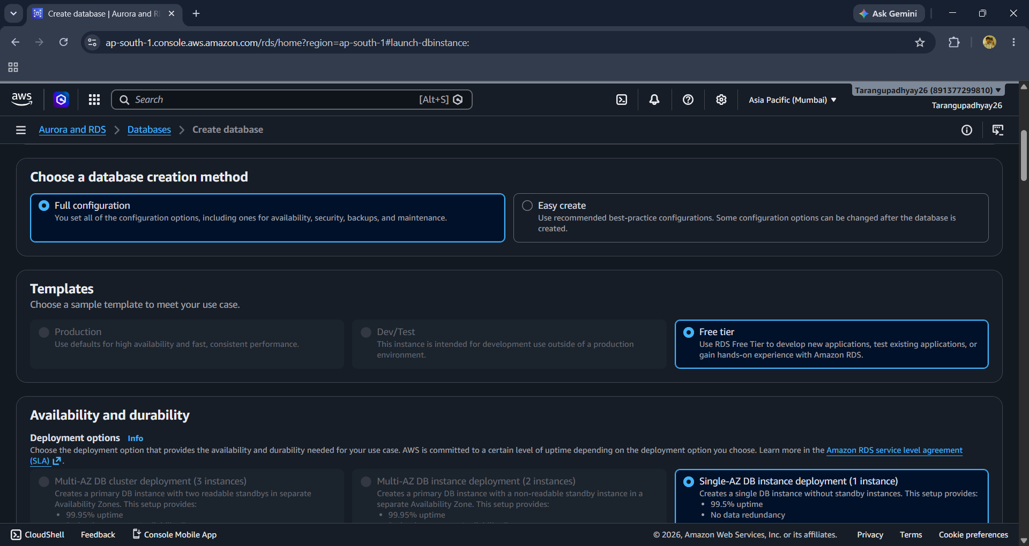

Step 5: Template & Deployment

Choose Free Tier and Single-AZ deployment for learning/lab purposes.
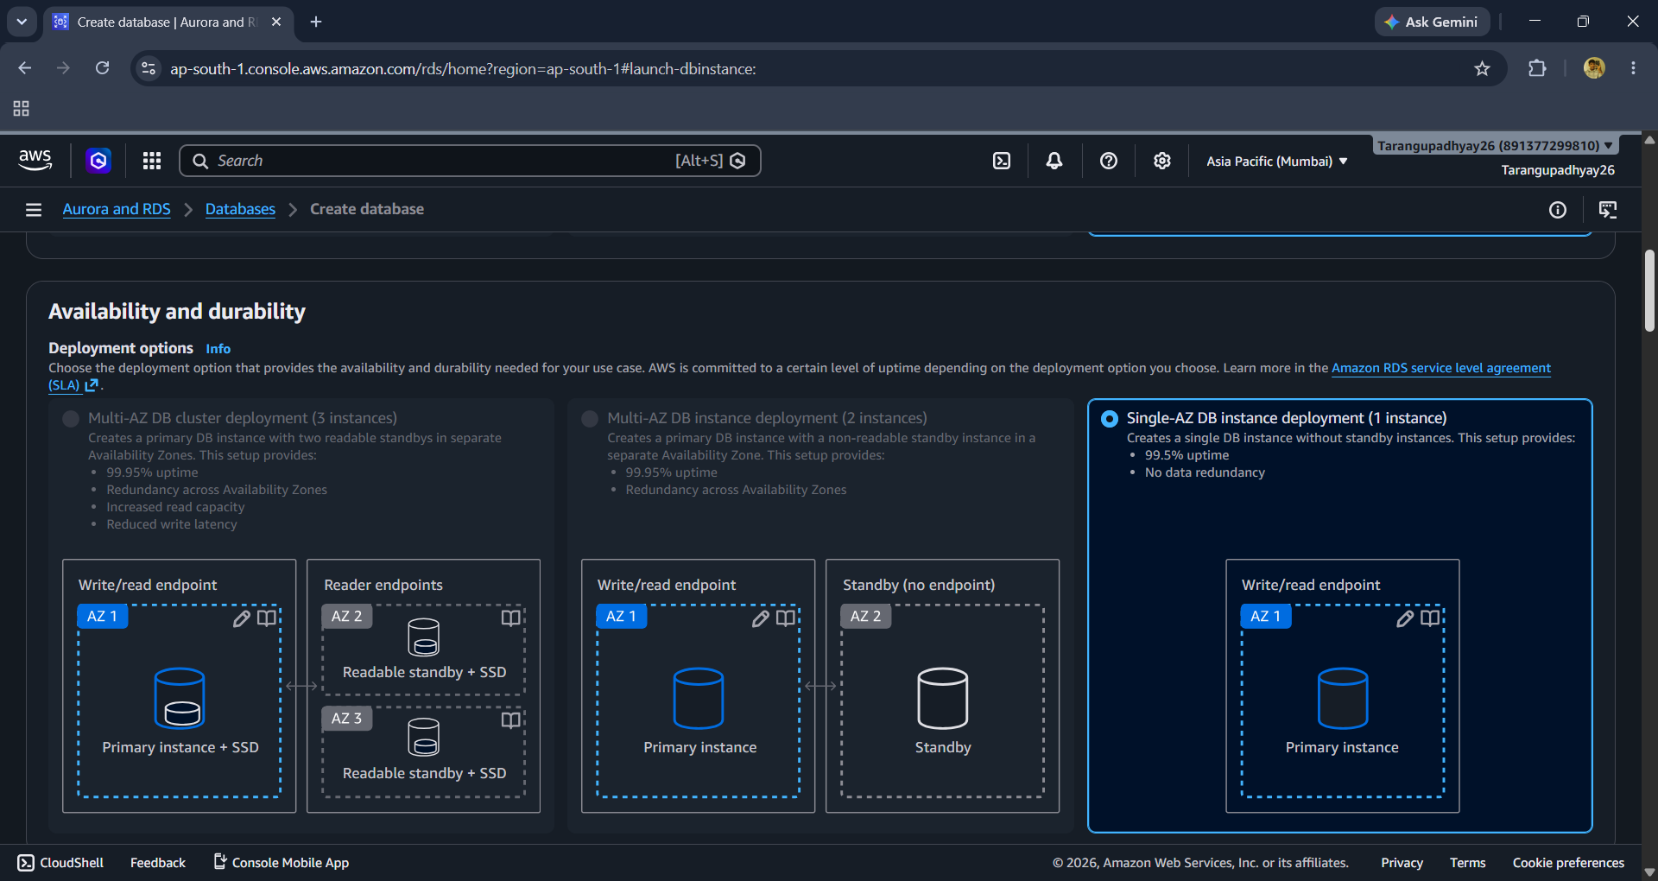

Step 6: Engine Version & Identifier
Select MySQL version and provide a unique DB Instance Identifier.
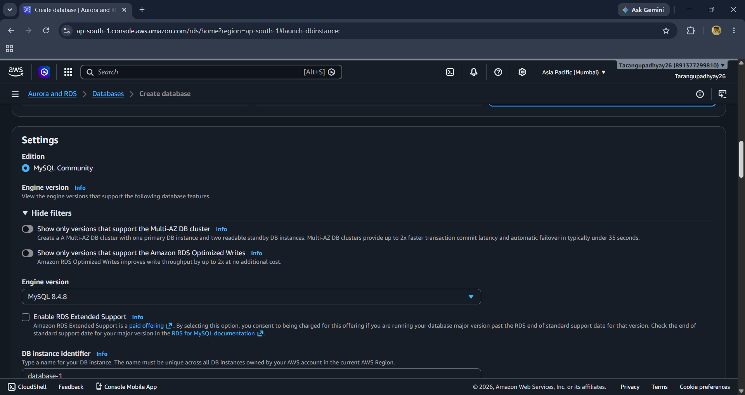

Step 7: Credentials
Set Master Username and Password management settings.
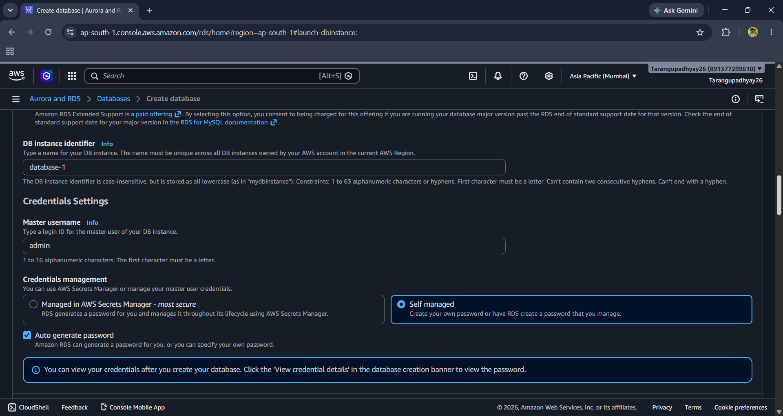

Step 8: Authentication
Use Password Authentication unless IAM/Kerberos is required.
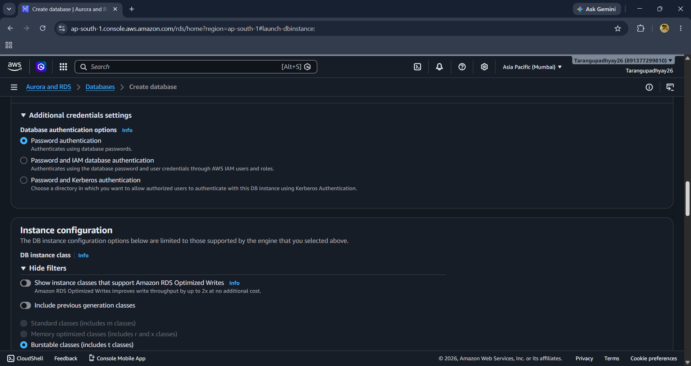

Step 9: Instance Configuration
Select db.t3.micro for Free Tier eligibility.
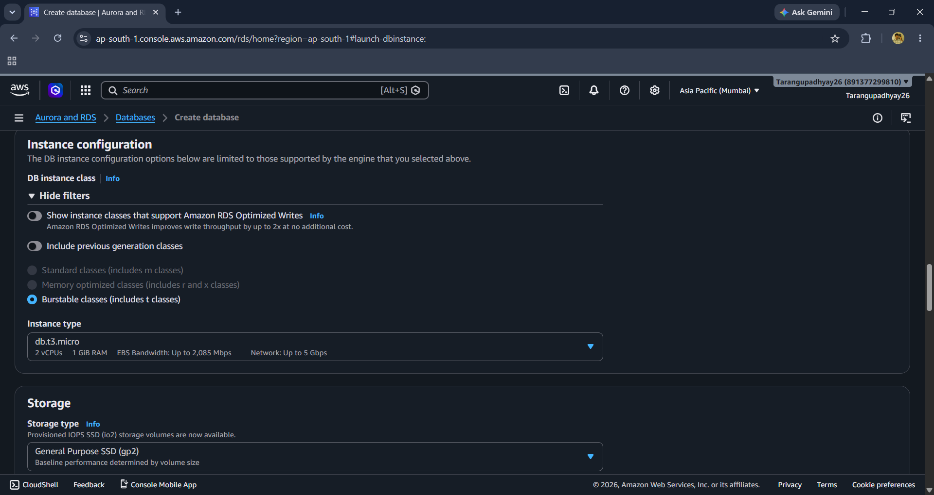

Step 10: Storage
Use General Purpose SSD (gp2) and allocate 20 GiB storage.
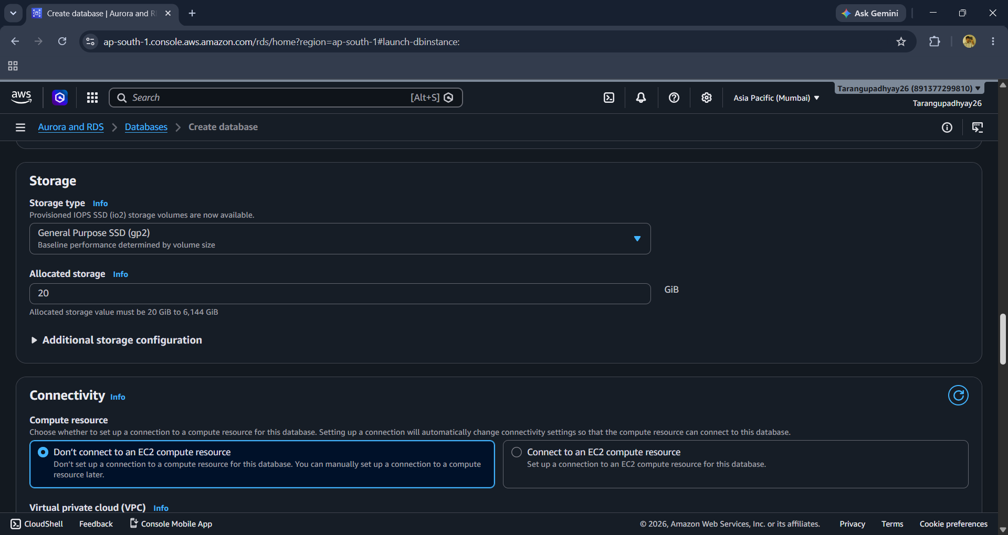

Step 11: Connectivity
Choose VPC, subnet group, and Public Access settings.
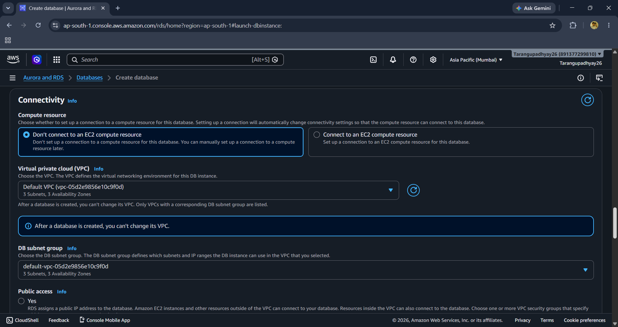

Step 12: Connectivity Details
Review VPC and DB subnet group configuration.

Step 13: Monitoring
Keep Database Insights Standard and enable monitoring if required.
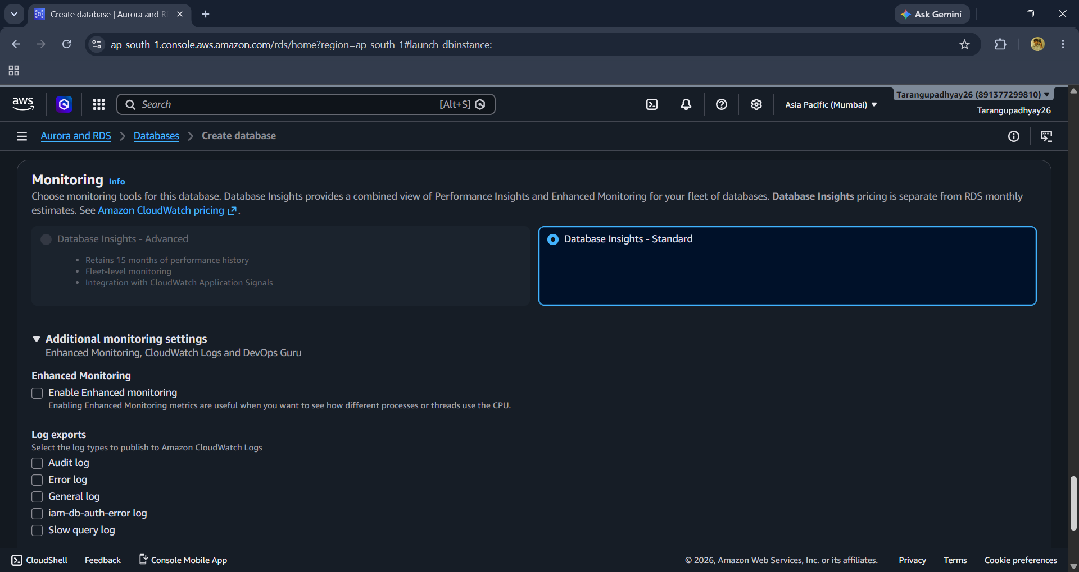

Step 14: Additional Configuration
Configure database name, parameter group, option group, and encryption.
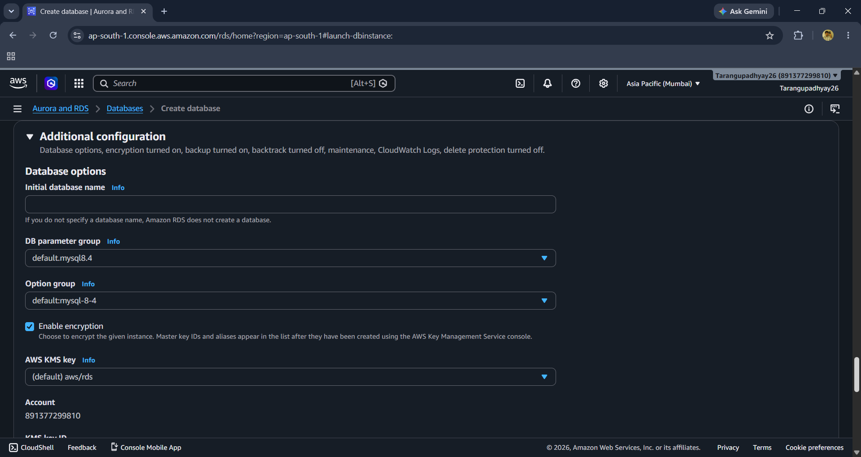

Step 15: Maintenance & Create
Enable auto minor version upgrades and click Create Database.
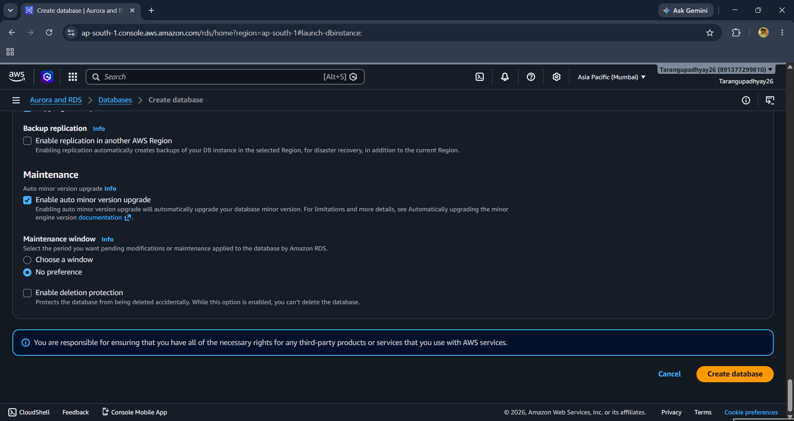

Important Revision Notes
- RDS = Managed Relational Database Service
- Free Tier Instance Class: db.t3.micro
- Storage: gp2 SSD, 20 GiB
- Deployment: Single-AZ for labs
- Security Group controls DB access
- Snapshots are used for backups and recovery
- Endpoint is used by applications to connect to the database
- Never expose production databases publicly unless required.

