AWS EC2 Instance Creation, EBS Volume and Snapshot SOP
Purpose:
To create an EC2 instance, attach/manage EBS volumes, create snapshots, and maintain documentation for AWS infrastructure.

Step 1: AWS Console Home
Login to AWS Console and navigate to EC2 from the Console Home page.
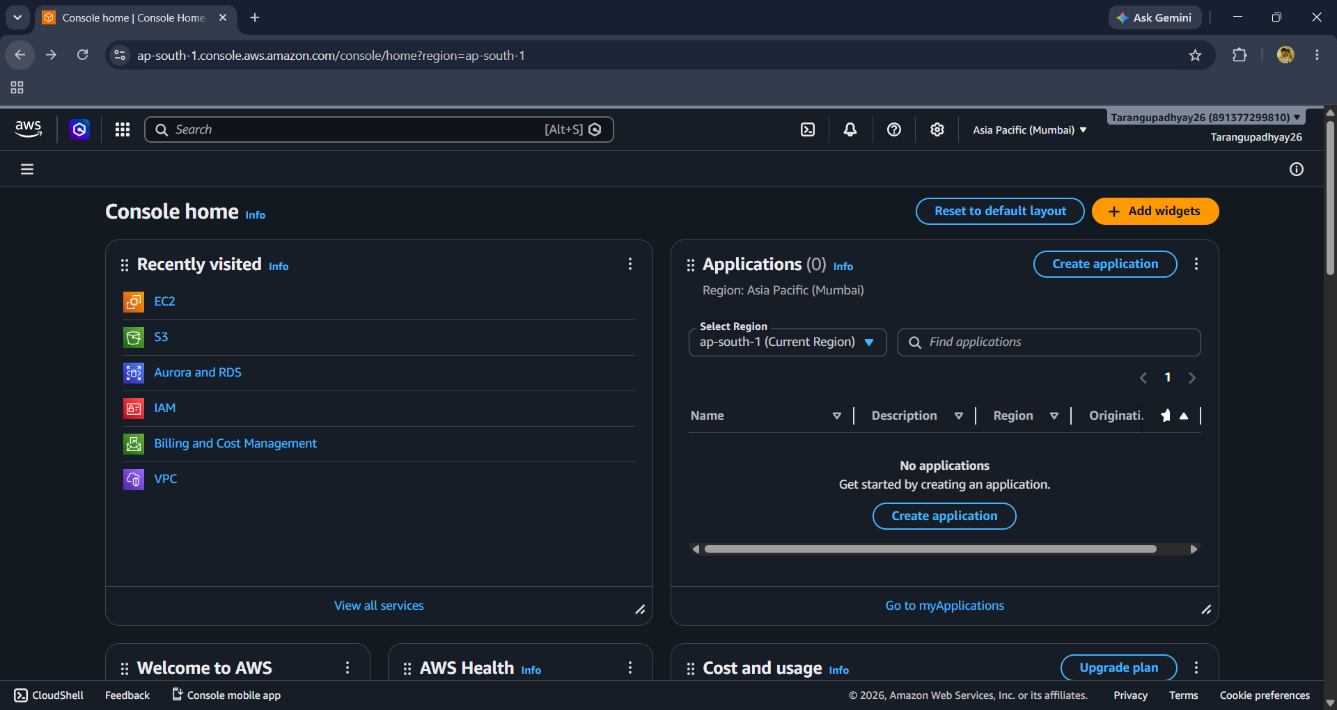

Step 2: EC2 Dashboard
Open EC2 service and click Launch Instance.

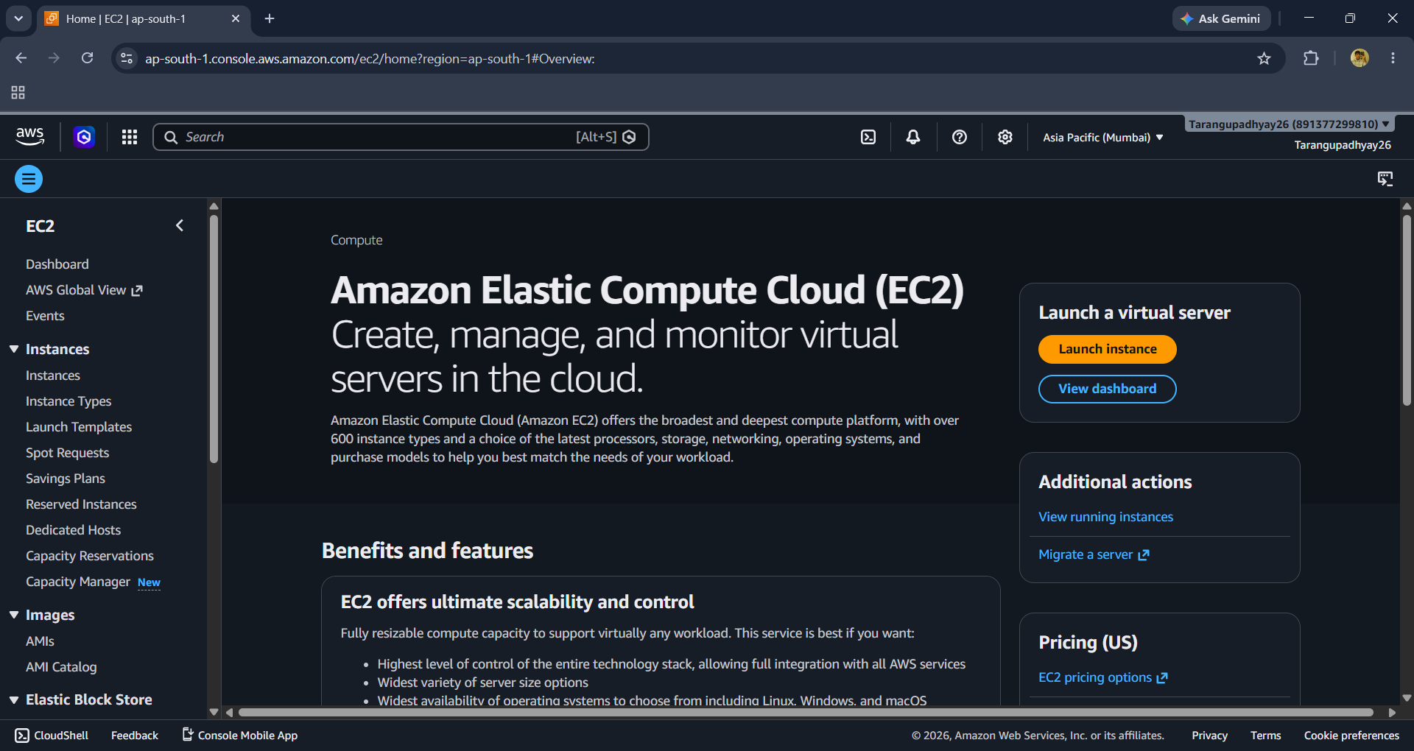

Step 3: Launch Instance - Basic Configuration
Provide instance name and select the required Amazon Machine Image (AMI).

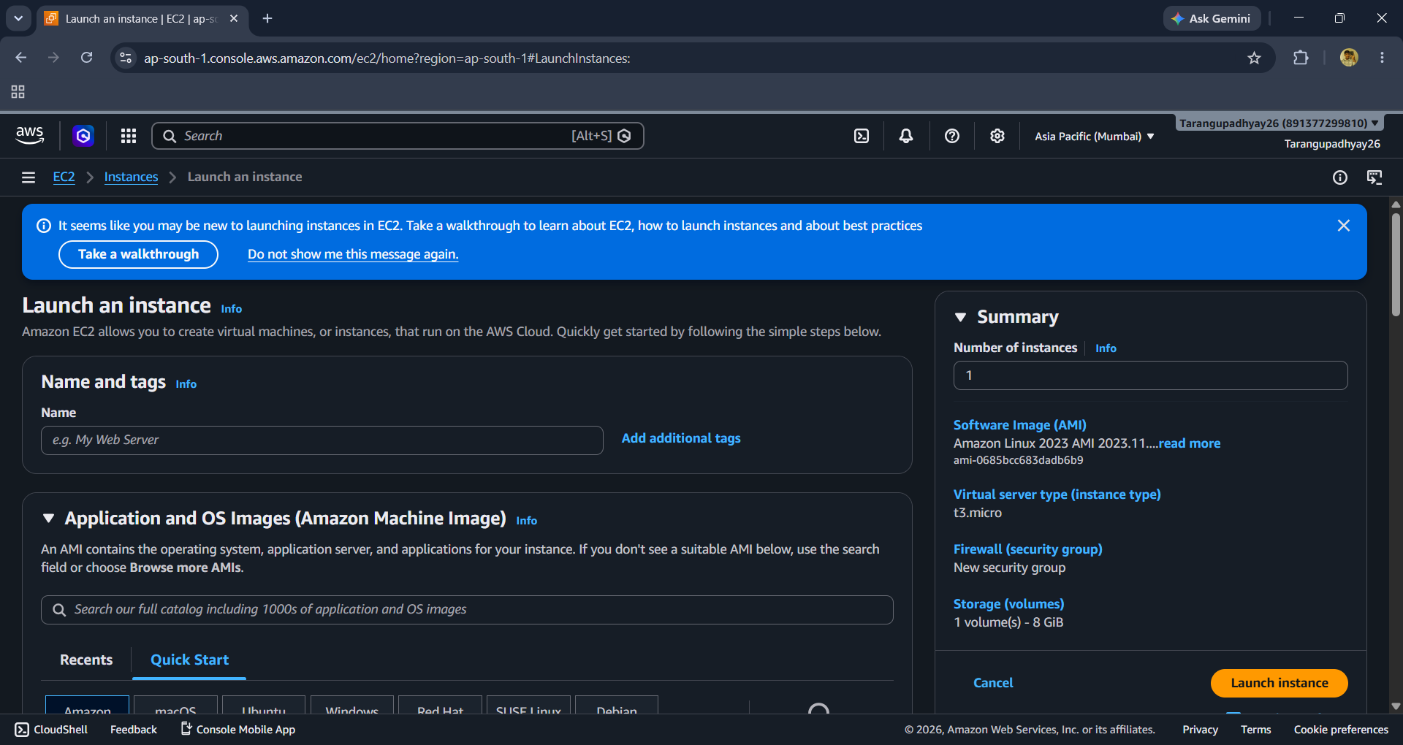

Step 4: Select AMI

Choose Amazon Linux/Ubuntu/Windows as per project requirements.
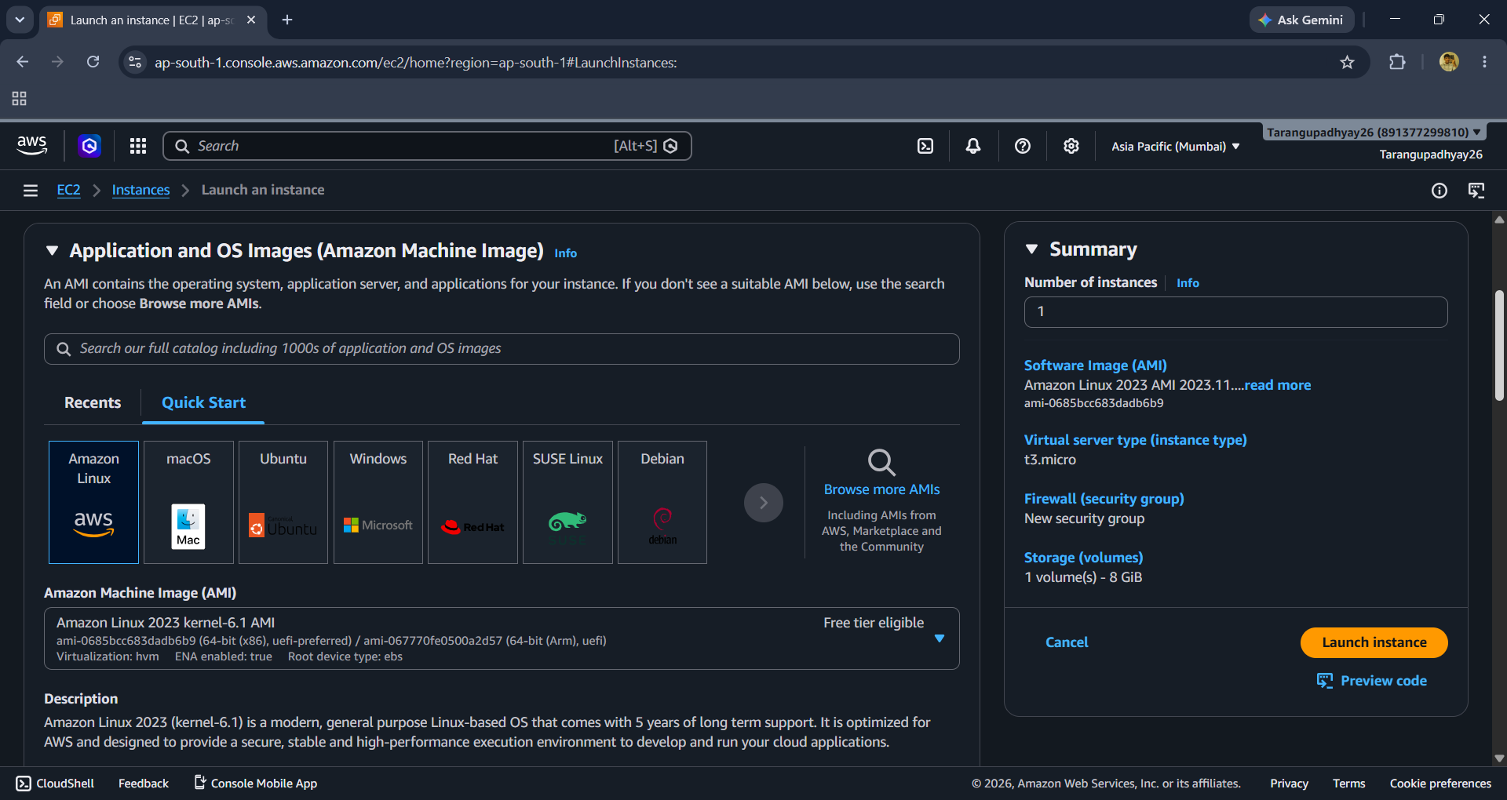

Step 5: Instance Type and Key Pair
Select instance type (e.g., t3.micro) and create/select a key pair.
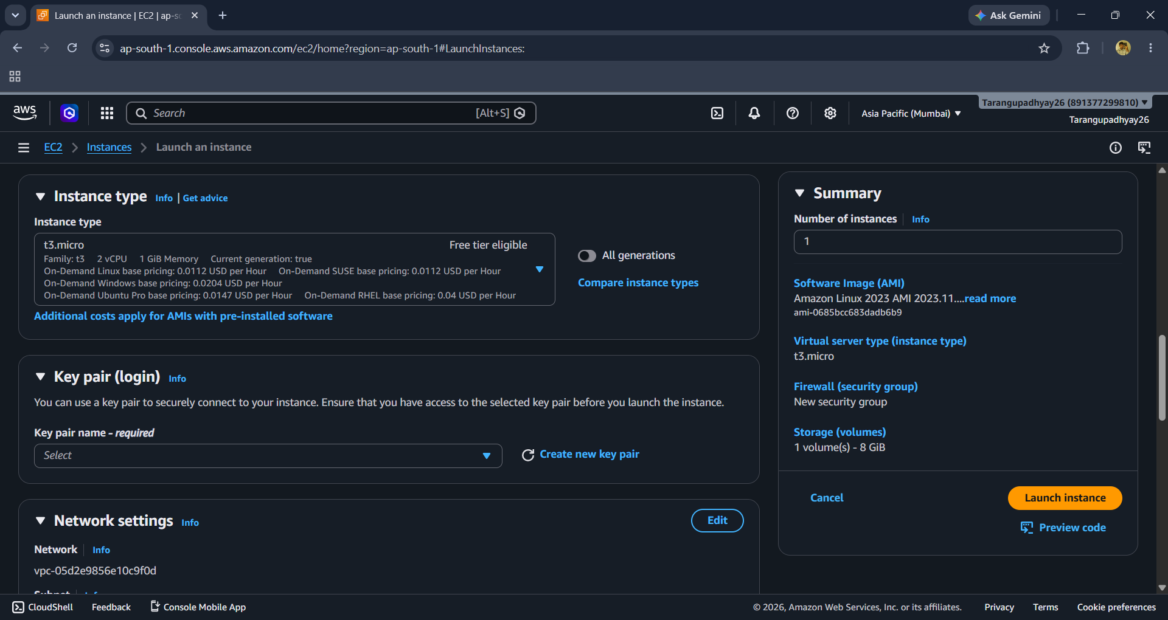

Step 6: Network Configuration
Configure VPC, subnet, public IP and security group rules (SSH/HTTP/HTTPS).
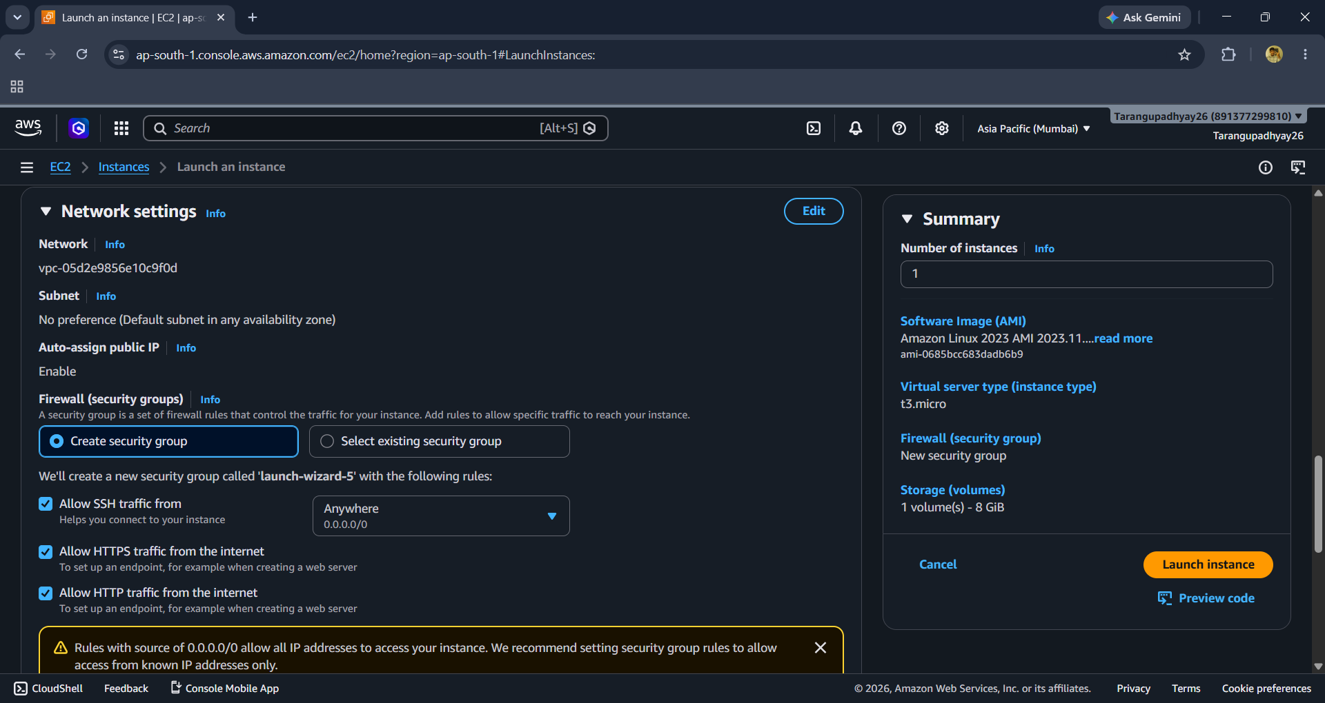

Step 7: Launch Instance
Review storage settings and click Launch Instance.
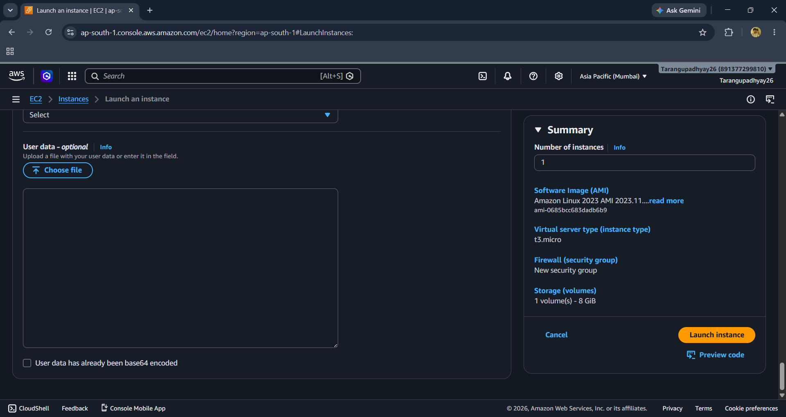

Step 8: Git Repository Structure
Store SOPs and infrastructure documentation in GitHub repository.
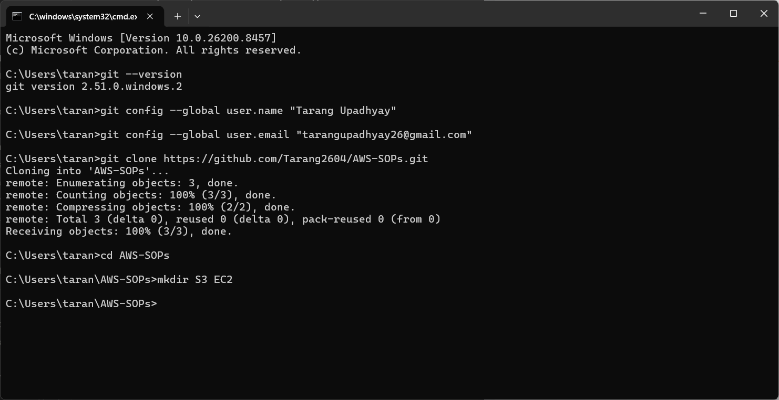

Creating and Managing EBS Volumes
1. Navigate to EC2 → Elastic Block Store → Volumes.
2. Click Create Volume.
3. Select volume type (gp3 recommended), size, and Availability Zone.
4. Create the volume.
5. Select the volume and choose Attach Volume.
6. Select the target EC2 instance and attach.
7. Login to the instance and format/mount the volume.

Creating EBS Snapshots
1. Navigate to EC2 → Elastic Block Store → Volumes.
2. Select the required EBS volume.
3. Actions → Create Snapshot.
4. Provide snapshot description and tags.
5. Click Create Snapshot.
6. Verify snapshot status under Snapshots section.

Restoring Volume from Snapshot
1. Open EC2 → Snapshots.
2. Select the snapshot.
3. Actions → Create Volume from Snapshot.
4. Choose Availability Zone and volume size.
5. Attach the new volume to an EC2 instance.

Best Practices
• Use least-privilege IAM permissions.
• Enable regular EBS snapshot backups.
• Tag all EC2 instances, volumes, and snapshots.
• Restrict SSH access to trusted IP addresses.
• Monitor resources using CloudWatch.

