**1. Basics:**

1. What is the difference between Discrete and Continuous Data?

Ans:

* Discrete Data is one that has clear spaces between values or which is countable.
* Continuous Data is one that falls on a continuous sequence.

1. What is the criteria for data to land into dimensions and measures?

Ans: -

* A dimension is a field that can be considered an independent variable. By default, Tableau treats any field containing qualitative, categorical information as a dimension.
* A measure is a field that is a dependent variable; that is, its value is a function of one or more dimensions. Tableau treats any field containing numeric (quantitative) information as a measure.

1. What is Metadata, where is it present in the workbook?

Ans:

* Metadata means data or data identifying other data. In technology circles, the prefix “meta” generally means” an underlying concept or explanation”. It makes it easier to locate and interact with data – so that users can filter or search different records.
* Metadata could be present in text files or multimedia files.

1. What happens when you aggregate or disaggregate the Data?

Ans:

* In simple words, Aggregate means to combine data and disaggregate means to separate or segregate data.
* Aggregate data combines and summarizes information, whereas disaggregate data separate aggregated data into separate points or pieces of information.

1. You are working on a dataset; the client adds in more data to the dataset. What happens to the Visualization that you had created? Give the explanation for both Live and Extracted data.

Ans:

* Live data will be updated automatically because it will take the changes that has been done at back end (server data) which will be reflected in tableau worksheets and extracted data will not be impacted because you have extracted or worked on subset of the data from dataset to perform visualization.
* Extracted data has high performance as compared to live data.

1. What are the file extensions in Tableau and how each one is different?

Ans:

|  |  |  |
| --- | --- | --- |
| File Type | Extension | Purpose |
| Tableau Workbook | . twb | It contains information on each sheet and dashboard that is present in a workbook. It has the details of the fields, which are used in each view and the formula applied to the aggregation of the measures. It also has the formatting and styles applied. It contains the data source connection information and any metadata information created for that connection. |
| Tableau Packaged Workbook | . twbx | This file format contains the details of a workbook as well as the local data that is used in the analysis. Its purpose is to share with other Tableau desktop or Tableau reader users, assuming it does not need data from the server. |
| Tableau Data Source | . tds | The details of the connection used to create the tableau report are stored in this file. In the connection details, it stores the source type (excel/relational/sap, etc.) as well as the data types of the columns. |
| Tableau Packaged Data Extract | .tdsx | This file is similar to the .tds file with the addition of data along with the connection details. |
| Tableau Data Extract | . tde | This file contains the data used in a .twb file in a highly compressed columnar data format. This helps in storage optimization. It also saves the aggregated calculations that are applied in the analysis. This file should be refreshed to get the updated data from the source. |
| Tableau Bookmark | . tbm | These files contain a single worksheet that is shared easily & to be pasted into other workbooks. |
| Tableau  Preferences | . tps | This file stores the color preference used across all the workbooks. It is mainly used for consistent look and feel across the users. |

**2. Text Table, Highlight Tables, Heat Maps, Tree Map:**

1. Create a text table for the Avg (Sales) for each subcategory using Sample Superstore? List which Sub Category is got Avg (Sale) more than $1000? - **Sample Superstore**
2. Create a Heat Table for the order date and Region against the Sub Category based in Count of Sales with two colours diverging that is distinguished by Sum of Profit - **Sample Superstore**
3. Create a Highlight table for the States for the Order Date Year whose highlighting is done based on Sum of profits - **Sample Superstore ?**
4. Which customer is having maximum of sales in the year 2012? - **Global Superstore**
5. How much is profit share less in Pennsylvania when compared to New York? - **Sample Superstore ?**
6. Check for the pane wise percentages of sales with Category, Sub- Category and quarter wise order date, also check for the Row wise grand totals and Column wise grand totals. - **Sample Superstore**

**3. Filled Maps, Symbol Maps:**

1. Use Global Superstore. Check Which Western Country in EMEA region has least profit percentage.
2. Use **“Sample Superstore. Xls”,** which state shares boarders only profit for tables **?**
3. Use **“Sample Superstore. Xls”,** which state has no data for Profits for Office Supplies

**4. Bar Charts, Stacked, Side by Side:**

1. Which Customer name & Year is having all the Product Categories sum of profit less than over-all Average profit? - **Sample Superstore ?**
2. What is the Maximum of Life Expectancy Female for the region Africa & year 2012? - **World Indicators**
3. What is the share of the top 20 customers based on the sales amount compared to the customers based on profit amounts - **Sample Superstore?**

**5. Line Graphs, Dual Line, dual axis:**

1. How can you show two different graphs in one view? - **Global Superstore**
2. Which Region is having Sum of Energy Usage>1000000 and sum of Population 65+>10? - **World Indicators**

**6. Trendlines, Cluster, scatter Plot, boxplot, Word Cloud (Packed Bubbles), Histogram:**

1. Draw a trend line for profit as a linear function of sales only for product technology? - **Sample Superstore**
2. Create a histogram showing the number of Sales using Sales Bins of $1000. Which bins have profit ratios of more than 25%? - **Global Superstore**
3. Using “**Sample Superstore”**, use order sheet create a histogram showing the number of orders using sales bins of $1000.
4. Using **“Global Superstore**”, use the orders sheet, build a scatter plot showing the sum of sales on the x-axis and sum of profits on the y axis for all products (Product name). What is the equation for linear regression for products in Technology?
5. Use **“World Indicators”.**  Take Health Exp% GDP, Health Exp/Capita, Life Expectancy Male, Female. What are the variables that are considered to create the clusters by default?

Ans: - Default variables that are considered to create the clusters are sales and Profit ratio.

**7. Calculate Fields, Quick table calculations, LOD:**

1. How do you create a profit ratio using the Calculated fields?
2. Global Superstore data set; Region wise year wise sales are ranked. What is the rank of some country when compared to last year?

Ans: - Rank will not show the relative position w.r.t. past data.

1. What percent of total profits do the top 10 customers by Sales represent? - **Sample Superstore**
2. Find the customer with the lowest overall profit. What is his/her profit ratio? - **Sample Superstore**
3. Ranking States based on Sales what is the rank of state which has sales crossed $20000. - **Sample Superstore**
4. What is the percent of orders which took more than 7 days on an average to deliver?
5. Use **“World Indicators”.** Without using table calculations what is the proper syntax to build a calculated field which will display overall total GDP on this view?

**8. Filters:**

1. What are the different types of filters and give their working order?

Ans: There are total 6 types of filters in Tableau and they are namely as

1. **Extract Filter**: They are used to extract data from the various sources, by saving a screengrab of the way it gets added on your file. Such methods can help in lowering the [tableau](https://www.upgrad.com/blog/tableau-architecture/) queries to the data source.
2. **Data Source Filter**: Used mainly to restrict sensitive data from the data viewers, the data source filters are similar to the extract filters in minimizing the data feeds for faster processing.
3. **Context Filter**: A context filter is a discrete filter on its own, creating datasets based on the original datasheet and the presets chosen for compiling the data. Since all the types of filters in tableau get applied to all rows in the datasheet, irrespective of any other filters, the context filter would ensure that it is first to get processed.
4. **Dimension Filter**: Now that you’ve chosen the data, you can access the values highlighted or remove them from the selected dimension, represented as strikethrough values. You can click All or None to select or deselect based on your operation in case of multiple dimensions.
5. **Measure Filter**: In this filter, you can apply the various operations like Sum, Avg, Median, Standard Deviation, and other aggregate functions. In the next stage, you would be presented with four choices: Range, At least, At most, and Special for your values.
6. **Table Filter:** The last filter to process is the table calculation that gets executed once the data view has been rendered. With this filter, you can quickly look into the data without any filtering of the hidden data.
7. Create a list of Top 10 Products based on Profits whose sale value is more than $5000? - **Global Superstore**
8. Create a Chart with Customer Name and Profit and check for the Sale Value for top 15 Customers? - **Global Superstore**
9. Apply filter to all the worksheet, filter by year 2011, then find the sum(sales) for the highest subcategory. - **Global Superstore**
10. What is the name of 375th top most customer by sum of profits - **Sample Superstore?**

**9. Dashboards & story:**

1. What are the different device type preview that Dashboards can use?

Ans: -

The Tableau Device Preview Guide allows you to make a dashboard viewable on a mobile, tablet, desktop & default previews. And corresponding procedure has mentioned below:

1. Once you have the basics in place for your dashboard, click on the Device Preview button underneath the Dashboard tab on the left.

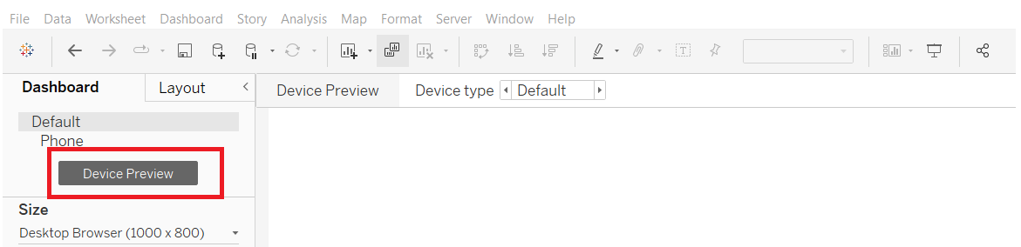

2. Once clicked the Device Preview toolbar will be displayed above your dashboard area.

3. There are four general Device Types

a. Desktop

b. Tablet

c. Phone

d. Default

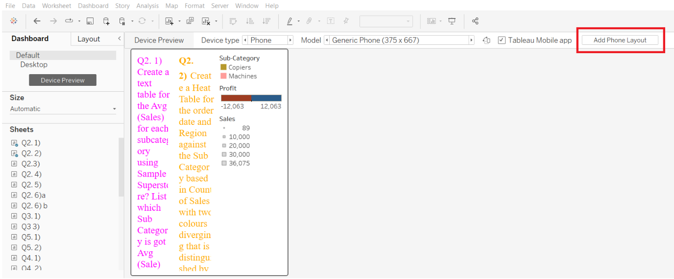

1. Within three device types, there are multiple Models. For simplicity’s sake, it is best to stick with the generic models of each device type.

a. Generic Desktop Monitor (1920 x 1080)

b. Generic Table (1024 x 768)

c. Generic Phone (375 x 667)

1. Before moving anything around, add each device type/model you wish to make, by clicking the Add Layout button

a. Add Desktop Layout

b. Add Tablet Layout

c. Add Phone Layout

Each device type model will be display underneath Default on the Dashboard tab. You can click on each device type to move between them quickly.

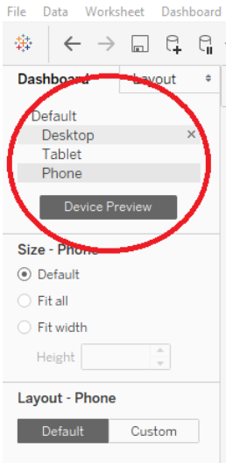

1. You can now begin to arrange your dashboard visualizations within each device type model. Within each type, you can also switch between portrait and landscape model. For the tablet and phone layouts, it is best to first design in portrait mode.

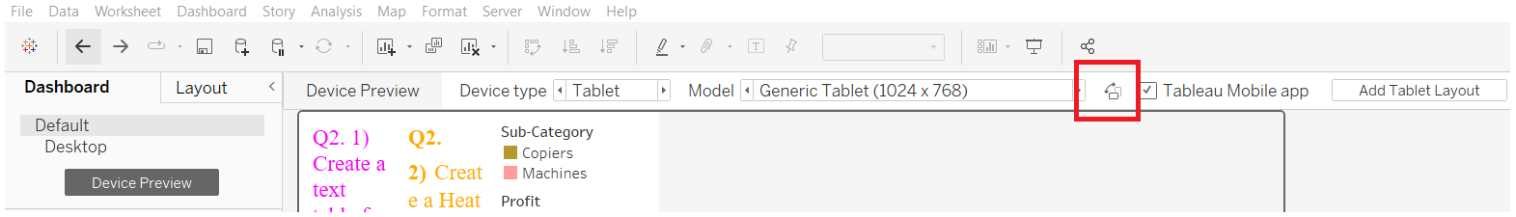

2.Create a dashboard using **World Indicators** showing the all the Actions that can be performed in Tableau.

**10. Time Series:**

1. Use Order date and drill down the information for Quarter and Month level separately and show the line Chart in a Continuous Form- **Global Superstore**

**11. Sets, Parameters, Groups:**

1. Parameters can be used in?

Ans: Parameters are place holders of values in Tableau. A parameter can be text, an integer, or a range of values. It helps in replacing values in calculations, filters, and the reference line.

1. What are the different ways to create a Parameter?

Ans: - Parameters are created through filters, sets & bins.

1.Using filter

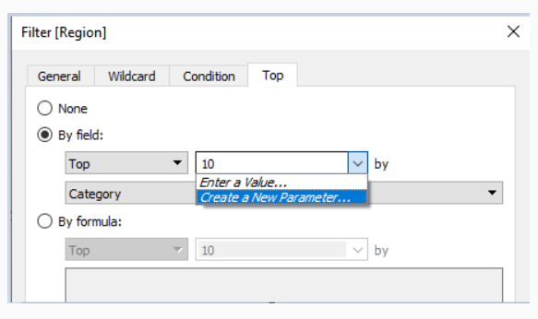

2.Using Sets:

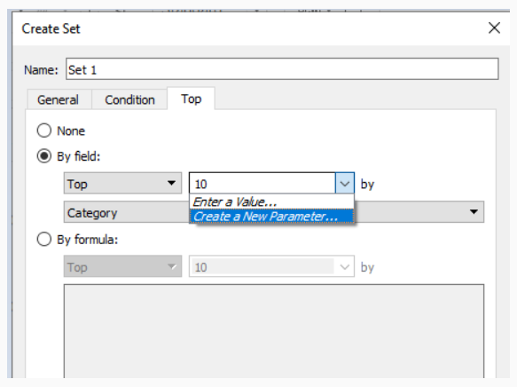

3.Using Bins:

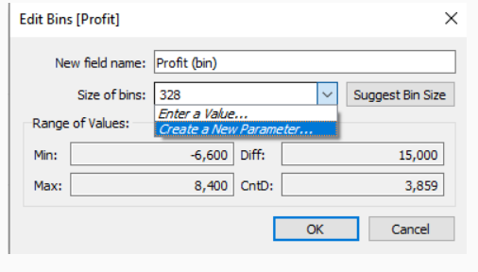

**12. Forecast:**

1. You are provided with the dataset for the past 10yrs. How can you forecast the data for next 4 years, Quarter wise?
2. Use **“Sample Superstore”.** What is the Sales Forecast Estimate for the month of September 2018?

**13. Pie Chart:**

1. Create a Pie Chart using regions and sum of sales, sort the pie in ascending order, increase the size in the view and label them with Count of Quantity and Sum of Profits- **Sample superstore**