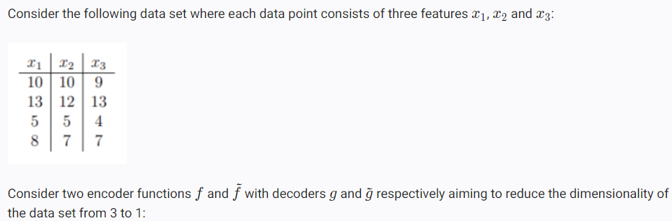

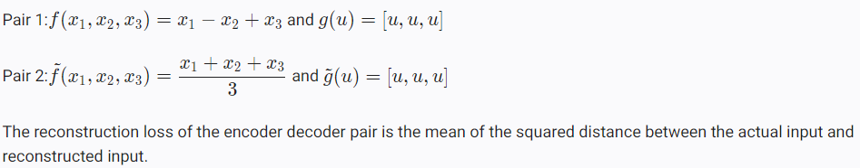

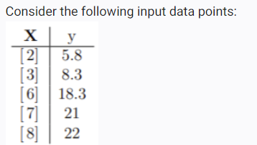



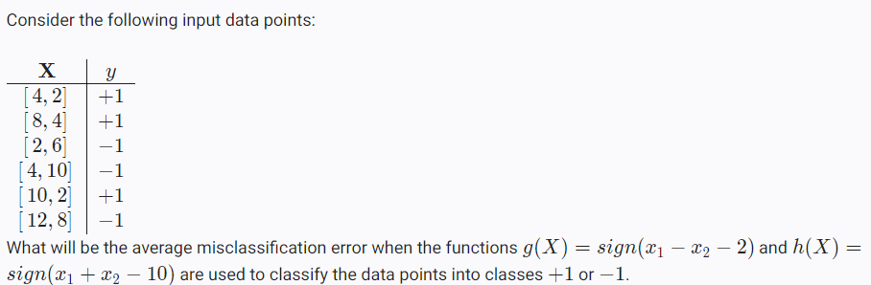

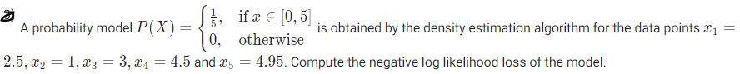

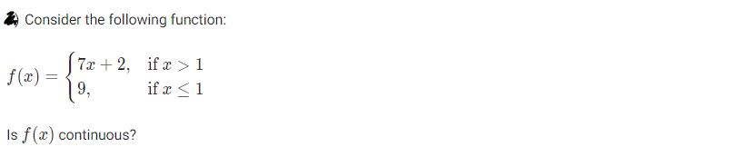

* 















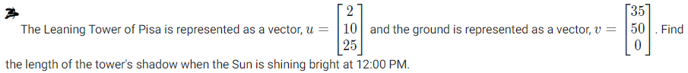



Hint: Give direction in (a + ib) and directional derivative as a scalar value.







Hint: Eigen-values are cubed as well, but eigen-vectors remains same.



Hint: For orthogonal matrix A, AAT = I







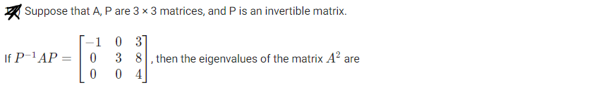

Hint: P-1AP = D => A = PDP-1. As per spectral theorem, diagonal elements of D is composed of A’s eigen-values and columns of P is composed of A’s eigen-vectors.



Hint: Take the conjugate of x before multiplying with y

* True or False?



Hint: UU\* = U\*U = I

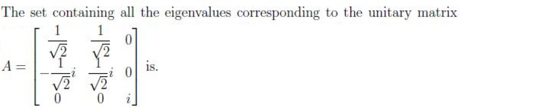

Hint: All (a + ib) where magnitude of the vector is 1 are valid solutions.





Hint: Use spectral theorem; eigen-values make the diagonal entries of D. Normalized eigen-vectors make the columns in U.

Hint: To normalize complex vectors, multiply with conjugate.



Hint: Q2 should be transposed.

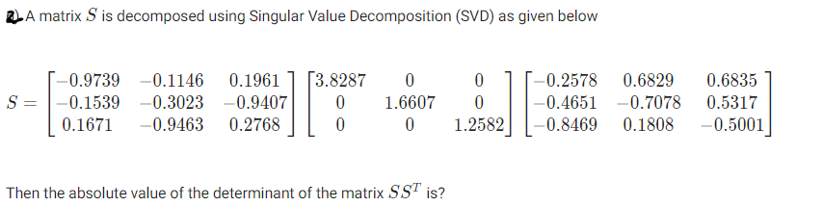



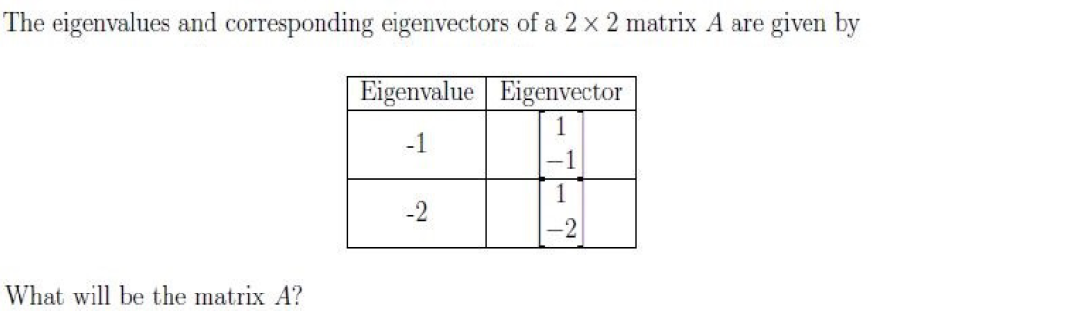

Hint:

Solve 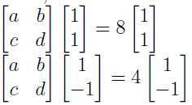. It can also be solved by using the formula A = SλS-1



Hint: 



Is it positive/negative definite/semi-definite?

Hint: Find the eigen values.



Is it positive/negative definite/semi-definite?

Hint: Find the eigen values





Hint: Find the Hessian matrix



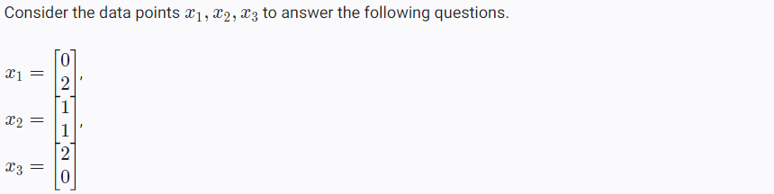

Do PCA, and project these data onto a single-dimension space. Find the reconstruction error and projected variance.



* The volume of the largest cone that can be inscribed in a sphere of radius 6m is





Hint: Use Taylor’s expansion







Hint: Find the Hessian matrix





. Is the function convex or concave?



Find the optimal w\*.



Further,



Find the

is h convex or concave? Is the function increasing or decreasing at the given point?

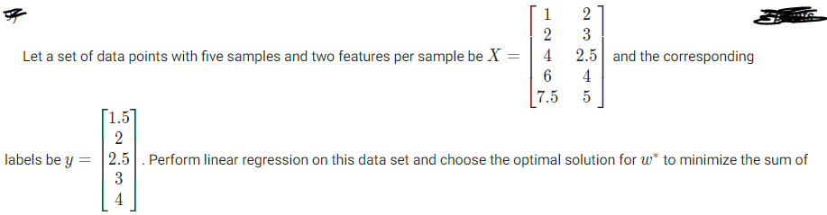



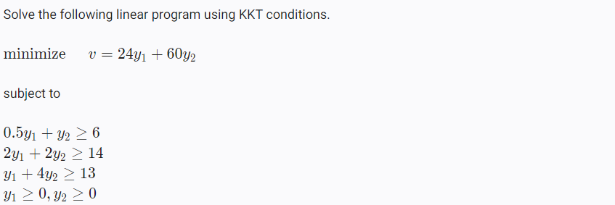

Find and 