MBA – Semester 2
Technology for Management (Course Code 2.1)

Commercial Core Banking Customer & Ledger System
Project Report – System Analysis, Design, Implementation, E-Commerce, Ethics and MySQL Decision Support
Team member | Roll no. | Role / modules owned
<Member 1 name> | <roll> | Database Architect – Modules 2 & 6 (DB)
<Member 2 name> | <roll> | Data Analyst & DSS Developer – Modules 2 & 6 (Analytics)
<Member 3 name> | <roll> | Systems & BPR Engineer – Modules 1 & 3
<Member 4 name> | <roll> | Tech Strategy & Ethics Officer – Modules 4 & 5
Replace the placeholders above with your names. If your group has 2 or 3 members, merge roles as per Section 3 of the project guidelines (Option A or B).

Contents
1. Executive Summary and Syllabus Coverage
2. Module 1 – Information System Foundations
3. Module 2 – MIS and RDBMS Design
4. Module 3 – Systems Analysis & Design and BPR
5. Module 4 – E-Commerce and Technology Adoption
6. Module 5 – IT Ethics, Security and Environmental Audit
7. Module 6 – Application Software and MySQL Implementation
8. Viva Preparation – Likely Questions
Appendix A – How to Run the Project
Appendix B – Individual Attribution Log

1. Executive Summary and Syllabus Coverage
A commercial bank lives or dies on two assets: trustworthy customer records and a ledger that always balances. This project designs and implements a compact Core Banking Customer & Ledger System that onboards customers under KYC, opens accounts, posts deposits, withdrawals and transfers using a double-entry ledger, and produces management information and decision-support reports from a MySQL database.
The deliverable contains a working MySQL database (14 customers, 18 accounts, 224 postings, 448 ledger lines), a Node.js/Express REST back end, a browser-based front end with role-based access, an Excel workbook of live-formula DSS reports, and this report. All six syllabus modules are covered, as the guidelines require.
Module | Where covered | Evidence / artifact
1 IS Foundations | Section 2 | Classification as TPS + MIS + DSS; enterprise framework table
2 MIS & RDBMS | Section 3 | System view, 3NF schema, ER diagram, 01_schema.sql
3 SAD & BPR | Section 4 | SDLC selection, Context diagram, Level-1 DFD, BPR AS-IS/TO-BE
4 E-Commerce & Adoption | Section 5 | Adoption curve, payment-gateway integration, security architecture
5 IT Ethics & Security | Section 6 | Ethics compliance report, cybercrime risk matrix, environmental/ergonomic audit
6 Application Software | Section 7 | MySQL scripts, 12 DSS queries, working app, Excel report

Key results
Customers | Active accounts | Total deposits (Rs) | Loan book (Rs) | Postings
14 | 16 | 8,479,585.03 | 4,770,000.00 | 224

The trial balance proves the ledger: total debits and total credits are both Rs 13,536,085.03, and customer deposits per the ledger reconcile exactly with the sum of account balances held in the accounts table.

2. Module 1 – Information System Foundations

2.1 Classification of the system
The Core Banking Customer & Ledger System is a hybrid information system. Its foundation is a Transaction Processing System (TPS); on top of the TPS sit management reporting (MIS) and analytical (DSS) layers. It is not an AI or knowledge-management system, although Section 7 notes where AI (fraud scoring) would extend it.
Layer | Class | What it does in this project | Users
Operational | TPS | Records deposits, withdrawals, transfers and interest in real time; each event is an atomic database transaction (ACID) with double-entry postings. | Tellers, customers
Management | MIS | Branch deposit position, account-status mix, KYC exposure, loan book – structured, periodic reports from the same database. | Branch managers
Decision | DSS | Ad-hoc analytical queries: wealth segmentation, dormancy watch, large-transaction (AML) screening, ranking, running balances. | Managers, auditors
Control | Audit / compliance | Immutable ledger, audit_log, trial balance, role-based access. | Auditors, regulator

2.2 Enterprise framework
Component | Implementation
Hardware | Application server, MySQL server, branch PCs/terminals, backup storage
Software | MySQL 8 (RDBMS), Node.js + Express (application), HTML/CSS/JavaScript (presentation), Excel/Word (reporting)
Data | Customers, accounts, transactions, ledger lines, loans, users, audit log
Procedures | KYC verification, maker-checker style role split, end-of-day trial balance, dormancy review
People | Teller, Manager, Auditor, Admin (RBAC roles in the users table)
Network | HTTPS between browser and API; payment network links for UPI/NEFT/IMPS/RTGS

3. Module 2 – MIS and RDBMS Design

3.1 System view of the business
Viewed as a system, the bank takes inputs (customer applications, KYC documents, cash and payment instructions), transforms them through processes (onboarding, account management, transaction processing, ledger posting) and produces outputs (receipts, statements, regulatory returns, management reports). Feedback arrives through audit findings, trial-balance exceptions and customer complaints, which adjust the controls. The environment includes the regulator (RBI), the payment network and competing banks.

3.2 Entity-relationship model
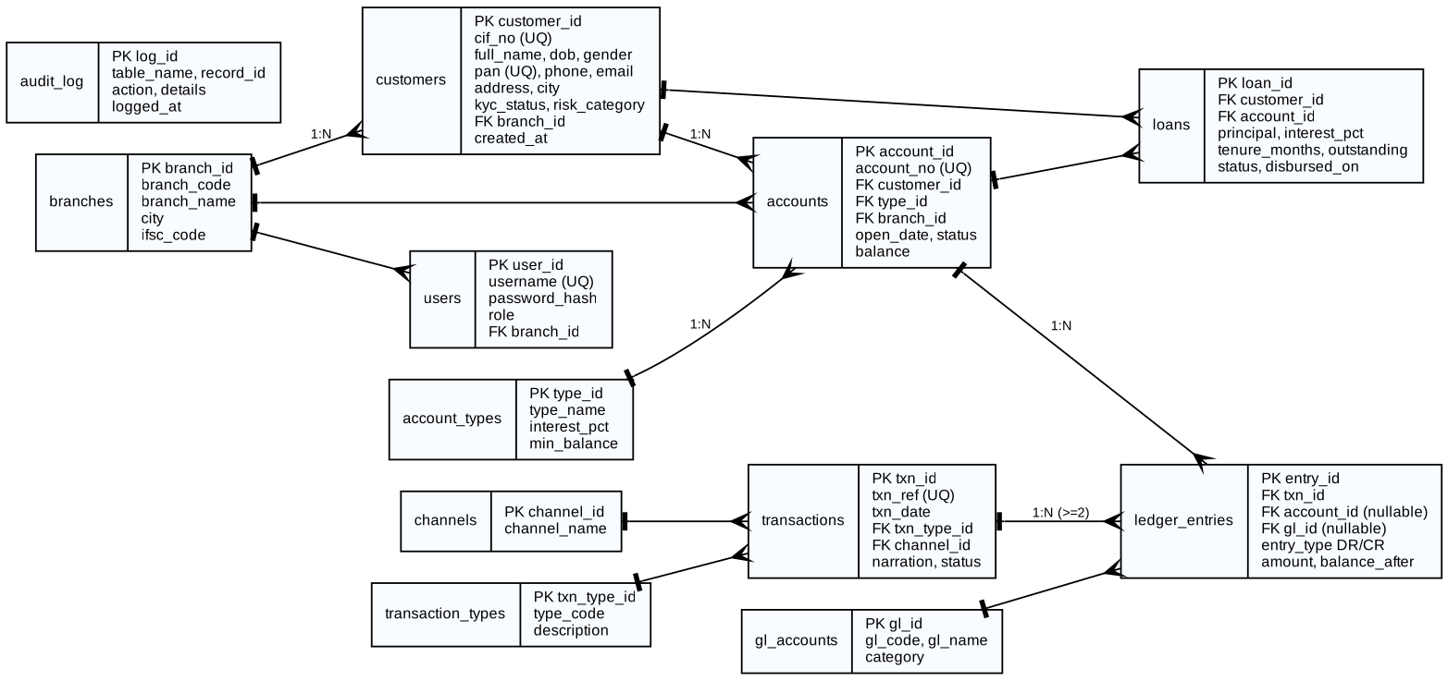
Figure 1 – Entity-relationship diagram (crow-foot notation)

3.3 Normalisation to Third Normal Form
The design starts from a single flat “bank statement” relation and is normalised step by step.
Normal form | Problem in the unnormalised design | Fix applied
1NF | Repeating groups: one customer row carried several accounts and several transactions | Separate rows; each attribute atomic; PKs added (customer_id, account_id, txn_id)
2NF | Partial dependency: branch name, account-type name depended on only part of a composite key | Account type and branch moved to their own tables
3NF | Transitive dependency: account → type_id → interest rate and minimum balance; txn → channel_id → channel name | Lookup tables account_types, channels, transaction_types, branches; foreign keys everywhere
Beyond | Transaction header and posting lines are different entities (one event, ≥2 lines) | transactions (header) + ledger_entries (lines) – the double-entry design

The accounts.balance column is a deliberate controlled redundancy: it equals the net of ledger lines and is maintained only by the stored procedures inside the same transaction. This avoids summing the ledger on every balance enquiry; Section 7 shows the reconciliation query that proves the two agree.

3.4 Integrity rules implemented in MySQL
- Primary, foreign and UNIQUE keys on every table (cif_no, pan, account_no, txn_ref, username).
- CHECK constraints: balance ≥ 0, amount > 0, valid e-mail pattern, and exactly one of account_id / gl_id on each ledger line.
- Triggers: ledger lines cannot be updated or deleted (reversals must be posted as new entries); changes to KYC status or contact details are written to audit_log.
- Stored procedures sp_deposit, sp_withdraw, sp_transfer and sp_post_interest: transaction with row locks (SELECT … FOR UPDATE), minimum-balance rule, account-status check, rollback on any error; transfers lock accounts in a fixed order to prevent deadlocks.
- Views v_account_overview, v_ledger_statement and v_trial_balance expose controlled read access.
- A least-privilege application user (bank_app) has SELECT, INSERT, UPDATE and EXECUTE only – no DELETE or DDL rights.

4. Module 3 – Systems Analysis & Design and BPR

4.1 SDLC model selection
Four models were compared against the characteristics of a core-banking build: stable regulatory requirements for ledger rules, but evolving customer-facing and reporting needs; very high cost of error in posting logic; a small team and an academic time-box.
Criterion | Waterfall | V-Model | Spiral | Iterative / Agile (chosen)
Requirements stability | Needs fixed | Needs fixed | Evolving | Handles both
Early working software | No | No | Prototype | Yes – every increment
Testing rigour for ledger | Late | Strong | Strong | Strong with per-sprint tests
Risk management | Weak | Moderate | Strong | Good – frequent review
Fit for small team | OK | Heavy | Heavy | Best

Decision: an iterative-incremental (Agile) lifecycle with a V-model style test gate on the posting engine. Increment 1 delivered the schema and posting procedures with ledger tests; Increment 2 the REST API; Increment 3 the user interface; Increment 4 the DSS reports and Excel workbook. The ledger core is treated as a safety-critical component, so its tests (trial balance equals zero, overdraft rejection, immutable ledger) must pass before any later increment is accepted.

4.2 Context diagram
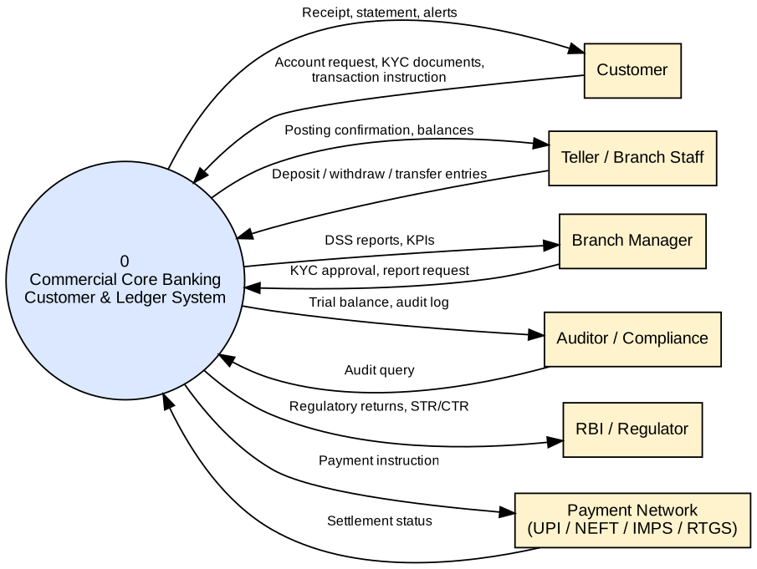
Figure 2 – Context diagram (Level 0)

4.3 Level-1 Data Flow Diagram
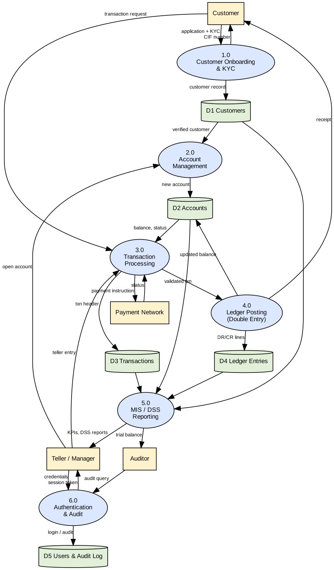
Figure 3 – Level-1 DFD: six processes, five data stores
Processes: 1.0 Onboarding & KYC, 2.0 Account Management, 3.0 Transaction Processing, 4.0 Ledger Posting, 5.0 MIS/DSS Reporting, 6.0 Authentication & Audit. Data stores D1–D5 map to the customers, accounts, transactions, ledger_entries and users/audit_log tables.

4.4 Business Process Re-engineering (BPR)
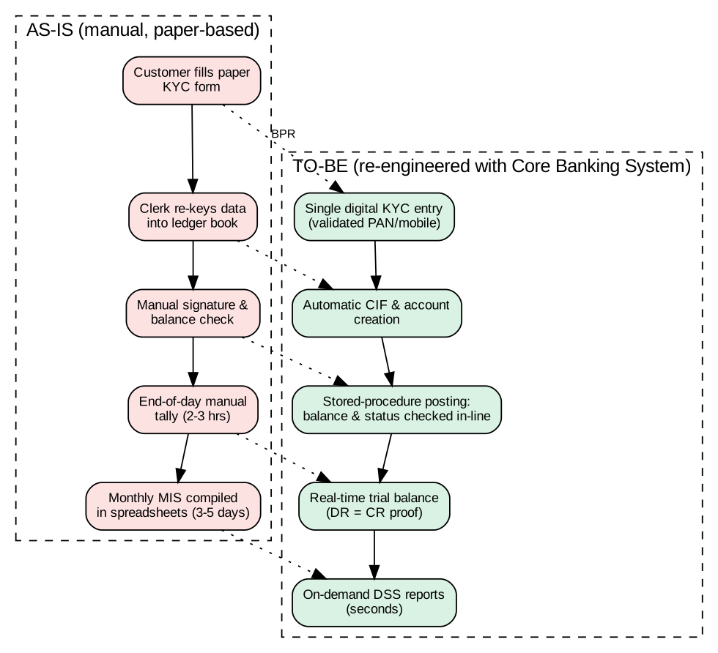
Figure 4 – BPR: manual process vs re-engineered process
Metric | AS-IS (manual) | TO-BE (system) | Improvement
Customer data entry | Paper form, re-keyed 2–3 times | Single validated entry (PAN, mobile) | Errors and rework removed
Balance check at posting | Clerk eyeballs ledger book | Procedure enforces minimum balance | Overdraft risk eliminated
End-of-day tally | 2–3 hours manual | Instant trial balance query | Close time minutes, not hours
Monthly MIS | 3–5 days in spreadsheets | On-demand reports in seconds | Decisions on current data
The figures in the AS-IS column are typical planning estimates for a manual branch process and should be replaced with your own observations if you conduct a field visit.

5. Module 4 – E-Commerce and Technology Adoption

5.1 Technology adoption
Adoption is analysed with Rogers’ diffusion of innovations and the Technology Acceptance Model (TAM). TAM predicts intention to use from perceived usefulness and perceived ease of use; tellers and managers score high on usefulness (faster, safer postings) while senior citizens score low on ease of use, so the plan gives them assisted channels.
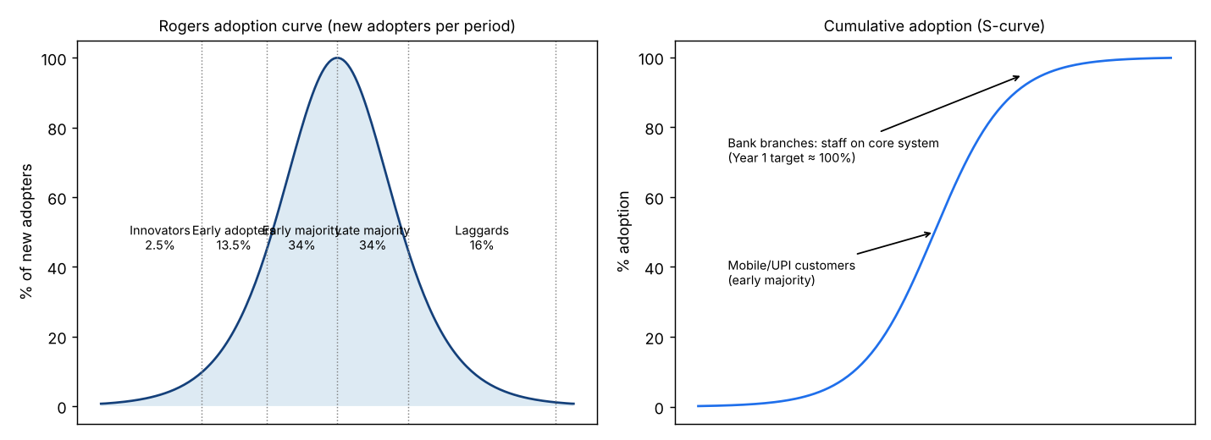
Figure 5 – Adoption curve and S-curve
User group | Rogers category | Adoption lever
Tellers, managers, auditors | Early adopters / early majority | Sandbox training, super-users, dashboards tied to KPIs
Retail customers (UPI, net banking) | Early majority | Cashback, QR payments, vernacular interface
Small-business owners | Early majority | Bulk transfers, GST-ready statements
Senior citizens | Late majority | Assisted branch service, large-font interface
Numeric assumptions behind this plan are in the Adoption sheet of the Excel workbook (editable blue cells).

5.2 E-payment integration
Channel | Mode | Typical limit / settlement* | How the system handles it
UPI | Real-time, 24×7 | Per-transaction cap set by NPCI/bank; instant | Channel recorded on transfer; fraud alert via DSS Q7
IMPS | Real-time, 24×7 | Instant | Posted via sp_transfer with channel = IMPS
NEFT | Batch settlement | Half-hourly batches | Same posting; status updated when settlement file returns
RTGS | Real-time gross | High-value, minimum amount applies | Large-value flag for AML review
*Limits and timings are set by RBI/NPCI and change; verify current figures before quoting them in the viva. The prototype posts the internal ledger entries; a production build would call the payment switch and mark the posting complete only on a signed success response.

5.3 Security architecture
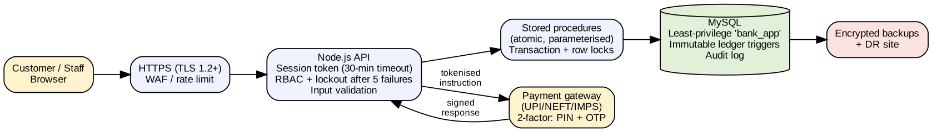
Figure 6 – Layered security architecture
Layer | Control | Implemented in prototype?
Transport | TLS 1.2+, HSTS | Deploy-time (run behind HTTPS reverse proxy)
Authentication | Password hash, lockout after 5 failures, 30-minute session timeout | Yes (SHA-256 demo; use bcrypt/argon2 + MFA in production)
Authorisation | Role-based access (Teller, Manager, Auditor, Admin); PAN/phone masked for tellers and auditors | Yes
Input handling | Server-side validation (PAN, mobile, amount range); parameterised SQL; whitelisted report SQL | Yes
Data layer | Least-privilege DB user; immutable ledger; audit log | Yes
Payments | OTP/PIN two-factor, tokenised instructions, signed responses | Design only
Resilience | Encrypted backups, disaster-recovery site | Design only

6. Module 5 – IT Ethics, Security and Environmental Audit

6.1 Ethics compliance report
A bank holds the most sensitive category of personal data: identity, financial position and behaviour. The table maps each obligation to the control in the system. Statute references are given for orientation; confirm exact sections with your faculty or a legal source before relying on them.
Principle / law | Obligation | Control in this system
Digital Personal Data Protection Act, 2023 | Lawful purpose, consent, purpose limitation, security safeguards, breach notification | KYC collected only for banking; masked display; audit trail; least-privilege access
Information Technology Act, 2000 | Penalises unauthorised access, data theft, identity theft and cheating by personation (e.g. Sections 43, 66, 66C, 66D); duty to protect sensitive data (Section 43A, as amended) | Authentication, lockout, logging; evidence retained in audit_log
RBI KYC / cyber-security directions | Customer due diligence, risk categorisation, monitoring, reporting of suspicious transactions | kyc_status, risk_category, large-transaction query (DSS Q7), KYC exposure report (Q9)
Fairness and accuracy | Customers must be able to rely on balances | Double-entry ledger, trial balance, reconciliation check
Accountability | Staff actions must be attributable | Role split; audit_log; immutable postings
Data minimisation | Collect only what is necessary | Schema holds no card numbers, Aadhaar numbers or biometrics

6.2 Cybercrime risk matrix
Each threat is scored Likelihood (1–5) × Impact (1–5). Scores ≥ 15 are High, 8–14 Medium, below 8 Low. These are the team’s judgements, not statistics; the editable version with live formulas is in the Risk_Matrix sheet of the workbook.
Threat | L | I | Score | Rating
Phishing / social engineering | 5 | 4 | 20 | High
SQL injection on API | 3 | 5 | 15 | High
Credential stuffing / brute force | 4 | 4 | 16 | High
Insider fraud | 3 | 5 | 15 | High
Ransomware | 2 | 5 | 10 | Medium
Session hijack / MITM | 3 | 4 | 12 | Medium
DDoS on payment channel | 3 | 3 | 9 | Medium
PII data leakage | 3 | 5 | 15 | High
UPI / account-takeover fraud | 4 | 4 | 16 | High
Unpatched software | 3 | 4 | 12 | Medium

Top risks by score are phishing (20), then SQL injection, credential stuffing, insider fraud, data leakage and account takeover. Mitigations for each are listed in the workbook; the most important design choices are parameterised SQL with whitelisted reports, lockout and session timeout, role-based masking, an immutable ledger and a delete-less application account.

6.3 Environmental and ergonomic audit
Area | Finding / recommendation
Paper reduction | Digital KYC, e-statements and e-receipts replace paper forms and passbook printing
Energy | Virtualised servers, power-saving schedules for branch PCs, efficient data-centre cooling
E-waste | Refurbish or recycle terminals through authorised e-waste handlers; track assets
Workstation ergonomics | Adjustable chairs and monitor height, 20-20-20 eye-rest rule, keyboard/mouse placement, regular breaks for tellers
Interface ergonomics | High-contrast light/dark themes, large click targets, clear error messages, keyboard-friendly forms
Accessibility and inclusion | Large-font option, vernacular language support, assisted service for senior citizens

7. Module 6 – Application Software and MySQL Implementation

7.1 What was built
Component | Technology | Files
Database | MySQL 8 / MariaDB 10.5+ | database/01_schema.sql, 02_seed_data.sql, 03_dss_queries.sql
Back end | Node.js, Express, mysql2 | backend/src/server.js, package.json
Front end | HTML, CSS, vanilla JavaScript | frontend/index.html, style.css, app.js
Reports | Excel (live formulas), Word | excel/Core_Banking_Reports.xlsx, this report

Seed data was generated with a fixed random seed and loaded through the posting procedures, so the ledger and balances are consistent by construction. Names, PAN numbers and phone numbers are fictitious.

7.2 DSS queries
# | Business question | SQL techniques
Q1 | Branch-wise deposit position | JOIN, GROUP BY, AVG
Q2 | Customers with combined balance above Rs 10 lakh | GROUP BY … HAVING
Q3 | Monthly volume and value by channel | Multi-table JOIN, GROUP BY
Q4 | Top 5 customers by turnover | JOIN, ORDER BY, LIMIT
Q5 | Accounts with no activity in 90 days | Correlated and NOT IN subqueries
Q6 | Trial balance: debits = credits? | View, UNION ALL, IF
Q7 | Large transactions above 3× average (AML) | Scalar subquery
Q8 | Loan portfolio quality and NPA share | GROUP BY, subquery
Q9 | KYC exposure by risk category | LEFT JOIN, COALESCE
Q10 | Running balance of an account | Window function SUM() OVER
Q11 | Top two customers per branch | RANK() OVER (PARTITION BY)
Q12 | Executive KPI row | Scalar subqueries

7.3 Executive report – sample output
Q1 – Branch deposit position
Branch | Customers | Accounts | Deposits (Rs)
Anna Nagar | 3 | 4 | 3,109,935.01
T. Nagar Main | 4 | 6 | 2,445,541.26
Adyar | 3 | 4 | 1,624,608.76
RS Puram | 3 | 4 | 1,299,500.00

Q2 – Customers above Rs 10 lakh
CIF | Customer | Accounts | Total balance (Rs)
CIF100014 | Tamil Selvi Traders (Prop. K. Selvam) | 2 | 1,672,000.00
CIF100004 | Divya Krishnan | 1 | 1,616,521.88
CIF100003 | Mohammed Faizal | 2 | 1,373,413.13
CIF100005 | Suresh Babu | 2 | 1,017,889.38

Q8 – Loan portfolio quality
Status | Loans | Sanctioned (Rs) | Outstanding (Rs) | % of book
ACTIVE | 4 | 4,900,000.00 | 4,470,000.00 | 93.71%
CLOSED | 1 | 800,000.00 | 0.00 | 0.00%
NPA | 1 | 300,000.00 | 300,000.00 | 6.29%

Reading the results: Anna Nagar holds the largest share of deposits; the loan book carries one NPA loan (about 6.3% of outstanding); two customers have KYC pending, so they cannot open accounts until a manager verifies them – a control enforced by the API.

7.4 Testing evidence
Test | Expected | Result
Trial balance after seed load | Debits = credits | Passed (both Rs 13,536,085.03)
Ledger vs account balances | Sum of balances equals net customer ledger | Passed (Rs 8,479,585.03)
Withdrawal below minimum balance | Rejected with message | Passed
Transfer between two accounts | Both balances change, two ledger lines | Passed
Customer with invalid PAN | API rejects | Passed
Login with wrong password | 401 Invalid credentials | Passed
Update/delete ledger row in SQL | Trigger blocks | Passed (trigger blocked both UPDATE and DELETE)

7.5 Limitations and future scope
- Passwords use SHA-256 for demo simplicity; production must use bcrypt or argon2 with salts and add multi-factor authentication.
- Sessions are held in server memory; use a signed-token or Redis store when scaling to several servers.
- Payment-network calls are simulated by the channel field; a real gateway integration, reversal workflow and maker-checker approval are future work.
- AI extension: a fraud-scoring model on the ledger history (anomaly detection) would move the system toward the AI-application class in Module 1.

8. Viva Preparation – Likely Questions
Each member is examined individually on the modules they own. Use these as prompts, and answer from your own understanding of the files you worked on.
Module | Question | Short answer pointer
1 | Why is this a TPS and not only an MIS? | It records live transactions atomically; MIS/DSS read what the TPS stores.
2 | Show a transitive dependency you removed. | account → type_id → interest/min balance, moved to account_types.
2 | Why keep balance in accounts if the ledger has everything? | Controlled redundancy for fast enquiry; reconciled by trial-balance check.
3 | Why Agile with a V-model gate? | Evolving UI/reporting, but ledger logic is safety-critical and must be tested first.
3 | What is the difference between context diagram and Level-1 DFD? | Context shows one process and external entities; Level-1 decomposes into six processes and data stores.
4 | What does TAM predict and how did you use it? | Intention from usefulness and ease of use; drives training and assisted channels.
5 | Which Indian laws apply to a bank’s customer data? | DPDP Act 2023, IT Act 2000, RBI KYC/cyber directions (cite from your notes).
6 | Explain what happens inside sp_transfer. | Start transaction, lock rows in order, validate, insert header, update balances, insert DR and CR lines, commit or roll back.
6 | Why FOR UPDATE and a fixed lock order? | Prevent lost updates and deadlocks under concurrent transfers.
6 | Which query uses HAVING and why? | Q2 – filters groups after aggregation (total balance above Rs 10 lakh).

Appendix A – How to Run the Project
- Install MySQL 8 (or MariaDB 10.5+) and Node.js 18+.
- In a terminal: mysql -u root -p < database/01_schema.sql, then 02_seed_data.sql. (Optional: 03_dss_queries.sql to see all reports.)
- cd backend; npm install; npm start. The app serves the front end at http://localhost:3000.
- Sign in with manager1 / manager123 (full access), teller1 / teller123, auditor1 / auditor123 or admin / admin123.
- If your MySQL root user requires a password, no change is needed for the app: it connects as bank_app, created by 01_schema.sql. Change the defaults via environment variables DB_HOST, DB_USER, DB_PASSWORD, DB_NAME.

Appendix B – Individual Attribution Log
Complete this table before submission. Groups without individual attribution are not evaluated.
Member | Modules | Files / sections authored | Signature
<Member 1> | 2, 6 | 01_schema.sql, 02_seed_data.sql, Section 3
<Member 2> | 2, 6 | 03_dss_queries.sql, Excel workbook, Section 7.2–7.3
<Member 3> | 1, 3 | Sections 2 and 4, diagrams
<Member 4> | 4, 5 | Sections 5 and 6, Risk_Matrix, Adoption sheets

