Lab04 - COMP228

Name: Taranjeet Singh
GitHub Repository: https://github.com/Taranjeet98/COMP228-Labs.git

Source Code:

Person.java
public class Person {
private String personId;
private String name;
private int age;

public Person(String personId, String name, int age) {
this.personId = personId;
this.name = name;
this.age = age;
}

public String getPersonId() {
return personId;
}

public void setPersonId(String personId) {
this.personId = personId;
}

public String getName() {
return name;
}

public void setName(String name) {
this.name = name;
}

public int getAge() {
return age;
}

public void setAge(int age) {
this.age = age;
}

public void performDuties() {
System.out.println(name + " is doing the regular hospital duties.");
}
}

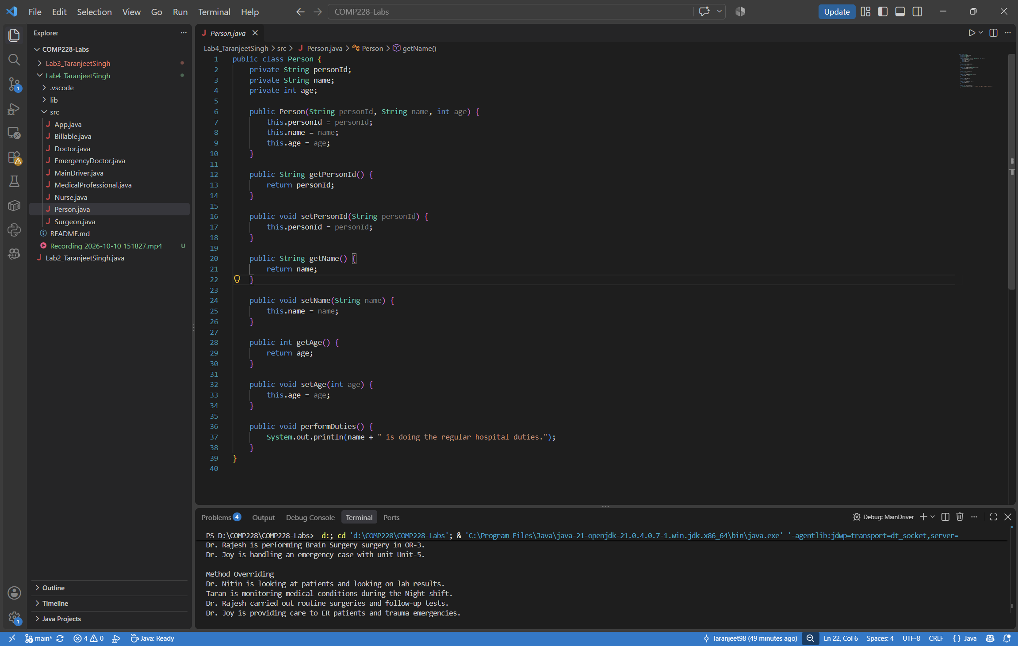

Doctor.java

public class Doctor extends Person{
private String specialization;
private double consultationFee;

public Doctor(String personId, String name, int age, String specialization, double consultationFee) {
super(personId, name, age);
this.specialization = specialization;
this.consultationFee = consultationFee;
}

public double getConsultationFee() {
return consultationFee;
}

public void diagnosePatient() {
System.out.println(getName() + " is diagnosing a patient in " + specialization + " with a consultation fee of $" + consultationFee + ".");
}

@Override
public void performDuties() {
System.out.println(getName() + " is looking at patients and looking on lab results.");
}
}

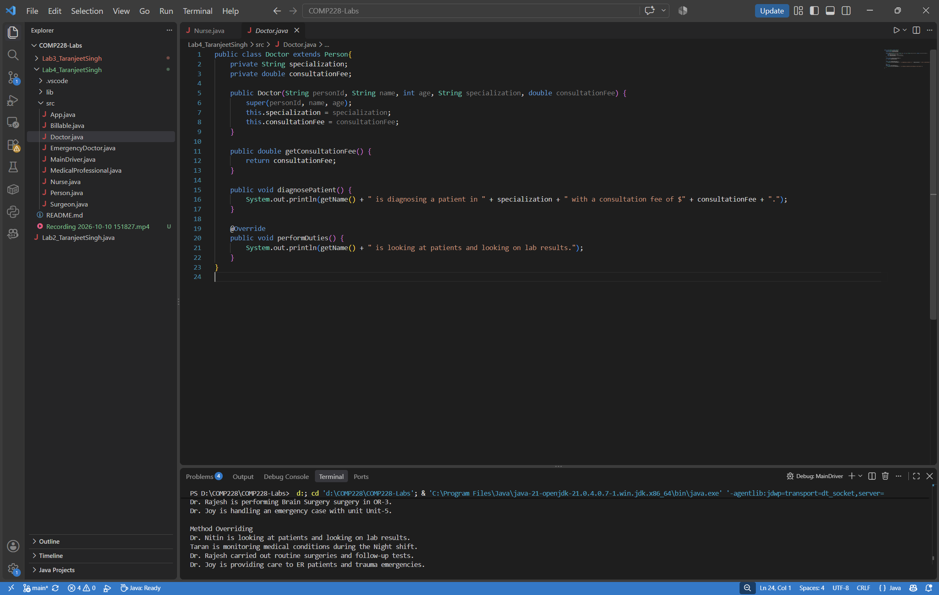

Nurse.java
public class Nurse extends Person {
private String department;
private String shift;

public Nurse(String personId, String name, int age, String department, String shift) {
super(personId, name, age);
this.department = department;
this.shift = shift;
}

public void assistPatient() {
System.out.println(getName() + " is helping patients in the " + department + " department.");
}

@Override
public void performDuties() {
System.out.println(getName() + " is monitoring medical conditions during the " + shift + " shift.");
}
}

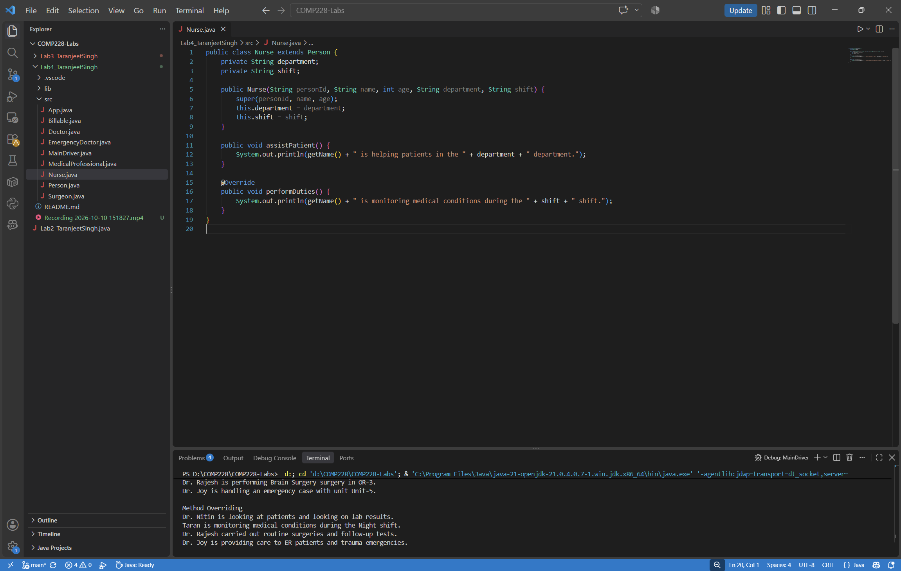

Surgeon.java
public class Surgeon extends Doctor{
private String surgeryType;
private String operatingRoom;

public Surgeon(String personId, String name, int age, String specialization, double consultationFee, String surgeryType, String operatingRoom) {
super(personId, name, age, specialization, consultationFee);
this.surgeryType = surgeryType;
this.operatingRoom = operatingRoom;
}

public void performSurgery() {
System.out.println(getName() + " is performing " + surgeryType + " surgery in " + operatingRoom + ".");
}

@Override
public void performDuties() {
System.out.println(getName() + " carried out routine surgeries and follow-up tests.");
}
}

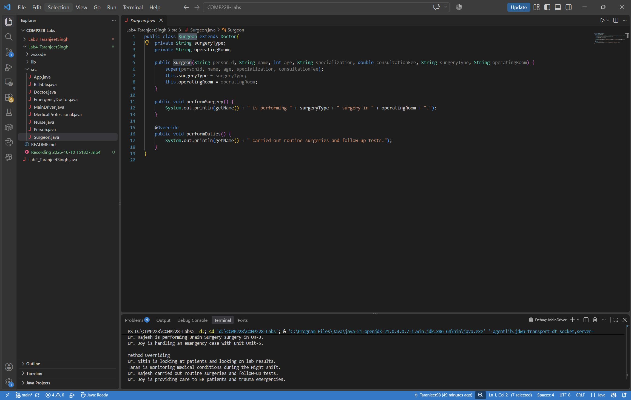

Billable.java
public interface Billable {
void generateBill();
}

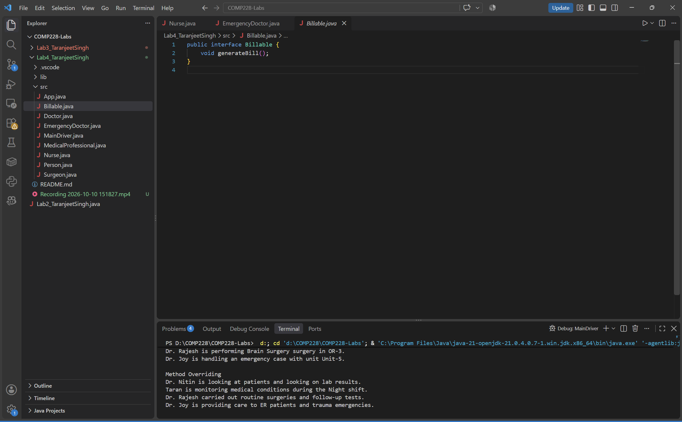

MedicalProfessional.java

public interface MedicalProfessional {
void prescribeMedication();
}

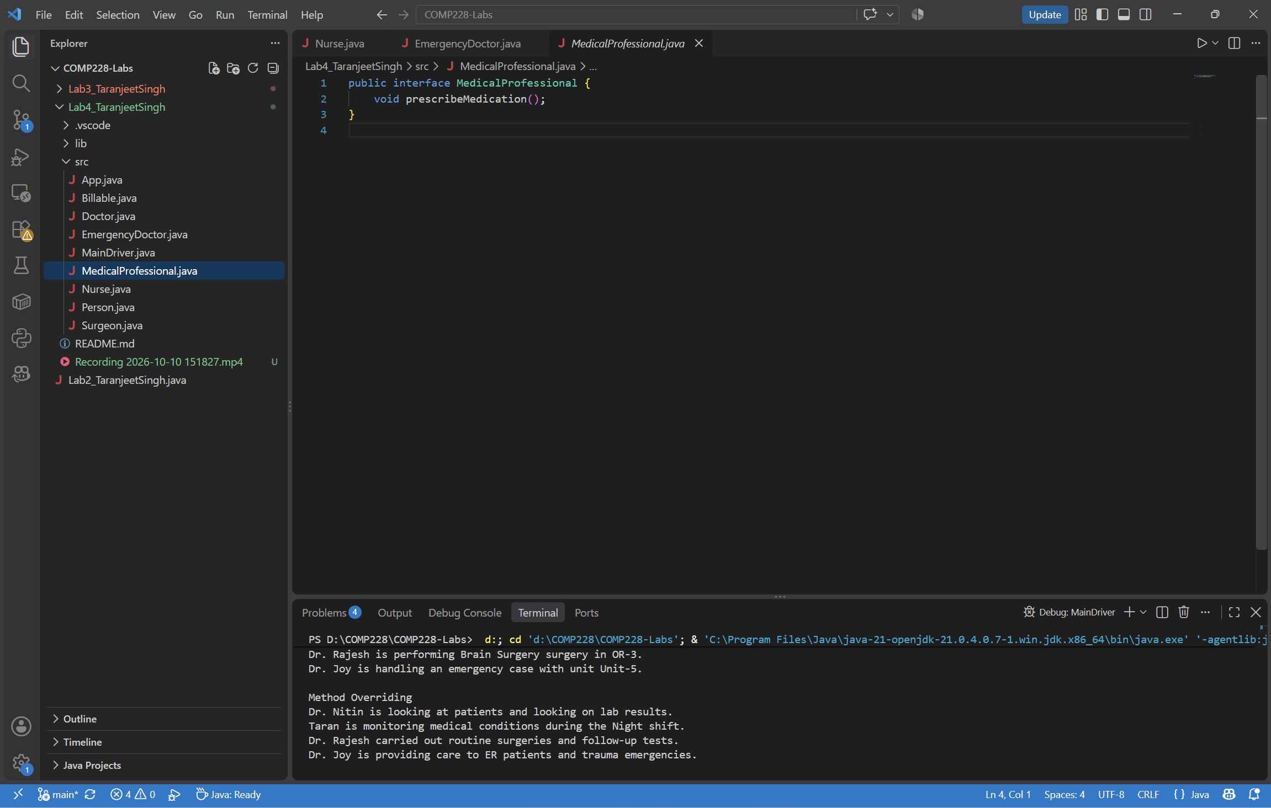

EmergencyDoctor.java

public class EmergencyDoctor extends Doctor implements MedicalProfessional, Billable {
private String ambulanceUnit;

public EmergencyDoctor(String personId, String name, int age, String specialization, double consultationFee, String ambulanceUnit) {
super(personId, name, age, specialization, consultationFee);
this.ambulanceUnit = ambulanceUnit;
}

public void handleEmergency() {
System.out.println(getName() + " is handling an emergency case with unit " + ambulanceUnit + ".");
}

@Override
public void prescribeMedication() {
System.out.println(getName() + " is writing medicines for emergency drugs.");
}

@Override
public void generateBill() {
System.out.println(getName() + " is creating the cost for the emergency visit.");
}

@Override
public void performDuties() {
System.out.println(getName() + " is providing care to ER patients and trauma emergencies.");
}
}

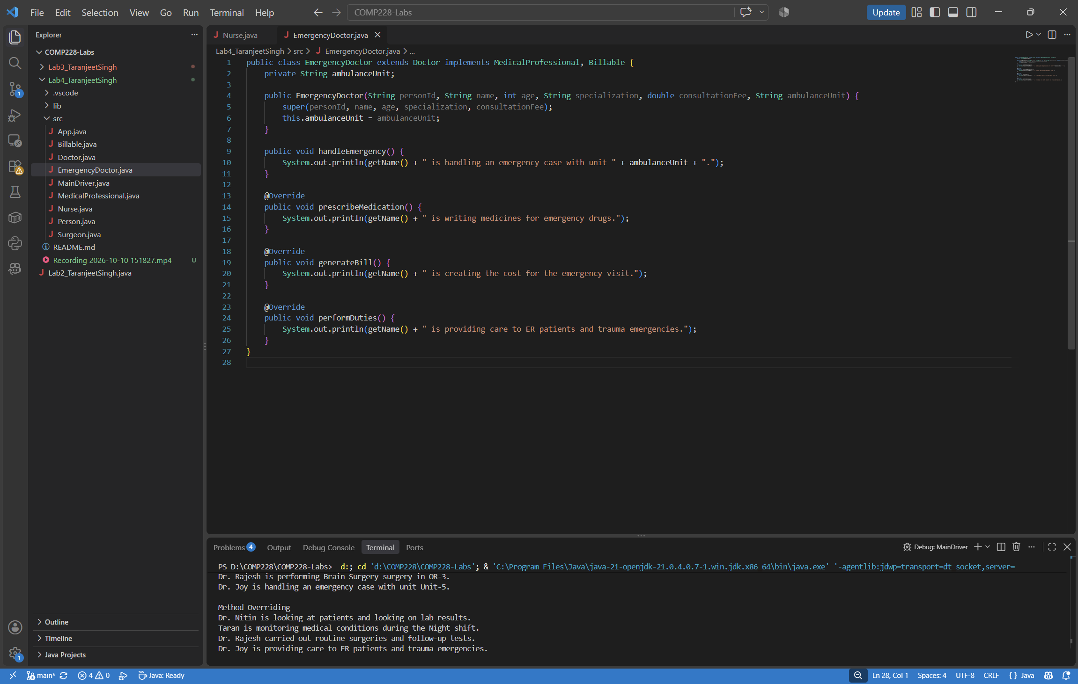

MainDriver.java
public class MainDriver {
public static void main(String[] args) {
Doctor dr = new Doctor("D001", "Dr. Nitin", 40, "Cardiology", 150.0);
Nurse nurse = new Nurse("N001", "Taran", 28, "ICU", "Night");
Surgeon surgeon = new Surgeon("S001", "Dr. Rajesh", 45, "Neurology", 300.0, "Brain Surgery", "OR-3");
EmergencyDoctor erDoc = new EmergencyDoctor("E001", "Dr. Joy", 35, "Emergency Medicine", 200.0, "Unit-5");

System.out.println("\nDisplaying Details");
dr.diagnosePatient();
nurse.assistPatient();
surgeon.performSurgery();
erDoc.handleEmergency();

System.out.println("\nMethod Overriding");
dr.performDuties();
nurse.performDuties();
surgeon.performDuties();
erDoc.performDuties();

System.out.println("\nPolymorphism");
Person person;

person = dr;
person.performDuties();

person = nurse;
person.performDuties();

person = surgeon;
person.performDuties();

person = erDoc;
person.performDuties();

System.out.println("\nInterface");
erDoc.prescribeMedication();
erDoc.generateBill();
}
}

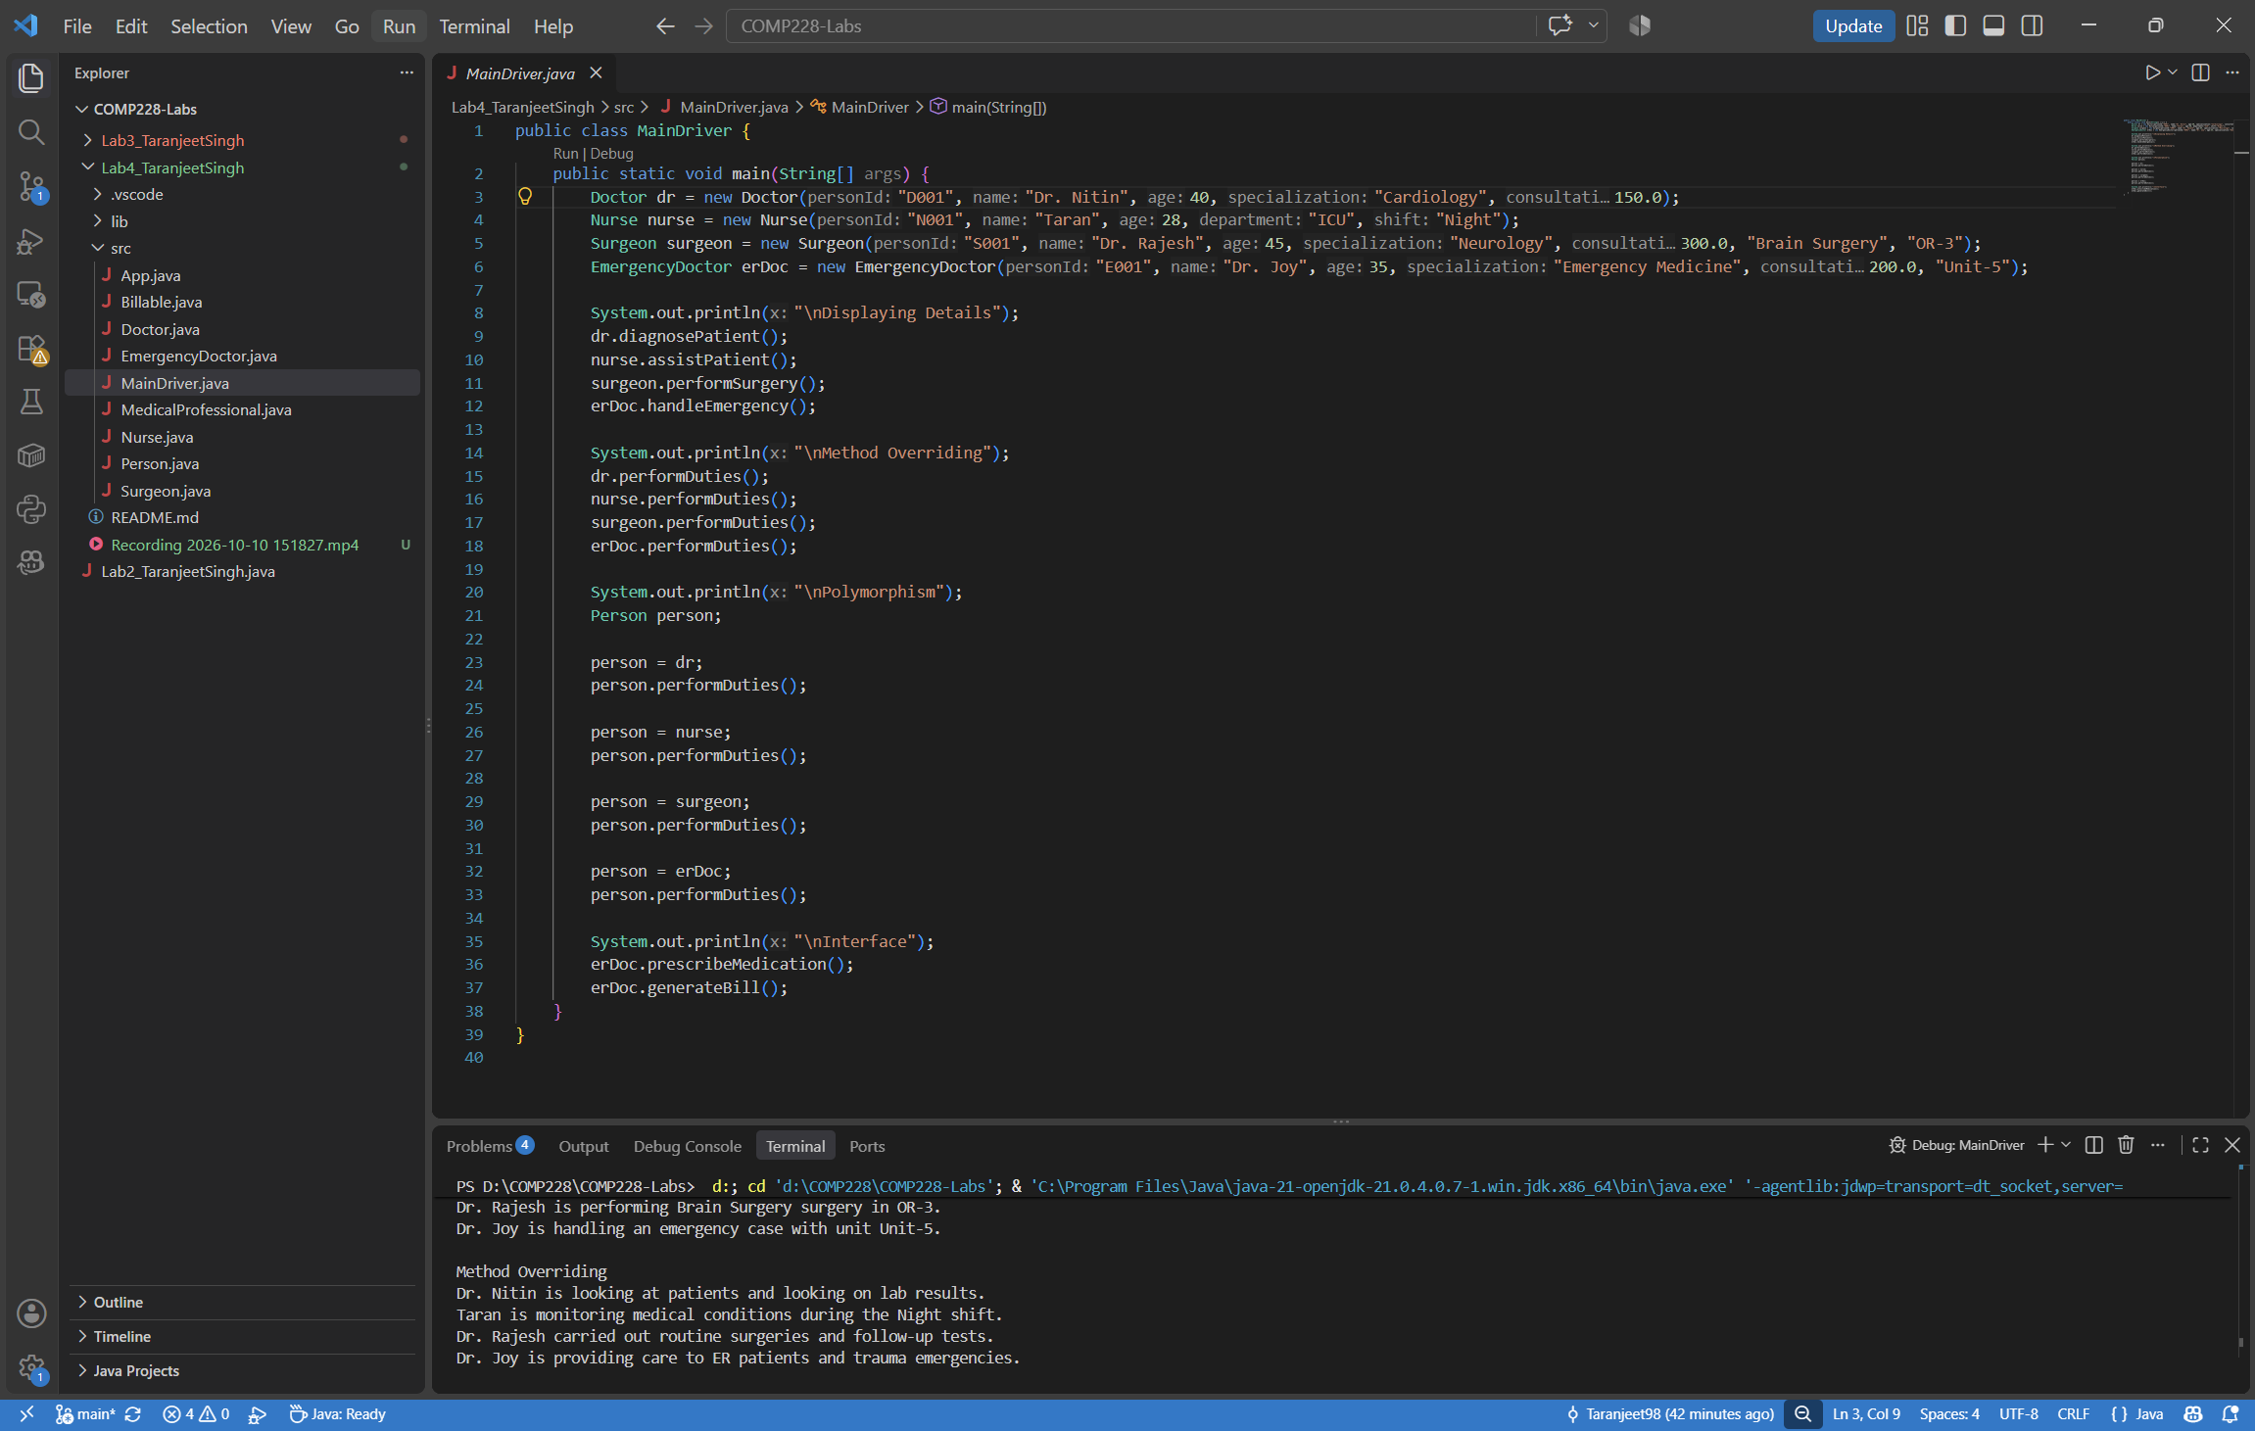

Output
