Software Requirements Specification

For

Automated Print-Out System

**Prepared by**

|  |  |  |
| --- | --- | --- |
| Taranjeet Singh | 101610091 | tsingh3_be16@thapar.edu |
| Manish Aggarwal | 101603183 | maggarwal_be16@thapar.edu |
| Loveneet Singh | 101603175 | lsingh_be16@thapar.edu |
|  |  |  |
|  |  |  |

|  |  |
| --- | --- |
| **Instructor:** | Dr. Vinay Arora |
| **Course:** | Software Engineering |
| **Lab Section:** | COE13 |
| **Date:** | 1st.Nov.2018 |

**Contents**

**Contents ii**

**Revisions ii**

**1** **Introduction 3**

1.1 Document Purpose 3

1.2 Product Scope 3

1.3 Intended Audience and Document Overview 3

1.4 Definitions, Acronyms and Abbreviations 3

1.5 Document Conventions 4

1.6 References and Acknowledgments 4

**2** **Overall Description 5**

2.1 Product Overview 5

2.2 Product Functionality 6

2.3 Design and Implementation Constraints 6

2.4 Assumptions and Dependencies 6

**3** **Specific Requirements 7**

3.1 External Interface Requirements 7

3.2 Functional Requirements 8

3.3 Use Case Model 9

**4** **Other Non-functional Requirements 17**

4.1 Performance Requirements 17

4.2 Safety and Security Requirements 17

4.3 Software Quality Attributes 17

**5** **Other Requirements 18**

**Appendix A – Data Dictionary 19**

**Appendix B - Group Log 19**

# Introduction

## Document Purpose

The purpose of the document is to collect and analyse all assorted ideas that have come up to define the system, its requirements with respect to consumers. Also, we shall predict and sort out how we hope this product will be used in order to gain a better understanding of the project, outline concepts that may be developed later, and document ideas that are being considered, but may be discarded as the product develops.

In short, the purpose of this SRS document is to provide a detailed overview of our software product, its parameters and goals. This document describes the project's target audience and its user interface, hardware and software requirements. It defines how our client, team and audience see the product and its functionality. Nonetheless, it helps any designer and developer to assist in software delivery lifecycle (SDLC) processes.

## Product Scope

Primarily, the scope pertains to the Print-out of pdf files and stationary items purchasing. It focuses on the Stationary & print-out shops and their applications, which allow for online sales.

This SRS is also aimed at specifying requirements of software to be developed but it can also be applied to assist in the selection of in-house and commercial software products. The standard can be used to create software requirements specifications directly or can be used as a model for defining an organization or project specific standard. It does not identify any specific method, nomenclature or tool for preparing an SRS.

## Intended Audience and Document Overview

The sequence in which who should read is

1. Introduction
2. Overall Description
3. Specific Requirements
4. Other non-functional Requirements

## Definitions, Acronyms and Abbreviations

None is used.

## Document Conventions

This document follows the IEEE formatting requirements. Arial font size 11, or 12 are used throughout the document for text. Italics are used for comments. Document text is single spaced and 1” margins are maintained in this template.

## References and Acknowledgments

We would like to acknowledge our lecturer Dr. Sanmeet Bhatia mam for teaching us about software engineering and how it is done on a professional level. We would also like to thank our lab instructor Dr. Vinay Arora for providing essential knowledge and information needed to accomplish this task.

# Overall Description

## Product Overview

This product is a self-contained product. This product significantly eradicates manual management method. Thereby reducing the possibilities of manual error, increasing the efficiency, reducing the work time to much extent. Still a little bit of manual interference is needed to operate this.

Basic working is done by using system, printers and internet.

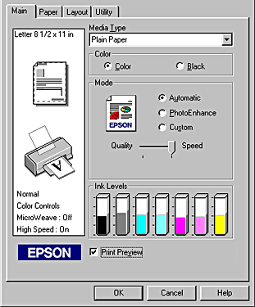

This Product when implemented will replace the conventional way of printing, i.e. people have to go to the shop with pen drives, email attachments and have to be physically there to give print command and they have to wait for it to be printed. This wastes a lot of time. In our solution to this people can upload their files online and can get their product just as they arrive at shop this saves a lot of time. This will also save the inconvenience of exchange money as payment is made online digitally.

Our product will be installed on shopkeeper’s pc which he will start every working day and shutdowns on evening in the time at which it is on customers can take their print-outs and stationaries. Even if someone orders at night it will be processed next morning as soon as shopkeeper powers on the system. Customers will have to pay online and in advance to protect from spamming.

## Product Functionality

1. It contains prices of all the Stationary items.
2. It helps Shopkeeper to add or update items in stationary stock.
3. Bill generation is done by outside service like paytm.
4. Reports are sent to shopkeeper after order is placed.
5. Shopkeeper can easily add or update Stock.

## Design and Implementation Constraints

There are no such constraints over the system. Still:

System should be fast enough to keep the process flawless even on busy days.

Internet connection should be in working condition all the time to receive orders.

Payment services should be in working conditions all the time so we don’t miss an order.

Printer should be capable enough of printing good quality coloured and black & white print-outs.

System is fully automated but still have to be managed by manpower to a small extent.

Customer must be provided the basic information to use the system.

Project should be designed in a way that it can deal with piracy that is there should be no loop holes by which someone is able to take services without paying for it.

## Assumptions and Dependencies

Client: We have assumed that all of the computer systems in the Shop are in proper working condition and that the user is capable of operating these system's basic functions including but not limited to being able to power on the system and login into it.

Provider: We have assumed that the shop’s software will be running on a properly database system.

Assumptions:

• There is no need to check the quantity of products.

• It is assumed that shopkeeper will maintain the sock of blank papers and see that cartridge is replaced after being used out.

• It is assumed that customer will correctly input the page numbers of coloured and black & white print-outs.

# Specific Requirements

## External Interface Requirements

### User Interfaces

Users basically faculty interact with software by visiting the website hosted by the system and they enter order details with the help of mouse and keyboard or with touch input if device is touch enabled. Shopkeeper interact by directly using software features like viewing current printing stock and updating the available stationary items.

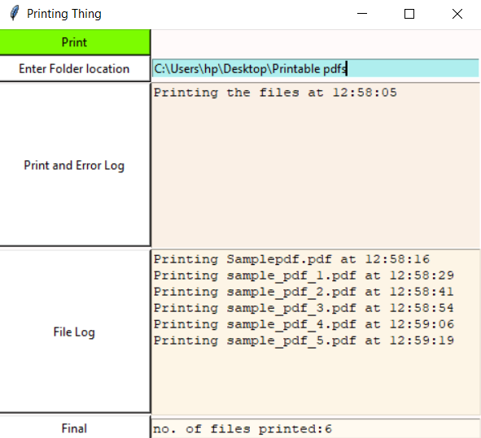

### Hardware Interfaces

Only hardware interface that we will be using in our software are two printers, one black & white and one coloured and one pc also on which software is installed. It will be used for viewing the current printing stock, the requested stationaries for each order, it will also show the mail ids of users with their respective orders. The printers should have high quality cartridges.

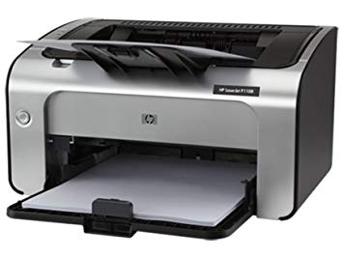

### Software Interfaces

The only software interface we will be using is Paytm or BHIM UPI. This will be used during payment of bill by the customers. Software will send the calculated cost of the order and customer will have to pay it in the account of shopkeeper at one of the Payment portal. Upon receiving the confirmation of payment the order will be processed at shop.

## Functional Requirements

1. **Functional requirements for customer welcome screen**

|  |  |
| --- | --- |
| **Purpose** | This screen provides information regarding the different prints and prices per page of the prints. It provides the information regarding extra stationary material if required. |
| **Inputs** | A customer has to login using his thapar.edu mail upload a PDF file and choose from different print options. Different option to buy extra stationary items. Selection is performed with a mouse. |
| **Processing** | Calculation of price based on the selections of the customer. |
| **Outputs** | Output consists of a screen where the sub-total is displayed and items the customer has purchased. |

1. **Functional requirements for customer payment screen**

|  |  |
| --- | --- |
| **Purpose** | This screen provides information regarding the sub-total of the customer and different modes of payment. |
| **Inputs** | A customer has to select from the different payment options and proceed for payment. Selection is performed with a mouse. |
| **Processing** | Paytm/BHIM UPI Gateway. |
| **Outputs** | QR code for the respective payment method is displayed. And also bill can be generated. |

1. **Functional requirements for shopkeeper welcome screen**

|  |  |
| --- | --- |
| **Purpose** | This screen provides information regarding the number of requests for the printouts and other stationeries. |
| **Inputs** | The shopkeeper have to power up the system and check for the stock of blank papers and cartridge. |
| **Processing** | The PDF is loaded up in a different tab. Which file is being printed is shown. |
| **Outputs** | A list of today’s orders can be seen along with the email id(s) of customers. |

## Use Case Model

### Use Case Story

There is a photocopy shop in Thapar Institute of Engineering and Technology. It is the only shop present in the campus for printing and photocopy. All the students visit the shop which creates a chaos at the shop. People many times get late for their prints and photocopy. Many times the pc’s of the shop aren’t working, the internet connectivity is poor, or the usb slot is damaged. This also causes a lot of problem to students. Sometimes, there is no electricity at shop and that too for a long period of time which causes a lots of problems in the class. The printer stops working or the ink is finished. These are some of the problems faced by the students at the printing shop.

### **Author –** Taranjeet Singh

**Purpose** - To specific business objective that the system needs to accomplish which in this case is automation of the print-out system and also include ordering stationaries.

**Requirements Traceability –** Pc, Printers (coloured and non-coloured).

**Priority** - This use case has a medium priority which helps in understanding the product and making it fully functional

**Preconditions** – The server should be always online to take order.

**Post conditions** – after taking the order shopkeeper should add the requested stationary along with collecting the specific pages for the respective order.

**Actors** – Customer, Shopkeeper, External payment service

**Extends –** If this is an extension use case, identify which use case(s) it extends

**Flow of Events**

* 1. Basic Flow - flow of events normally executed in the use-case
  2. Alternative Flow - a secondary flow of events due to infrequent conditions
  3. Exceptions - Exceptions that may happen during the execution of the use case

**Notes/Issues** – No relevant notes are required.

### Use Case Scenario

Customer is required to login into with thapar.edu mail for prints and to buy something. After that the customer has to upload his file for print and specify what kind of prints are required and can also specify if the file is required. Customer can also select other stationary items which he/she wants to buy from the stationary shop. Then it will move towards the finalized order where the total bill would be calculated and displayed. Then it will move forward to the payment panel where the customer has choice to select between COD, Paytm and UPI. After the payment is the done and the order is finalized shopkeeper will get a confirmation on his desktop. The shopkeeper will then print the desired file and ready other stationary materials if any.

* + 1. **Ishikawa Diagram**

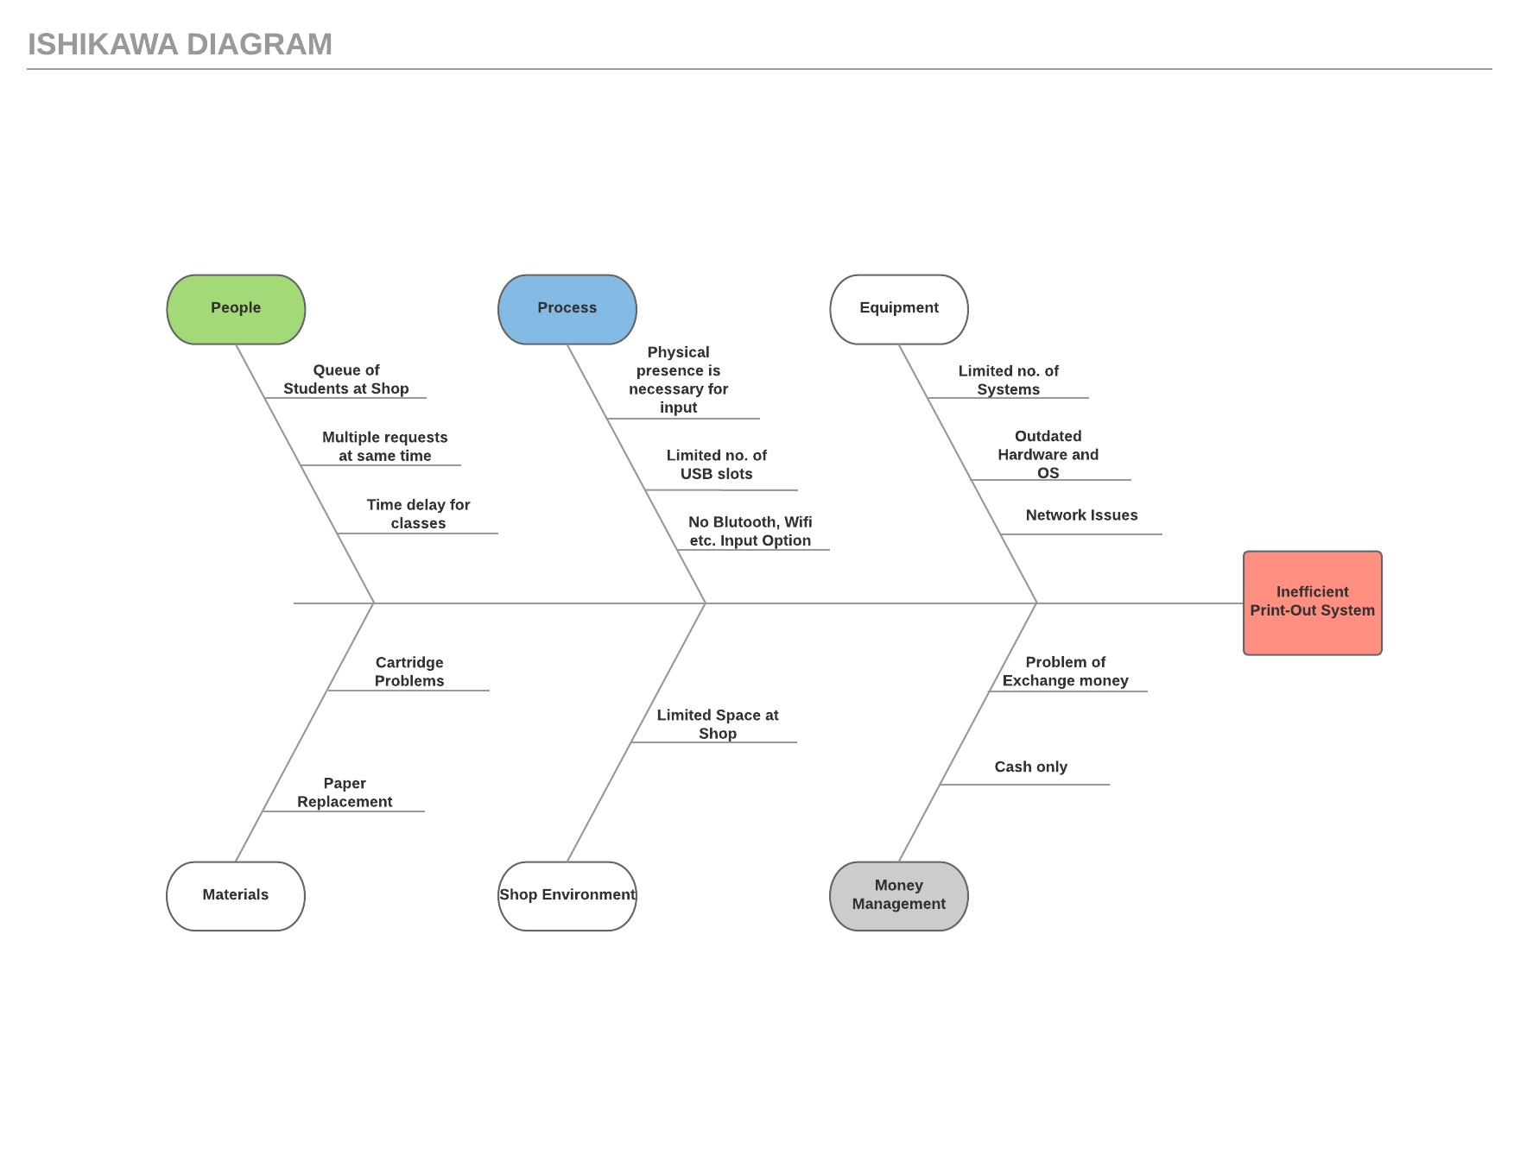

**Use case Diagram**

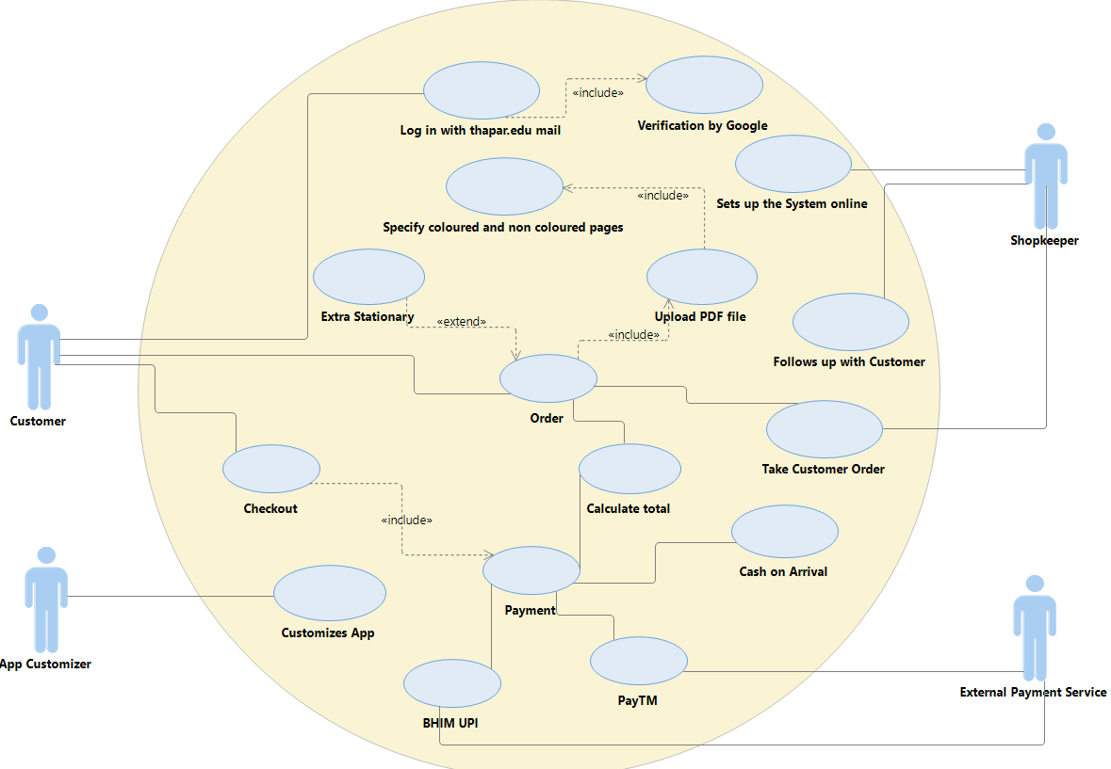

**Activity Diagram**

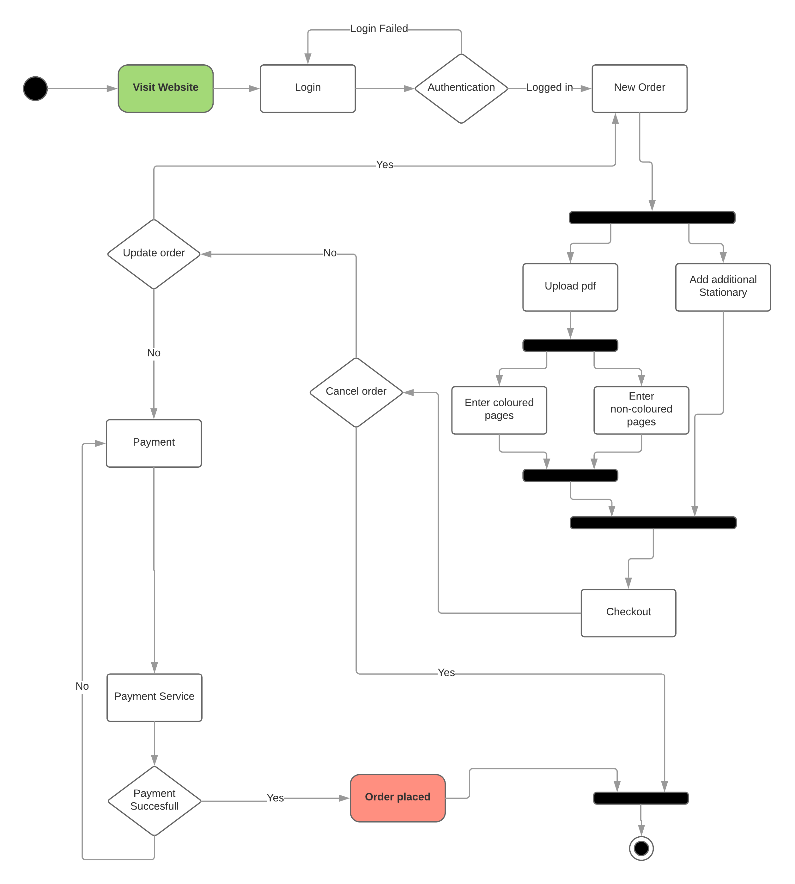

**DFD Level 0**

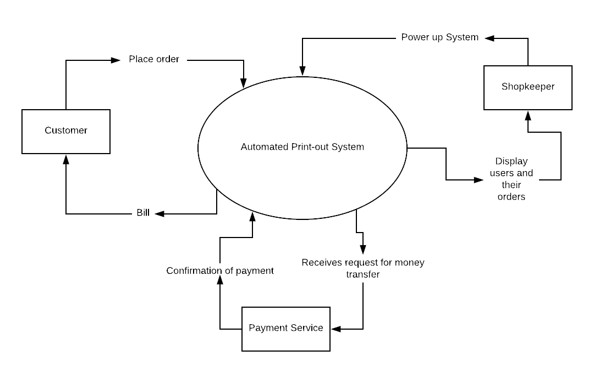

**DFD level 1**

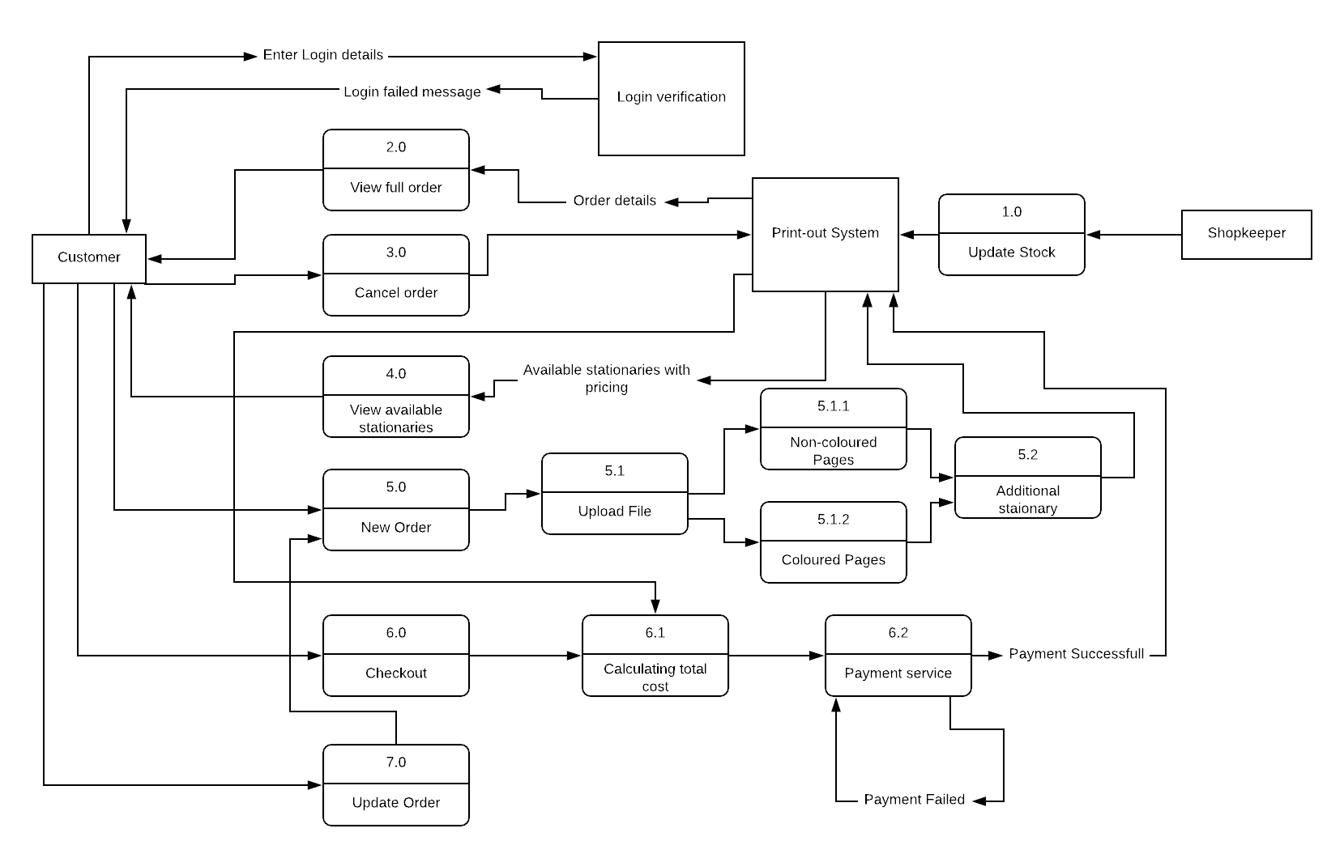

**DFD level 2**

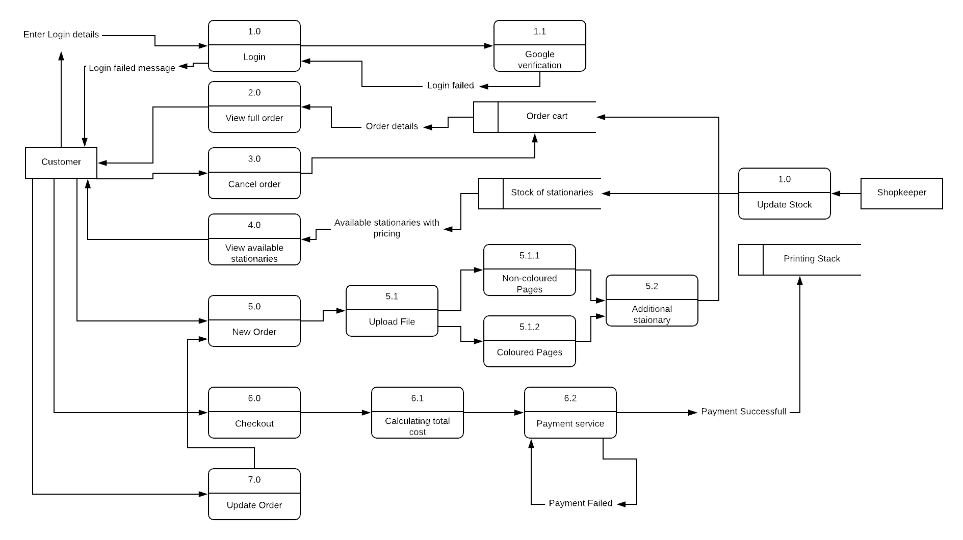

**Class Diagram**

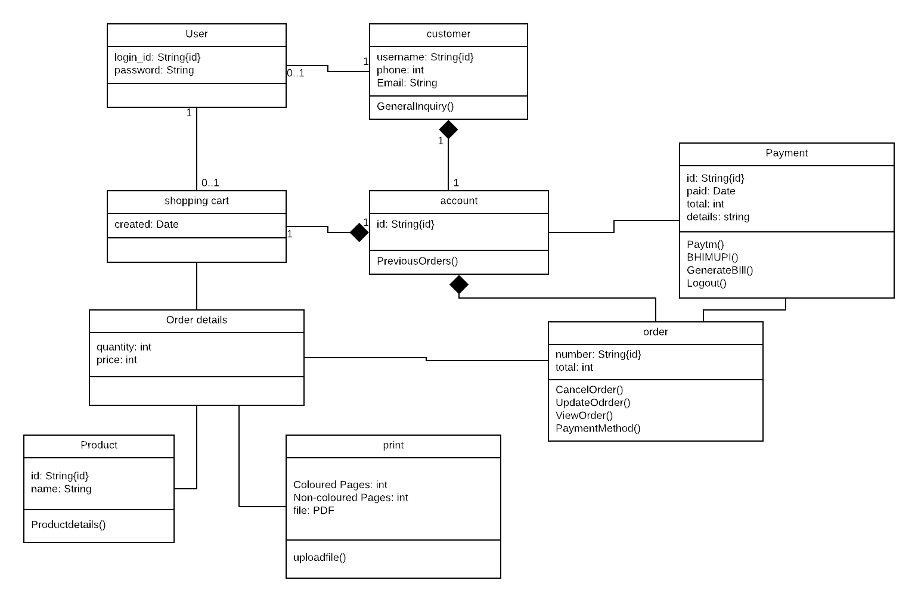

**Component Diagram**

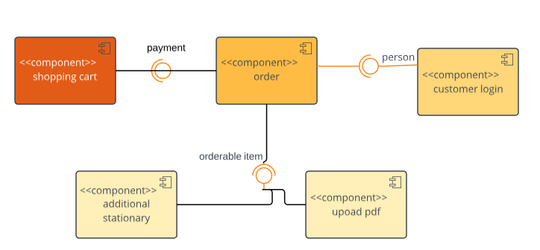

**Sequence Diagram**

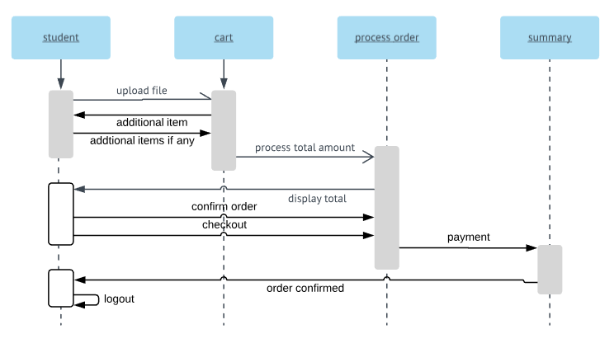

**State Chart Diagram**

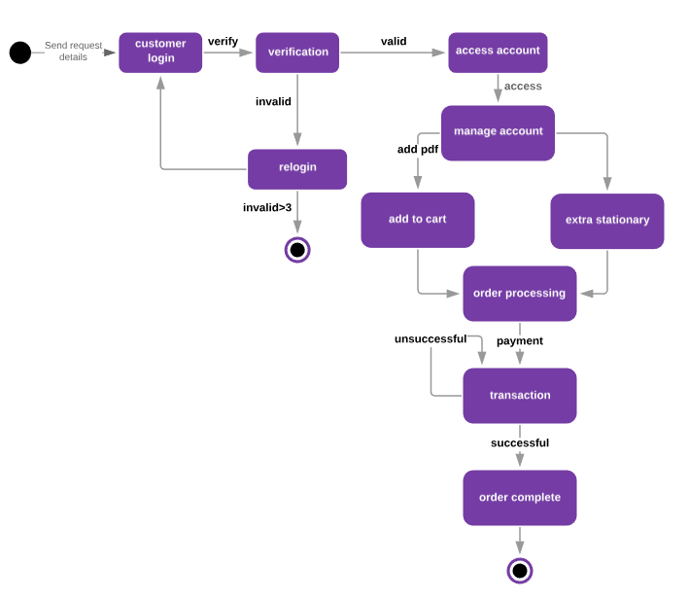

# Other Non-functional Requirements

## Performance Requirements

The Printers and server we are using should be of high quality and should be able to work after a power cut. Also the speed of system that will be using our software should be high. The payment processing, cost calculation and bill generation should be fast enough. Also uploading speed at server should be high enough to upload file in size of Megabytes. If a power cut happens the hardware should work correctly afterwards.

## Safety and Security Requirements

Payment is required to be done in advance by the customer to avoid any spamming of not needed. This is the security measure taken to safeguard any misuse of resources of the shopkeeper.

A refund can be taken by customer if the order is not done in time which is unlikely as the whole process when implemented will be a smooth process until a unfortunate event occurs like power cut, cartridge problems, blank paper shortage, etc.

## Software Quality Attributes

This software is very easy to use as it reduces a lot of work of the faculty who will be dealing with the customer. This system is also easily adaptable as shopkeeper does not have to deal with many things. There are just 2 or 3 things that he should know. It is more reliable and efficient than humans.

Software is capable of continuing itself after a long shutdown when it was offline, as the server takes orders and store them in database, the only time system would be offline will be during off time of the shop and only time system would not take requests will be when server is down which is a hardware issue.

# Other Requirements

*<This section is* ***Optional.*** *Define any other requirements not covered elsewhere in the SRS. This might include database requirements, internationalization requirements, legal requirements, reuse objectives for the project, and so on. Add any new sections that are pertinent to the project.>*

# Testing

**6.1 Introduction**

**Software Testing is an empirical investigation conducted to provide stakeholders with information about the quality of the product or service under test, with respect to the context in which it is intended to operate. Software Testing also provides an objective, independent view of the software to allow the business to appreciate and understand the risks at implementation of the software. Test techniques include, but are not limited to, the process of executing a program or application with the intent of finding software bugs. It can also be stated as the process of validating and verifying that a software program/application/product meets the business and technical requirements that guided its design and development, so that it works as expected and can be implemented with the same characteristics. Software Testing, depending on the testing method employed, can be implemented at any time in the development process, however the most test effort is employed after the requirements have been defined and coding process has been completed.**

**6.1.1 Unit Testing:**

**The primary goal of unit testing is to take the smallest piece of testable software in the application, isolate it from the remainder of the code, and determine whether it behaves exactly as you expect. Each unit is tested separately before integrating them into modules to test the interfaces between modules. Unit tests are typically written and run by software developers to ensure that code meets it design and behaves as intended. Its implementation can vary from being very manual (pencil and paper) to being formalized as part of build automation.**

**6.1.2 Integration Testing:**

**Integration testing, also known as integration and testing (I&T), is a software development process which program units are combined and tested as groups in multiple ways. Integration testing can expose problems with the interfaces among program components before trouble occurs in real- world program execution. There are two major ways of carrying out an integration test, called the bottom-up method and the top-down method. Bottom-up integration testing begins with unit testing, followed by tests of progressively higher-level combinations of units called modules or builds. In top-down integration testing, the highest-level modules are tested first and progressively lower- level modules are tested after that. In a comprehensive software development environment, bottom-up testing is usually done first, followed by top-down testing.**

**6.1.3 Validation Testing:**

**At the validation level, testing focuses on user visible actions and user recognizable output from the system. Validations testing is said to be successful when software functions in a manner that can be reasonably expected by the customer.**

**Two types of validation testing:**

**Alpha testing is simulated or actual operational testing by potential users/customers or an independent test team at the developers' site. Alpha testing is often employed for off-the-shelf software as a form of internal acceptance testing, before the software goes to beta testing. Beta testing comes after alpha testing. Versions of the software, known as beta version, are released to a limited audience outside of the programming team. The software is released to groups of people so that further testing can ensure the product has few faults or bugs. Sometimes, beta versions are made available to the open public to increase the feedback field to a maximal number of future users**

**6.2 Test Cases :**

**This software explains Test cases for Style Transfer neural network testing is a critical element of software quality assurance and represents the ultimate review of specification, design and coding. Testing presents an interesting of a system using various test data. Preparation of the test data plays a vital role in the system testing. After preparation, the test data, the system under study is tested those test data. Errors were found and corrected by using the following testing steps and corrections are recorded for future references. Thus, series of testing is performed on the system before it is already for implementation. The development of software systems involves a series of production activities where opportunities for injection of human errors are enormous. Errors may begin to occur at the very inception of the process where the objectives may be erroneously or imperfectly specified as well as in later design and development stages.**

**6.2.1 Objectives:**

**The test plan for the system should support following objectives:**

**Identify which features of the system will be tested.**

**Define the pass/fail criteria for each feature to be tested.**

**Specify the testing approaches that will be used during testing.**

**Identify the deliverables of the testing process.**

**6.2.2 Description:**

**Test Steps - List all the test execution steps in detail. Write test steps in the order in which they should be executed. Make sure to provide as many details as you can. Test Data - Use of test data as an input for this test case. You can provide different data**

**sets with exact values to be used as an input.**

**Expected Result - What should be the system output after test execution? Describe the**

**expected result in detail including message/error that should be displayed on the screen.**

**Actual result - Actual test result should be filled after test execution. Describe**

**system behavior after test execution.**

**Status (Pass/Fail) - If actual result is not as per the expected result mark this test as**

**failed. Otherwise, update it as passed.**

**Notes/Comments/Questions - If there are some special conditions to support the**

**above fields, which can’t be described above or if there are any questions related to**

**expected or actual results then mention them here.**

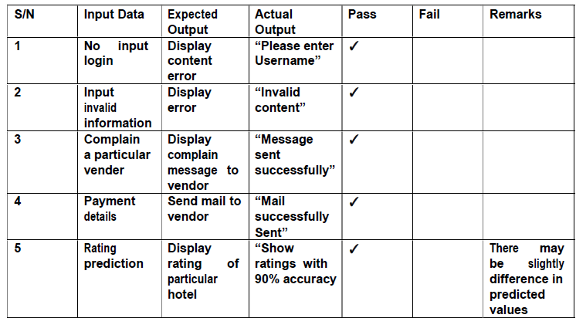

**6.2.3 Approach:**

**Only functional black box testing will be performed to test the functionality of the system. The features mentioned above describe how the user will interact with the system, so the testing will require the tester to interact with the system in the same way a typical user would. The user actions will be simulated through a set of test scenarios.**

**6.3 Suspension Criteria and Resumption Requirements**

**6.3.1 Suspension Criteria:**

**If a test case fails, testing will be suspended for all dependent features. The failed test case will be logged into a test log along with a description of the failure.**

**6.3.2 Resumption Requirement:**

**Test cases, not dependent on the case for which the bug is reported, will continue to**

**be executed parallel to bug fixing. Testing for the failed test case will resume after the**

**bug has been identified and resolved**

**Appendix A – Data Dictionary**

*<Data dictionary is used to track all the different variables, states and functional requirements that you described in your document. Make sure to include the complete list of all constants, state variables (and their possible states), inputs and outputs in a table. In the table, include the description of these items as well as all related operations and requirements.>*

**Appendix B - Group Log**

Our group has spent a lot of time in making of software, different languages were used in making of this project. HTML was used to create web pages for the server to host in which the user input the order details. In the backend of server nodejs was used to do some minor calculation like total cost, some DBMS was used to store order details. It was also used for downloading the pdf files along with their print instructions. For the development of the windows app python was used. This app automatically prints all the pending pdf files according to the instructions. It also shows error message whenever there is a hardware problem in printing the files like shortage of blank papers, etc.

Hours of work was done by our team in making of this project.