**Automation for Printout Facility**

**UCS 503**

**Software Engineering**

**Submitted by**

**101610091 – Taranjeet Singh**

**101603183 – Manish Aggarwal**

**101603175 – Loveneet Singh**

**B.E Third Year, Computer Engineering**

**Submitted to**

**Dr. Vinay Arora**

**Designation**



**Thapar Institute of Engineering and Technology**

**Nov 2018**

**UCS 503**

**Software Engineering, BE 3rd Year**

**CONTENTS**

**1. INTRODUCTION………………………………………………………………….1**

1.1 SCOPE DEFINATION………………………………………………………..1

1.2 BLOCK DIAGRAM OF THE PROJECT…………………………………….1

1.3 ISHIKAWA DIAGRAM OF THE PROBLEM FORMULATED…………....2

**2. ANALYSIS PHASE………………………………………………………………..3**

2.1 USE CASE DIAGRAM……………………………………………………….3

2.2 ACTIVITY DIAGRAM……………………………………………………….4

2.3 DATA FLOW DIAGRAM…………………………………………….............5

2.4 SOFTWARE REQUIREMENT SPECIFICATIONS…………………………7

2.4.1 INTRODUCTION………………………………………………….......7

2.4.2 OVERALL DESCRIPTION……………………………………………8

2.4.3 SPECIFIC REQUIREMENTS………………………………………...11

2.4.4 OTHER NON-FUNCTIONAL REQUIREMENTS…………………..15

**3. DESIGN PHASE…………………………………………………………………..16**

3.1 CLASS DIAGRAM…………………………………………………………..16

3.2 SEQUENCE DIAGRAM……………………………………………………..16

3.3 STATE CHART DIAGRAM………………………………………………....17

**4. TESTING PHASE…………………………………………………………………18**

4.1 TEST PLAN…………………………………………………………………..18

4.2 TEST CASES…………………………………………………………………19

4.3 TEST REPORT……………………………………………………………….19

**5. DEPLOYMENT PHASE………………………………………………………….27**

5.1 COMPONENT DIAGRAM…………………………………………………..27

5.2 DELPOYMENT DIAGRAM…………………………………………………27

**1. INTRODUCTION**

**1.1 SCOPE DEFINATION**

The goal of this project is to design and implement a software which will ease the space allocation for society events. In this software each intended user will have an authentication ID and password. Societies can choose a slot for their event based on the occupancy in that particular time period. Further the faculty advisors approve of the request and the Dean of Academic Affairs provides the confirmation whether the event can be held or not. If yes, the Admin officer is requested to provide the space along with the facilities needed. The final notification is pushed on the profile page of the society. All of this is done with the help of a mobile based application.

The project is limited to the TIET Campus for now.

**1.2 BLOCK DIAGRAM OF THE PROJECT**

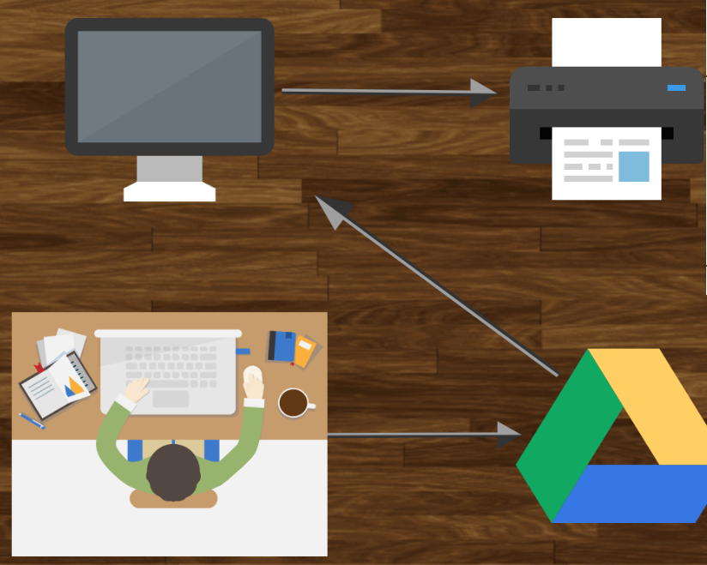

**1.3. ISHIKAWA DIAGRAM OF THE PROBLEM FORMULATED**

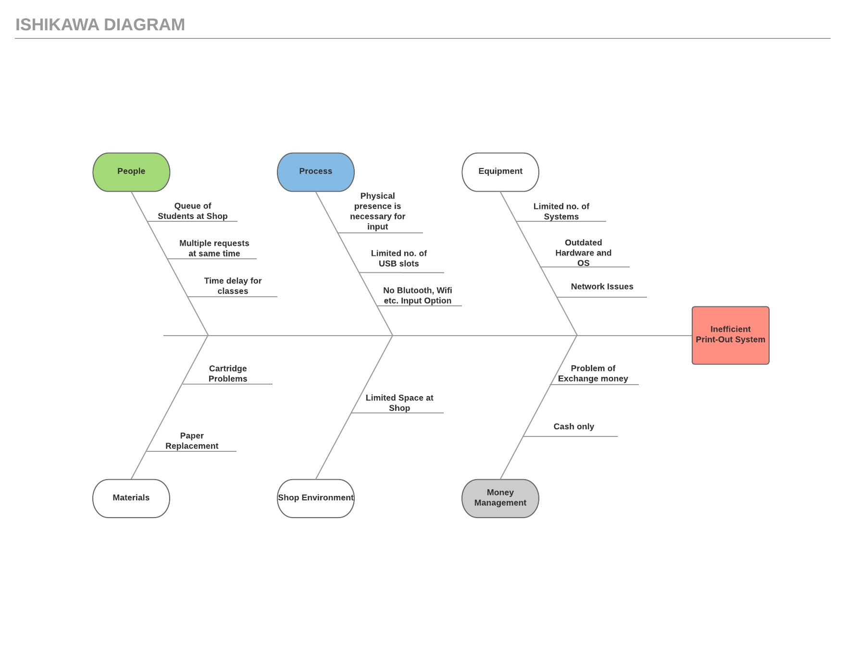

**2. ANALYSIS PHASE**

**2.1 USE CASE DIAGRAM**

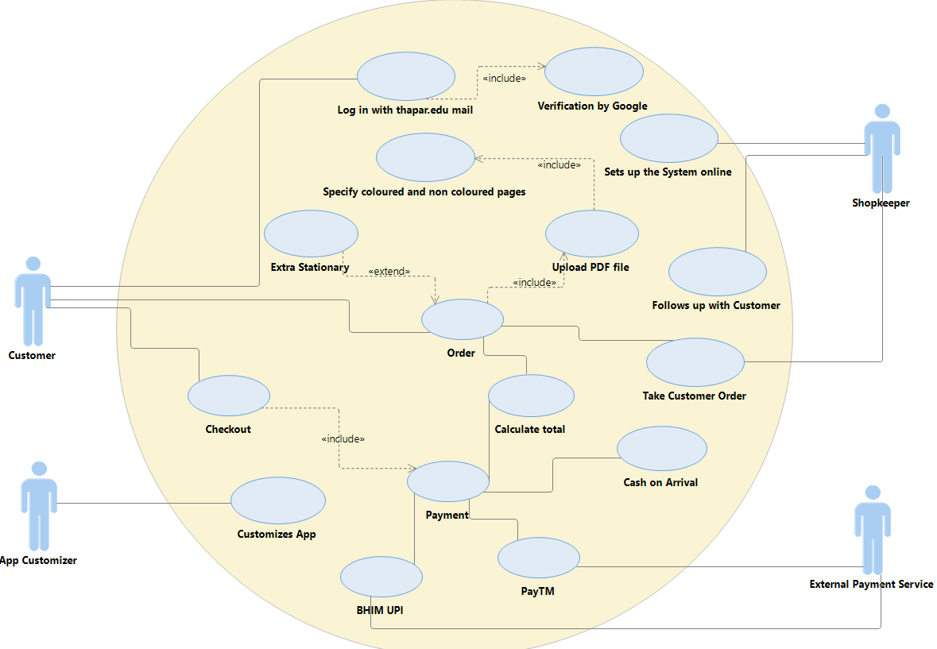

**2.2. ACTIVITY DIAGRAM**

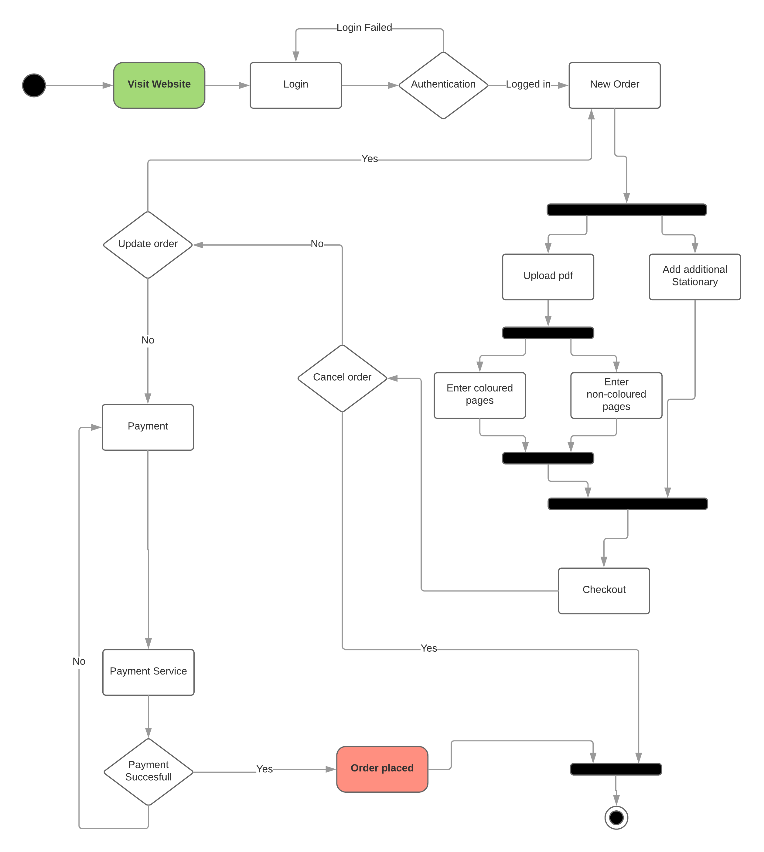

**2.3. DATA FLOW DIAGRAMS**

**DFD-0**

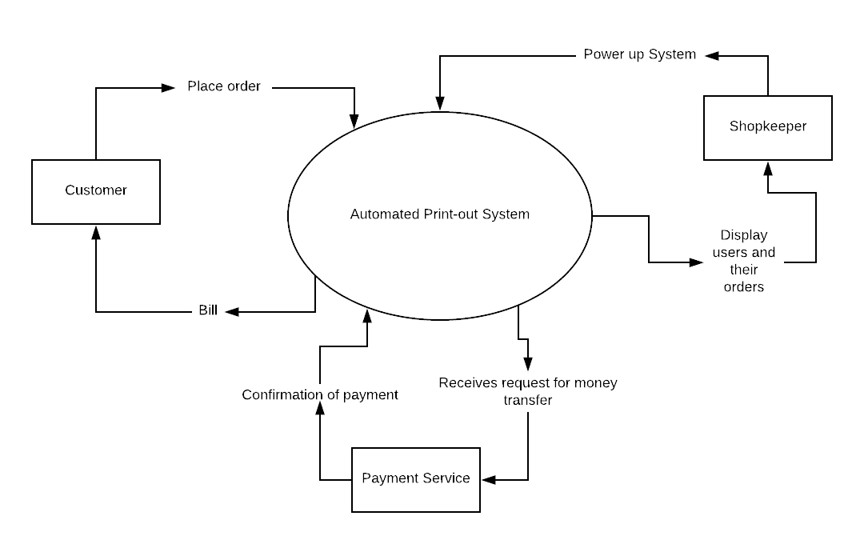

**DFD-1**

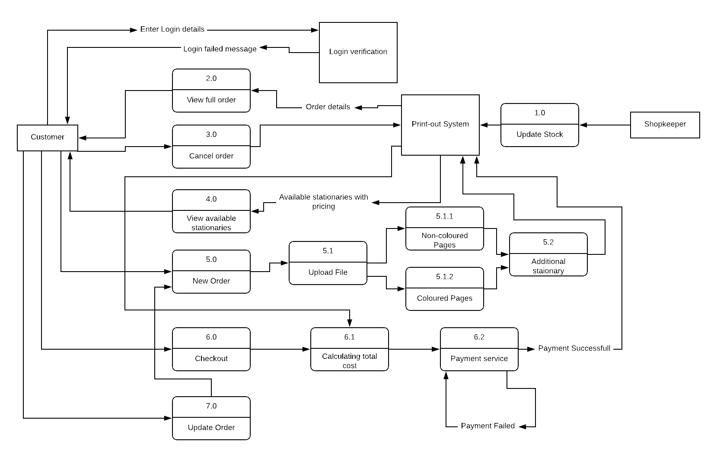

**DFD-2**

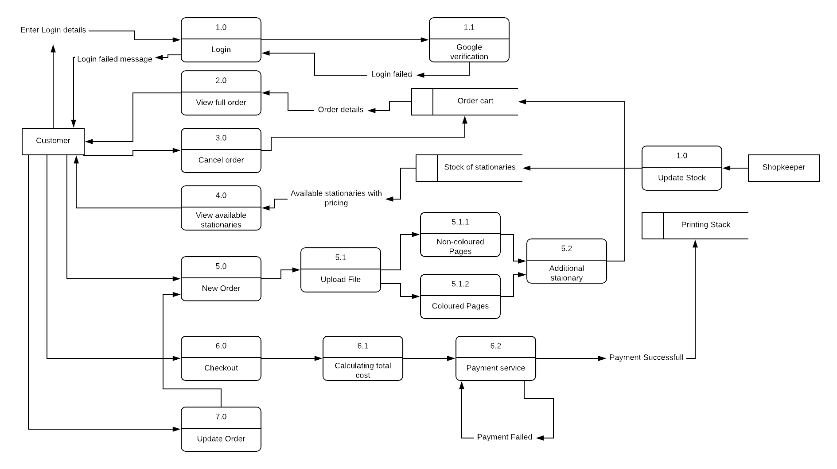

**2.4 SOFTWARE REQUIREMENTS SPECIFICATION**

# **2.4.1 Introduction**

* 1. **Document Purpose**

The purpose of the document is to collect and analyse all assorted ideas that have come up to define the system, its requirements with respect to consumers. Also, we shall predict and sort out how we hope this product will be used in order to gain a better understanding of the project, outline concepts that may be developed later, and document ideas that are being considered, but may be discarded as the product develops.

In short, the purpose of this SRS document is to provide a detailed overview of our software product, its parameters and goals. This document describes the project's target audience and its user interface, hardware and software requirements. It defines how our client, team and audience see the product and its functionality. Nonetheless, it helps any designer and developer to assist in software delivery lifecycle (SDLC) processes.

* 1. **Product Scope**

Primarily, the scope pertains to the Print-out of pdf files and stationary items purchasing. It focuses on the Stationary & print-out shops and their applications, which allow for online sales.

This SRS is also aimed at specifying requirements of software to be developed but it can also be applied to assist in the selection of in-house and commercial software products. The standard can be used to create software requirements specifications directly or can be used as a model for defining an organization or project specific standard. It does not identify any specific method, nomenclature or tool for preparing an SRS.

* 1. **Intended Audience and Document Overview**

The sequence in which who should read is

1. Introduction
2. Overall Description
3. Specific Requirements
   1. **Definitions, Acronyms and Abbreviations**

This document contains the following acronyms and abbreviations:

IEEE – Institute of Electrical and Electronics Engineers

RSA – Rational Software Architect

UML – Unified Modelling Language

* 1. **Document Conventions**

This document follows the IEEE formatting requirements. Arial font size 11, or 12 are used throughout the document for text. Italics are used for comments. Document text is single spaced and 1” margins are maintained in this template.

* 1. **References and Acknowledgments**

We would like to acknowledge our lab instructor Dr. Vinay Arora for teaching us about software engineering and how it is done on a professional level. We would also like to thank our lecturer Dr. Sanmeet Bhatia mam for providing essential knowledge and information needed to accomplish this task.

IEEE SRS Format Std830-1998

Software Engineering by Ian Sommerville.

**2.4.2 Overall Description**

* 1. **Product Overview**

This product is a self-contained product. This product significantly eradicates manual management method. Thereby reducing the possibilities of manual error, increasing the efficiency, reducing the work time to much extent. Still a little bit of manual interference is needed to operate this.

Basic working is done by using system, printers and internet.

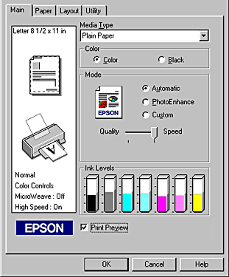

This Product when implemented will replace the conventional way of printing, i.e. people have to go to the shop with pen drives, email attachments and have to be physically there to give print command and they have to wait for it to be printed. This wastes a lot of time. In our solution to this people can upload their files online and can get their product just as they arrive at shop this saves a lot of time. This will also save the inconvenience of exchange money as payment is made online digitally.

Our product will be installed on shopkeeper’s pc which he will start every working day and shutdowns on evening in the time at which it is on customers can take their print-outs and stationaries. Even if someone orders at night it will be processed next morning as soon as shopkeeper powers on the system. Customers will have to pay online and in advance to protect from spamming.

**Product Functionality**

1. It contains prices of all the Stationary items.
2. It helps Shopkeeper to add or update items in stationary stock.
3. Bill generation is done by outside service like paytm.
4. Reports are sent to shopkeeper after order is placed.
5. Shopkeeper can easily add or update Stock.
   1. **Design and Implementation Constraints**

There are no such constraints over the system. Still:

System should be fast enough to keep the process flawless even on busy days.

Internet connection should be in working condition all the time to receive orders.

Payment services should be in working conditions all the time so we don’t miss an order.

Printer should be capable enough of printing good quality coloured and black & white print-outs.

System is fully automated but still have to be managed by manpower to a small extent.

Customer must be provided the basic information to use the system.

Project should be designed in a way that it can deal with piracy that is there should be no loop holes by which someone is able to take services without paying for it.

* 1. **Assumptions and Dependencies**

Client: We have assumed that all of the computer systems in the Shop are in proper working condition and that the user is capable of operating these system's basic functions including but not limited to being able to power on the system and login into it.

Provider: We have assumed that the shop’s software will be running on a properly database system.

Assumptions:

• There is no need to check the quantity of products.

• It is assumed that shopkeeper will maintain the sock of blank papers and see that cartridge is replaced after being used out.

• It is assumed that customer will correctly input the page numbers of coloured and black & white print-outs.

**2.4.3 Specific Requirements**

* 1. **External Interface Requirements**
     1. User Interfaces

Users basically faculty interact with software by visiting the website hosted by the system and they enter order details with the help of mouse and keyboard or with touch input if device is touch enabled. Shopkeeper interact by directly using software features like viewing current printing stock and updating the available stationary items.

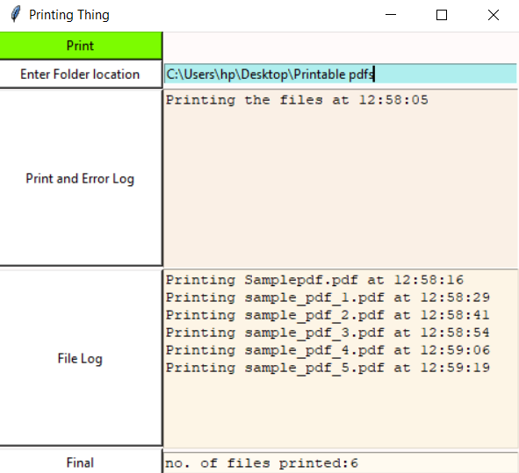

* + 1. Hardware Interfaces

Only hardware interface that we will be using in our software are two printers, one black & white and one coloured and one pc also on which software is installed. It will be used for viewing the current printing stock, the requested stationaries for each order, it will also show the mail ids of users with their respective orders. The printers should have high quality cartridges.

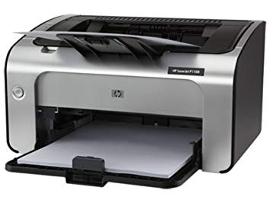

* + 1. Software Interfaces

The only software interface we will be using is Paytm or BHIM UPI. This will be used during payment of bill by the customers. Software will send the calculated cost of the order and customer will have to pay it in the account of shopkeeper at one of the Payment portal. Upon receiving the confirmation of payment the order will be processed at shop.

* 1. **Functional Requirements**

1. **Functional requirements for customer welcome screen**

|  |  |
| --- | --- |
| **Purpose** | This screen provides information regarding the different prints and prices per page of the prints. It provides the information regarding extra stationary material if required. |
| **Inputs** | A customer has to login using his thapar.edu mail upload a PDF file and choose from different print options. Different option to buy extra stationary items. Selection is performed with a mouse. |
| **Processing** | Calculation of price based on the selections of the customer. |
| **Outputs** | Output consists of a screen where the sub-total is displayed and items the customer has purchased. |

1. **Functional requirements for customer payment screen**

|  |  |
| --- | --- |
| **Purpose** | This screen provides information regarding the sub-total of the customer and different modes of payment. |
| **Inputs** | A customer has to select from the different payment options and proceed for payment. Selection is performed with a mouse. |
| **Processing** | Paytm/BHIM UPI Gateway. |
| **Outputs** | QR code for the respective payment method is displayed. And also bill can be generated. |

1. **Functional requirements for shopkeeper welcome screen**

|  |  |
| --- | --- |
| **Purpose** | This screen provides information regarding the number of requests for the printouts and other stationeries. |
| **Inputs** | The shopkeeper have to power up the system and check for the stock of blank papers and cartridge. |
| **Processing** | The PDF is loaded up in a different tab. Which file is being printed is shown. |
| **Outputs** | A list of today’s orders can be seen along with the email id(s) of customers. |

* 1. **Use Case Model**
     1. Use Case Story

There is a photocopy shop in Thapar Institute of Engineering and Technology. It is the only shop present in the campus for printing and photocopy. All the students visit the shop which creates a chaos at the shop. People many times get late for their prints and photocopy. Many times the pc’s of the shop aren’t working, the internet connectivity is poor, or the usb slot is damaged. This also causes a lot of problem to students. Sometimes, there is no electricity at shop and that too for a long period of time which causes a lots of problems in the class. The printer stops working or the ink is finished. These are some of the problems faced by the students at the printing shop.

**Author –** Taranjeet Singh

**Purpose** - To specific business objective that the system needs to accomplish which in this case is automation of the print-out system and also include ordering stationaries.

**Requirements Traceability –** Pc, Printers (coloured and non-coloured).

**Priority** - This use case has a medium priority which helps in understanding the product and making it fully functional

**Preconditions** – The server should be always online to take order.

**Post conditions** – after taking the order shopkeeper should add the requested stationary along with collecting the specific pages for the respective order.

**Actors** – Customer, Shopkeeper, External payment service

**Extends –** If this is an extension use case, identify which use case(s) it extends

**Flow of Events**

* 1. Basic Flow - flow of events normally executed in the use-case
  2. Alternative Flow - a secondary flow of events due to infrequent conditions
  3. Exceptions - Exceptions that may happen during the execution of the use case

**Notes/Issues** – No relevant notes are required.

* + 1. Use Case Scenario

Customer is required to login into with thapar.edu mail for prints and to buy something. After that the customer has to upload his file for print and specify what kind of prints are required and can also specify if the file is required. Customer can also select other stationary items which he/she wants to buy from the stationary shop. Then it will move towards the finalized order where the total bill would be calculated and displayed. Then it will move forward to the payment panel where the customer has choice to select between COD, Paytm and UPI. After the payment is the done and the order is finalized shopkeeper will get a confirmation on his desktop. The shopkeeper will then print the desired file and ready other stationary materials if any.

**2.4.4 Other Non-functional Requirements**

* 1. **Performance Requirements**

The Printers and server we are using should be of high quality and should be able to work after a power cut. Also the speed of system that will be using our software should be high. The payment processing, cost calculation and bill generation should be fast enough. Also uploading speed at server should be high enough to upload file in size of Megabytes. If a power cut happens the hardware should work correctly afterwards.

* 1. **Safety and Security Requirements**

Payment is required to be done in advance by the customer to avoid any spamming of not needed. This is the security measure taken to safeguard any misuse of resources of the shopkeeper.

A refund can be taken by customer if the order is not done in time which is unlikely as the whole process when implemented will be a smooth process until a unfortunate event occurs like power cut, cartridge problems, blank paper shortage, etc.

* 1. **Software Quality Attributes**

This software is very easy to use as it reduces a lot of work of the faculty who will be dealing with the customer. This system is also easily adaptable as shopkeeper does not have to deal with many things. There are just 2 or 3 things that he should know. It is more reliable and efficient than humans.

Software is capable of continuing itself after a long shutdown when it was offline, as the server takes orders and store them in database, the only time system would be offline will be during off time of the shop and only time system would not take requests will be when server is down which is a hardware issue.

**3. DESIGN PHASE**

**3.1 CLASS DIAGRAM**

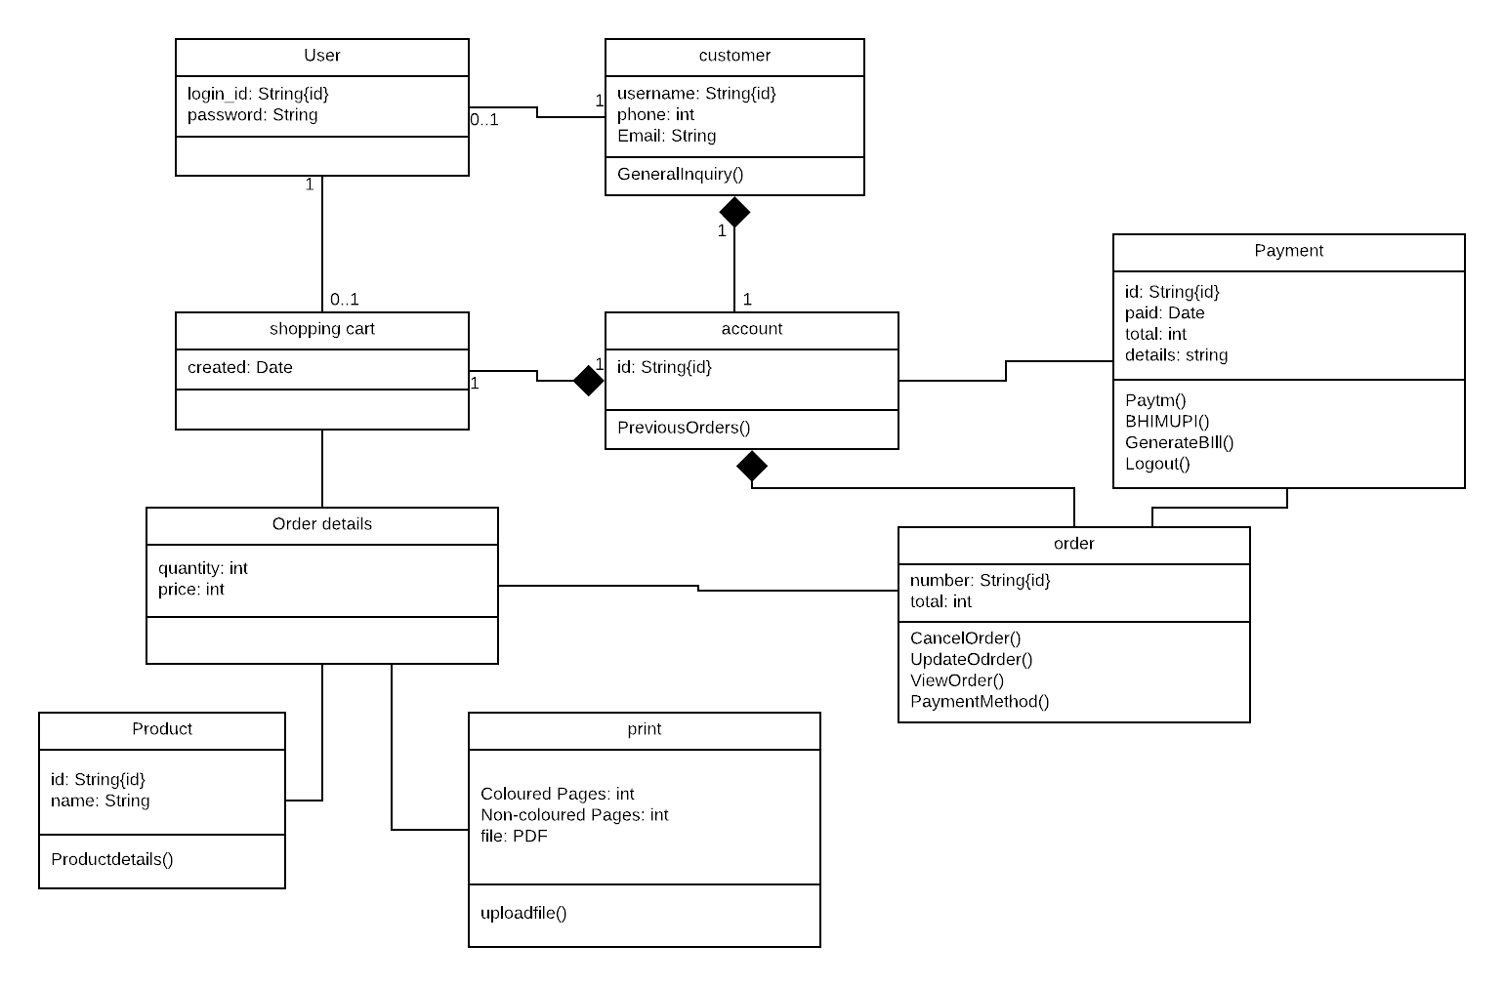

**3.2. SEQUENCE DIAGRAM**

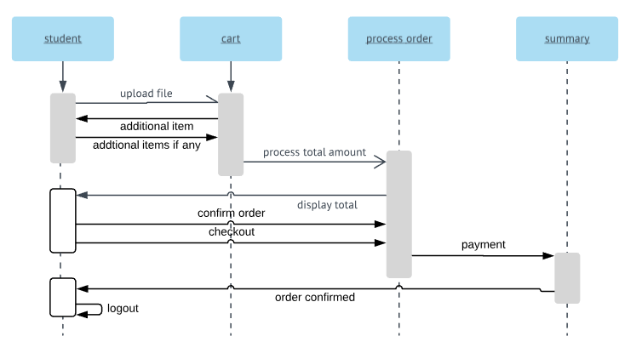

**3.3. STATE CHART DIAGRAM**

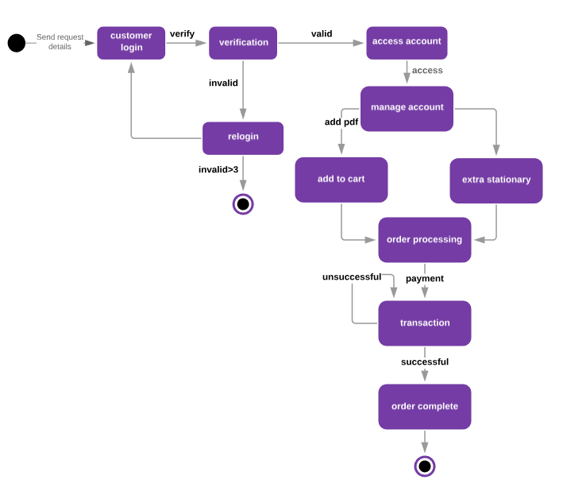

**4. TESTING PHASE**

**4.1 TEST PLAN**

**Test**: We check for by taking the worst case scenario. For every interface, that is for admin, for user, for scoring and for correct word we take inputs and check our result.

**Scenarios**:

For shopkeeper side use we take scenarios in which he inputs wrong folder location.

For student side use we check that student should not be able to upload files without login.

**4.2 TEST CASES**

|  |  |  |  |
| --- | --- | --- | --- |
| **Test Case id** | **User** | **Steps** | **Expectation** |
| Tc-01 | Shopkeeper | 1. He enters right folder location. | Program is fine it would go on. |
|  |  | 2. He enters wrong folder location. | Error should pop up  In the window |
|  |  | 3. He presses print button. | All pending files will be printed |
|  |  | 4. He presses clear button. | All printed files will be deleted from folder as well as from drive |
| Tc-02 | Student | 1. Tries to upload without login. | Should not be able to upload |
|  |  | 2. Uploads while logged in. | Upload will work fine |

**4.3 TEST REPORT**

1. It pops up when the Shopkeeper double click the exe file.

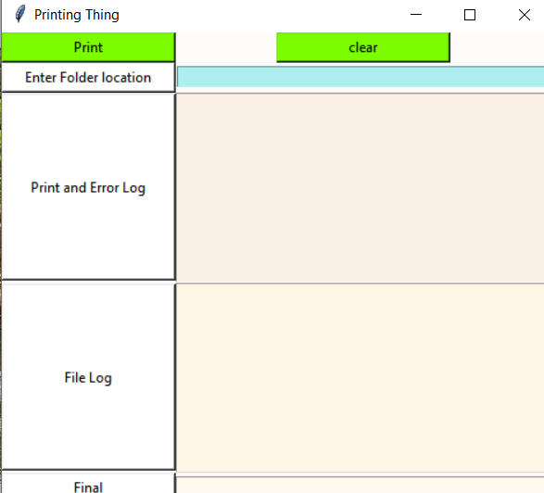

2. When entered a wrong folder it shows Error.

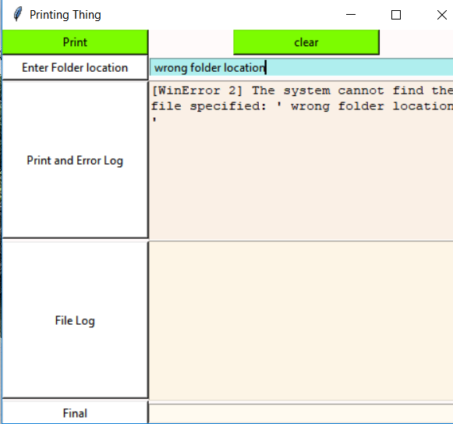

3. It does not show any error when entered a right location.

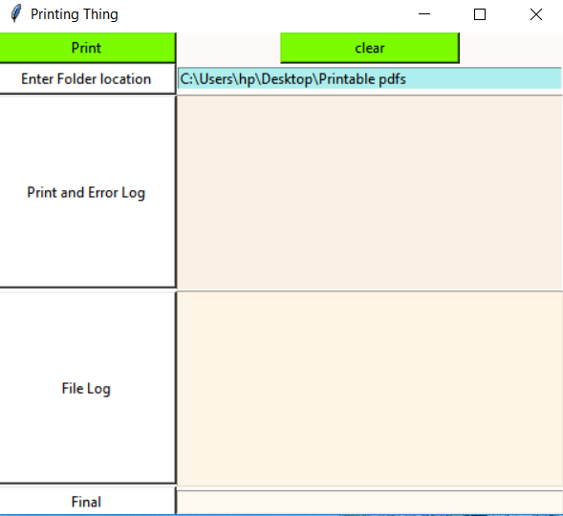

4. As we can see below students have to sign in with their gmail ids to upload PDFs.

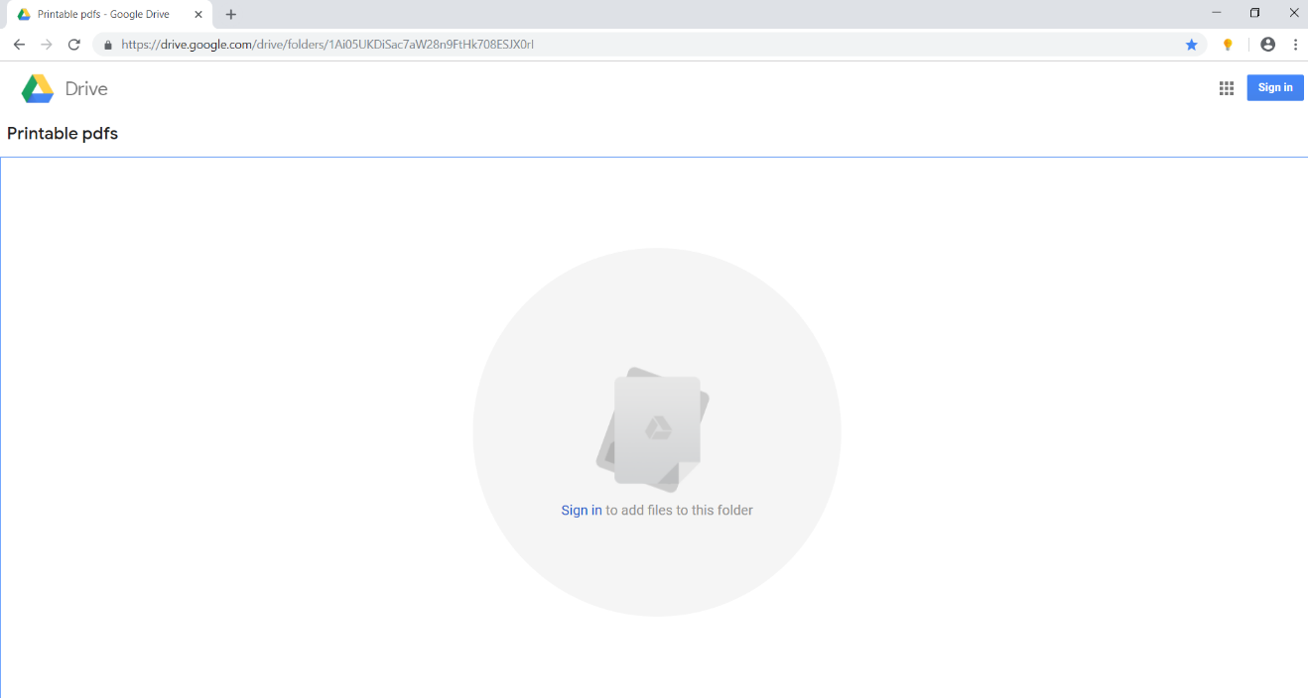

5. When logged in people can upload files.

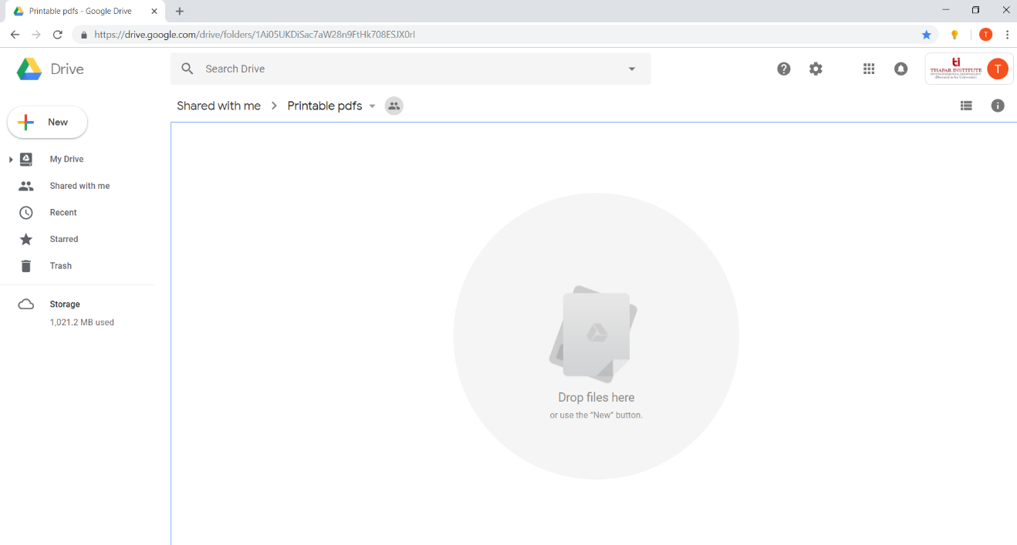

6. A user has just requested to print 6 files and this request will be processed in below steps.

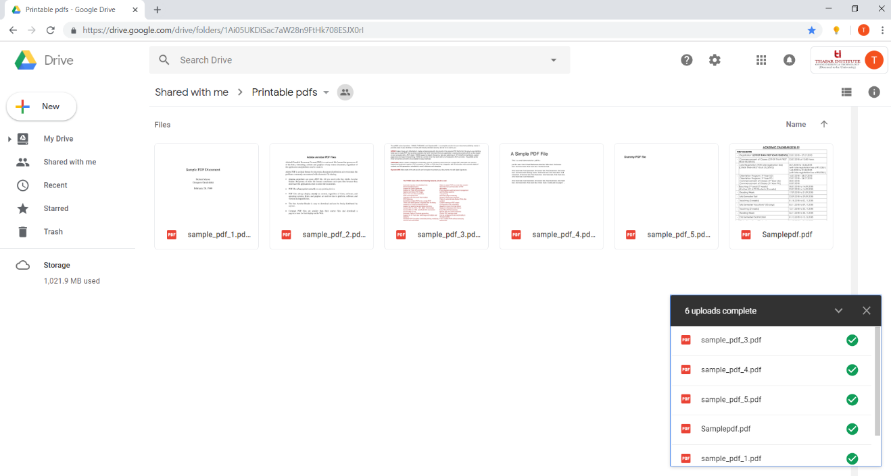

7. As we can see below the files requested have arrived in the local folder of shopkeeper’s pc.

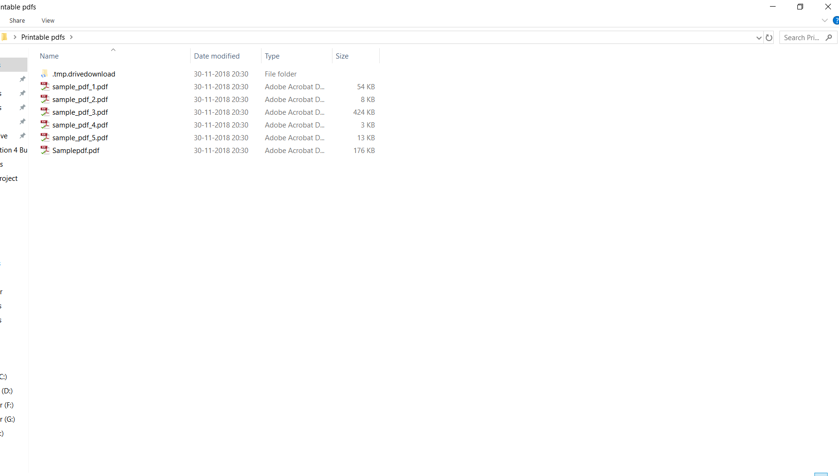

8. After pressing the print button the files are printed as we can see below.

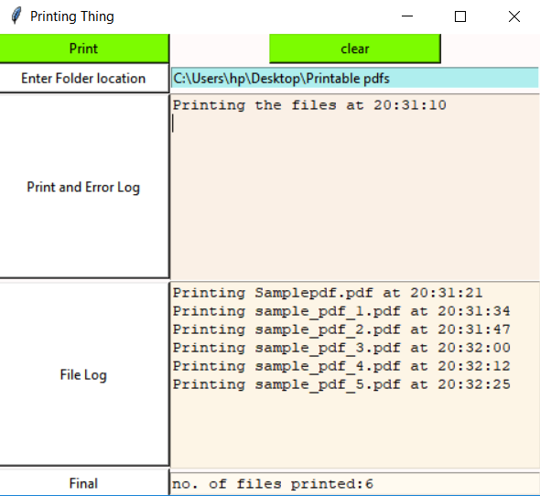

9. After pressing the clear button the files are being deleted from the local folder and the google drive folder will follow.

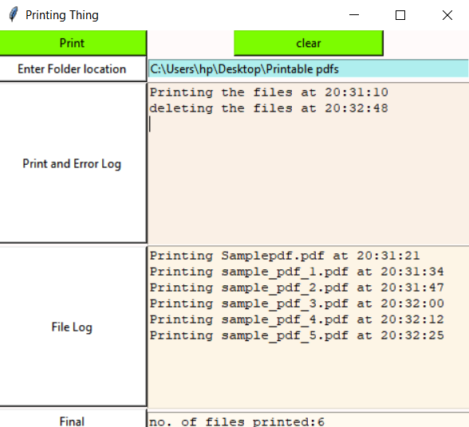

10. As we can see below the files have been deleted from local machine of shopkeeper after being printed.

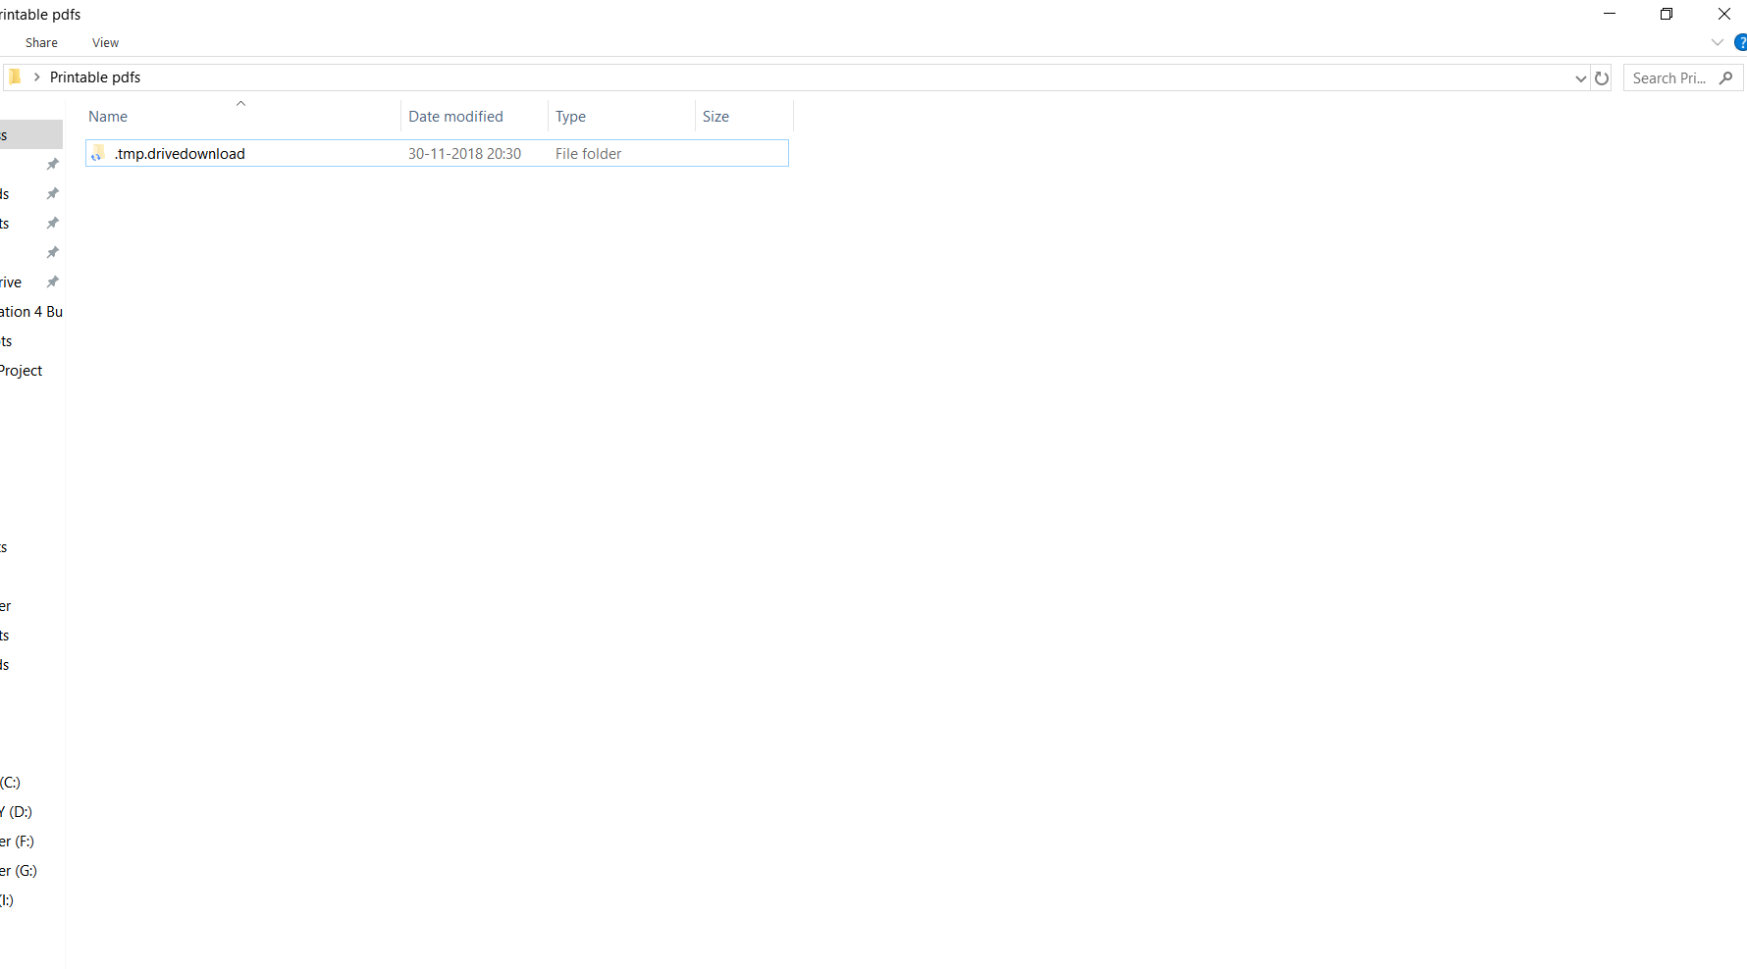

11. As we can see below the files have been deleted from server side google drive folder after being printed.

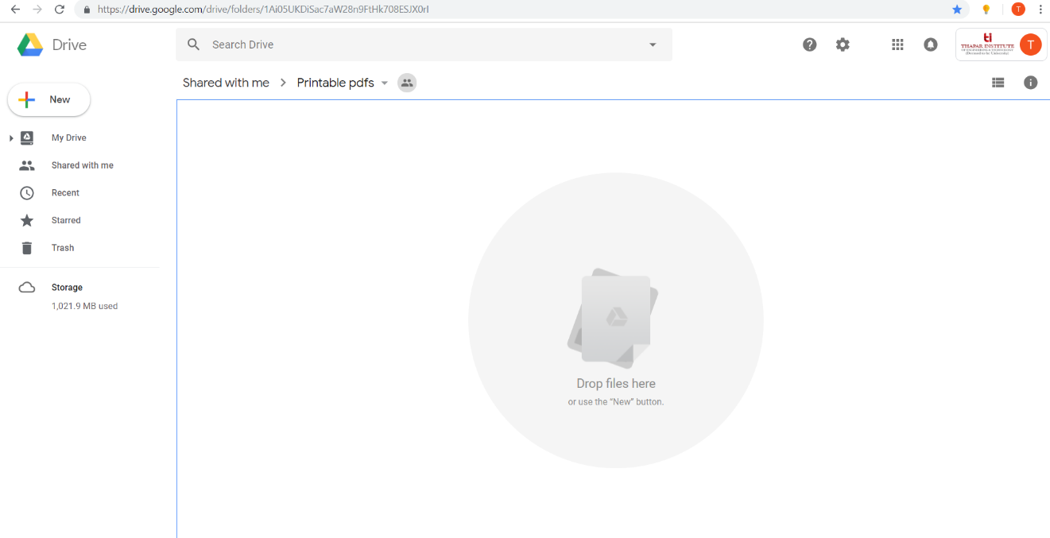

**5. DEPLOYMENT PHASE**

**5.1 COMPONENT DIAGRAM**

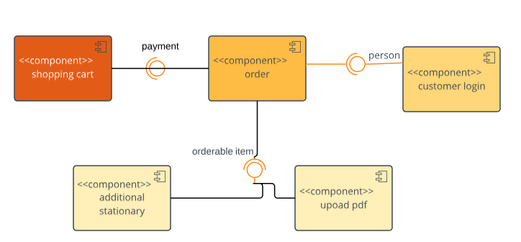

**5.2 DEPLOYMENT DIAGRAM**

