## Mini Project Report On

**ONLINE QUIZ MANAGEMENT SYSTEM**

## *Submitted By:*

***NAME: Taranjit Singh***

***ROLL NUMBER: 1911985032***

***YEAR:2022***

***SEM: 6***

***BATCH: 6***

**CERTIFICATE**

*Certified that this is a bonafide record of the project work titled “****ONLINE QUIZ* MANAGEMENT SYSTEM”**

*Done by*

# ACKNOWLEDGEMENT

We take this occasion to thank God, almighty for blessing us with his grace and taking our endeavor to a successful culmination. We extend our sincere and heartfelt thanks to our esteemed guide, , for providing us with the right guidance and advice at the crucial junctures and for showing me the right way. We also take this opportunity to express a deep sense of gratitude to our class coordinators, and for their cordial support, valuable suggestions and guidance. We extend our sincere thanks to our respected **Head of the division** , for allowing us to use the facilities available. We would like to thank the other faculty members also, at this occasion. Last but not the least, we would like to thank our friends and family for the support and encouragement they have given us during the course of our work.

## TABLE OF CONTENTS

ABSTRACT 5

1. INTRODUCTION 6
   1. PROJECT AIMS AND OBJECTIVES 6
   2. BACKGROUND OF PROJECT 7
   3. OPERATION ENVIRONMENT 8
2. SYSTEM ANALYSIS 9
   1. SOFTWARE REQUIREMENT SPECIFICATION 9
   2. EXISTING VS PROPOSED 15
   3. SOFTWARE TOOL USED 16
3. SYSTEM DESIGN 20
   1. TABLE DESIGN 20
   2. DATA FLOW DIAGRAM’S 24
4. SYSTEM IMPLEMENTATION 30
   1. MODULE DESCRIPTION 30
   2. SCREEN SHOTS 80
5. SYSTEM TESTING 85
   1. UNIT TESTING 85
   2. INTEGRATION TESTING 87
6. CONCLUSION & FUTURE SCOPE 88
7. REFERENCES 89

#### ABSTRACT

##### Online quiz management system is a project which aims in developing a computerized system to host quiz competitions. This project has many features which are generally not available in normal quiz hosting platforms like facility of user login and a facility of teacher’s login .It also has a facility of admin login through which the admin can monitor the whole system. It has also a facility where participant after logging in their accounts can see list of quizzes issued by the admin. The Admin after logging into his account i.e admin account can generate various categories and add quizzes accordingly.

Overall this project of ours is being developed to help the participants to attain knowledge in the best way possible and also reduce the human efforts.

**CHAPTER 1 INTRODUCTION**

This chapter gives an overview about the aim, objectives, background and operation environment of the system.

#### PROJECT AIMS AND OBJECTIVES

The project aims and objectives that will be achieved after completion of this project are discussed in this subchapter. The aims and objectives are as follows:

* + - Online quiz attempts
    - Participant login page where participant can find topics issued by admin and give them a try.
    - An admin login page where admin can organize the online quiz attempts and add topics.

#### BACKGROUND OF PROJECT

Online Quiz Management System is an application which refers to quiz competition hosting platform which or medium in size. are generally small It is used by host to manage the quiz using a computerized system where he/she can record various transactions like issue of topics, return of topics, addition of new topics, addition of new participants etc.

Questions and participant maintenance modules are also included in this system which would keep track of the participants using the Quiz and also a detailed description about the topics a Quiz contains. With this computerized system there will be no loss of questions record or member record which generally happens when a non-computerized system is used.

In addition, report module is also included in Quiz Management System. If user’s position is admin, the user is able to generate different kinds of reports like lists of participants registered, list of topics, issue and return reports.

All these modules are able to help Admin to manage the Quiz with more convenience and in a more efficient way as compared to Quiz systems which are not computerized.

#### OPERATION ENVIRONMENT

|  |  |
| --- | --- |
| PROCESSOR | INTEL CORE PROCESSOR OR BETTER PERFORMANCE |
| OPERATING SYSTEM | WINDOWS VISTA ,WINDOWS7, UBUNTU |
| MEMORY | 1GB RAM OR MORE |
| HARD DISK SPACE | MINIMUM 3 GB FOR DATABASE USAGE FOR FUTURE |
| DATABASE | MY SQL |

**CHAPTER 2**

**SYSTEM ANALYSIS**

In this chapter, we will discuss and analyze about the developing process of Quiz Management System including software requirement specification (SRS) and comparison between existing and proposed system . The functional and non functional requirements are included in SRS part to provide complete description and overview of system requirement before the developing process is carried out. Besides that, existing vs proposed provides a view of how the proposed system will be more efficient than the existing one.

#### SOFTWARE REQUIREMENT SPECIFICATION

* + 1. **GENERAL DESCRIPTION**

PRODUCT DESCRIPTION:

Quiz Management System is a computerized system which helps user (Admin) to manage the Quiz daily activity in electronic format. It reduces the risk of paper work such as file lost, file damaged and time consuming.

It can help user to manage the transaction or record more effectively and time- saving.

PROBLEM STATEMENT:

The problem occurred before having computerized system includes:

* + - File lost

When computerized system is not implemented file is always lost because of human environment. Sometimes due to some human error there may be a loss of records.

* + - File damaged

When a computerized system is not there file is always lost due to some accident like spilling of water by some member on file accidentally. Besides some natural disaster like floods or fires may also damage the files.

* + - Difficult to search record

When there is no computerized system there is always a difficulty in searching of records if the records are large in number.

* + - Space consuming

After the number of records become large the space for physical storage of file and records also increases if no computerized system is implemented.

* + - Cost consuming

As there is no computerized system to add each record paper will be needed which will increase the cost for the management of Quiz.

#### SYSTEM OBJECTIVES

* + - Improvement in control and performance

The system is developed to cope up with the current issues and problems of Quiz

.The system can add user, validate user and is also bug free.

* + - Save cost

After computerized system is implemented less human force will be required to maintain the Quiz thus reducing the overall cost.

* + - Save time

Admin is able to search record by using few clicks of mouse and few search keywords thus saving his valuable time.

#### SYSTEM REQUIREMENTS

* + - 1. NON FUNCTIONAL REQUIREMENTS
         * Product Requirements EFFICIENCY REQUIREMENT

When a Quiz management system will be implemented Admin and user will easily access Quiz as searching will be very faster.

RELIABILITY REQUIREMENT

The system should accurately performs member registration, member validation, report generation, topic transaction and search.

USABILITY REQUIREMENT

The system is designed for a user friendly environment so that participant and staff of Quiz can perform the task easily and in an effective way.

ORGANIZATIONAL REQUIREMENT IMPLEMENTATION REQUIREMNTS

In implementing whole system it uses html in front end as server side scripting language which will be used for database connectivity and the backend i.e. the database part is developed using MySQL.

DELIVERY REQUIREMENTS

The whole system is expected to be delivered in six months of time with a weekly evaluation by the project guide.

* + - 1. FUNCTIONAL REQUIREMENTS

1. NORMAL USER
   1. USER LOGIN Description of feature

This feature used by the user to login into system. They are require to enter user id and password before they are allowed to enter the system .The user id and password will be verified and if invalid id is there user is allowed to not enter the system.

Functional requirements

-user id is provided when they register.

-The system must only allow user with valid id and password to enter the system.

-The system performs authorization process which decides what user level can access to.

-The user must be able to logout after they finished using system.

* 1. REGISTER NEW USER

Description of feature

This feature can be performed by all users to register new user to create account.

Functional requirements

-System must be able to verify information

-System must be able to delete information if information is wrong

* 1. REGISTER NEW TOPIC Description of feature

This feature allows to add new topics to the Quiz. Functional requirements

-System must be able to verify information

-System must be able to enter number of questions into table.

#### SOFTWARE AND HARDWARE REQUIREMENTS

This section describes the software and hardware requirements of the system

* + - 1. SOFTWARE REQUIREMENTS
         * Operating system- Windows 11 is used as the operating system as it is stable and supports more features and is more user friendly
         * Database MYSQL-MYSQL is used as database as it easy to maintain and retrieve records by simple queries which are in English language which are easy to understand and easy to write.
         * Development tools and Programming language- HTML is used to write the whole code and develop webpages with css, java script for styling.
      2. HARDWARE REQUIREMENTS
* Intel core i5 2nd generation is used as a processor because it is fast than other processors and provide reliable and stable and we can run our pc for longtime. By using this processor we can keep on developing our project without any worries.
* Ram 1 GB is used as it will provide fast reading and writing capabilities and will in turn support in processing

#### EXISTING VS PROPOSED SYSTEM

* + 1. Existing system does not have any facility of teachers login or participant login where as proposed system will have a facility of participant login as well as teacher’s login
    2. Existing system does not have a facility of online reservation of topics whereas proposed system has a facility of online reservation of topics
    3. Existing system does not have any facility of online notice board where description of workshops happening in our college as well as nearby colleges is being provided.
    4. Existing system does not has any option of lectures notes uploaded by teachers whereas proposed system will have this facility
    5. Existing system does not have any facility to generate participant reports as well topic issue reports whereas proposed system provides Admin with a tool to generate reports
    6. Existing system does not has any facility for topic request and sugeestions where as in proposed system after logging in to their accounts participant can request topics as well as provide suggestions to improve Quiz

#### SOFTWARE TOOLS USED

The whole Project is divided in two parts the front end and the back end.

* + 1. Front end

The front end is designed using of html, css, and Javascript

* + 1. BACK END- The back end is designed using MySQL which is used to design the databases

## CHAPTER 3 SYSTEM DESIGN

#### TABLE DESIGN

VARIOUS TABELS TO MAINTAIN INFORMATION

 TOPIC TABLE FOR KEEPING TRACK OF TOPICS

|  |  |  |  |  |
| --- | --- | --- | --- | --- |
| **Field** | **Data type** | **Default** | **Key** | **Extra** |
| Code | INT(11) | Not Null | Primary | Auto increment |
| Topicname | VARCHAR(255) | Null |  |  |
| Author | VARCHAR(255) | Null |  |  |
| Publication | VARCHAR(255) | Null |  |  |
| Subject | VARCHAR(255) | Null |  |  |
| No of copies | INT(10) | Null |  |  |

* PARTICIPANT TABLE FOR PARTICIPANT INFORMATION

|  |  |  |  |  |
| --- | --- | --- | --- | --- |
| **Field** | **Data type** | **Default** | **Key** | **Extra** |
| libid | INT(11) | NOT NULL | Primary key | Autoincrement |
| regno | INT(10) | NULL |  |  |
| branch | VARCHAR(255) | NULL |  |  |
| section | VARCHAR(255) | NULL |  |  |
| semester | VARCHAR(255) | NULL |  |  |
| section | VARCHAR(2) | NULL |  |  |
| yearofadm | INT(5) | NULL |  |  |

### TEACHER TABLE TO KEEP TEACHER INFORMATION

|  |  |  |  |  |
| --- | --- | --- | --- | --- |
| **Field** | **Data Type** | **Default** | **Key** | **Extra** |
| Tid | INT(11) | NOT NULL | Primary key | Auto increment |
| Name | VARCHAR(255) | NULL |  |  |
| Designation | VARCHAR(255) | NULL |  |  |
| Branch | VARCHAR(255) | NULL |  |  |
| Contactno | INT(13) | NULL |  |  |
| Lectures | LONG BLOB | NULL |  |  |

* Issue table to keep track of topics issued

|  |  |  |  |  |
| --- | --- | --- | --- | --- |
| **Field** | **Data Type** | **Default** | **Key** | **Extra** |
| topicid | INT(11) | NOT NULL | Foreign key | References topic |
| stuid | INT(11) | NOT NULL | Foreign key | References Participant |
| issuedate | DATE | NULL |  |  |
| returndate | DATE | NULL |  |  |

* PARTICIPANT LOGIN TABLE

|  |  |  |  |  |
| --- | --- | --- | --- | --- |
| **Field** | **Data type** | **Default** | **Key** | **Extra** |
| logid | INT(11) | NOT NULL | Foreign key | References Participant |
| Username | VARCHAR(255) | NULL |  |  |
| Password | VARCHAR(255) | NULL |  |  |
| numtopics | INT(1) | NULL |  |  |

* EVENT TABLE FOR EVENT INFORMATION

|  |  |  |  |  |
| --- | --- | --- | --- | --- |
| **Field** | **Data type** | **Default** | **Key** | **Extra** |
| Name | Varchar(255) | NULL |  |  |
| Date | Date(yyyy/mm/dd) | NULL |  |  |
| Time | VARCHAR(255) | NULL |  |  |
| Mname | VARCHAR(255) | NULL |  |  |
| Contactno. | Int(30) | NULL |  |  |
| Email | VARCHAR(255) | NULL |  |  |
| Venue | varchar(255) | NULL |  |  |

* TEACHER LOGIN TABLE

|  |  |  |  |  |
| --- | --- | --- | --- | --- |
| **Field** | **Data Type** | **Default** | **Key** | **Extra** |
| Loginid | INT(11) | NOT NULL | Foreign key | References teacher |
| Username | VARCHAR(255) | NULL |  |  |
| Password | VARCHAR(255) | NULL |  |  |

#### DATA FLOW DIAGRAMS

DATA FLOW DIAGRAM FOR PARTICIPANT LOGIN

PARTICIPANT

DATABASE

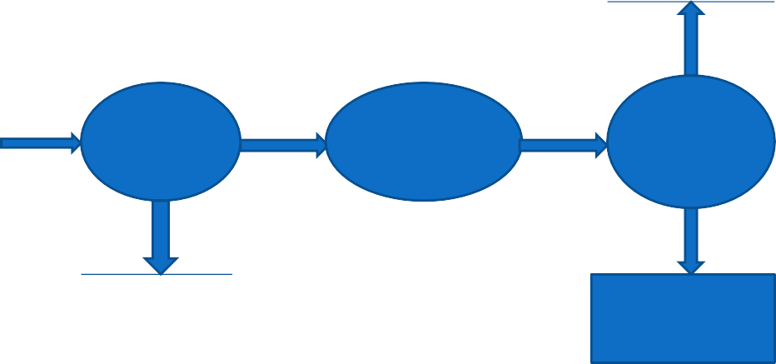

ENTER

URL

ENTER

USERNAME

&

PASSWORD

CHECK

VALIDITY

IF VALID

WEB SERVER

PARTICIPANT

LOGIN PAGE

PARTICIPANT

After entering to the home page of the website, participant can choose the PARTICIPANT LOGIN option where they are asked to enter username & password, and if he/she is a valid user then a participant login page will be displayed.

DATA FLOW DIAGRAM FOR TOPIC ISSUE

LOGIN

DATABASE

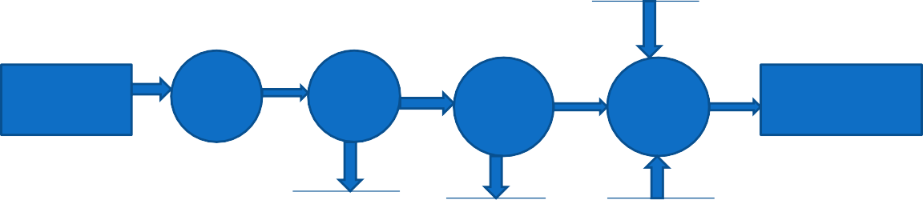

PARTICIPANT

LOGIN

PAGE

SELECT

TOPIC

ISSUE

ENTER

TOPIC

DETAIL

IF

AVBL

SELECT

TOPIC ISSUE

IF NO.

OF

TOPIC

ISSUED LESS THAN

3

UPDATE

NO. OF

COPIES

MESSAGE

“TOPIC

RESERVED”

TOPIC

DATABASE

LOGIN

TABLE

TOPIC

DATABASE

It is a 2nd level Data Flow Diagram where after entering PARTICIPANT LOGIN page he/she can select a topic issue option where after entering the topic detail, he/she can select the topic issue option and if the maximum no of topics issued limit is not crossed then a request will be sent to the Admin who will approve the topic issue.

DATA FLOW DIAGRAM FOR TOPIC SEARCH

SELECT

ADVANCE SEARCH

ENTER

TOPIC DETAIL

IF

FOUND

TOPIC

DETAILS

HOME

TOPIC DATABASE

After the home page login there will be an option of the topic search where after entering topic detail like author name, publication, topic name etc topic details will be displayed.

DATA FLOW DIAGRAM FOR ACCOUNT CREATION

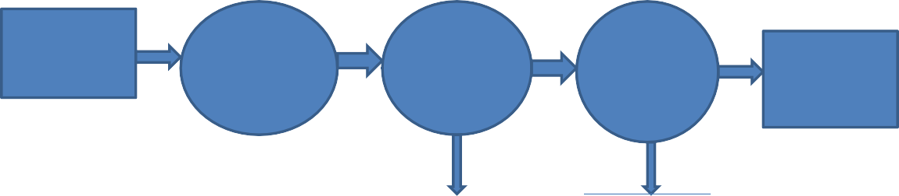

HOME

SELECT

ACCOUNT CREATION

ENTER

PARTICIPANT DETAIL

ADMIN

VERIFY STUDEN T

MESSAGE

SENT

TO PARTICIPANT

IF ALL REG.

PARTIALLY

IS

FILLED

IF VALID

ADMIN

DATABASE

PARTICIPANT

DATABASE

After the home page login there will be an option of CREATE AN ACCOUNT where after entering participant detail, if all the fields are filled then a request will be sent to the Admin who will approve him as a registered member of the Quiz.

## CHAPTER 4

**SYSTEM IMPLEMENTATION**

###### 4.1.1 Screenshot for homepage

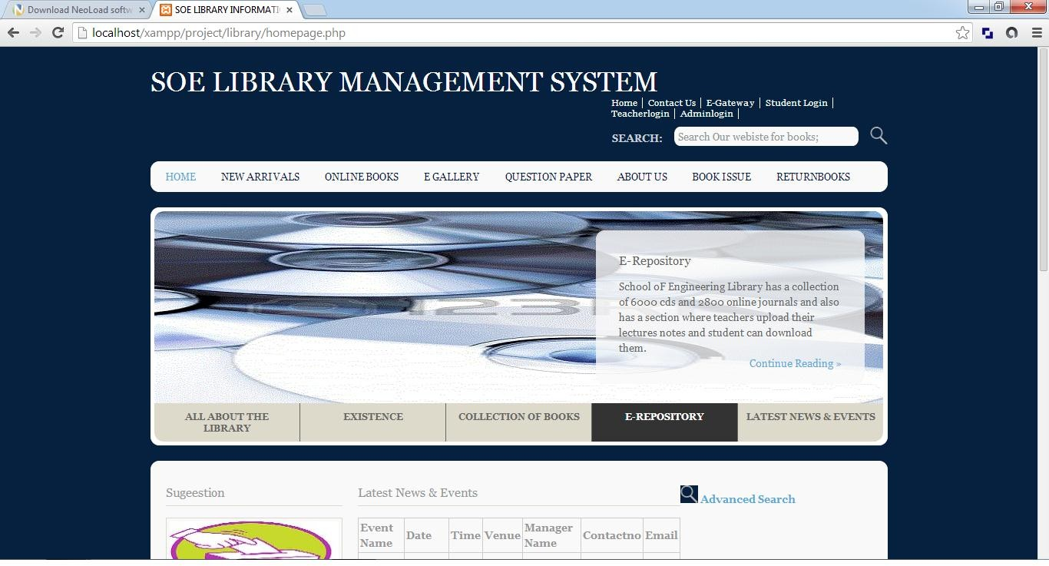

#### MODULE DESCRIPTION

For Quiz Management System it is divided into the following Modules:

* + 1. **Admin Module**

REPORT GENERATION

TEACHER REGISTRATION

ADMIN

TOPIC ADDITION

PARTICIPANT VALIDATION

The following module contains various facilities like participant validation, teacher registration, topic addition, and report generation.

###### Screenshot for Admin login

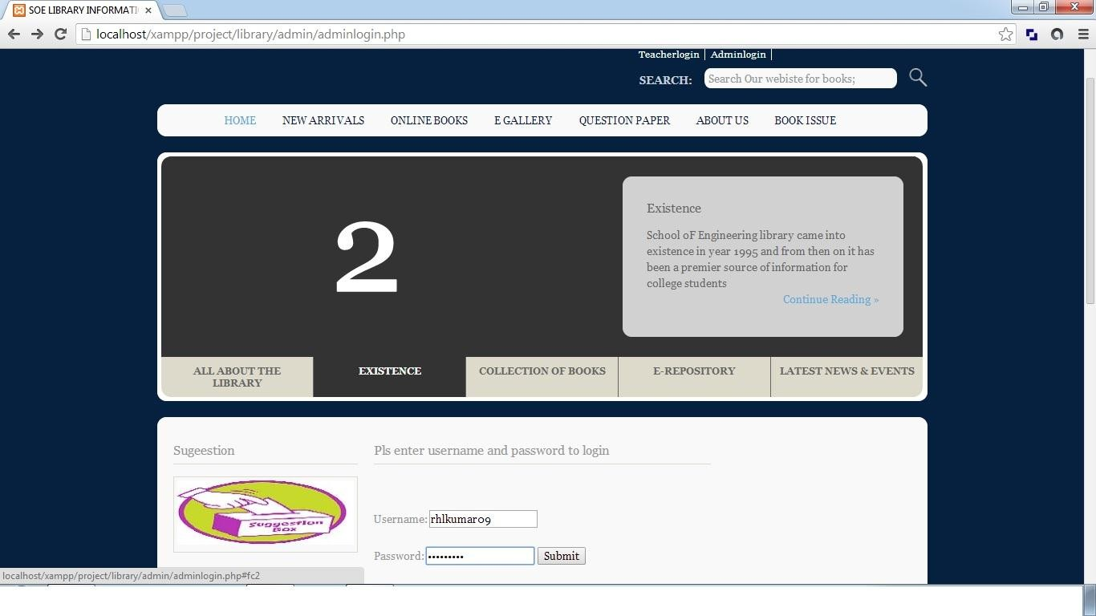

* + 1. **Participant Module**

PARTICIPANT

EVENT ADDITION

PARTICIPANT LOGIN

FORGOT PASSWORD

USERNAME AND PASSWORD

AUTHENTICATION

ONLINE TOPIC RESERVATTION

PARTICIPANT REGISTRATION

The following module contains various facilities like participant registration, participant login, online topic reservation, and event addition. Any participant if at any moment forgets his password he can retrieve it from forgot password option.

###### 4.1.2 Screenshot for Participant login

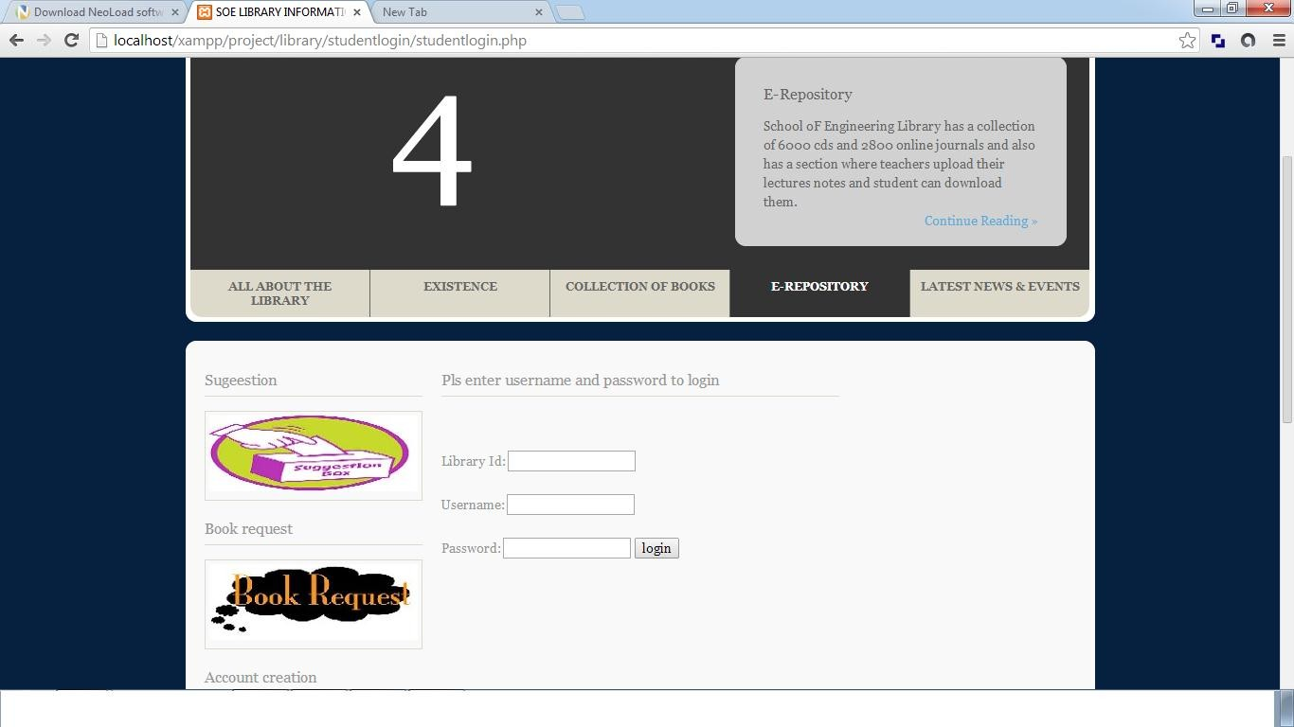

* **4.1.3 Teacher Module**

FORGOT PASSWORD

TEACHER LOGIN

TEACHER

SUGGESTIONS

USERNAME AND PASSWORD AUTHENTICATION

EVENT ADDITION

The following module contains various facilities like teacher login, suggestions, and event addition. Further any teacher if at any moment forgets his/her password he/she can retrieve it from ‘forgot password’ option.

###### 4.1.3 Screenshot for teacher’s login

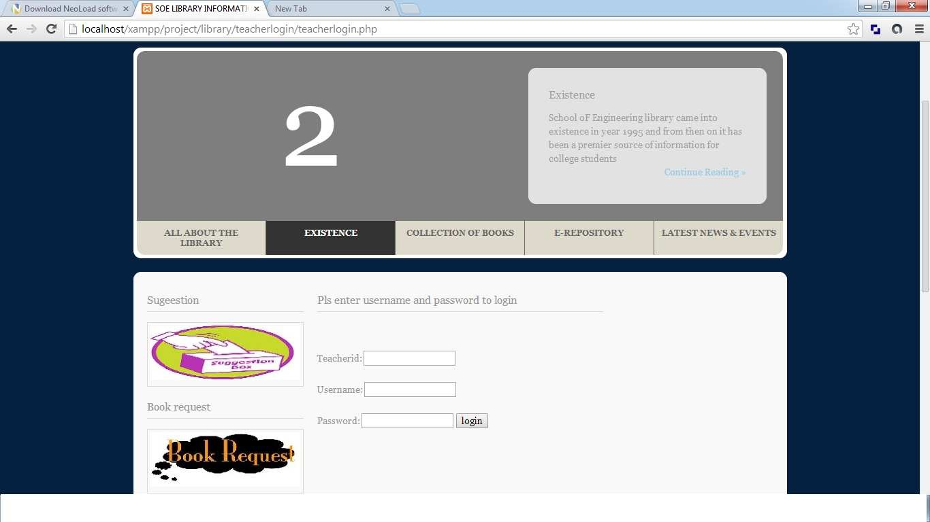

* + - * + **4.1.4 Topic Module**

SEARCH TOPIC

ADD NEW TOPIC

TOPIC MAINTENANCE

The following module contains various facilities like add new topic and search topic. In the ‘add new topic’ section if any new topic comes in the Quiz then the Admin can add its specifications. Similarly if the user wants to search for a specific topic then he/she can use search topic option to do it.

#### 4.1.5 Topic Transaction Module

ISSUE TOPIC

CHECK RESERVATION

RETURN TOPIC

TOPIC TRANSACTION

The following module contains various facilities like issue topic, return topic and check reservation.

?>

###### 4.1.2 Screenshot for Topic search

* + - * + **4.1.6 Report Module**

TRANSACTION REPORT

TEACHER REPORT

REPORT

TOPIC REPORT

PARTICIPANT REPORT

The following module contains various facilities like participant report, teacher report, topic report, and transaction report.

# CHAPTER 5 SYSTEM TESTING

The aim of the system testing process was to determine all defects in our project .The program was subjected to a set of test inputs and various observations were made and based on these observations it will be decided whether the program behaves as expected or not.

Our Project went through two levels of testing 1.Unit testing

1. integration testing

## UNIT TESTING

Unit testing is undertaken when a module has been created and succesfully reviewed .In order to test a single module we need to provide a complete environment ie besides the module we would require

* + The procedures belonging to other modules that the module under test calls
  + Non local data structures that module accesses
  + A procedure to call the functions of the module under test with appropriate parameters

Unit testing was done on each and every module that is described under module description of chapter 4

1. Test For the admin module
   * Testing admin login form-This form is used for log in of administrator of the system.In this we enter the username and password if both are correct administration page will open other wise if any of data is wrong it will get redirected back to the login page and again ask for username and password
   * Participant account addition- In this section the admin can verify participant details from participant academinc info and then only add participant details to main Quiz database it contains add and delete buttons if user click add button data will be added to participant database and if he clicks delete button the participant data will be deleted
   * Topic Addition- Admin can enter details of topic and can add the details to the main topic table also he can view the topics requests .
2. Test for Participant login module
   * Test for Participant login Form-This form is used for log in of Participant .In this we enter theQuizid, username and password if all these are correct participant login page will open otherwise if any of data is wrong it will get redirected back to the login page and again ask for Quizid, username and password.
   * Test for account creation- This form is used for new account creation when participant does not fill the form completely it asks again to fill the whole form when he fill the form fully it gets redirected to page which show waiting for conformation message as his data will be only added by administrator after verification.

## INTEGRATION TESTING

In this type of testing we test various integration of the project module by providing the input

.The primary objective is to test the module interfaces in order to ensure that no errors are occurring when one module invokes the other module.

# CHAPTER 6 CONCLUSION & FUTURE SCOPE

This website provides a computerized version of quiz competetion system which will benefit the participants as well as the staff of the Quiz.

It makes entire process online where participant can search topics, staff can generate reports and do topic transactions. It also has a facility for participant login where participant can login and can see status of topics issued as well request for topic or give some suggestions. It has a facility of teacher’s login where teachers can add lectures notes and also give necessary suggestion to Quiz and also add info about workshops or events happening in our college or nearby college in the online notice board.

There is a future scope of this facility that many more features such as online lectures video tutorials can be added by teachers as well as online assignments submission facility , a feature Of group chat where participants can discuss various issues of engineering can be added to this project thus making it more interactive more user friendly and project which fulfills each users need in the best way possible

# CHAPTER 7 REFERENCES

* <http://www.w3schools.com/html/html_intro.asp>
* <http://www.w3schools.com/css/css_background.asp>
* <http://www.w3schools.com/js/js_datatypes.asp>
* <http://www.w3schools.com/sql/sql_insert.asp>
* <http://www.w3schools.com/sql/sql_update.asp>
* <http://www.w3schools.com/php/php_forms.asp>
* Fundamentals of software engineering by Rajib mall, PHIlearning
* Web development and application development by Ivan Byross BPB publications