**\*\*\* css for all ( style.css ) \*\*\***

body{ font-family: sans-serif;

margin: 20px;

border: 3px dashed;

padding: 20px; }

h2{text-decoration: underline;

font-family: Arial, sans-serif;

font-size: xx-large;

font-weight: 600;

background: black;

color: white;

text-align: center;}

table{width: 100%;

border-collapse: collapse;

border: 5px solid black;

text-align: center;

margin-top: 20px;}

td{background-color: rgb(145, 241, 250);

border: 2px solid rgb(41, 39, 39);

font-size: 20px;

padding: 5px;}

th{background-color: rgb(52, 115, 250);

border: 2px solid rgb(41, 39, 39);

font-size: 25px;

font-weight: 600;

padding: 5px;}

1. Create an JSON File for student where it contains the following data (Minimum 5 Records):

(student Name, Address,Birthdate,Gender,Mobile_No).

**--------------------------------------------------------------------------------------------------------------------------------------**

<!DOCTYPE html>

<html lang="en">

<head>

<meta charset="UTF-8">

<meta name="viewport" content="width=>, initial-scale=1.0">

<title>Document</title>

<link rel="stylesheet" href="style.css">

<style>

th{background-color: rgb(52, 115, 250);}

td{background-color: rgb(145, 241, 250)}

</style>

</head>

<body>

<h2>Students Information</h2>

<script>

var st = [{"stu_name" : "Zeba", "stu_address" : "Variyav", "stu_dob" : "7-8-2005", "stu_gender" : "Female", "stu_mo_no" : 5678954328},

{"stu_name" : "Tarannum", "stu_address" : "Variyav", "stu_dob" : "7-10-2005", "stu_gender" : "Female", "stu_mo_no" : 5678458328},

{"stu_name" : "Zara", "stu_address" : "Variyav", "stu_dob" : "9-8-2005", "stu_gender" : "Female", "stu_mo_no" : 7598954328},

{"stu_name" : "Sonika", "stu_address" : "Goga Chok", "stu_dob" : "15-7-2005", "stu_gender" : "Female", "stu_mo_no" : 5678954678},

{"stu_name" : "Jisha", "stu_address" : "Ugat Road", "stu_dob" : "13-3-2006", "stu_gender" : "Female", "stu_mo_no" : 5652954328}];

document.write ("<table border = '1'><tr><th>Student Name</th><th>Student Address</th><th>Student BirthDate</th><th>Student Gender</th><th>Student Mobile No.</th></tr>");

for ( var i = 0; i < st.length; i++)

{

document.write("<tr><td>" + st[i].stu_name + "</td><td>" + st[i].stu_address +"</td><td>" + st[i].stu_dob + "</td><td>" + st[i].stu_gender +"</td><td>" + st[i].stu_mo_no +"</td></tr>");

}

document.write("</table>");

</script>

</body>

</html>

**Output :**

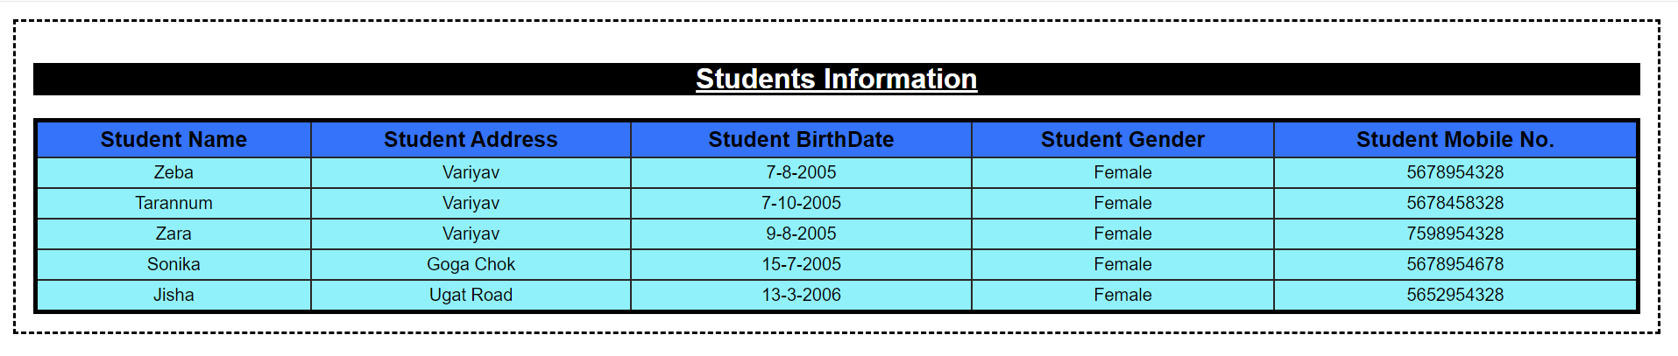

1. Create an JSON File which will display the Doctor information which includes,

Doctor_id, Doctor_ Name, Doctor_ ContactNo, Doctor_ Specialization)

(Minimum 5 Records):

**--------------------------------------------------------------------------------------------------------------------------------------**

<!DOCTYPE html>

<html lang="en">

<head>

<meta charset="UTF-8">

<meta name="viewport" content="width=>, initial-scale=1.0">

<title>Document</title>

<link rel="stylesheet" href="style.css">

<style>

th{background-color: rgb(179, 191, 216);}

td{background-color: rgba(66, 68, 71, 0.109);}

</style>

</head>

<body>

<h2>Doctor Information</h2>

<script>

var dr = [{"dr_id" : "01", "dr_name" : "Zeba", "dr_mob_no" : 5678954328, "dr_sp" : "Orthopedic"},

{"dr_id" : "02", "dr_name" : "Tarannum", "dr_mob_no" : 5678954328, "dr_sp" : "Dentist"},

{"dr_id" : "03", "dr_name" : "Zara", "dr_mob_no" : 5678954328, "dr_sp" : "Dermatologist"},

{"dr_id" : "04", "dr_name" : "Sonika", "dr_mob_no" : 5678954328, "dr_sp" : "Cardiologist"},

{"dr_id" : "05", "dr_name" : "Jisha", "dr_mob_no" : 5678954328, "dr_sp" : "Sergon"}];

document.write ("<table border = '1'><tr><th>Doctor ID</th><th>Doctor Name</th><th>Doctor Contact_No</th><th>Doctor Specialization</th></tr>");

for ( var i = 0; i < dr.length; i++)

{

document.write("<tr><td>" + dr[i].dr_id + "</td><td>" + dr[i].dr_name +"</td><td>" + dr[i].dr_mob_no + "</td><td>" + dr[i].dr_sp + "</td></tr>");

}

document.write("</table>");

</script>

</body>

</html>

**Output :**

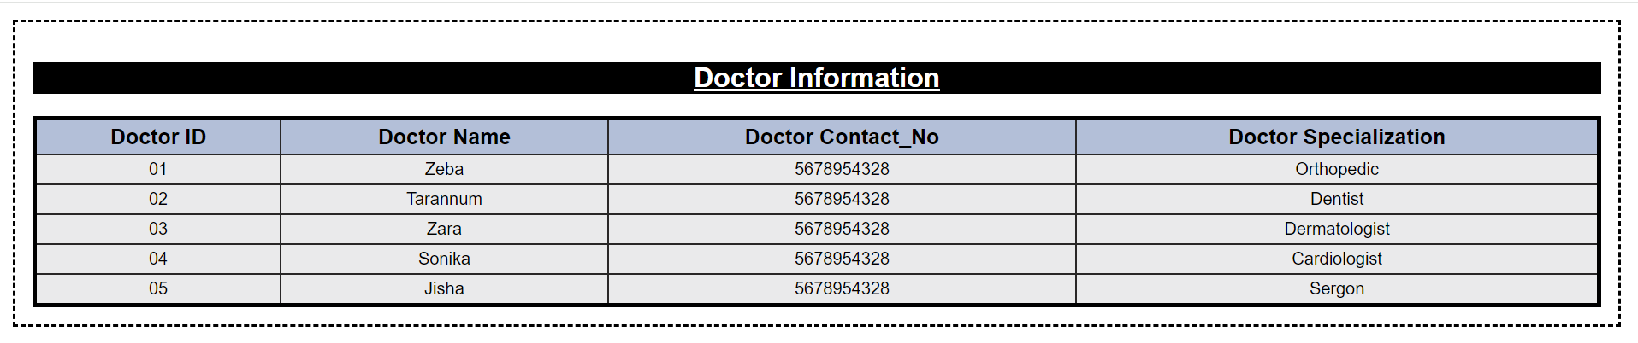

1. Create an JSON document Books where its contain the Following data

Books(Book_Title,author,year,publisher)

**--------------------------------------------------------------------------------------------------------------------------------------**

<!DOCTYPE html>

<html lang="en">

<head>

<meta charset="UTF-8">

<meta name="viewport" content="width=>, initial-scale=1.0">

<title>Document</title>

<link rel="stylesheet" href="style.css">

<style>

th{background-color: rgb(255, 151, 151);}

td{background-color: rgba(226, 159, 159, 0.371);}

</style>

</head>

<body>

<h2>Book Information</h2>

<script>

var bk = [{"bk_title" : "Web Design", "bk_author" : "xyz", "year" : 2009, "publisher" : "lmn"},

{"bk_title" : "OOPS", "bk_author" : "lmn", "year" : 2015, "publisher" : "xyz"},

{"bk_title" : "JAVA", "bk_author" : "pqr", "year" : 2010, "publisher" : "abc"},

{"bk_title" : ".NET", "bk_author" : "stp", "year" : 2017, "publisher" : "njm"},

{"bk_title" : "Python", "bk_author" : "abc", "year" : 2020, "publisher" : "opq"},];

document.write ("<table border = '1'><tr><th>Doctor ID</th><th>Doctor Name</th><th>Doctor Contact_No</th><th>Doctor Specialization</th></tr>");

for ( var i = 0; i < bk.length; i++)

{

document.write("<tr><td>" + bk[i].bk_title + "</td><td>" + bk[i].bk_author +"</td><td>" + bk[i].year + "</td><td>" + bk[i].publisher + "</td></tr>");

}

document.write("</table>");

</script>

</body>

</html>

**Output :**

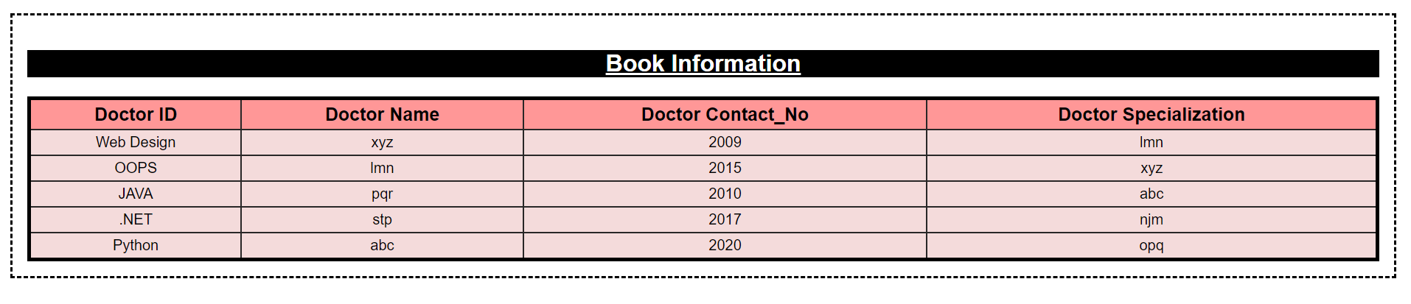

1. Create an XML document for student where it contains the following data:

(student Name, Personal info(Address,Birthdate,Gender,Mobile_No,)), Result(Total, Percentage, Grade)

**--------------------------------------------------------------------------------------------------------------------------------------**

**Output :**

To Read/Retrive data from XML file using Ajax.

1. Create an JSON File for student where it contains the following data:

(student Name, Address,Birthdate,Gender,Mobile_No,)

To Read/Retrive data from JSON(TEXT) file using Ajax.

**--------------------------------------------------------------------------------------------------------------------------------------**

**Output :**