Name: Tara Rai
Assignment: Module 9 - APIs
Course: CSD-325
Date:02/2/2026

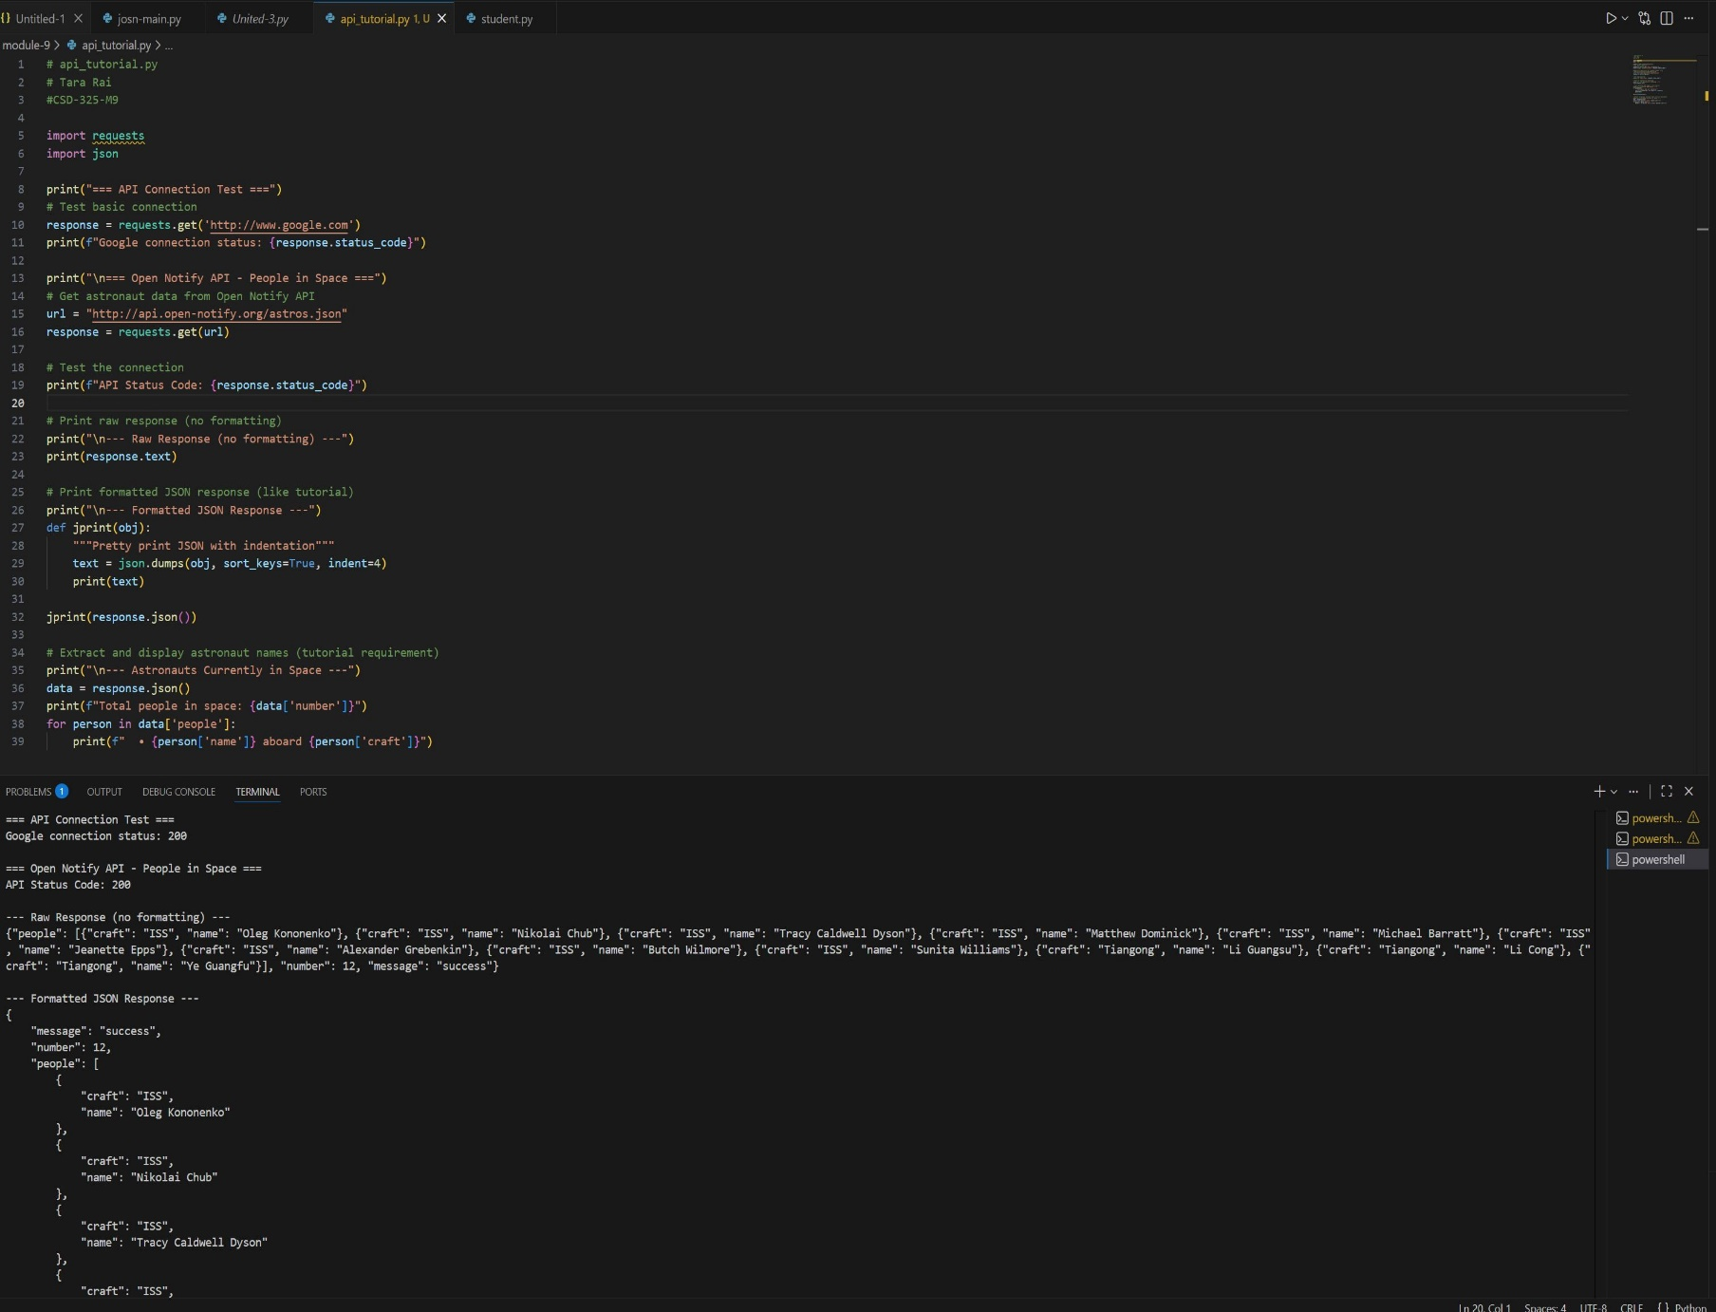
- Test Connection & Get Astronaut Data

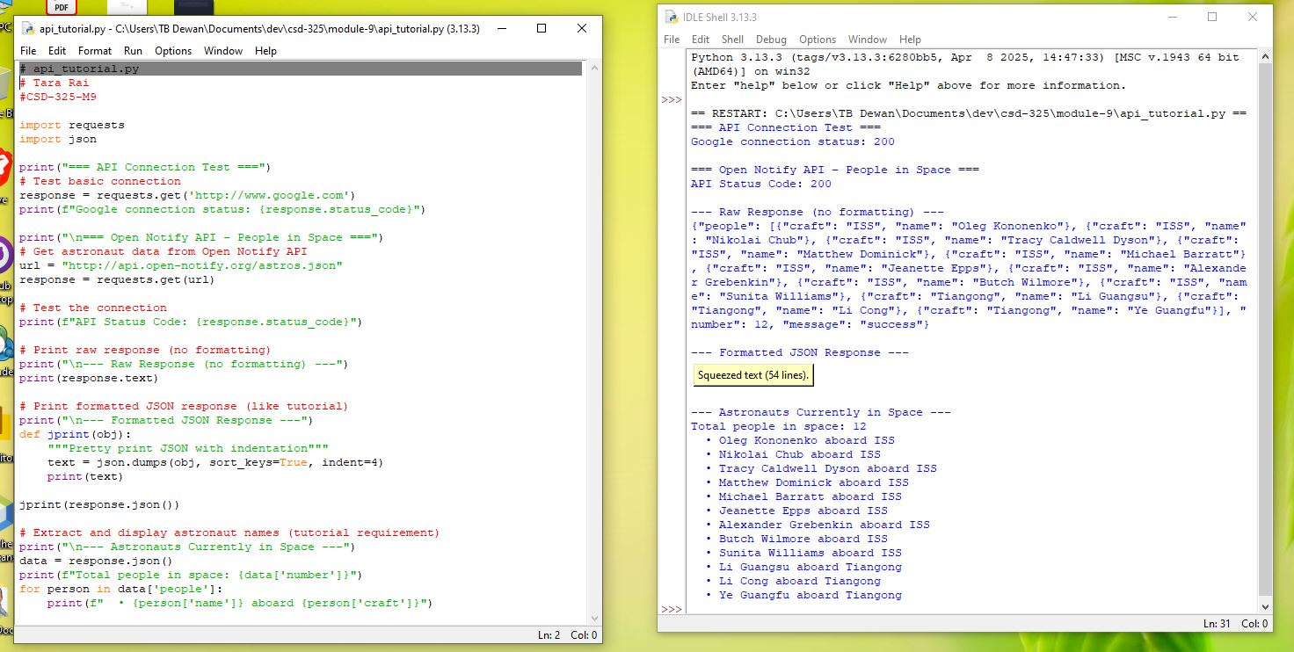

PS C:\Users\TB Dewan\Documents\dev\csd-325\module-9> & "C:\Users\TB Dewan\AppData\Local\Programs\Python\Python313\python.exe" "c:/Users/TB Dewan/Documents/dev/csd-325/module-9/api_tutorial.py"
Traceback (most recent call last):
File "c:\Users\TB Dewan\Documents\dev\csd-325\module-9\api_tutorial.py", line 5, in <module>
import requests
ModuleNotFoundError: No module named 'requests'
PS C:\Users\TB Dewan\Documents\dev\csd-325\module-9> & "C:\Users\TB Dewan\AppData\Local\Programs\Python\Python313\python.exe" "c:/Users/TB Dewan/Documents/dev/csd-325/module-9/api_tutorial.py"
=== API Connection Test ===
Google connection status: 200

=== Open Notify API - People in Space ===
API Status Code: 200

--- Raw Response (no formatting) ---
{"people": [{"craft": "ISS", "name": "Oleg Kononenko"}, {"craft": "ISS", "name": "Nikolai Chub"}, {"craft": "ISS", "name": "Tracy Caldwell Dyson"}, {"craft": "ISS", "name": "Matthew Dominick"}, {"craft": "ISS", "name": "Michael Barratt"}, {"craft": "ISS", "name": "Jeanette Epps"}, {"craft": "ISS", "name": "Alexander Grebenkin"}, {"craft": "ISS", "name": "Butch Wilmore"}, {"craft": "ISS", "name": "Sunita Williams"}, {"craft": "Tiangong", "name": "Li Guangsu"}, {"craft": "Tiangong", "name": "Li Cong"}, {"craft": "Tiangong", "name": "Ye Guangfu"}], "number": 12, "message": "success"}

--- Formatted JSON Response ---
{
"message": "success",
"number": 12,
"people": [
{
"craft": "ISS",
"name": "Oleg Kononenko"
},
{
"craft": "ISS",
"name": "Nikolai Chub"
},
{
"craft": "ISS",
"name": "Tracy Caldwell Dyson"
},
{
"craft": "ISS",
"name": "Matthew Dominick"
},
{
"craft": "ISS",
"name": "Michael Barratt"
},
{
"craft": "ISS",
"name": "Jeanette Epps"
},
{
"craft": "ISS",
"name": "Alexander Grebenkin"
},
{
"craft": "ISS",
"name": "Butch Wilmore"
},
{
"craft": "ISS",
"name": "Sunita Williams"
},
{
"craft": "Tiangong",
"name": "Li Guangsu"
},
{
"craft": "Tiangong",
"name": "Li Cong"
},
{
"craft": "Tiangong",
}
]
}

--- Astronauts Currently in Space ---
Total people in space: 12
• Oleg Kononenko aboard ISS
• Nikolai Chub aboard ISS
• Tracy Caldwell Dyson aboard ISS
• Matthew Dominick aboard ISS
• Michael Barratt aboard ISS
• Jeanette Epps aboard ISS
• Alexander Grebenkin aboard ISS
• Butch Wilmore aboard ISS
• Sunita Williams aboard ISS
• Li Guangsu aboard Tiangong
• Li Cong aboard Tiangong
• Ye Guangfu aboard Tiangong

- My choice API, JSONPLaceholder
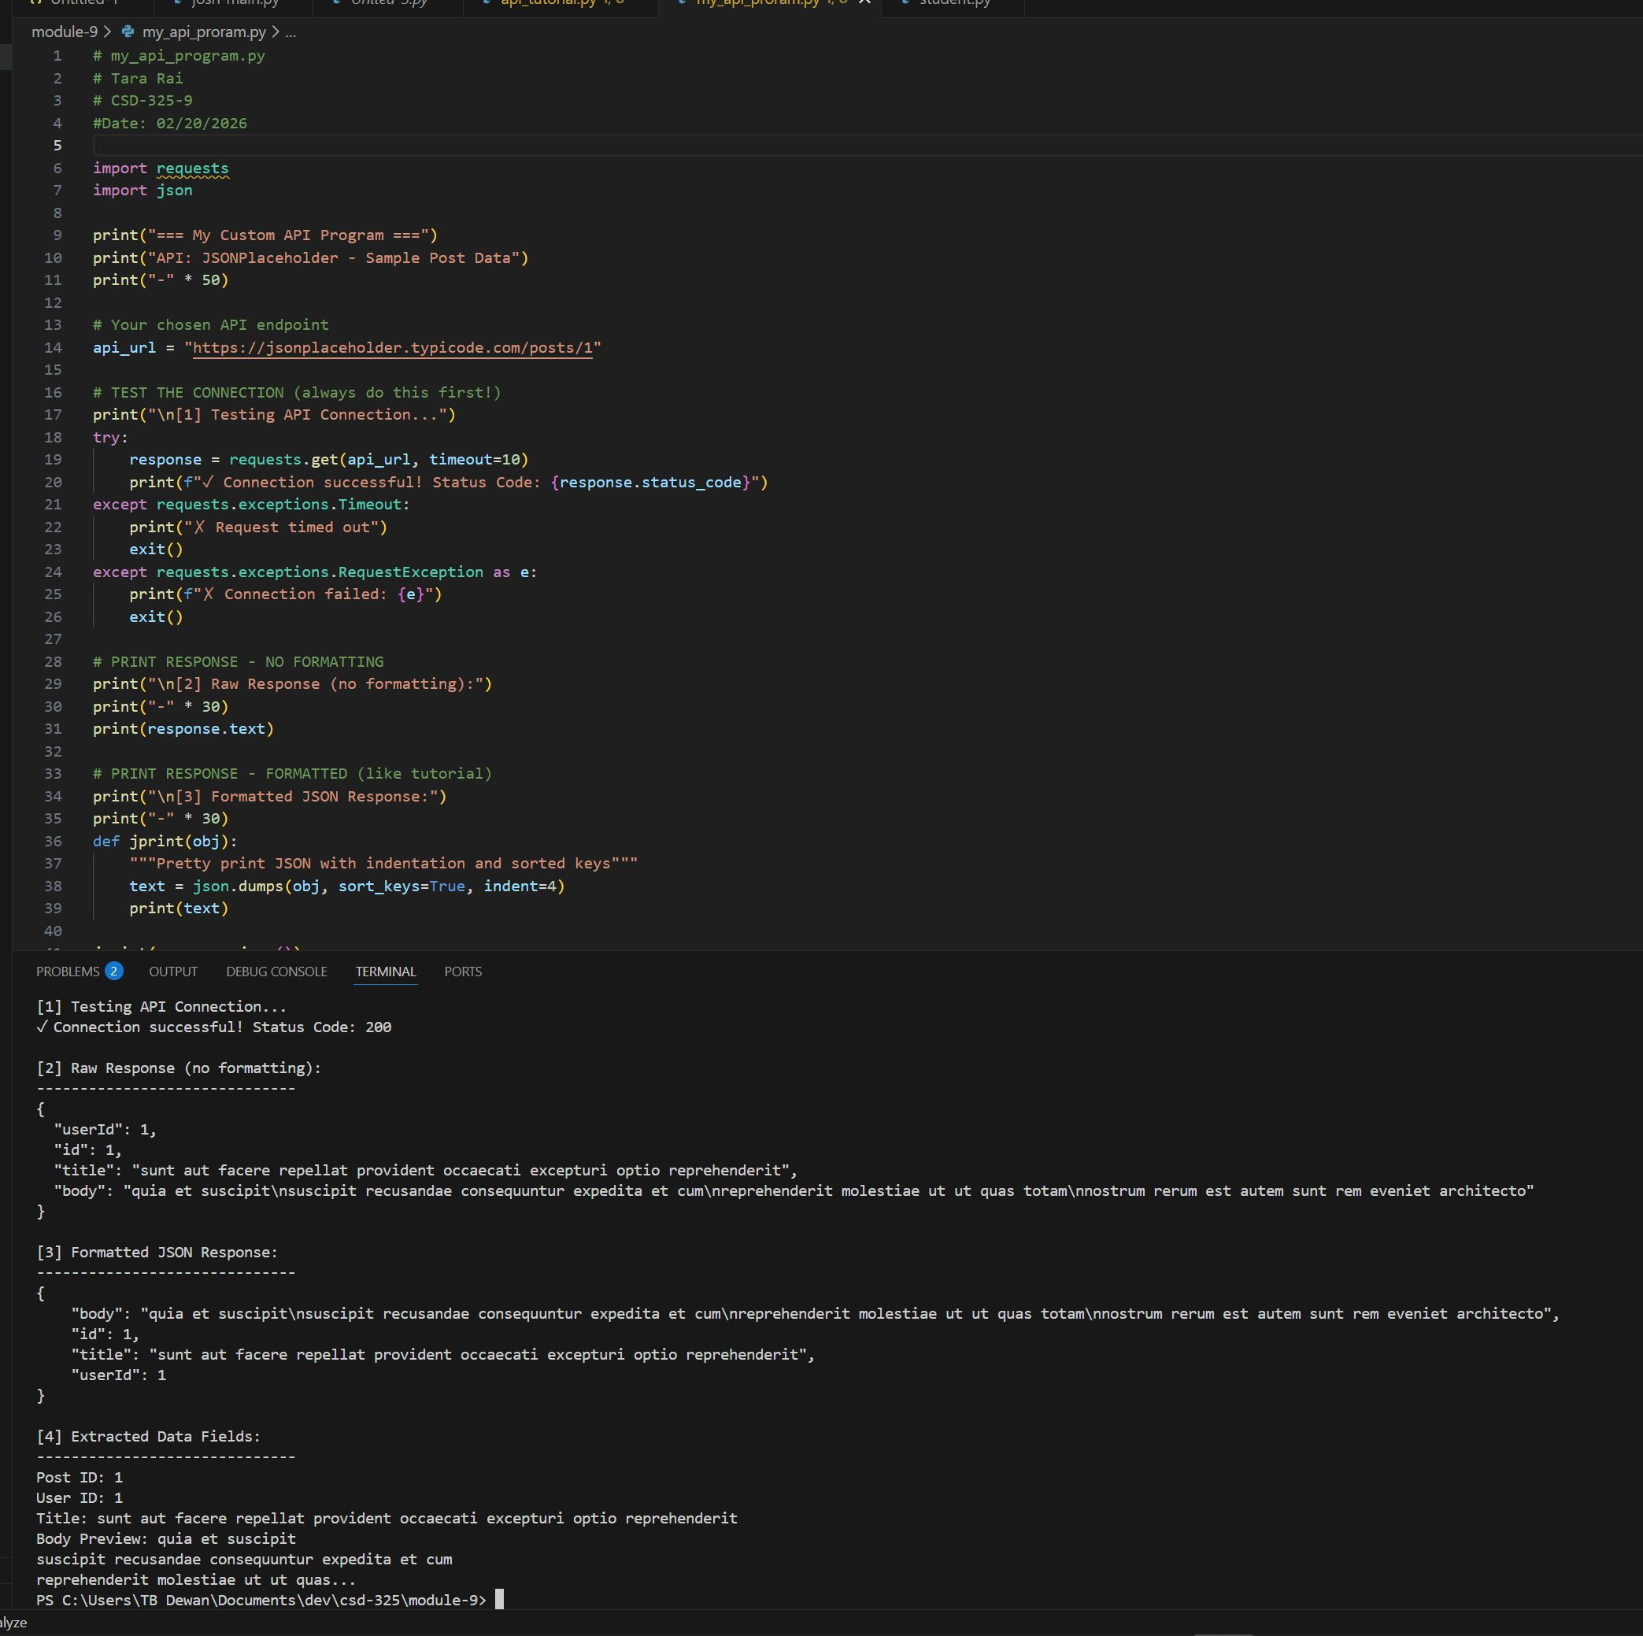

[1] Testing API Connection...
✓ Connection successful! Status Code: 200

[2] Raw Response (no formatting):
------------------------------
{
"userId": 1,
"id": 1,
"title": "sunt aut facere repellat provident occaecati excepturi optio reprehenderit",
"body": "quia et suscipit\nsuscipit recusandae consequuntur expedita et cum\nreprehenderit molestiae ut ut quas totam\nnostrum rerum est autem sunt rem eveniet architecto"
}

[3] Formatted JSON Response:
------------------------------
{
"body": "quia et suscipit\nsuscipit recusandae consequuntur expedita et cum\nreprehenderit molestiae ut ut quas totam\nnostrum rerum est autem sunt rem eveniet architecto",
"id": 1,
"title": "sunt aut facere repellat provident occaecati excepturi optio reprehenderit",
"userId": 1
}

[4] Extracted Data Fields:
------------------------------
Post ID: 1
User ID: 1
Title: sunt aut facere repellat provident occaecati excepturi optio reprehenderit
Body Preview: quia et suscipit
suscipit recusandae consequuntur expedita et cum
reprehenderit molestiae ut ut quas...
PS C:\Users\TB Dewan\Documents\dev\csd-325\module-9>

