Django Basics Assignment-Module 11

Student Name: Tara Rai
Course: CSD-325 M11
Date: March 1, 2026

Assignment Overview
Through this assignment, a person confirms the proper installation and setup of the Django web framework, the creation of a simple Django project, and the development of a custom web application with new content.

Tasks Completed:
- Installed Django framework.
- Created a Django project named "demo".
- Created a Django app named "sampson."
- Configured URL routing.
- Modified views to display custom content.
- Successfully ran the development server.

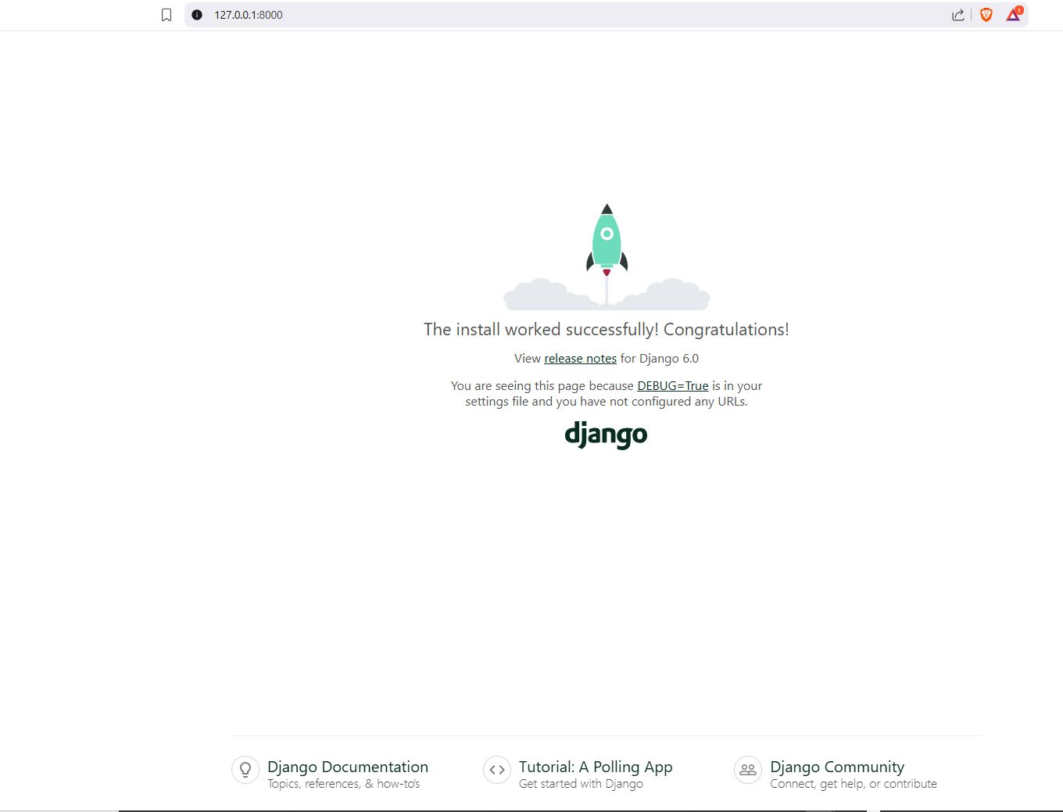
Screenshot 1: Django Project Default Page
URL: http://127.0.0.1:8000/

This screenshot shows the default Django welcome page, indicating that Django has been properly installed and the development server is running smoothly. The page shows "The install worked successfully! Congratulations!" above the Django logo and links to documentation and tutorials. It means that DEBUG=True is set in the settings file.

Screenshot 2: Custom Application Page
URL: http://127.0.0.1:8000/sampson/
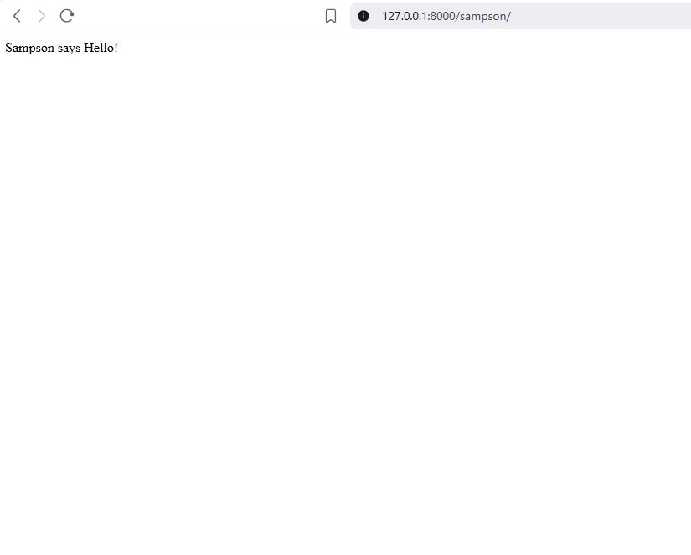

A custom Django view has been successfully demonstrated in the screenshot. The page shows a personal message, "Sampson says Hello!" that was configured by:
- Using the python manage.py startapp sampson command to create the sampson appEditing sampson/views.py file to add the view function corresponding to the new page.
from django.http import HttpResponse

def index(request):
return HttpResponse("Sampson says Hello!")

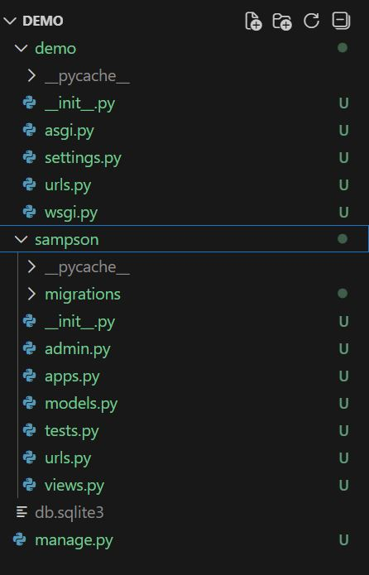
Technical Implementation Details

Project Structure:

Key Files Modified:
demo/urls.py (Project-level URL configuration):
from django.contrib import admin
from django.urls import include, path

urlpatterns = [
path('sampson/', include('sampson.urls')),
path('admin/', admin.site.urls),
]

sampson/views.py (View function):
from django.http import HttpResponse

def index(request):
return HttpResponse("Sampson says Hello!")

sampson/urls.py (App-level URL configuration):

from django.urls import path
from . import views

urlpatterns = [
path('', views.index, name='index'),
]

The development server is up and running at http://127.0.0.1:8000/, and the custom app is available at http://127.0.0.1:8000/sampson/
