**Logo -** 01_home page

**Home** – 01_home page

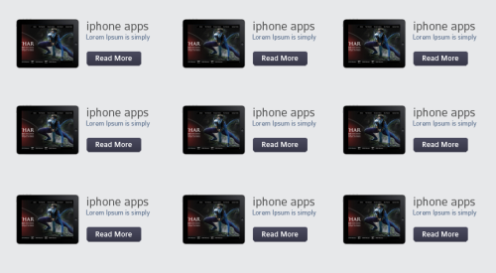

Read More – 04_blog_page

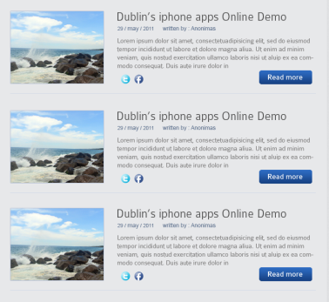

Read More – 05_blog_innerpage

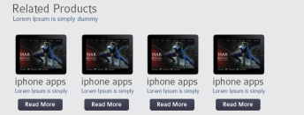

Read More - 01_home page

**Ipad apps** – 02_producs page

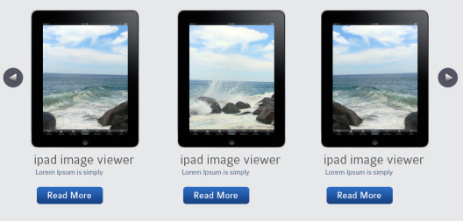

Read More - 02_producs_page

**Demonstrations** -03_product_demo

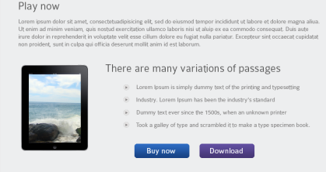

Buy now – 09_web_elements

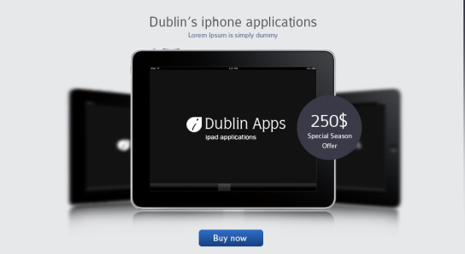

Buy now – 09_web_elements

**Leopards media -** 04_blog_page

**Connect us** – 08_contact_page