Міністерство освіти і науки України

Національний університет “Львівська політехніка”



Звіт

про виконання лабораторної роботи №1

iз курсу “Аналітичні та нереляційні бази даних”

**Виконав**:

ст. гр. ІР-41, ІКТА

Білоус Тарас

**Прийняв**:

Верес З.Є.

Львів – 2020

**Лабораторна робота №1**

**Завдання:** реалізувати базу даних Instagram, яка дозволяє зберегти всі необхідні дані.

**Скрипт для створення БД**

USE [master]

GO

CREATE DATABASE [Lab_1]

GO

ALTER DATABASE [Lab_1] SET COMPATIBILITY_LEVEL = 140

GO

IF (1 = FULLTEXTSERVICEPROPERTY('IsFullTextInstalled'))

begin

EXEC [Lab_1].[dbo].[sp_fulltext_database] @action = 'enable'

end

GO

ALTER DATABASE [Lab_1] SET ANSI_NULL_DEFAULT OFF

GO

ALTER DATABASE [Lab_1] SET ANSI_NULLS OFF

GO

ALTER DATABASE [Lab_1] SET ANSI_PADDING OFF

GO

ALTER DATABASE [Lab_1] SET ANSI_WARNINGS OFF

GO

ALTER DATABASE [Lab_1] SET ARITHABORT OFF

GO

ALTER DATABASE [Lab_1] SET AUTO_CLOSE OFF

GO

ALTER DATABASE [Lab_1] SET AUTO_SHRINK OFF

GO

ALTER DATABASE [Lab_1] SET AUTO_UPDATE_STATISTICS ON

GO

ALTER DATABASE [Lab_1] SET CURSOR_CLOSE_ON_COMMIT OFF

GO

ALTER DATABASE [Lab_1] SET CURSOR_DEFAULT GLOBAL

GO

ALTER DATABASE [Lab_1] SET CONCAT_NULL_YIELDS_NULL OFF

GO

ALTER DATABASE [Lab_1] SET NUMERIC_ROUNDABORT OFF

GO

ALTER DATABASE [Lab_1] SET QUOTED_IDENTIFIER OFF

GO

ALTER DATABASE [Lab_1] SET RECURSIVE_TRIGGERS OFF

GO

ALTER DATABASE [Lab_1] SET DISABLE_BROKER

GO

ALTER DATABASE [Lab_1] SET AUTO_UPDATE_STATISTICS_ASYNC OFF

GO

ALTER DATABASE [Lab_1] SET DATE_CORRELATION_OPTIMIZATION OFF

GO

ALTER DATABASE [Lab_1] SET TRUSTWORTHY OFF

GO

ALTER DATABASE [Lab_1] SET ALLOW_SNAPSHOT_ISOLATION OFF

GO

ALTER DATABASE [Lab_1] SET PARAMETERIZATION SIMPLE

GO

ALTER DATABASE [Lab_1] SET READ_COMMITTED_SNAPSHOT OFF

GO

ALTER DATABASE [Lab_1] SET HONOR_BROKER_PRIORITY OFF

GO

ALTER DATABASE [Lab_1] SET RECOVERY FULL

GO

ALTER DATABASE [Lab_1] SET MULTI_USER

GO

ALTER DATABASE [Lab_1] SET PAGE_VERIFY CHECKSUM

GO

ALTER DATABASE [Lab_1] SET DB_CHAINING OFF

GO

ALTER DATABASE [Lab_1] SET FILESTREAM( NON_TRANSACTED_ACCESS = OFF )

GO

ALTER DATABASE [Lab_1] SET TARGET_RECOVERY_TIME = 60 SECONDS

GO

ALTER DATABASE [Lab_1] SET DELAYED_DURABILITY = DISABLED

GO

EXEC sys.sp_db_vardecimal_storage_format N'Lab_1', N'ON'

GO

ALTER DATABASE [Lab_1] SET QUERY_STORE = OFF

GO

USE [Lab_1]

GO

SET ANSI_NULLS ON

GO

SET QUOTED_IDENTIFIER ON

GO

CREATE TABLE [dbo].[Comments](

[comment_id] [int] IDENTITY(1,1) NOT NULL,

[user_id] [int] NOT NULL,

[post_id] [int] NOT NULL,

[text] [nvarchar](1000) NOT NULL,

CONSTRAINT [PK_Comments] PRIMARY KEY CLUSTERED

(

[comment_id] ASC

)WITH (PAD_INDEX = OFF, STATISTICS_NORECOMPUTE = OFF, IGNORE_DUP_KEY = OFF, ALLOW_ROW_LOCKS = ON, ALLOW_PAGE_LOCKS = ON) ON [PRIMARY]

) ON [PRIMARY]

GO

SET ANSI_NULLS ON

GO

SET QUOTED_IDENTIFIER ON

GO

CREATE TABLE [dbo].[Emoji](

[emoji_id] [int] IDENTITY(1,1) NOT NULL,

[image] [varbinary](max) NULL,

[description] [nvarchar](10) NOT NULL,

CONSTRAINT [PK_Emoji] PRIMARY KEY CLUSTERED

(

[emoji_id] ASC

)WITH (PAD_INDEX = OFF, STATISTICS_NORECOMPUTE = OFF, IGNORE_DUP_KEY = OFF, ALLOW_ROW_LOCKS = ON, ALLOW_PAGE_LOCKS = ON) ON [PRIMARY]

) ON [PRIMARY] TEXTIMAGE_ON [PRIMARY]

GO

SET ANSI_NULLS ON

GO

SET QUOTED_IDENTIFIER ON

GO

CREATE TABLE [dbo].[Likes](

[like_id] [int] IDENTITY(1,1) NOT NULL,

[user_id] [int] NOT NULL,

[post_id] [int] NOT NULL,

[emoji_id] [int] NOT NULL,

[date] [date] NOT NULL,

CONSTRAINT [PK_Likes] PRIMARY KEY CLUSTERED

(

[like_id] ASC

)WITH (PAD_INDEX = OFF, STATISTICS_NORECOMPUTE = OFF, IGNORE_DUP_KEY = OFF, ALLOW_ROW_LOCKS = ON, ALLOW_PAGE_LOCKS = ON) ON [PRIMARY]

) ON [PRIMARY]

GO

SET ANSI_NULLS ON

GO

SET QUOTED_IDENTIFIER ON

GO

CREATE TABLE [dbo].[Location](

[location_id] [int] IDENTITY(1,1) NOT NULL,

[post_id] [int] NOT NULL,

[city] [nvarchar](100) NOT NULL,

[latitude] [decimal](16, 8) NOT NULL,

[longtitude] [decimal](16, 8) NOT NULL,

CONSTRAINT [PK_Location] PRIMARY KEY CLUSTERED

(

[location_id] ASC

)WITH (PAD_INDEX = OFF, STATISTICS_NORECOMPUTE = OFF, IGNORE_DUP_KEY = OFF, ALLOW_ROW_LOCKS = ON, ALLOW_PAGE_LOCKS = ON) ON [PRIMARY]

) ON [PRIMARY]

GO

SET ANSI_NULLS ON

GO

SET QUOTED_IDENTIFIER ON

GO

CREATE TABLE [dbo].[Posts](

[post_id] [int] IDENTITY(1,1) NOT NULL,

[user_id] [int] NOT NULL,

[photo] [varbinary](max) NULL,

[date] [datetime] NOT NULL,

[text] [nvarchar](1000) NOT NULL,

CONSTRAINT [PK_posts] PRIMARY KEY CLUSTERED

(

[post_id] ASC

)WITH (PAD_INDEX = OFF, STATISTICS_NORECOMPUTE = OFF, IGNORE_DUP_KEY = OFF, ALLOW_ROW_LOCKS = ON, ALLOW_PAGE_LOCKS = ON) ON [PRIMARY]

) ON [PRIMARY] TEXTIMAGE_ON [PRIMARY]

GO

SET ANSI_NULLS ON

GO

SET QUOTED_IDENTIFIER ON

GO

CREATE TABLE [dbo].[Posts_Tags](

[id] [int] IDENTITY(1,1) NOT NULL,

[post_id] [int] NOT NULL,

[tag_id] [int] NOT NULL,

CONSTRAINT [PK_Posts_Tags] PRIMARY KEY CLUSTERED

(

[id] ASC

)WITH (PAD_INDEX = OFF, STATISTICS_NORECOMPUTE = OFF, IGNORE_DUP_KEY = OFF, ALLOW_ROW_LOCKS = ON, ALLOW_PAGE_LOCKS = ON) ON [PRIMARY]

) ON [PRIMARY]

GO

SET ANSI_NULLS ON

GO

SET QUOTED_IDENTIFIER ON

GO

CREATE TABLE [dbo].[Tags](

[tag_id] [int] IDENTITY(1,1) NOT NULL,

[description] [nvarchar](20) NOT NULL,

CONSTRAINT [PK_Tags] PRIMARY KEY CLUSTERED

(

[tag_id] ASC

)WITH (PAD_INDEX = OFF, STATISTICS_NORECOMPUTE = OFF, IGNORE_DUP_KEY = OFF, ALLOW_ROW_LOCKS = ON, ALLOW_PAGE_LOCKS = ON) ON [PRIMARY]

) ON [PRIMARY]

GO

SET ANSI_NULLS ON

GO

SET QUOTED_IDENTIFIER ON

GO

CREATE TABLE [dbo].[Users](

[user_id] [int] IDENTITY(1,1) NOT NULL,

[country] [nvarchar](100) NOT NULL,

[password] [nvarchar](100) NOT NULL,

[first_name] [nvarchar](100) NOT NULL,

[last_name] [nvarchar](100) NOT NULL,

[username] [nvarchar](100) NOT NULL,

[age] [int] NOT NULL,

CONSTRAINT [PK_user_accounts] PRIMARY KEY CLUSTERED

(

[user_id] ASC

)WITH (PAD_INDEX = OFF, STATISTICS_NORECOMPUTE = OFF, IGNORE_DUP_KEY = OFF, ALLOW_ROW_LOCKS = ON, ALLOW_PAGE_LOCKS = ON) ON [PRIMARY]

) ON [PRIMARY]

GO

SET ANSI_NULLS ON

GO

SET QUOTED_IDENTIFIER ON

GO

CREATE TABLE [dbo].[Users_Followers](

[user_id] [int] NOT NULL,

[follower_id] [int] NOT NULL,

[blocked] [bit] NOT NULL,

CONSTRAINT [PK_Users_Followers] PRIMARY KEY CLUSTERED

(

[user_id] ASC,

[follower_id] ASC

)WITH (PAD_INDEX = OFF, STATISTICS_NORECOMPUTE = OFF, IGNORE_DUP_KEY = OFF, ALLOW_ROW_LOCKS = ON, ALLOW_PAGE_LOCKS = ON) ON [PRIMARY]

) ON [PRIMARY]

GO

ALTER TABLE [dbo].[Comments] WITH CHECK ADD CONSTRAINT [FK_Comments_Posts] FOREIGN KEY([post_id])

REFERENCES [dbo].[Posts] ([post_id])

GO

ALTER TABLE [dbo].[Comments] CHECK CONSTRAINT [FK_Comments_Posts]

GO

ALTER TABLE [dbo].[Comments] WITH CHECK ADD CONSTRAINT [FK_Comments_Users] FOREIGN KEY([user_id])

REFERENCES [dbo].[Users] ([user_id])

GO

ALTER TABLE [dbo].[Comments] CHECK CONSTRAINT [FK_Comments_Users]

GO

ALTER TABLE [dbo].[Likes] WITH CHECK ADD CONSTRAINT [FK_Likes_Emoji] FOREIGN KEY([emoji_id])

REFERENCES [dbo].[Emoji] ([emoji_id])

GO

ALTER TABLE [dbo].[Likes] CHECK CONSTRAINT [FK_Likes_Emoji]

GO

ALTER TABLE [dbo].[Likes] WITH CHECK ADD CONSTRAINT [FK_Likes_Posts] FOREIGN KEY([post_id])

REFERENCES [dbo].[Posts] ([post_id])

GO

ALTER TABLE [dbo].[Likes] CHECK CONSTRAINT [FK_Likes_Posts]

GO

ALTER TABLE [dbo].[Likes] WITH CHECK ADD CONSTRAINT [FK_Likes_Users] FOREIGN KEY([user_id])

REFERENCES [dbo].[Users] ([user_id])

GO

ALTER TABLE [dbo].[Likes] CHECK CONSTRAINT [FK_Likes_Users]

GO

ALTER TABLE [dbo].[Location] WITH CHECK ADD CONSTRAINT [FK_Location_Posts1] FOREIGN KEY([post_id])

REFERENCES [dbo].[Posts] ([post_id])

GO

ALTER TABLE [dbo].[Location] CHECK CONSTRAINT [FK_Location_Posts1]

GO

ALTER TABLE [dbo].[Posts] WITH CHECK ADD CONSTRAINT [FK_Posts_Users] FOREIGN KEY([user_id])

REFERENCES [dbo].[Users] ([user_id])

GO

ALTER TABLE [dbo].[Posts] CHECK CONSTRAINT [FK_Posts_Users]

GO

ALTER TABLE [dbo].[Posts_Tags] WITH CHECK ADD CONSTRAINT [FK_Posts_Tags_Posts] FOREIGN KEY([post_id])

REFERENCES [dbo].[Posts] ([post_id])

GO

ALTER TABLE [dbo].[Posts_Tags] CHECK CONSTRAINT [FK_Posts_Tags_Posts]

GO

ALTER TABLE [dbo].[Posts_Tags] WITH CHECK ADD CONSTRAINT [FK_Posts_Tags_Tags] FOREIGN KEY([tag_id])

REFERENCES [dbo].[Tags] ([tag_id])

GO

ALTER TABLE [dbo].[Posts_Tags] CHECK CONSTRAINT [FK_Posts_Tags_Tags]

GO

ALTER TABLE [dbo].[Users_Followers] WITH CHECK ADD CONSTRAINT [FK_Users_Followers_Users] FOREIGN KEY([user_id])

REFERENCES [dbo].[Users] ([user_id])

GO

ALTER TABLE [dbo].[Users_Followers] CHECK CONSTRAINT [FK_Users_Followers_Users]

GO

ALTER TABLE [dbo].[Users_Followers] WITH CHECK ADD CONSTRAINT [FK_Users_Followers_Users1] FOREIGN KEY([follower_id])

REFERENCES [dbo].[Users] ([user_id])

GO

ALTER TABLE [dbo].[Users_Followers] CHECK CONSTRAINT [FK_Users_Followers_Users1]

GO

USE [master]

GO

ALTER DATABASE [Lab_1] SET READ_WRITE

GO

Діаграма створена у MS SQL Management Studio

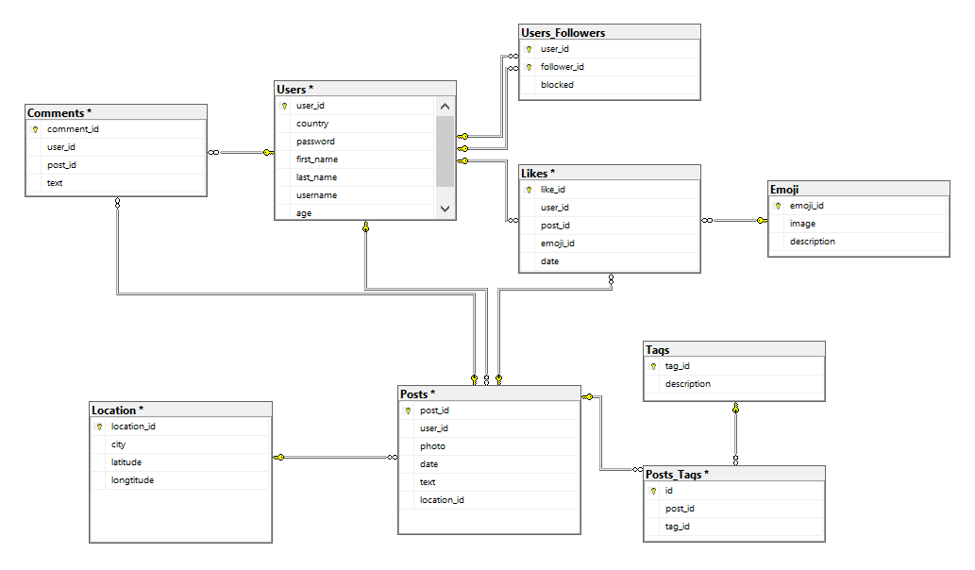

Основний клас – це пост, який має кілька інформаційних полів(фото, дата, текст). Окрім цього пост може посилатися на певний набір тегів і локацію, які мають свої інформаційні поля. Один і той самий тег або локація можуть бути використані в різних постах.

Пости створюються користувачами. Користувач може залишити коментар під постом або вподобати його, при цьому він сам вибирає, яку емоджі використати(можна вподобати кілька разів). Кожна емоджі має свій текстовий опис.

Окрім цього, користувач має змогу слідкувати за іншими користувачами або блокувати їх.

**Висновок:** в результаті виконання даної лабораторної роботи я навчився проектувати базу даних для зберігання необхідної інформації та створювати її в MS SQL Management Studio.