**Lab 1 Problem 3: Mobile App Design**

3.1 Give an example of a mobile app which can be downloaded from Google Play store or Apple App store and that follow at least three principles of the mobile design best practices

3.1.1 What’s the app name?

Ans YouTube

3.1.2 What's the app rating?

Ans 4.7 stars on the App Store.

3.1.3 What’s the app download link?

Ans <https://apps.apple.com/th/app/youtube/id544007664?l=th>

3.1.4 What are at least three mobile design best practices that the app follows?

Ans

1. Prioritize Intuitive Navigation - The bottom navigation bar uses 3 – 5 icons. Icons are clear and self-explanatory.

1. Responsive Design - The app adapts seamlessly to different screen sizes and orientations. Videos play in both portrait and landscape modes, maximizing usability.

1. Personalization - YouTube's home page curates video suggestions based on the user's watch history, likes, subscriptions, and search activity.

3.2 Give an example of a mobile app which can be downloaded from Google Play store or Apple App store and that **DOES NOT** follow at least three principles of the mobile design best practices.

3.2.1 What’s the app name?

Ans KKU REG

3.2.2. What’s the app rating?

Ans 2.7 stars on the App Store.

3.2.3 What’s the app download link?

Ans <https://apps.apple.com/th/app/kku-reg/id1608513284?l=th>

3.2.4 What are at least three best practices that the app **DOES NOT**follow?

Ans

1. Visual Hierarchy - The interface lacks a clear visual hierarchy. All icons and text are displayed in a grid format, with no prioritization of frequently used features. The lack of padding and grouping. (In iPad)

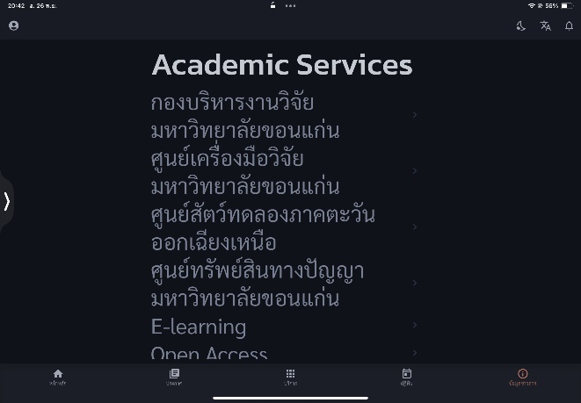

2. Consistency in Design - The icons and text sizes are inconsistent, making the interface feel unpolished. (In iPad)

3. Mobile layout design - The information view button is in the top left corner, which is difficult to reach with your thumb when holding the phone with one hand.

