## EN813701

### Exercise 5 Comment Web Design

### **Problem 1 Commenting website that have bad designs (5 points)**

* Comment **at least three items** of **what you think the web should be improved based on web design best-practices**
* **Capture the part of the commented website and insert the captured image** in the document so that the explanation can be understood more clearly
  + For example, please don’t just say “bad colors” but should say
    - The colors should be selected such that they are more well contrasted
* For the student ID that ends with 2, 7
  + Comment on the web of <https://www.berkshirehathaway.com/>

1.

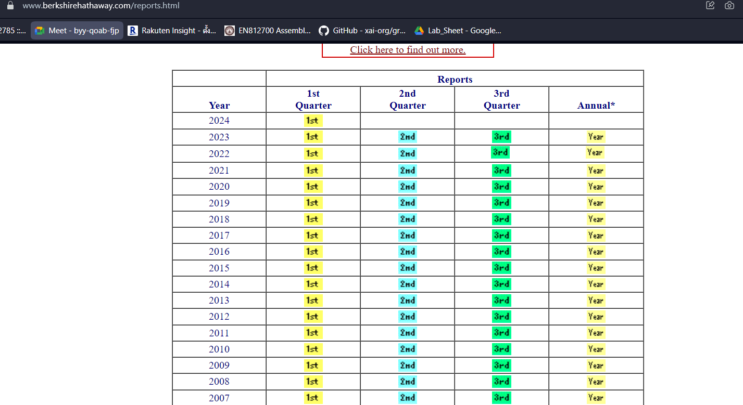

The text is blurry, making it difficult to read.Should choose a font that is easier to read.

2.

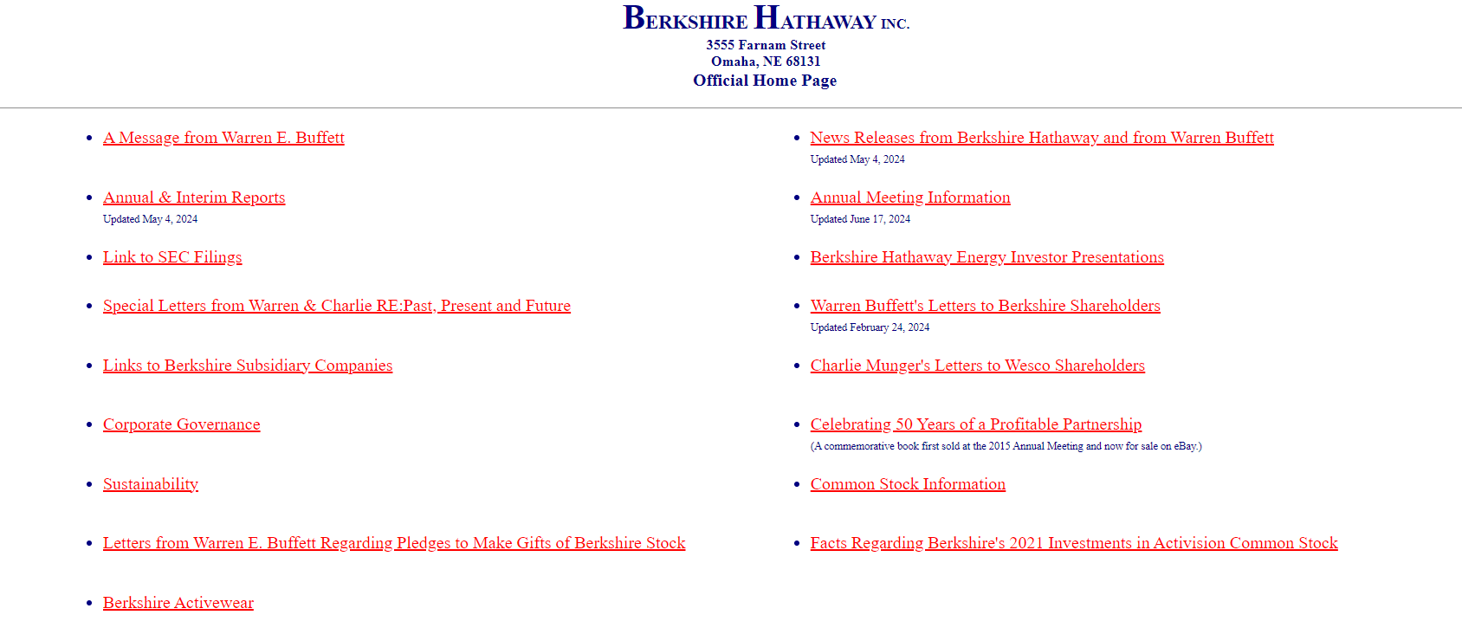

The website looks too empty and has a small font size. Should add some elements to make it more interesting for users and increase font size.

3.

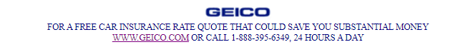

There are all caps hard to read.It should be written according to the principles of language so that it is easy to read.