EN813701

Exercise 5 Comment Web Design

**Problem2 Learning from websites with good design (5 points)**

* For the students who have ID that ends with 2, 8

-Comments on the web <https://medium.com>

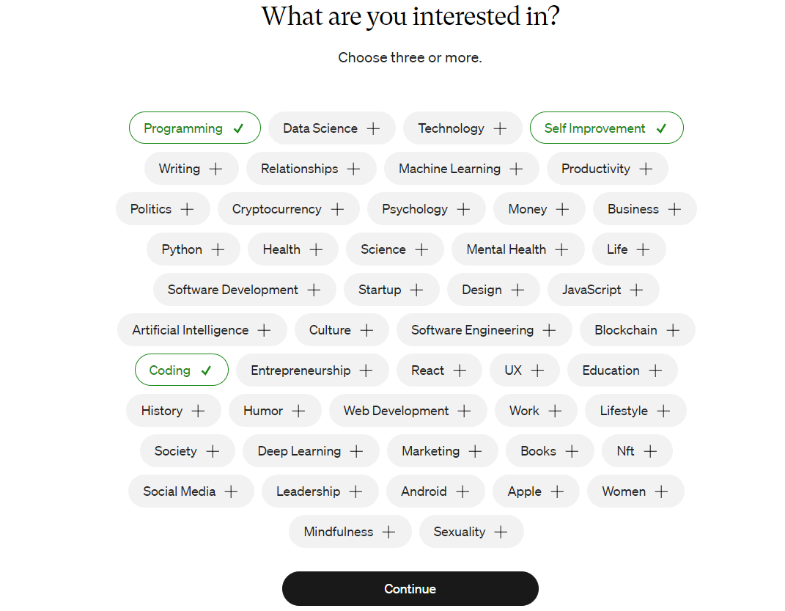

1. The text colors are well contrasted. It makes the users scan and read it easier.

2. The font size is arranged well, making it easy for users to read.

3. The website is a hierarchy that lets users know where they should press to enter the website.