1 Problem definition
The project simulates a Hospital Management System that allows the interaction of patients, doctors, and hospital administrators. The system will enable the management of medical checkups between doctors and patients. Users will be categorized into four different roles: Unsigned, Patient, Doctor, and Admin. Each of these roles will have different permissions regarding account management, viewing information, checkup management, and viewing user data.
- Analysis phase: Defines the functional requirements and specific use cases based on user roles.
- Design phase: Details the system architecture, database structure, component interactions, and design patterns.
- Implementation phase: Presents the technology used and the application structure.

2.1 Functional requirements(new)
The system must perform the following operations based on the core problem statement:
- The system must allow users to create an account (sign up), authenticate (sign in), and end their session (sign out).
- The system must distinguish between Unsigned, Patient, Doctor, and Admin roles.
- The system must allow Unsigned users to view a directory of all available Doctors and their medical specialties.
- The system must allow authenticated Patients to view a list of all checkups scheduled for them.
- The system must allow authenticated Patients to sort a list of all checkups scheduled for them by username or appointment date, ascending or descending.
- The system must allow authenticated Doctors to schedule new checkups with Patients.
- The system must allow Admins to schedule checkups between any existing Doctor and Patient.
- The system must allow Admins to view basic account information (username and email) for all registered users, while strictly restricting access to user passwords.
- The system must allow all authenticated roles to download the list of doctor checkups that concerns them. The format can be chosen as .josn, .scv, .Xml. The users must allso be able to sort or filter the information.
- The system must allow admins to download the information of all accounts. . The format can be chosen as .josn, .scv, .Xml. The admin must allso be able to sort the information.
- The system must emit an email to the current user the result of operations (Create, Update, Delete). It must do so by emiting an event for the operations and to be cauth by a Notification Service.

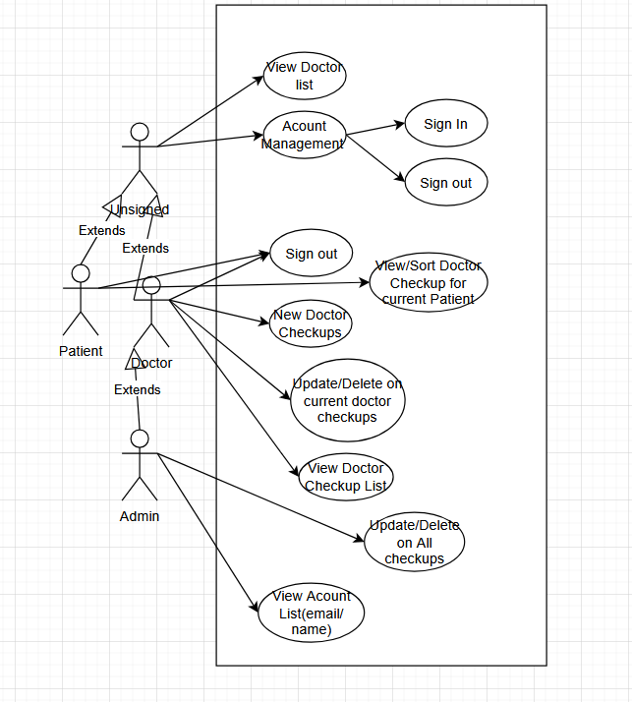
3.2 Entity-relationship diagram
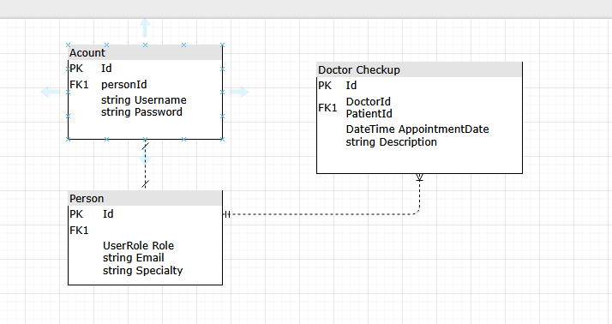

1. Account Table
- Purpose: Stores user login credentials.
- Attributes:
  - Id: Primary Key.
  - Username: String.
  - Password: String
- Relationships: One-to-one with the Person table (via personId Foreign Key).

2. Person Table
- Purpose: Stores user profiles and system roles.
- Attributes:
  - Id: Primary Key.
  - Role: Enum (Patient, Doctor, Admin).
  - Email: String.
  - Specialty: String (Populated only if Role is Doctor).
- Relationships: * One-to-one with the Account table.
  - One-to-many with the Doctor Checkup table (a person can have multiple checkups as a doctor or patient).

3. Doctor Checkup Table
- Purpose: Records scheduled medical appointments.
- Attributes:
  - Id: Primary Key.
  - AppointmentDate: DateTime.
  - Description: String (appointment details/notes).
- Relationships: Links to the Person table via two Foreign Keys (DoctorId and PatientId), connecting one doctor and one patient.
3.3 Sequence diagram:
View, update, and Delete Doctor checkups. Doctors can operate of their checkups and admins on all. Patients can just view them.
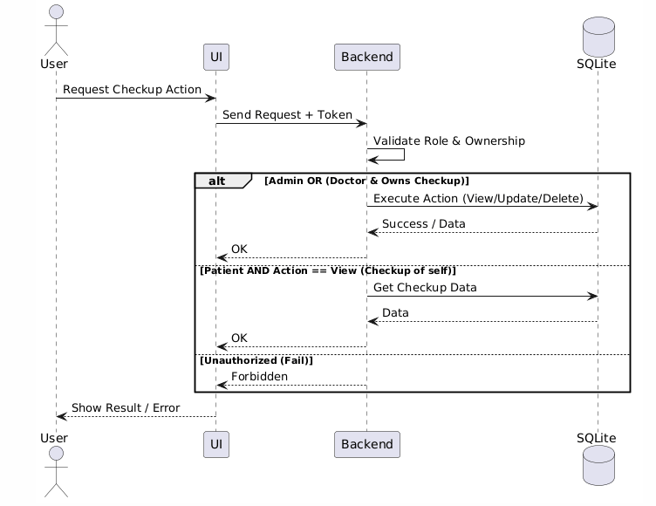

3.4 Class Diagrams
Diagram of entity-mapped objects
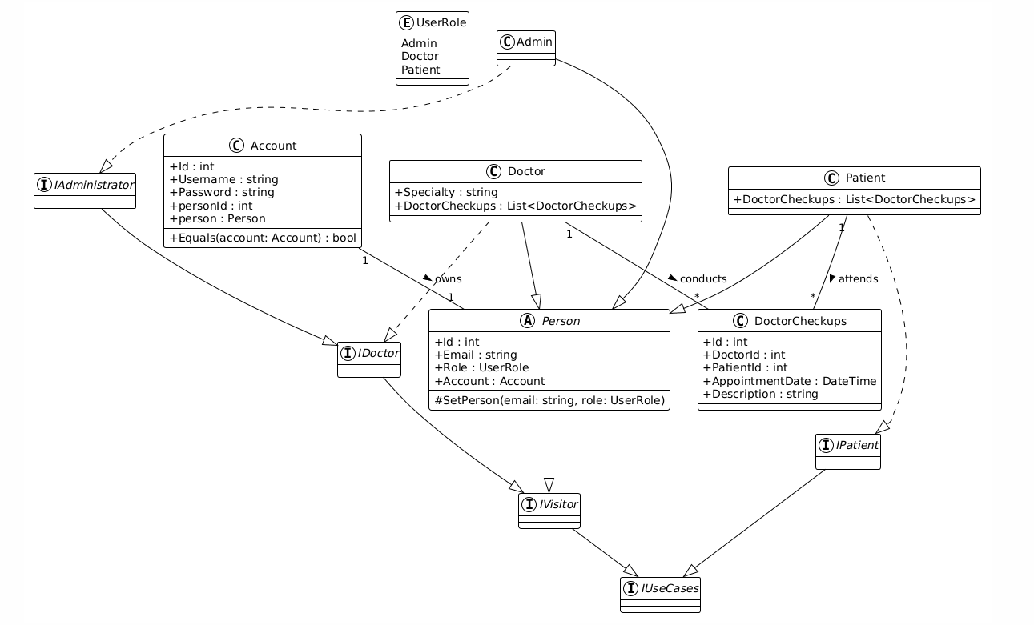

Diagram for Controller, Service, Repository setup for CRUD operations on Doctor Checkups. Events on Operations, Export Strategies and singleton DB connection
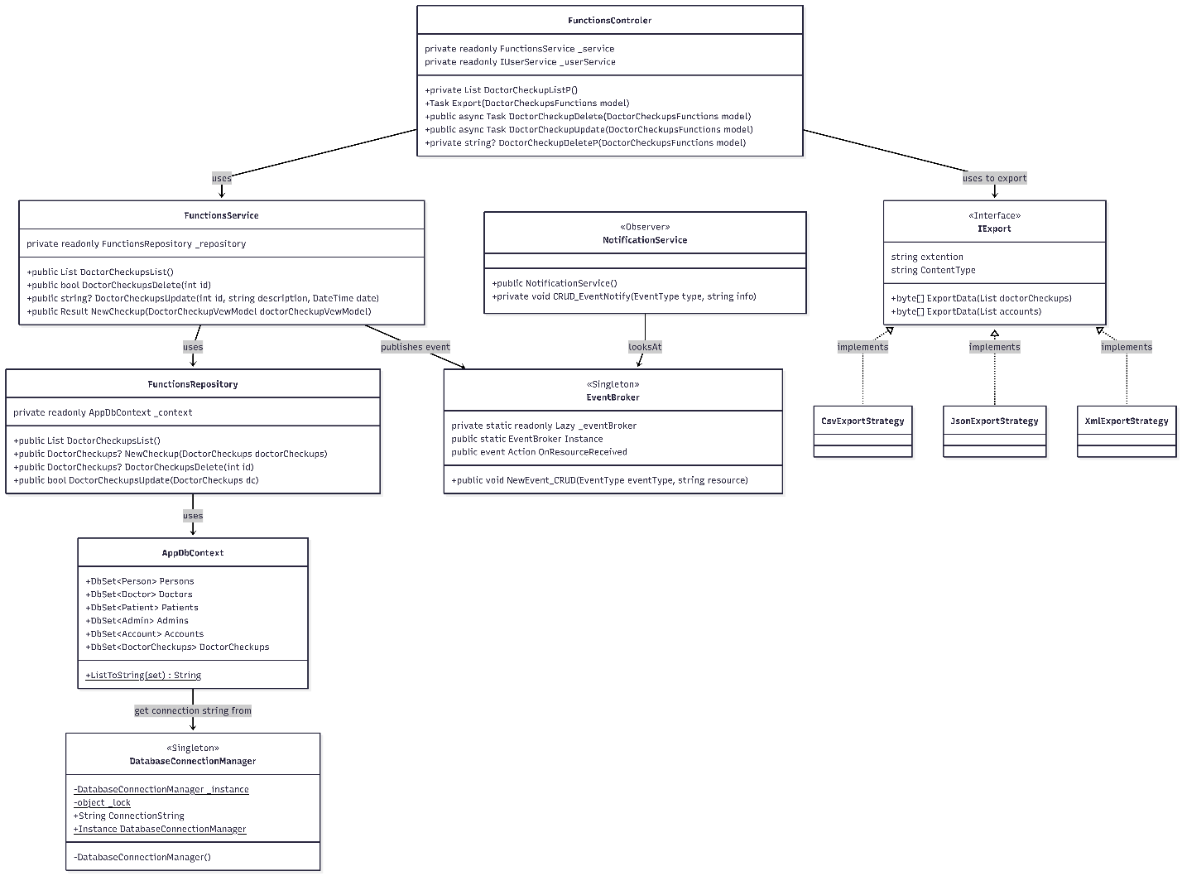

4.1 Tools and technologies
- Programming Language: C# was chosen for me to learn it.
- Framework: .NET The .NET framework is used to build the application's backend. provides built-in tools for creating web APIs
- Database Management System: SQLite. SQLite is the database for this project because it is lightweight and easy to configure. It stores the entire database in a single local file.
- Communication Protocols & Architecture: HTTPS and REST. The communication between the client interface and the server is handled using the HTTPS protocol. The backend is designed as a REST API. The client interacts with the server using standard HTTP methods (get, post).

4.2 Application structure
The application is built using a layered MVC (Model-View-Controller) architecture
The project is divided into the following primary layers and directories:
- Controllers (/Controllers) This layer handles incoming HTTP requests and user interactions. The controllers communicate with the Service layer and return the appropriate Views.
FunctionsControler and AccountController can call Export functions for doctor checkups and acoounts depending on the stategy chosen.
- Services (/Service) This layer contains the business logic of the application. Classes like AccountService and FunctionsService act as the intermediary between the Controllers and the Data Access layer.
FunctionsService emits events for CRUD operation involving doctor checkups
NotificationService attaches a function to EventBroker that prints the event message to Console(Email).
- Repositories (/Repositories) This is the Data Access layer. It encapsulates all direct database queries and operations using the AppDbContext. There are dedicated repositories (AccountRepository and DoctorRepository) for each Service class.
DatabaseConnectionManager is used as a singelton to configure the database once and to transmit a single Instance of a connection to all the specific Repositories.
- Models (/Models) This directory holds the data structures used throughout the application. It is further subdivided into:
  - Entities: The core domain objects mapped to the database tables (e.g., Accounts, DoctorCheckup).
  - ViewModels: Classes used strictly to pass data from the Controllers to the Views (SignInModel, SignUpModel).
  - HelperStructures:
  - - Utility classes like Result and Pair are used for internal logic.
  - - Export functions for checkups and accounts
  - - Getting and setting current roles
Notification Service. Listens to events and displays them in the console.
Event Broker: Singelton that collects events and listeners.

- Views (/Views) This directory contains the graphical user interface components (.cshtml files). The folders inside indicate the kind of operation being performed and map directly to the controllers (/Views/Account folder handles SignIn.cshtml and SignUp.cshtml).

