|  |  |  |  |  |
| --- | --- | --- | --- | --- |
|  | Agent | Discriminator | SVPG / Envs | Disc. Plot |
| 1 | Fixed, scratch  (fixed at random initialization) | Trained | Fixed  (ref: 16, rand:10) |  |
| 2 | Fixed, loaded  (trained agent on 13) | Trained | Fixed  (ref: 16, rand:10) |  |
| 3 | Fixed, loaded  (trained agent on 13) | Trained | Fixed  (ref: 13, rand:10) |  |
| 4 | Fixed, loaded  (trained agent on 10) | Trained | Fixed  (ref: 16, rand:10) |  |
| 5 | Fixed, loaded  (trained agent on 13) | Trained | Trained  (ref: 13, rand: 8-20) |  |
| 6 | Trained | Fixed, scratch | Fixed  (ref: 16, rand:10) |  |
| 7 | Trained | Fixed, loaded  (output of 3) | Fixed  (ref: 13, rand:10) |  |
| 8 | Trained | Fixed, loaded  (output of 4) | Fixed  (ref: 16, rand:10) |  |
| 9 | Trained | Trained | Fixed  (ref: 16, rand:10) |  |
| 10 | Trained | Trained | Fixed  (ref: 13, rand:13) |  |
| 11 | Trained | Trained | Random, No Overlap  (ref: 16, rand: 8-13) |  |
| 12 | Trained | Trained | Random, Overlap  (ref: 13, rand: 8-20) |  |
| 13 | Trained | Trained | Trained, Overlap  (ref: 13, rand: 8-20) |  |

* Ref label: 0, Rand label: 1 (y-axis) 🡪 operating range: [1.0-0.5], with 0.5 (or lower) being the discriminator perceiving the randomized transitions it receives (at its inference time) as being maximally similar to the reference transitions
* Training episodes (x-axis)

SVPG:

Creating a Peak at values 12.5 – 15.5 MES

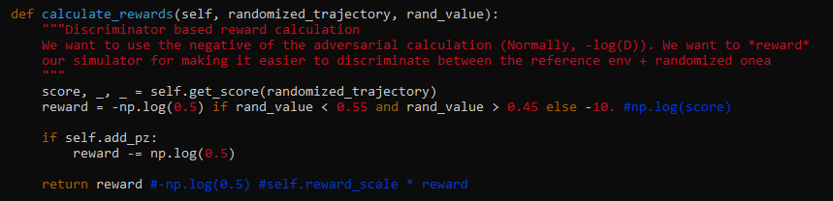

|  |  |
| --- | --- |
| Temperature | Plots |
| 5 |  |
| 0.1 |  |
| 0.01 |  |
| 0.001 |  |
| 0.0001 |  |