**TA’s Evaluate Mode Results**

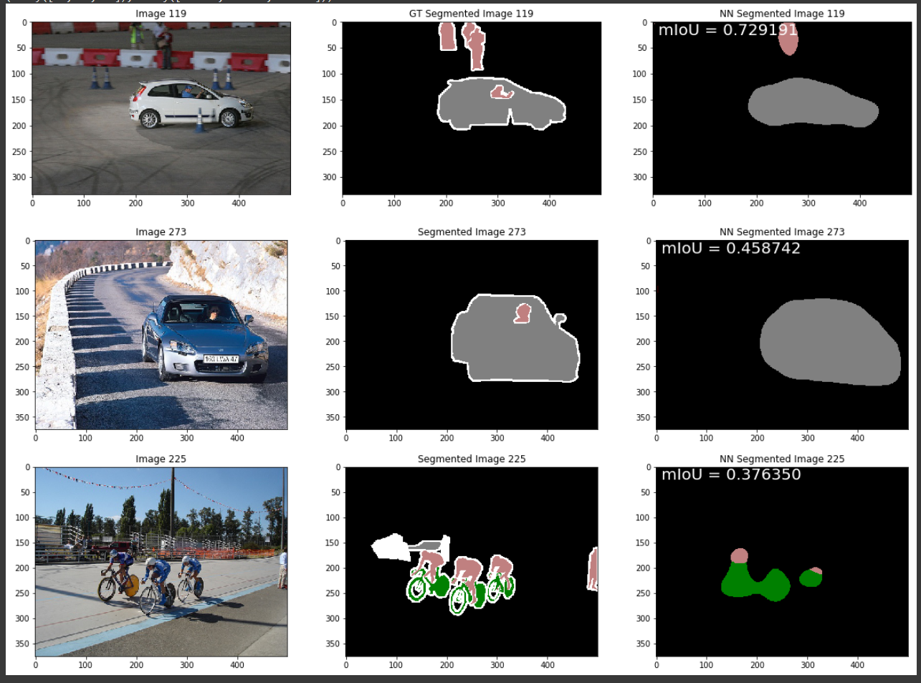

* **Bicubic up sampling method found to produce eval results closest to TA (to see where this observation came, compare image above with following pages…)**

**1st Try (Training 40 Epochs + Nearest up sampling + NN implemented from last tutorial slide)**

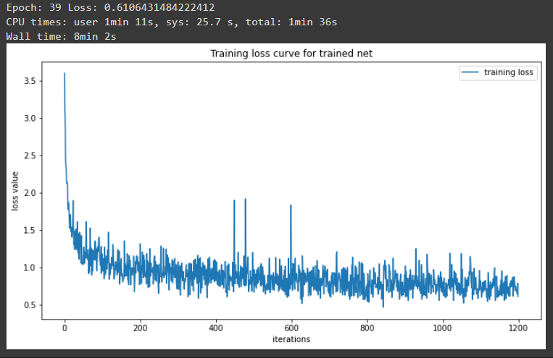

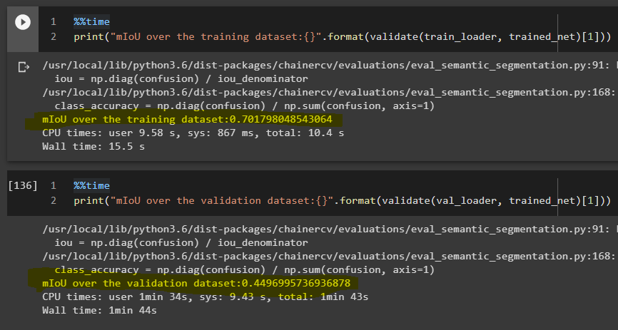

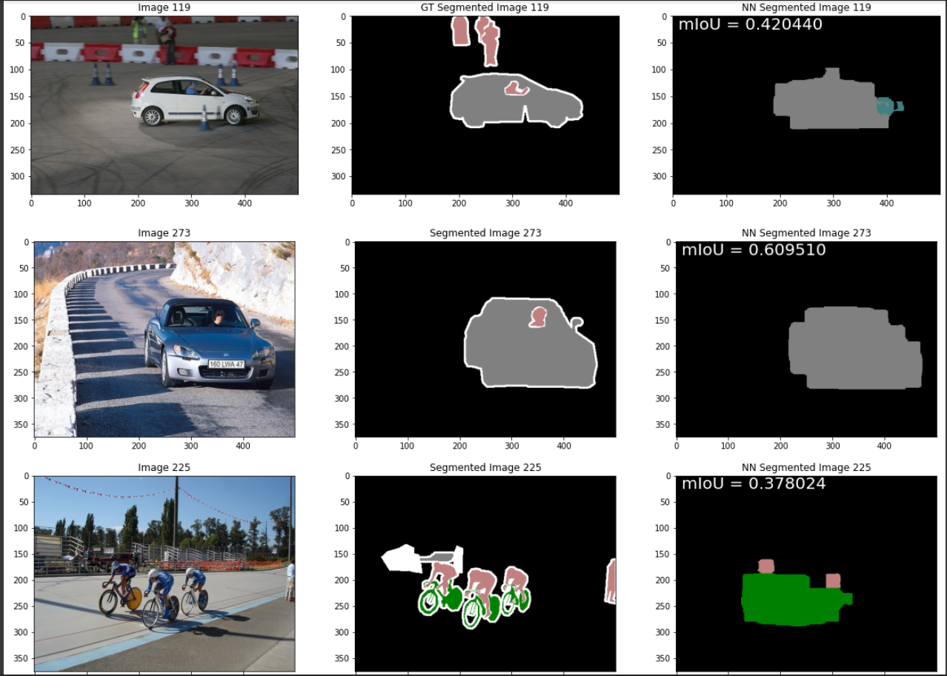

**2nd Try (Training 40 Epochs + Bilinear up sampling + NN implemented from last tutorial slide)**

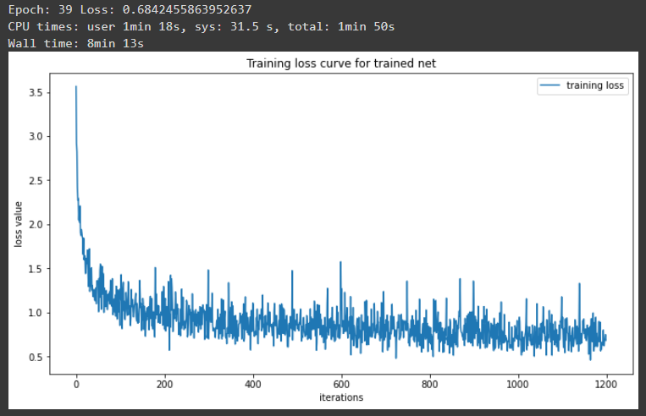

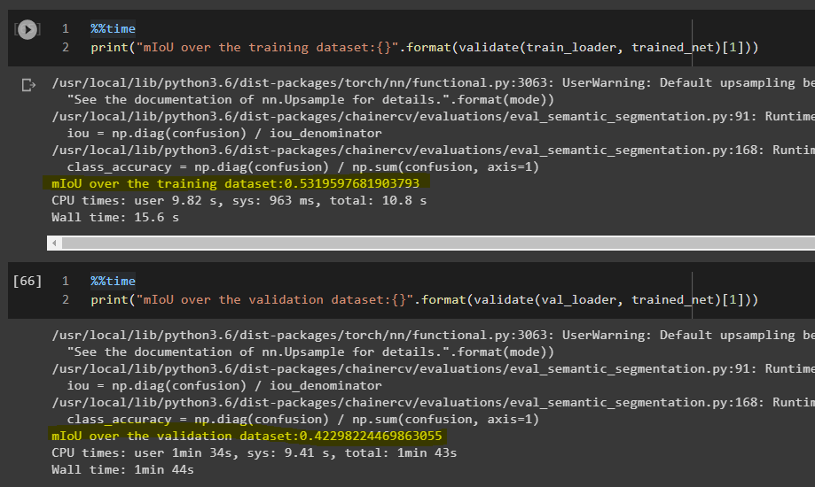

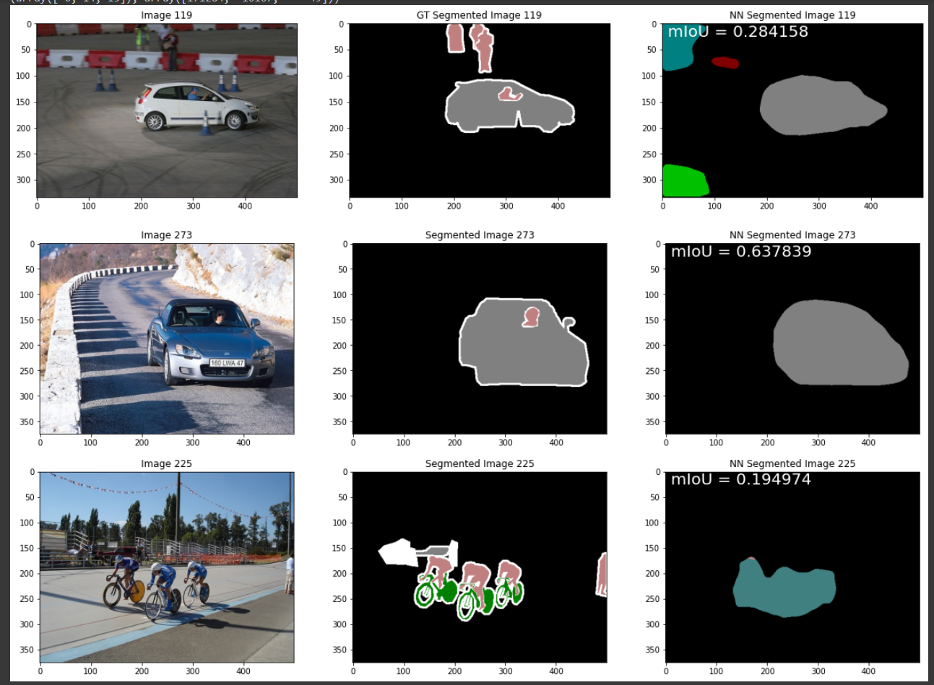

**3rd Try (Training 40 Epochs + Bicubic up sampling + NN implemented from last tutorial slide)**

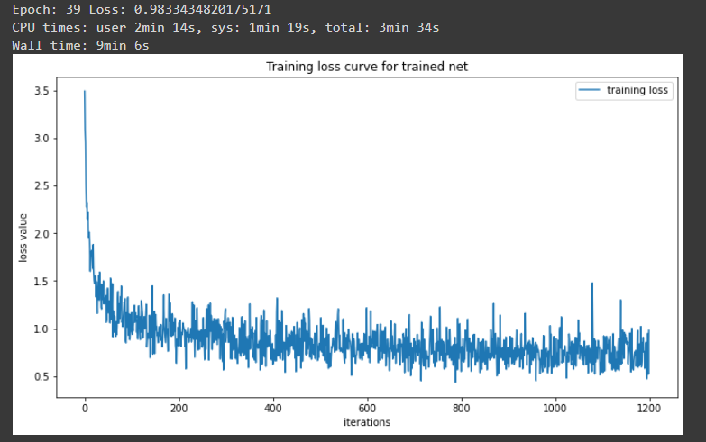

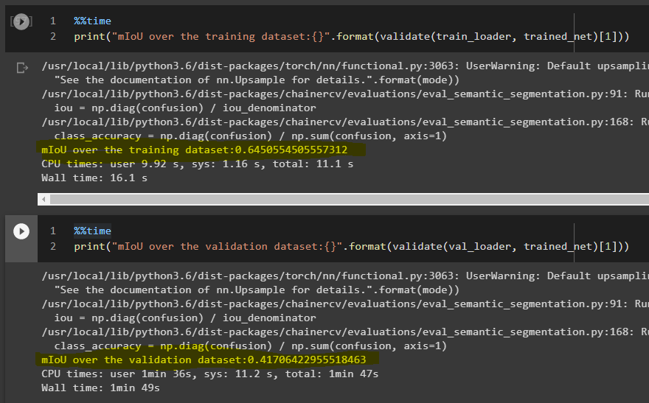

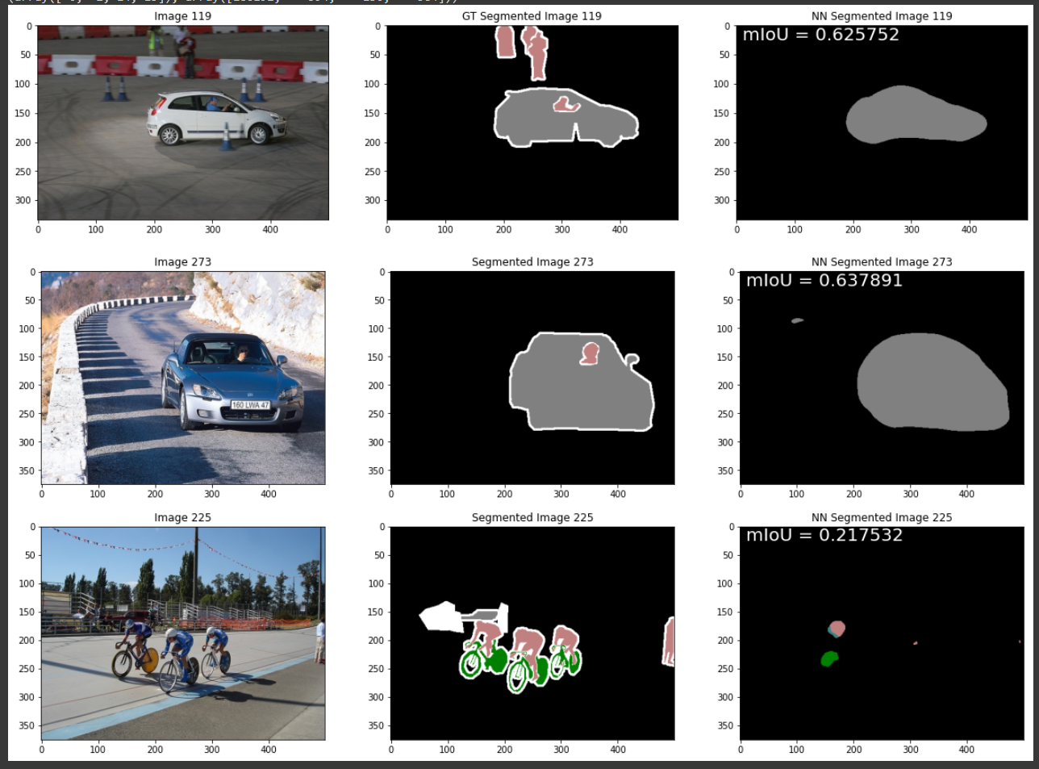

**4th Try (Training 60 Epochs + Bicubic up sampling + NN implemented from last tutorial slide)**

