# Puppet Training

**Prepare development environment,**$ sudo su -

$ yum update

$ yum groupinstall -y "development tools"

$ yum install -y lsof, wget, vim-enhanced, Words, which

$ **git** config --global user.name "Your Name"

$ **git** config --global user.email [your_email@example.com](mailto:your_email@example.com)

$ **ssh**-keygen -t rsa -b 4096 -C [email@address.here](mailto:email@address.here)

$ **cat** /root/.ssh/id_rsa.pub

$ **git** clone git@github.com:talhakim/puppet-training.git

$ curl <https://raw.githubusercontent.com/linuxacademy/content-python3-sysadmin/master/helpers/bashrc> -o ~/.bashrc

$ curl [https://raw.githubusercontent.com/linuxacademy/content-python3-sysadmin/master/helpers/vimrc -o ~/.vimrc](https://raw.githubusercontent.com/linuxacademy/content-python3-sysadmin/master/helpers/vimrc%20-o%20~/.vimrc)

PORTS #  
Agent: 8140   
MCollective: 61613  
Installer: 3000  
Console: 443  
PostgrSQL: 5432  
DB traffic: 8081  
Orchestration: 8142

SELinux must be disabled or set to permissive (warnings only)

**/var/log/messages**

**/etc/puppetlabs/puppet/puppet.conf**

**/etc/puppetlabs/enterprise/conf.d/pe.conf**

**R10K:** /etc/puppetlabs/r10k

**Environments**: /etc/puppetlabs/code/environments

**Modules** Direcotry for master modules

**Manifests** start point for catalog compilation

**SSL Certificate** infrasturucture /etc/puppetlabs/puppet/ssl

## Log Locations

Master: /var/log/puppetlabs/puppetserver  
Agent: /var/log/messages  
ActiveMQ: /var/log/puppetlabs/activemq  
MCollective & Console logs: /var/log/puppetlabs/  
Installer: /var/log/puppetlabs/installer

## Resources, Classes & Modules

Classes

Modules

Resource Types

Module – Self contained bundle of code to manage a technology.

Class – Use Resource types for configuration. It is a named block of code that is used in a Module. Must be invoked by name to apply.

$ puppet module generate training-ssh

$ puppet describe package -l\-s #(-l for listings. -s for short description)

$ puppet resource user root

***Puppet apply*** vs ***puppet agent -t***

*Puppet apply* is code\manifest applied locally and then recognised by the agent.

*Puppet Agent --test* is modules applied from master site.pp

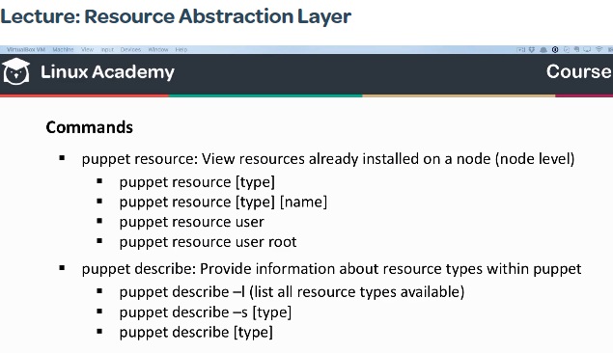

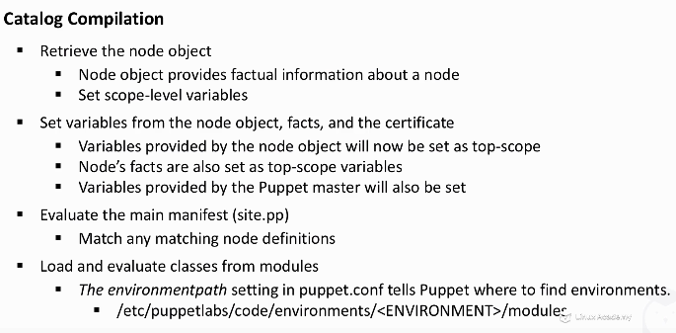

## Puppet Certificates

**Puppet cert [list, sign, revoke, clean] <-a>**

**Puppet cert sign [hostname, -a, --allow-dns-alt-names <name>]** # sign based on DNS names

## Puppet Classification

## 

#### SITE.PP FILE #####

node_default {

class {‘ntp’:

}

}

node server01.local {

include pe_repo::platfrom::ubuntu_1404_amd64

include pe_repo::platfrom::el_7_x86_64

}

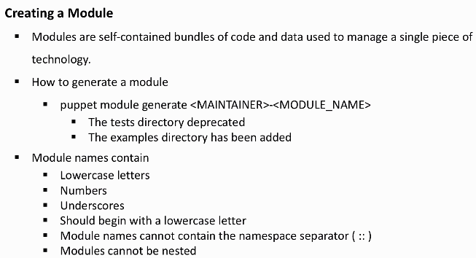

**Puppet Syntax**

<TYPE> {‘<TITLE>’:

<ATTRIBUITE> => <VALUE>,

}

class tree::install {

package {‘tree’,

ensure => present,

}

**Custom Facts**

# vim /etc/puppetlabs/facter/facts.d/facts.txt

owner=Tarek Alhakim

**Meta-parameters**

**Require:** require a resource to apply first

**Before:** self applied before the resource

**Subscribe:** listen to changes applied to a resource

**Notify:** generate a notification when changes applied to a resource