Space Time Block Codes (STBC) is a coding technique which manipulates the transmit diversity of the parallel multiple transmitting channels to improve the quality of the received signal via the multiple copies of the transmitted data via the different paths of the channels.

Signal transmission in wireless communication must be able to transmit multiple streams of data across a number of antennas Space Time Block Codes (STBC) was used to accommodate this requirement and exploiting the various received version of the data to improve the reliability of data transfer. Wireless communication utilise unguided transmission for data transfer, thus the signal will experienced scattering, reflection, reflection, refraction and the receiver might have thermal noise which corrupting the message signal.

The way that wireless transmission was performed is that the signal will be transmitted repeatedly and the receiver will receive a number of versions of that signal. Due to interference and noise, some of the signal is better than the other and receiver will use the redundancy of the received signal and decode it. STBC combines all of the versions and extract as much information as possible from it.

STBC represented in matrix form with each rows represents a time slot and each column represents antenna’s transmission over time.

*Transmit antennas*

$time-slots \left[\begin{matrix}s_{11} & s_{12} & … & s_{{1n}_{T}} \\ s_{21} & s_{22} & … & s_{{2n}_{T}} \\ ⋮ & ⋮ & ⋮ & ⋮ \\ s_{T1} & s_{T2} & … & s_{{Tn}_{T}}\end{matrix}\right]$

*s­­ij* = modulated symbol to be transmitted in time slot *i* from antenna *j*.

*T* = time slots.

*nT =*transmit antennas.

*nR* = receive antennas.

In designing STBC, orthogonal matrix is needed which the vectors representing any pair of columns from the coding matrix is orthogonal which result simple, linear, and optimal decoding at the receiver. Due to this, the data will sacrifice some portion of the data rate. Quasi-orthogonal STBC can achieve higher data rate but will experiencing inter-symbol interference (ISI).

Alamouti’s code is the simplest STBC which was designed for a two-transmit antenna system with 2 by 2 matrix. Tarokh et al. designed higher order STBC for 3 and 4 transmit antennas and later prove that the code-rate cannot be achieved fully for any pairs more than 2 transmit antennas.

Rate less Space Time Block Coding (RSTBC) is a coding technique which manipulates the transmit diversity of the parallel multiple transmitting channels to improve the quality of the received signal via the multiple copies of the transmitted data via the different paths of the channels while applying the principle of rate less codes.

RSTBC requires time delay, due to, RSTBC are transmitted through different channels that are orthogonal with time.

**4 x 4 Uncoded MIMO using Zero Forcing**

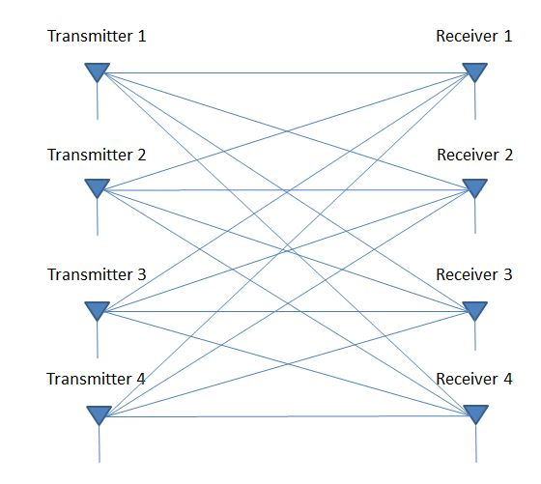

Figure Channel from Transmitter j to Receiver i is represented by hij

Following Rayleigh distribution, the impulse response envelope was developed.

Tabulation of the symbols transmitted is as below:

|  |  |  |  |  |
| --- | --- | --- | --- | --- |
|  | **T1** | **T2** | **T3** | **T4** |
| **1st Time Slot** | x1 | x2 | x3 | x4 |
| **2nd Time Slot** | x5 | x6 | x7 | x8 |

In the table, T denotes as the Transmitter xi’s are the QAM modulated Symbols

Following that, the vectors can now be written in matrix form as below:

Where yi is received signal at ith receiver antenna and ni is cumulative AWGN noise at ith receiver antenna.

**MATLAB SIMULATION**

For this simulation, 16 channels are required in every time slot which the channel impulse responses followed Rayleigh distribution:

$$h=x+iy$$

Where x and y are the Gaussian random variables. We first generate H matrix which is the matrix channel and then generate X matrix for 4-QAM modulated input symbols.

**Decoding 4x4 Uncoded System Using Zero Forcing (ZF) Techniques.**

A ZF decoder generates an estimate of the transmitted matrix as:

$$\hat{X}=pinv\left(H\right)Y$$

Where *pinv* denotes as the pseudo inverse operation and denotes as the estimation of *X*.

The estimated, , ….. were sent into an ML decoderand and the nearest constellation point is obtained for each of them separately.

**Results and Discussion**

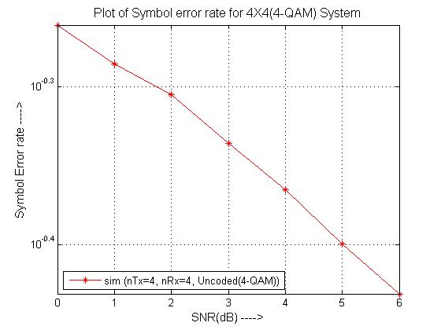

Figure above shows the plot of the symbol error rate (SER) for 4x4 (4-QAM) system with SNR range from 0 to 6db.

The graph shows that with the increase of the SNR. The SER is dropping to 0 with SNR value of 6db. The highest SER is 10-0.5479 with SNR value of 0db.

**Appendix:**

**MATLAB Codes for 4X4 STBC for MIMO in 4-QAM:**

%%%%%%%%%%%%% 4 X 4 STBC %%%%%%%%%%%%%%%

clc

clear all;

close all;

%parameter setup

N = 4*10^4; %number of bit to process

M=4; %size of signal constellation

x = randi([0 3],1,N); %generating random number

% signal modulation

xmod=qammod(x,4);

xmod=reshape(xmod,4,N/4);

xmod=kron(xmod,[1,1,1,1]); %Matrix formed by taking all %possible products between the elements of xmod and the matrix of 1's

%generating 4x4 matrix and zero forcing

for i=1:16

h(i,:)=1/sqrt(2)*(randn(1,N/4) + 1i*randn(1,N/4));

end

H=reshape(h,4,N);

y=reshape(sum(H.*xmod,1),4,N/4);

H=reshape(h,4,4,N/4);

snr=linspace(0,6,7);

ser=zeros(1,length(snr));

for ii=1:length(snr)

N1=1/sqrt(2)*(randn(1,N)+1i*randn(1,N));

N1=reshape(N1,4,N/4);

ynoisy=y+10^(-(snr(ii)-10*log10(16))/20)*N1;

ynoisy=awgn(y,snr(ii),'measured'); %adding white gaussian noise

ynoisy=reshape(ynoisy,4,1,N/4);

B=[];recvd=[];

for kk=1:N/4

Heq=transpose(H(:,:,kk));

B=pinv(Heq);

recvd=[recvd,B*ynoisy(:,:,kk)];

end

finy=qamdemod(reshape(recvd,1,N),4); %signal demodulation

[num ty]=symerr(x,finy);

ser(ii)=ty;

end

semilogy(snr,ser,'r-*'); %result presentation

grid on;hold on;

title('Plot of Symbol error rate for 4X4(4-QAM) System','FontSize',12);

legend('sim (nTx=4, nRx=4, Uncoded(4-QAM))','location','southwest');

xlabel('SNR(dB) ---->','Color','k','FontSize',11);Ylabel('Symbol Error rate ---->','Color','k','FontSize',11);

**128 x 128 Uncoded MIMO using Zero Forcing**

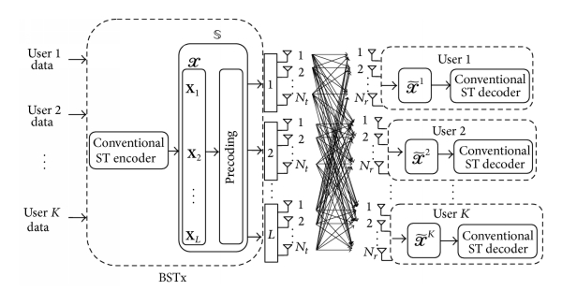

Following Rayleigh distribution, the impulse response envelope was developed.

Tabulation of the symbols transmitted is as below:

|  |  |  |  |  |  |  |  |  |  |
| --- | --- | --- | --- | --- | --- | --- | --- | --- | --- |
|  | **T1** | **T2** | **T3** | **T4** | **.** | **.** | **.** | **.** | **T128** |
| **1st Time Slot** | x1 | x2 | x3 | x4 | . | . | . | . | X128 |
| **2nd Time Slot** | x5 | x6 | x7 | x8 | . | . | . | . | X16384 |

In the table, T denotes as the Transmitter xi’s are the QAM modulated Symbols

Following that, the vectors can now be written in matrix form as below:

Where yi is received signal at ith receiver antenna and ni is cumulative AWGN noise at ith receiver antenna.

**MATLAB SIMULATION**

For this simulation, 128*128= 16384 channels are required in every time slot which the channel impulse responses followed Rayleigh distribution:

$$h=x+iy$$

Where x and y are the Gaussian random variables. We first generate H matrix which is the matrix channel and then generate X matrix for 4-QAM modulated input symbols.

**Decoding 128x128 Uncoded System Using Zero Forcing (ZF) Techniques.**

A ZF decoder generates an estimate of the transmitted matrix as:

$$\hat{X}=pinv\left(H\right)Y$$

Where *pinv* denotes as the pseudo inverse operation and denotes as the estimation of *X*.

The estimated, , ….. were sent into an ML decoderand and the nearest constellation point is obtained for each of them separately.

**Results and Discussion**

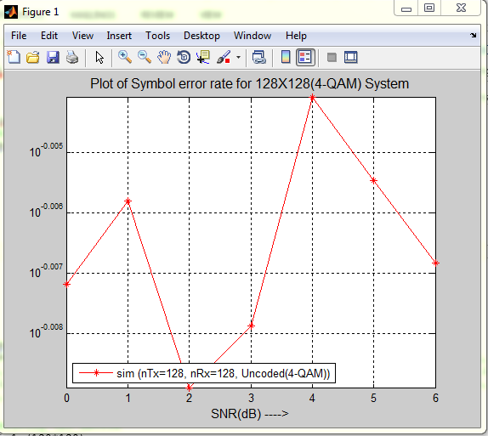

Figure above shows the plot of the symbol error rate (SER) for 128x128 (4-QAM) system with SNR range from 0 to 6db.

The graph shows that with the increase of the SNR. The SER is dropping to 0 with SNR value of 6db. The highest SER is 10-0.005479 with SNR value of 0db.

**Appendix:**

**MATLAB Codes for 128X128 RSTBC for MIMO in 4-QAM**

%%%%%%%%%%%%% 128 X 128 STBC %%%%%%%%%%%%%%%

clc

clear all;

close all;

%parameter stup

N = 128*10; %number of bit to process

M=4; %size of signal constellation

x = randi([0 3],1,N); %generating random number

% signal modulation

xmod=qammod(x,4);

xmod=reshape(xmod,128,N/128);

xmod=kron(xmod,[1,1,1,1,1,1,1,1,1,1,1,1,1,1,1,1,1,1,1,1,1,1,1,1,1,1,1,1,1,1,1,1,1,1,1,1,1,1,1,1,1,1,1,1,1,1,1,1,1,1,1,1,1,1,1,1,1,1,1,1,1,1,1,1,1,1,1,1,1,1,1,1,1,1,1,1,1,1,1,1,1,1,1,1,1,1,1,1,1,1,1,1,1,1,1,1,1,1,1,1,1,1,1,1,1,1,1,1,1,1,1,1,1,1,1,1,1,1,1,1,1,1,1,1,1,1,1,1]); %Matrix formed by taking all %possible products between the elements of xmod and the matrix of 1's

%generating 128x128 matrix

for i=1:(128*128)

h(i,:)=1/sqrt(2)*(randn(1,N/128) + 1i*randn(1,N/128));

end

H=reshape(h,128,N);

y=reshape(sum(H.*xmod,1),128,N/128);

H=reshape(h,128,128,N/128);

snr=linspace(0,6,7);

ser=zeros(1,length(snr));

for ii=1:length(snr)

N1=1/sqrt(2)*(randn(1,N)+1i*randn(1,N));

N1=reshape(N1,128,N/128);

ynoisy=y+10^(-(snr(ii)-10*log10(128*128))/20)*N1;

ynoisy=awgn(y,snr(ii),'measured'); %adding white gaussian noise

ynoisy=reshape(ynoisy,128,1,N/128);

B=[];recvd=[];

for kk=1:N/128

Heq=transpose(H(:,:,kk));

B=pinv(Heq);

recvd=[recvd,B*ynoisy(:,:,kk)];

end

finy=qamdemod(reshape(recvd,1,N),128); %signal demodulation

[num ty]=symerr(x,finy);

ser(ii)=ty;

end

semilogy(snr,ser,'r-*'); %result presentation

grid on;hold on;

title('Plot of Symbol error rate for 128X128(4-QAM) System','FontSize',12);

legend('sim (nTx=128, nRx=128, Uncoded(4-QAM))','location','southwest');

xlabel('SNR(dB) ---->','Color','k','FontSize',11);Ylabel('Symbol Error rate ---->','Color','k','FontSize',11);

**Reference:**

1. **http://spacetimecodes.blogspot.sg/**
2. **MIMO Space-Time Block Coding (STBC): Simulations and Results, Luis Miguel Cortes-Pena, DESIGN PROJECT: PERSONAL AND MOBILE COMMUNICATIONS, GEORGIA TECH (ECE6604), APRIL 2009.**
3. **Rateless STBC: http://www.hindawi.com/journals/ijap/2014/154261/**