
Project 1: Snooping Cache Coherence Simulator (MESI)
EECE 422-Applied Parallel Computing and Programming
Professor Mazen Saghir
May 4th, 2026

1. Design
Architecture: The simulator uses five components. The System object which manages the execution of the simulation(sends each trace event to the right cache), caches, bus, memory, and stats object. The Cache stores a direct-mapped array of lines. Bus broadcasts BusRd, BusRdX, BusUpgr, and BusWB and calls the snoop logic in every other cache. Memory only counts writebacks because the project tracks addresses, not data values. Stats keeps the per-core and global counters required by the handout.
State representation: Each cache line stores a tag and one MESI state: Invalid (I), Shared S, Exclusive E, or Modified M. The direct-mapped placement is index = address mod C and tag = address // C. That choice makes conflict behavior repeatable, which is helpful when checking the experiments.
Configuration: Number of cores(N), cache lines(C), and Memory size (M) are constructor arguments. The enable_e flag turns the Exclusive state on or off. When enable_e is False, read misses install S instead of E, so the simulator can run the MSI-like comparison used in Experiment 4.
State transition diagram: Figure 1 splits the MESI state machine into processor-side and snoop-side transitions. The processor diagram omits conflict evictions to keep the figure readable; evictions are handled in the implementation text below.
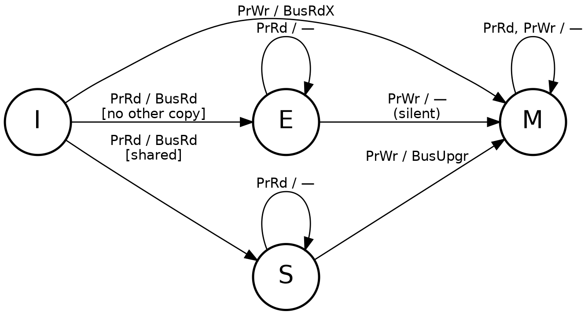
Figure 1a - Processor-side transitions. A private read installs E; a shared read installs S.
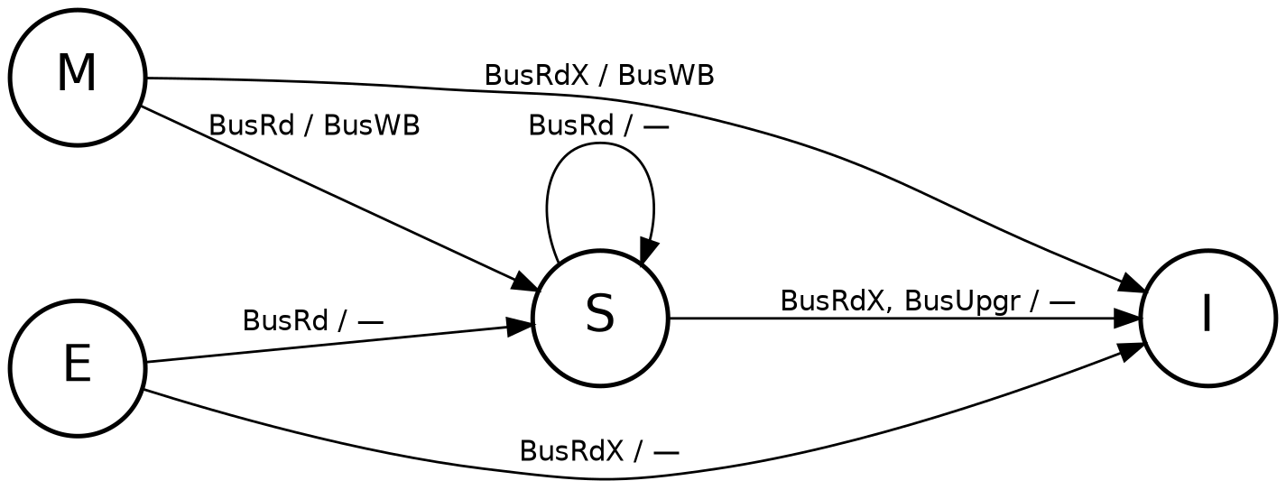
Figure 1b - Snoop-side transitions. Dirty owners write back before sharing or invalidating.
Data structures: The code keeps the bus stateless (i.e it does not maintain a sharer table). On each bus request it asks every other cache whether it holds the line. That matches the snooping model in the handout and keeps the simulator easy to inspect. The stats object stores arrays for per-core counters and scalar counters for bus events.

2. Implementation
Atomic order: The simulator is single-threaded. Each trace entry completes before the next one starts, so a bus request is fully snooped before another processor event is handled.
Read miss flow: A read miss first checks the target cache slot. If a different modified line sits there, the simulator issues a BusWB for the eviction. Then the requester broadcasts BusRd. A remote M line writes back and moves to S, a remote E line moves to S without writeback, and S stays S. If no other cache responds, the requester installs E. Otherwise it installs S.
Write flow: A write miss broadcasts BusRdX and installs M. Other holders invalidate; an M holder writes back first. A write hit in M is silent. A write hit in E silently upgrades to M and increments the silent-upgrade counter. A write hit in S sends BusUpgr, invalidates other S copies, and then moves to M. The simulator counts this S-to-M case as a write hit because the data is already present; the ownership cost is counted through BusUpgr and invalidation counters.
Evictions and checks: Clean S/E evictions are silent; M evictions issue BusWB. After the runs, invariant_check verifies that M and E never coexist with any other valid copy and that multiple M or E holders never appear. The audited code also rejects bad system sizes and Trace A configurations that would make supposedly private address ranges overlap.
Testing: The final test suite has 39 functions and 140 assertions. It covers processor transitions, snooped transitions, dirty and clean evictions, enable_e=False behavior, empty traces, one-core runs, boundary addresses, bad core/address/op inputs, bad N/C/M values, Trace A window validation, and a dense write-hammer stress pattern. After testing, all the tests have passed.

3. Experiments
All runs are deterministic. Unless stated otherwise, the configuration is N = 4, C = 8, and M = 64. Tables report event counts, not cycles.

3.1 Experiment 1: Baseline protocol behavior
Trace A has four cores repeatedly reading four private addresses for three passes. Trace B has core 0 write six addresses, then cores 1-3 read them. Trace C is sixteen writes to one address in round-robin core order.
Table 1 - Global baseline statistics. A = private, B = producer-consumer, C = migratory.
Trace | RH | RM | WH | WM | MR | BusRd | BusRdX | BusUpgr | BusWB | BusTot | Inv | SU
A | 32 | 16 | 0 | 0 | 0.333 | 16 | 0 | 0 | 0 | 16 | 0 | 0
B | 0 | 18 | 0 | 6 | 1.000 | 18 | 6 | 0 | 6 | 30 | 0 | 0
C | 0 | 0 | 0 | 16 | 1.000 | 0 | 16 | 0 | 15 | 31 | 15 | 0
Table 2 - Per-core baseline counters. SU is zero for all rows.
Trace | Core | RH | RM | WH | WM | InvC | InvR | SU
A | 0 | 8 | 4 | 0 | 0 | 0 | 0 | 0
A | 1 | 8 | 4 | 0 | 0 | 0 | 0 | 0
A | 2 | 8 | 4 | 0 | 0 | 0 | 0 | 0
A | 3 | 8 | 4 | 0 | 0 | 0 | 0 | 0
B | 0 | 0 | 0 | 0 | 6 | 0 | 0 | 0
B | 1 | 0 | 6 | 0 | 0 | 0 | 0 | 0
B | 2 | 0 | 6 | 0 | 0 | 0 | 0 | 0
B | 3 | 0 | 6 | 0 | 0 | 0 | 0 | 0
C | 0 | 0 | 0 | 0 | 4 | 3 | 4 | 0
C | 1 | 0 | 0 | 0 | 4 | 4 | 4 | 0
C | 2 | 0 | 0 | 0 | 4 | 4 | 4 | 0
C | 3 | 0 | 0 | 0 | 4 | 4 | 3 | 0

3.2 Experiment 2: Effect of number of cores
Trace B was rebuilt for each N. Core 0 still produces six addresses, while the remaining N - 1 cores consume them.
Table 3 - Trace B while varying N, with C = 8 and M = 64.
N | BusRd | BusRdX | BusUpgr | BusWB | BusTot | Inv
2 | 6 | 6 | 0 | 6 | 18 | 0
4 | 18 | 6 | 0 | 6 | 30 | 0
6 | 30 | 6 | 0 | 6 | 42 | 0
8 | 42 | 6 | 0 | 6 | 54 | 0

3.3 Experiment 3: Effect of cache size
Trace C was run with C = 4, 8, 16, and 32. A private capacity-sensitive workload is also included to separate capacity misses from coherence misses.
Table 4 - Trace C while varying C, with N = 4 and M = 64.
C | MR | BusTot | BusRd | BusRdX | BusUpgr | BusWB
4 | 1.000 | 31 | 0 | 16 | 0 | 15
8 | 1.000 | 31 | 0 | 16 | 0 | 15
16 | 1.000 | 31 | 0 | 16 | 0 | 15
32 | 1.000 | 31 | 0 | 16 | 0 | 15
Table 5 - Capacity-sensitive private reads: 16 addresses per core, three passes.
C | MR | BusTot | BusRd | BusWB
4 | 1.000 | 192 | 192 | 0
8 | 1.000 | 192 | 192 | 0
16 | 0.333 | 64 | 64 | 0
32 | 0.333 | 64 | 64 | 0

3.4 Experiment 4: Silent upgrade analysis
The required Trace A has no writes, so full MESI and E-disabled MESI produce the same bus count. A second read-then-write private trace shows where the E state matters.
Table 6 - Required Trace A: E enabled versus E disabled.
Config | BusRd | BusRdX | BusUpgr | BusWB | BusTot | SU
MESI | 16 | 0 | 0 | 0 | 16 | 0
E disabled | 16 | 0 | 0 | 0 | 16 | 0
Table 7 - Read-then-write private trace.
Config | BusRd | BusRdX | BusUpgr | BusWB | BusTot | SU
MESI | 16 | 0 | 0 | 0 | 16 | 16
E disabled | 16 | 0 | 16 | 0 | 32 | 0

4. Analysis

4.1 Baseline behavior
Trace A behaves like a clean private-read workload. Each core has four cold misses on its first pass and eight hits later. No line is shared, so there are no invalidations, writebacks, or ownership upgrades. The 16 BusRd events are exactly the 16 first touches.
Trace B is producer-consumer sharing without later producer updates. Core 0 writes six addresses, creating six BusRdX events and six M lines. Core 1 is the first reader, so each of its six reads finds a dirty owner and forces one BusWB while downgrading core 0 from M to S. Cores 2 and 3 read the same lines after that; they still miss locally, but the remote copies are already clean S lines, so no more writebacks occur. That gives 18 BusRd, 6 BusRdX, 6 BusWB, and 0 invalidations.
Trace C is the opposite pattern. One line keeps moving between writers. The first write installs M without invalidating anyone. The next fifteen writes each find a previous M owner, so each causes one BusRdX, one dirty writeback, and one invalidation. Total traffic is therefore 16 BusRdX + 15 BusWB = 31 bus transactions, with 15 invalidations. The per-core invalidation counts are slightly uneven only because core 0 owns the first version and core 3 owns the last one.

4.2 Core count scaling
For Trace B, total bus traffic follows 12 + 6(N - 1). The constant 12 is the producer work: six BusRdX writes plus six writebacks when the first consumer reads the dirty lines. The 6(N - 1) term comes from the consumers: every consumer reads six lines and issues six BusRd transactions. Adding cores therefore adds bus traffic even though the data set stays fixed. That is the shared-bus snooping bottleneck: every bus event is still seen by every cache.

4.3 Cache size and coherence misses
Trace C is intentionally insensitive to cache capacity because it touches one address. The misses are not capacity misses; they are coherence misses caused by another core taking ownership. Increasing C from 4 to 32 cannot stop a remote write from invalidating the local copy, so the miss rate and bus traffic stay flat.
Table 5 is a useful contrast. Each core reads 16 private addresses three times. With C = 4 or 8, the working set does not fit and every pass misses. With C = 16 or 32, only the first pass misses, so the miss rate drops to 16 / 48 = 0.333 per core. The two tables together separate two effects: cache size helps capacity behavior, but it does not fix true sharing traffic.

4.4 Exclusive state and silent upgrades
On the required Trace A, the traffic reduction is 0%. That result is correct because Trace A never writes after reading. E lines are created, but they never use the E-to-M silent path.
The read-then-write private trace shows the point of E. With MESI, 16 first reads install E and the first write to each line silently upgrades it to M. The second write pass then hits in M. Total traffic remains 16 BusRd.Now with E disabled, the first reads install S, so the first write to each line issues BusUpgr even though no other core has the line. Total traffic becomes 16 BusRd + 16 BusUpgr = 32. Also, The E state cuts bus traffic by 50% on this workload.

4.5 Limits of the model
The simulator reports event counts, not performance time. It assumes an atomic bus, one-word lines, direct-mapped caches, no cache-to-cache transfer, and no false sharing. These limits match the project scope, but they mean the results should be read as coherence-behavior counts, not as latency or bandwidth predictions for a real processor.

