Spatial-Temporal Dynamics of Conflict Mortality: A Multi-Scalar Analysis of the War in Yemen (2015–2026)

1. Executive Summary

This report evaluates the geographic and temporal distribution of conflict-related fatalities in Yemen from the initiation of major external military interventions in early 2015 through mid-2026. Utilizing multi-scalar demographic data aggregated at both the governorate (macro) and district (micro) administrative levels, this analysis tests whether violence was uniformly distributed or structurally concentrated.

The empirical findings reveal a conflict characterized by extreme geographic polarization and distinct temporal waves. Refinement of spatial metrics via Lorenz Curves indicates that 10% of municipal districts shouldered nearly 68% of the entire nationwide death toll, generating a hyper-concentrated Gini Coefficient of 0.7906. Temporally, a clear "truce cliff" in mid-2022 permanently altered the war's trajectory, transitioning the conflict from high-intensity campaigns to a frozen, low-intensity regional equilibrium.

2. Methodology & Spatial Units

To eliminate analytical biases associated with spatial aggregation, conflict mortality was evaluated using two separate administrative resolutions across Yemen's 22 Governorates:

- Macro-Administrative Level (Governorate): Evaluates broad regional balances of power across the country's 22 primary provinces.
- Micro-Administrative Level (District): Evaluates local municipal environments across 332 districts to expose inner-province variances.

Inequality and concentration of fatalities were mathematically calculated using the Lorenz Curve and integrated via the Trapezoidal Rule to extract definitive Gini Coefficients (G), where G = 0 represents perfect equality (violence evenly spread) and G = 1 represents absolute concentration (all deaths in a single locality).

3. Main Empirical Findings & Results

A. Extreme Spatial Inequality (The Lorenz Shift)
The distribution of lethal kinetic violence across Yemen was structurally uneven, functioning as a series of localized enclave battles rather than a broad, uniform civil war.

- Governorate-Scale Disparity (G = 0.5684)
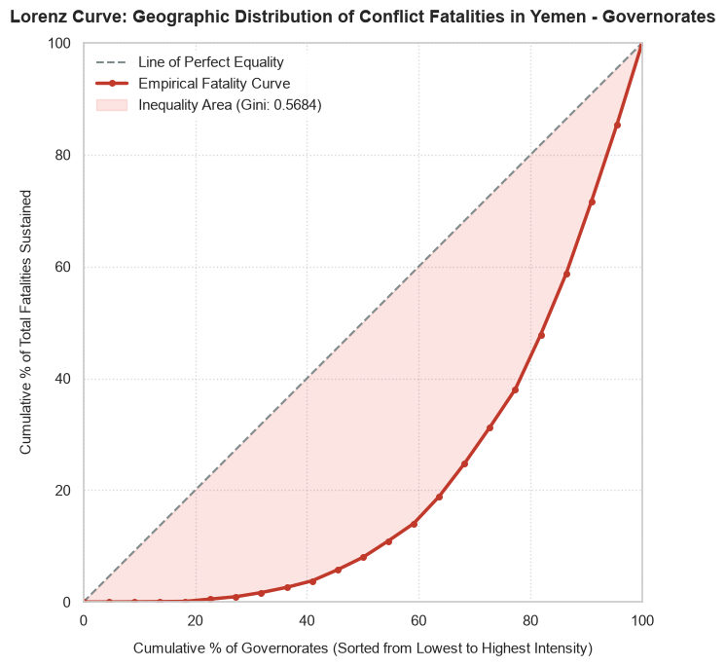

At the macro level, a mere 5 governorates (Marib, Taiz, Sa'dah, Al Hudaydah, and Al Jawf) accounted for approximately 62% (~101,500 deaths) of the ~164,000 total recorded fatalities. The top 10 governorates captured roughly 89% (~146,000 deaths), leaving the remaining 12 governorates to split a minor 11% slice of nationwide fatalities.

- District-Scale Hyper-Concentration (G = 0.7906)
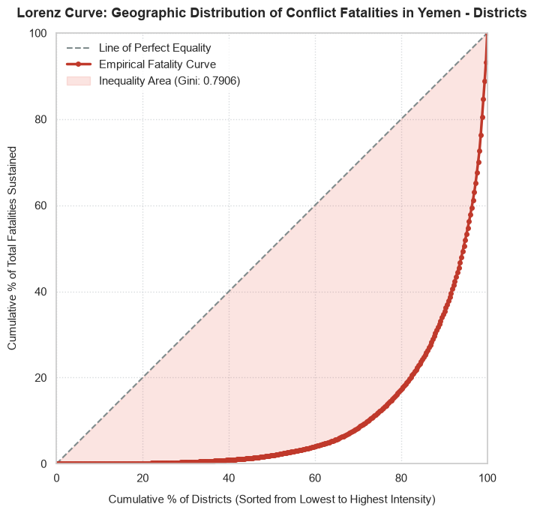

Refining the data down to district boundaries exposes a severe Modifiable Areal Unit Problem (MAUP) in standard conflict tracking. The district-level Lorenz Curve reveals that the bottom 75% of districts in Yemen combined accounted for a mere ~10% of fatalities. Conversely, a tiny 10% elite bracket of strategic districts absorbed roughly 68% of all conflict mortality.

This mathematical surge proves that even within heavily embattled governorates, vast stretches of land remained insulated from direct combat.

B. High-Frequency Temporal Volatility
Temporal tracking from 2015 to 2026 across annual and monthly bounds confirms that violence operated in intense, volatile tactical waves aimed at shifting these spatial chokepoints:
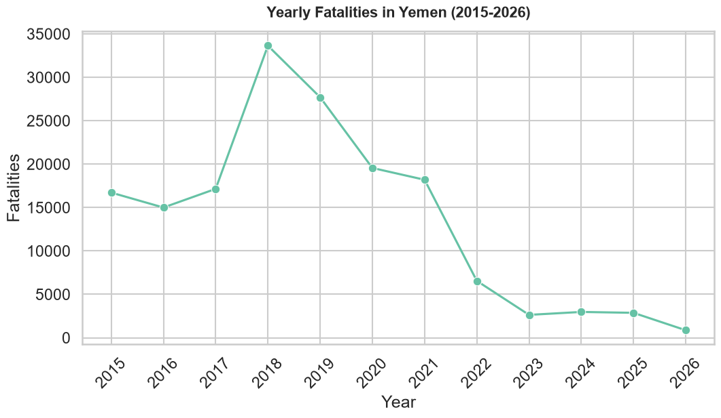
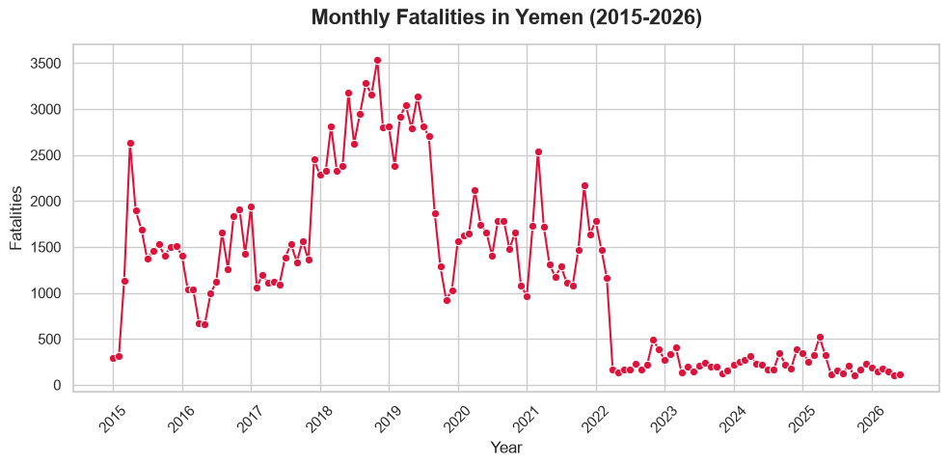
- Temporal Conflict Phases:
  - [2015–2017] Baseline Attrition --> Constant air/ground campaigns (~16k deaths/yr)
  - [2018] The Escalation Peak --> Battle of Al Hudaydah Port City (~33.5k deaths)
  - [2019–2021] The Attrition Plateau --> Protracted battles for Marib Energy Hub
  - [2022–2026] The Truce Cliff --> Post-April 2022 UN Truce floor (<3k deaths/yr)

- The 2018 Urban Zenith: The monthly timeline reveals that the absolute peak of the war occurred in late 2018, where monthly fatalities broke 3,500 deaths/month during Operation Golden Victory, the intense offensive to capture the vital humanitarian and commercial Red Sea port of Al Hudaydah.
- The 2022 "Truce Cliff": Following the implementation of the UN-brokered nationwide ceasefire in April 2022, monthly deaths fell off a precipitous cliff, dropping from roughly 2,000 per month to a flat, permanent floor below 250 deaths/month that sustained all the way through mid-2026.

4. Key Strategic Drivers

The data shows that conflict mortality was a direct variable of resource geography. The hotspots driving the 0.7906 Gini index match specific economic and political targets:

- Economic Hubs (Marib): High-attrition desert warfare centered heavily on capturing Yemen's primary domestic oil and gas fields.
- Logistical Lifelines (Al Hudaydah): Port infrastructure serving as the maritime entrance point for national food and aid supplies turned the province into a vital tactical chokepoint.
- Ideological Strongholds (Sa'dah): Proximity to the northern border and its status as the Houthi movement's core base made it a target for constant, heavy aerial bombardment.
- Geopolitical Crossroad Sieges (Taiz): Yemen's third-largest city suffered continuous high-density urban casualties due to a catastrophic, multi-year chokehold over the roads linking northern and southern territory.

5. Conclusions & Policy Implications

- Methodological Conclusion: Research frameworks that evaluate civil conflicts using macro-provincial data run a severe risk of misrepresenting the scale of violence. Micro-level spatial auditing (such as District grouping) is mandatory to map the actual architectural realities of modern warfare.
- Humanitarian Implications: Because 68% of the direct combat deaths are localized within just 10% of the districts, post-conflict stabilization programs cannot simply distribute funds evenly or province-by-province. Mine clearance, heavy trauma medical infrastructure, and structural reconstruction must be surgically funneled exclusively into these micro-frontlines.
- Macroeconomic Shift: For the remaining 90% of districts, which suffered minor direct combat but heavy casualties from blockades, inflation, and healthcare decay, interventions must bypass military stabilization and focus entirely on macroeconomic restoration, currency stabilization, and clean water networks to curb indirect under-5 child mortality.

