3D Shape Completion Using an Encoder–Predictor Network (EPN)
Tarek Eltantawy
University of Miami
CSC 598/689 Final Report
Spring 2025

Abstract-
This project investigates whether a lightweight Encoder–Predictor Network (EPN) can perform 3D shape completion on partial Truncated Signed Distance Fields (TSDFs) using a small synthetic dataset. The model takes an incomplete TSDF volume and predicts a full signed distance field, from which a mesh is extracted using Marching Cubes. Several architectural and training improvements were introduced, including increasing the TSDF resolution from 32³ to 64³, adding BatchNorm3D, expanding the model’s channel capacity, and correcting truncation preprocessing. These updates significantly reduced validation loss—from 0.104 at 32³ to 0.007 with the improved model—and produced cleaner, more detailed reconstructions. The results show that simple volumetric models, when properly optimized, can achieve strong performance even under limited data conditions.

- INTRODUCTION

3D shape completion is the process of reconstructing a complete 3D geometry from incomplete or occluded input data. Real-world scans—especially those from consumer devices—often miss back-facing surfaces or contain holes due to sensor limitations, self-occlusion, or restricted viewpoints. These partial observations limit downstream applications in robotics, AR/VR, object recognition, and digital fabrication.
This project explores whether a lightweight Encoder–Predictor Network (EPN) can reconstruct full 3D shapes from partial Truncated Signed Distance Fields (TSDFs), even when trained on a small synthetic dataset rather than large-scale benchmarks like ModelNet or ShapeNet. The goal is to evaluate feasibility, identify architectural bottlenecks, and quantify improvements gained through higher resolution, model capacity, and normalization layers.

- RELATED WORK

The foundation of this project is the Encoder–Predictor Network introduced by Dai et al. (CVPR 2017). Their method demonstrated that 3D CNNs combined with a global latent bottleneck could infer missing structure from partial voxel grids. The EPN established a strong baseline and influenced many later works, including ScanComplete (2018), which extended shape completion to large indoor scenes.
Additional research has explored:
- Implicit surface models (e.g., DeepSDF, occupancy networks), which achieve high fidelity but require complex training.
- Diffusion-based reconstruction methods, such as SC-Diff, which generate shapes with rich detail but depend on extremely large datasets and compute resources.
- GAN inversion approaches, which map partial inputs into latent spaces learned from full shapes.
Compared to these methods, the present project deliberately uses a simpler, resource-efficient EPN, making it suitable for small datasets and modest hardware while still demonstrating the core principles of volumetric shape completion.

- METHODOLOGY

The project pipeline begins with generating full and partial TSDF volumes from simple synthetic meshes. Each mesh is converted into a signed distance field, and simulated occlusion is applied to remove unseen regions, producing the incomplete TSDF that serves as the model’s input. These volumes are normalized to a fixed range to ensure stable learning. The reconstruction model used is a compact Encoder–Predictor Network (EPN), which processes the partial TSDF through a 3D convolutional encoder that progressively downsamples the grid while extracting local geometric structure and broader spatial context. The compressed representation is passed into a fully connected bottleneck layer that mixes global information and forms a latent “shape code” capturing the object’s overall structure. A 3D convolutional decoder then upsamples this latent code back to full resolution, refining it into a complete TSDF with values constrained to the appropriate range. After prediction, the Marching Cubes algorithm extracts a watertight mesh by locating zero-crossings of the TSDF and connecting them into triangular faces. Throughout the project, several improvements were incorporated: increasing grid resolution from 32³ to 64³ for finer detail, adding BatchNorm3D layers for training stability, expanding the network’s channel capacity, correcting TSDF truncation processing, and resolving checkpoint-loading issues. These changes collectively enhanced reconstruction quality and enabled the model to produce more accurate and detailed 3D surfaces.

- RESULTS

64³ Grid, Medium Model + BatchNorm3D
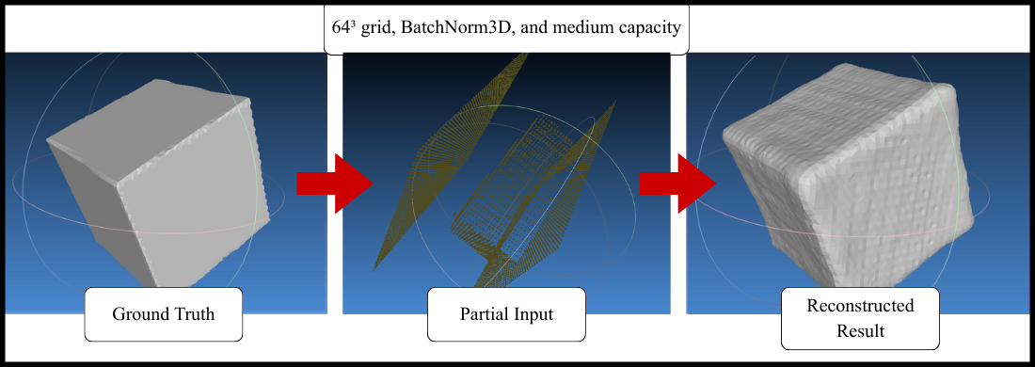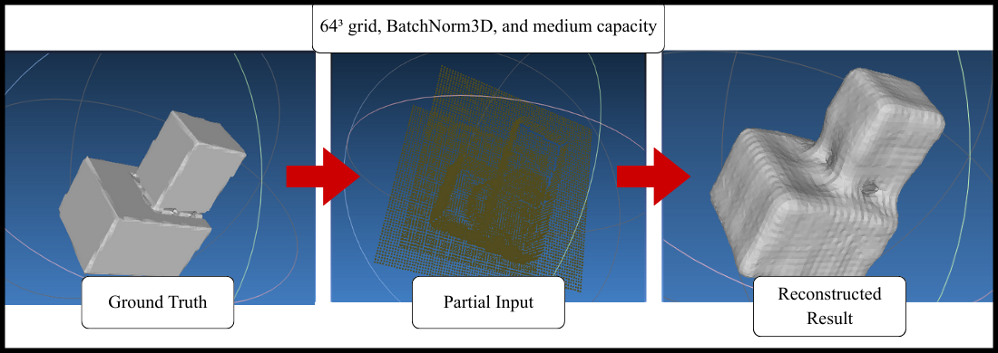
These reconstructions display smooth surfaces, strong global consistency, and accurate recovery of missing regions, even for complex L-shaped objects.
32³ Baseline
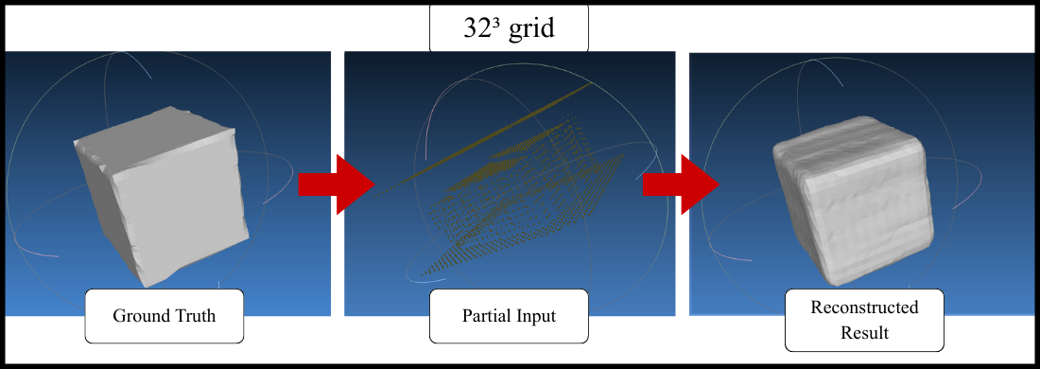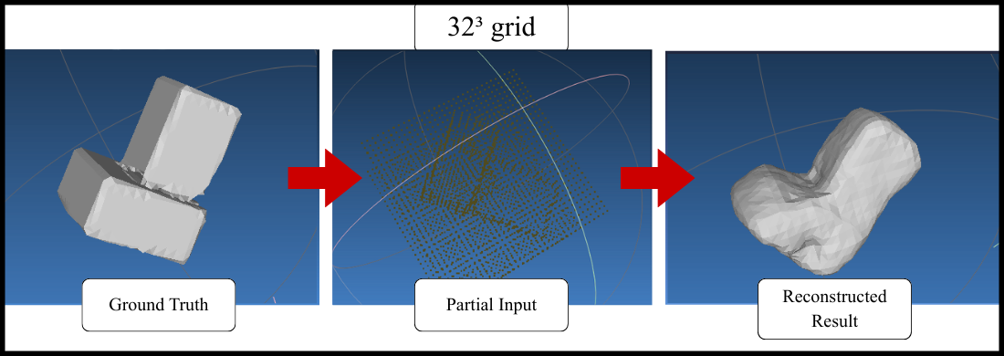
Lower resolution results in blocky surfaces and loss of detail; thin structures are poorly reconstructed.
64³ Grid, Small Model
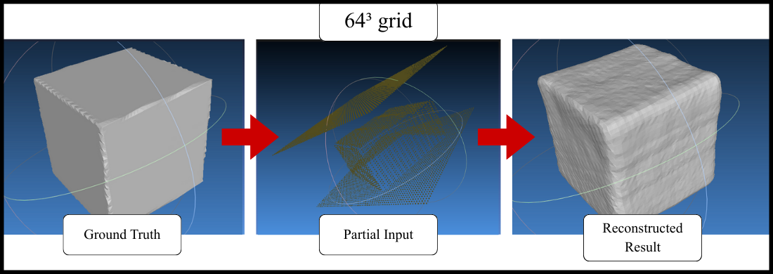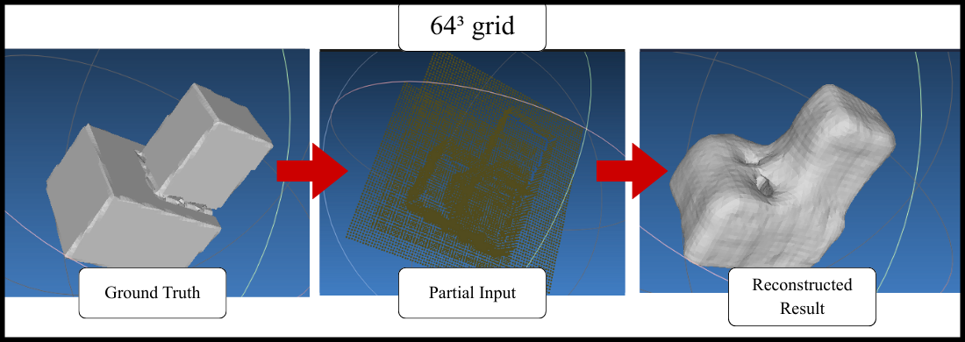
(Improved over 32³ but lacks the smoothness and accuracy of the medium-capacity model with BatchNorm3D.

Model Variant | Grid | Validation Loss | Notes
32³ small | 32³ | 0.104 | Underfits; low detail
64³ small | 64³ | 0.049 | Improved geometry; still limited
64³ medium + BN | 64³ | 0.007 | Best performance; stable training

Key Findings:
- Increasing resolution alone provides major improvement
- BatchNorm3D adds stability and prevents training collapse
- Doubling capacity from 16 to 32 channels improves complex shape reconstruction
- Correct preprocessing and checkpoint loading were essential for meaningful training

- CONCLUSION

This project successfully demonstrates that a compact Encoder–Predictor Network can perform meaningful 3D shape completion using partial TSDF inputs, even under constrained data and hardware conditions. Increasing TSDF resolution, expanding model capacity, and incorporating BatchNorm3D all contributed to improved performance, with the best model achieving a validation loss of 0.007 and producing smooth, coherent reconstructions. The results show that volumetric CNNs remain practical and powerful for shape completion tasks, especially when paired with careful preprocessing and training strategies. Future work may explore implicit neural representations, sparse voxel structures, or diffusion-based methods to further increase fidelity and scalability.

REFERENCES

Dai, A., Qi, C. R., & Nießner, M. Shape Completion Using 3D Encoder–Predictor CNNs and Shape Synthesis. CVPR 2017.
Dai, A., Diller, C., & Nießner, M. ScanComplete: Large-Scale Scene Completion and Semantic Segmentation for 3D Scans. CVPR 2018.
Schaefer, S., et al. SC-Diff: 3D Shape Completion with Latent Diffusion Models. arXiv, 2025.
Zhang, J., et al. Unsupervised 3D Shape Completion through GAN Inversion. 2021.
TSDF Fusion and Completion with Multimodal Data. arXiv, 2024.

