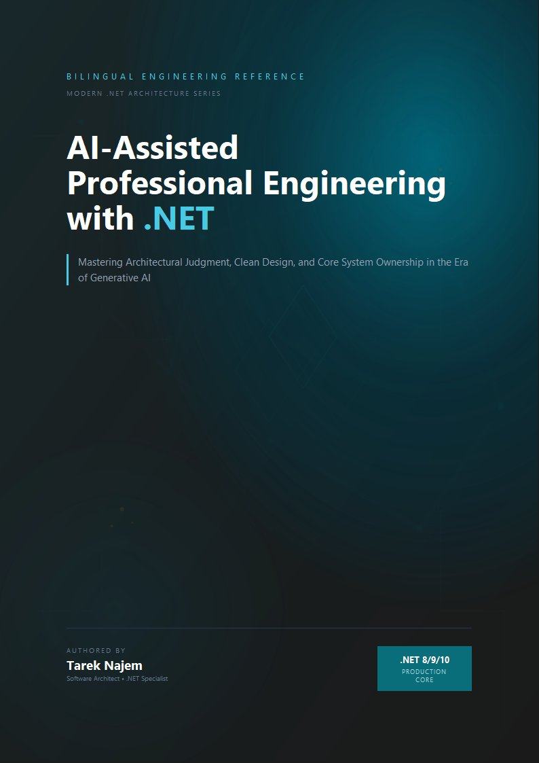

AI-Assisted Professional Engineering with .NET

English Introduction / Manifesto
Software engineering is entering its most dangerous and transformative decade.
For the first time in the history of our industry, engineers can generate systems faster than they can understand them.
A single developer can now produce thousands of lines of functioning code in minutes. Entire APIs can be scaffolded in a single prompt. Architectural recommendations can be generated instantly. Tests, documentation, refactoring plans, deployment scripts — all produced at machine speed.
And yet, despite this unprecedented acceleration, a disturbing reality is emerging across the industry:
Teams are shipping systems that nobody fully understands.
AI-generated abstractions are entering production environments without rigorous architectural review. Technical debt is accumulating at a rate that was operationally impossible only a few years ago. Engineers are delegating judgment — not merely implementation — to probabilistic systems that possess neither accountability nor long-term ownership of the software they help create.
This is not a tooling shift.
It is a fundamental engineering crisis.
Modern software systems are already extraordinarily difficult to build correctly. Cloud-native infrastructures, distributed systems, asynchronous execution models, third-party APIs, event-driven architectures, machine learning pipelines, compliance constraints, zero-downtime deployment requirements, and globally distributed teams have transformed software engineering into one of the most cognitively demanding disciplines in modern industry.
A contemporary enterprise .NET system is no longer “an application.”
It is a living sociotechnical organism with hundreds of interconnected failure points, evolving requirements, operational pressures, and architectural tradeoffs that persist for years after the original implementation decisions are made.
Into this complexity arrived artificial intelligence.
And with it came an enormous amount of confusion.
A growing portion of AI-related content treats software engineering as though it were primarily a typing problem. Tutorials demonstrate how quickly a language model can generate code, while ignoring the difficult realities that define professional engineering: architectural integrity, behavioral correctness, observability, operational resilience, maintainability, security boundaries, debugging under production pressure, and long-term ownership of systems that outlive the teams who originally built them.
Real engineering has never been about producing code quickly.
Engineering is the discipline of making difficult decisions under uncertainty.
It is choosing between architectures when every option contains tradeoffs. It is designing systems that fail gracefully instead of catastrophically. It is building software that remains understandable years after its creators have moved on. It is recognizing when an elegant abstraction introduces hidden operational complexity. It is knowing when not to trust a generated answer — even when that answer appears convincing.
Artificial intelligence does not eliminate this discipline.
It amplifies it.
In the hands of a disciplined engineer, AI becomes a remarkable force multiplier. It can externalize years of accumulated implementation patterns on demand. It can accelerate research, summarize architectural alternatives, generate edge-case test scenarios, assist in debugging complex runtime failures, explain obscure framework behavior, and preserve reasoning continuity across long-running projects.
Used correctly, it resembles an exceptionally knowledgeable engineering partner — one capable of recalling vast amounts of technical material instantly, from RFCs and framework internals to distributed systems failures and architectural design patterns.
But in the hands of an engineer without strong architectural foundations, the same technology becomes dangerous.
Code is generated faster than it can be validated. Complexity grows faster than comprehension. Architectural ownership slowly dissolves into prompt iteration. Systems become operationally fragile while appearing superficially productive.
This book is not about that failure mode.
This book is about professional engineering in the age of AI.
It is a rigorous technical reference for engineers who intend to build production-grade systems responsibly inside an AI-augmented world.
The .NET ecosystem is an ideal environment for this discussion because it rewards precisely the kind of disciplined thinking that AI-assisted engineering requires. The CLR, the type system, dependency injection, asynchronous execution models, middleware pipelines, and the broader architectural philosophy of modern .NET all embody decades of accumulated engineering judgment about how reliable systems should be constructed.
This book approaches AI from that perspective.
Not as a novelty.
Not as a replacement for engineers.
And not as a shortcut around software engineering fundamentals.
You will learn how to integrate AI into architectural workflows without surrendering architectural ownership. You will learn how to use language models to strengthen debugging and testing processes rather than weaken them. You will learn how to deploy AI capabilities inside production systems with explicit failure boundaries, observability strategies, governance controls, and operational safeguards.
The topics in this book were selected because they represent the real problems professional engineers already face:
Legacy systems that cannot be rewritten from scratch.
Security boundaries that must remain trustworthy even when AI behavior is probabilistic.
Testing strategies capable of validating AI-assisted implementations.
Production systems that require observability even when portions of their behavior are non-deterministic.
Teams attempting to maintain engineering standards while machine-generated code becomes increasingly common.
These are not hypothetical concerns.
They are the emerging realities of modern software engineering.
By the end of this book, you will not simply “use AI tools.”
You will think architecturally about intelligent systems.
You will understand how to design with AI, constrain it, validate it, observe it, debug it, secure it, and operate it responsibly under production conditions.
You will become an AI-augmented software engineer capable of exercising professional judgment in an industry increasingly tempted to automate judgment away.
That distinction may define the next generation of software engineering itself.
