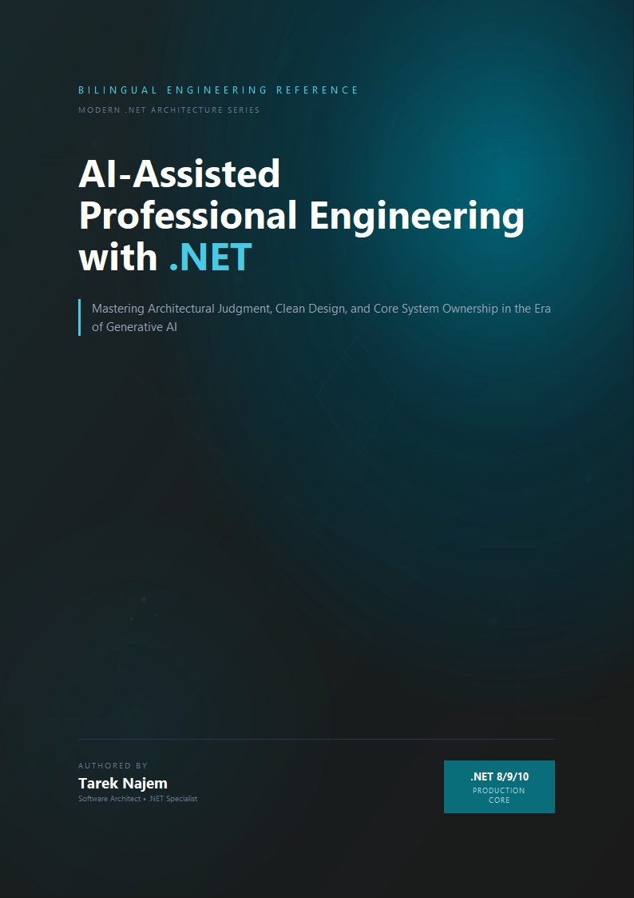

AI-Assisted Professional Engineering with .NET

Section 01 — What an LLM Actually Does: Tokens, Embeddings, Context, and Inference

The Mechanism Behind the Interface
A large language model produces every token in its output through a single repeated operation: given a sequence of numbers representing the text so far, produce a probability distribution over what number is most likely to come next, sample one number from that distribution, append it to the sequence, and repeat. This is the entire generative process — there is no separate planning step, no internal representation of the problem, no retrieval from a knowledge base. Everything else — the appearance of reasoning, the fluency, the architectural vocabulary, the code that compiles — is what this process produces when the numbers represent language and the model producing the distribution has been trained on an enormous corpus of human text.
A .NET engineer interacting with this system for the first time encounters something deceptively familiar: a request goes out, a response comes back, and the response is text — often syntactically valid C#, often structurally sound architectural reasoning, often phrased with the same register a senior colleague would use in a design review. Every instinct built over a career of working with deterministic systems suggests that there must be something underneath producing this output in a way that parallels how a service produces a response: some internal representation of the problem, some retrieval of relevant facts, some process that resembles thinking. But the actual mechanism is fundamentally different — and understanding it precisely is the subject of this section.
This section builds that mechanism from the ground up, using vocabulary and framing that maps onto concepts a .NET engineer already has working intuitions for: serialization, lookup tables, fixed-size buffers, and function calls. The goal is not mathematical completeness — it is a mental model precise enough that the behaviours described in the rest of this chapter stop looking like quirks and start looking like direct, predictable consequences of how the system works.

Tokens: The Unit of Everything
Before a language model can do anything with text, the text must be converted into a sequence of integers. This conversion is performed by a tokenizer, and the integers it produces are called tokens. A token is not necessarily a word. Common words are often a single token. Less common words are split into multiple tokens — prefixes, suffixes, and word fragments that recur often enough across the training corpus to have earned their own entry in the tokenizer’s vocabulary. Punctuation, whitespace, and even parts of common code patterns each have their own token identities.
For a .NET engineer, the closest intuition is a dictionary-based compression scheme: the tokenizer maintains a fixed vocabulary — typically on the order of 50,000 to 200,000 entries depending on the model family — and every piece of input text is encoded as a sequence of indices into that vocabulary. The word "CancellationToken" might be a single token in a vocabulary trained heavily on code, because the sequence of characters CancellationToken appears often enough in the training data that the tokenizer’s construction process — typically a variant of byte-pair encoding — merged it into one unit. A less common identifier, say "IIdempotencyKeyGenerator", is more likely to be split into several tokens: perhaps I, Idem, potency, Key, Generator, each a fragment that recurred often enough on its own to warrant a vocabulary entry, even though the full identifier did not.
This has a direct, measurable consequence that engineers building AI-integrated .NET systems encounter immediately: cost and context consumption are measured in tokens, not words or characters, and the relationship between source text and token count is uneven. A block of common English prose might average around four characters per token. A block of C# code dense with project-specific identifiers, GUIDs, or unusual naming conventions can consume substantially more tokens for the same character count, because the tokenizer is forced to fall back to shorter fragments more often. When a .NET service constructs a prompt that embeds a stack trace, a configuration file, or a chunk of legacy code with idiosyncratic naming, the token cost of that context is not something that can be estimated by counting characters and dividing by a constant — it depends on how well the tokenizer’s vocabulary, shaped by its training corpus, happens to match the vocabulary of the text being encoded.
Diagram: dg-f611cff9811c
The diagram above is the complete generative loop. Every box matters for the engineering decisions that follow in this chapter, but the loop itself — particularly the feedback arrow from sampling back into the transformer layers — is the single most important structural fact about how these systems operate. The model does not produce a response and then stop to evaluate it. It produces one token, appends that token to its own input, and runs the entire forward pass again. A model generating a five-hundred-token response to an architectural question performs five hundred complete forward passes, each one conditioned on everything generated so far, including its own earlier tokens — whether or not those earlier tokens were correct.

Embeddings: Where Meaning Lives as Geometry
Token IDs are arbitrary integers — the specific number assigned to CancellationToken carries no inherent meaning beyond its role as a lookup key. The first substantive operation the model performs is to convert each token ID into a vector: a list of floating-point numbers, typically somewhere between several hundred and several thousand elements long depending on the model’s size. This vector is called the token’s embedding, and it is retrieved from a learned lookup table — conceptually similar to a Dictionary<int, float[]> where the dictionary itself was produced by training, not configuration.
The geometry of this vector space is where the model’s “knowledge” of language lives. During training, the embedding for a token is adjusted so that tokens which tend to appear in similar contexts end up with similar vectors — close together in the high-dimensional space the embeddings occupy. This is not a designed property; it falls out of the training objective. A model trained to predict the next token, given enough text, discovers that IRepository and IService and IPaymentGateway all tend to appear in similar syntactic positions — after private readonly, before a generic type parameter or a constructor parameter name — and their embeddings drift toward each other in the vector space as a side effect of optimizing for that shared distributional behaviour. The model never receives an explicit instruction that these are all “interface types representing injected dependencies.” It discovers a geometric regularity that happens to correlate with that human concept, because the concept is what produced the regularity in the training data in the first place.
This matters for an engineering reason that becomes concrete in later sections: when a model generates a suggestion involving an unfamiliar identifier — a method name, a package name, a configuration key it has never specifically seen — it is not retrieving that identifier from anything resembling a database lookup of real APIs. It is positioned, by the geometry of the embedding space and the patterns learned over it, near identifiers that look like that one, and it generates something that occupies a similar position in the space of “plausible identifiers in this context.” Sometimes that position corresponds to a real API. Sometimes it corresponds to an API that would make sense, given the conventions of the ecosystem, but does not exist. The mechanism that produces both outcomes is identical. Nothing in the generative process distinguishes “this identifier is real” from “this identifier merely looks like the identifiers near it in embedding space.”

The Context Window: A Fixed-Size Working Set
Every model has a maximum number of tokens it can process in a single forward pass — the context window. Modern models offer context windows ranging from tens of thousands to over a million tokens, but the number is always finite, and it is shared between everything the model needs to consider: the system prompt, the conversation history, any documents or code provided as context, and the response being generated so far.
The closest .NET analogy is a fixed-size buffer or a bounded Memory<T> allocated once per request. Unlike a List<T>, which grows as needed, the context window does not expand to accommodate more information — if the combined token count of everything that needs to be in context exceeds the window, something must be truncated, summarized, or omitted before the request is even sent. And critically, every token inside that window is re-processed on every forward pass during generation. The transformer layers in the diagram above operate over the entire sequence — input plus everything generated so far — at every step. This is why response latency for long contexts grows non-linearly with context length for many model architectures: doubling the context does not merely double the data being read, it changes the computational cost of every attention operation across every layer, because attention is computed between every pair of tokens in the sequence.
For an engineer designing a .NET service that constructs prompts programmatically — assembling a system prompt, retrieved documentation, recent conversation turns, and a user query into a single request — the context window is a hard resource constraint with cost and latency consequences, not a soft guideline. A service that naively concatenates “everything that might be relevant” into the prompt is making a resource allocation decision with the same category of consequences as a service that allocates an unbounded buffer per request: it works fine until the inputs grow, and then it either fails outright (context limit exceeded) or degrades in ways that are much harder to diagnose, which is the subject of Section 02’s examination of “lost in the middle” effects.

Inference: One Forward Pass, One Token
With tokens converted to embeddings and the context window established, the transformer layers perform what is called inference: a sequence of mathematical operations — primarily attention, which computes how much each token’s representation should be influenced by every other token’s representation, and feed-forward transformations applied independently to each position — that produce, at the final layer, a vector of raw scores called logits, one score per entry in the vocabulary. These logits are converted into a probability distribution via a softmax operation, and the next token is chosen by sampling from that distribution.
The word “sampling” is doing real work in that sentence and deserves to be unpacked, because it is the source of behaviour that engineers used to deterministic systems often find disorienting. The model does not select “the most likely next token” as a deterministic rule by default — though it can be configured to do so. Instead, a parameter called temperature controls how the probability distribution is converted into a selection: at temperature zero, the highest-probability token is always chosen (deterministic, or as close to it as floating-point reproducibility allows across hardware); at higher temperatures, tokens with lower probability have a real, non-zero chance of being selected, which produces more varied — and, from the model’s internal perspective, equally “valid” — output. From the model’s perspective, there is no difference in kind between the highest-probability continuation and the fifth-highest-probability continuation. Both are points on the same distribution. The only thing that differs is how likely each one is to have been selected.
// Target Framework: .NET 8.0
// Chapter: 02 | Section: 01
// book/chapters/chapter-02/sections/section-01.en.md
//
// Minimal .NET console application that calls a streaming chat
// completion endpoint and prints the response token-by-token as it
// arrives, alongside the token count of the prompt and response.
//
// Purpose: make the per-token, sequential nature of generation visible.
// Each line printed below corresponds to ONE forward pass through the
// model — not a single "thinking" step that produced the whole answer.
using System.ClientModel;
using OpenAI.Chat;
var client = new ChatClient(
model: "gpt-4o-mini",
credential: new ApiKeyCredential(
Environment.GetEnvironmentVariable("OPENAI_API_KEY")
?? throw new InvalidOperationException("OPENAI_API_KEY not set")));
var messages = new ChatMessage[]
{
new SystemChatMessage(
"You are a senior .NET engineer. Answer in one short paragraph."),
new UserChatMessage(
"What does the CancellationToken parameter do in an async method?"),
};
Console.WriteLine("--- Streaming response, one chunk per forward pass ---");
var tokenCount = 0;
await foreach (var update in client.CompleteChatStreamingAsync(messages))
{
foreach (var part in update.ContentUpdate)
{
// Each `part.Text` here typically corresponds to one or a small
// number of tokens — the smallest unit the model can emit per
// forward pass. Printing immediately, without buffering, shows
// the sequential generation process in real time.
Console.Write(part.Text);
tokenCount++;
}
}
Console.WriteLine();
Console.WriteLine($"\n--- Approximate output chunks observed: {tokenCount} ---");
// Architecture note (S01->S02 handoff):
// Every chunk printed above was produced by re-running the ENTIRE
// transformer stack over the prompt PLUS every chunk generated so far.
// There is no separate "planning" pass that ran before this loop began.
// Whatever structure the final answer has — if it has a clear beginning,
// middle, and conclusion — emerged token-by-token, with each token chosen
// based only on the sequence so far, not on a pre-computed outline.
The code above is deliberately minimal, but the behaviour it surfaces is not. Running it against the same prompt multiple times — even at a fixed, low temperature — can produce subtly different token sequences, because the sampling step introduces a genuine source of variation that does not exist in a typical .NET method call. A .NET engineer accustomed to writing unit tests that assert exact string equality on a method’s return value will find that this assumption does not transfer to AI-generated output without an explicit architectural decision about how much variation is acceptable and how it will be detected — a concern this chapter returns to directly in Section 05’s treatment of deterministic versus probabilistic systems.

What This Mechanism Does Not Contain
It is worth being explicit about absences, because the absences are exactly where engineering intuitions trained on deterministic systems lead engineers astray.
There is no persistent memory between requests beyond what is explicitly included in the context window. A model does not “remember” a previous conversation unless that conversation’s tokens are re-sent as part of the current context. There is no separate database of facts that the model consults — everything it “knows” is encoded, implicitly and inseparably, in the weights of the embedding tables and transformer layers, set during training and not updated by anything that happens during inference. There is no explicit representation of “the current task” or “the plan for this response” that exists independently of the token sequence itself — if the model’s output reads as though it followed a plan, that structure exists only as a pattern in the generated tokens, indistinguishable, from the model’s perspective, from any other sequence of tokens it might have produced.
This is not a limitation that better prompting fully overcomes, and it is not a limitation that will necessarily be removed by larger models — it is the architecture. Everything explored in the remainder of this chapter — why models seem to reason, where that apparent reasoning breaks down, why hallucination is structural rather than incidental, and what calibrated trust looks like in practice — follows directly from the mechanism described in this section.

Distinguishing the Different Kinds of “Error” in a Large Language Model
One of the most common misunderstandings among .NET engineers encountering large language models for the first time is to imagine that a model’s errors resemble runtime exceptions or type errors: discrete events that can be detected and managed reliably. The mechanism described in this section shows why that picture is structurally misleading.
In a deterministic .NET system, an incorrect code path fails in exactly one of three ways: either the compiler refuses to compile it because it violates the type system, or the runtime crashes and throws an exception at the point of failure, or it produces incorrect output that a test with exposing inputs can detect. In all three cases, the failure is discrete and its bounds can be determined.
A large language model has no equivalent discriminator. The next token is simply the most probable token under the learned distribution, whether it is part of a correct answer or part of a fabricated claim. The model has no internal state representing “I am confident” or “I am guessing” — it produces a probability distribution in both cases, and the difference between the two cases lies in the relative likelihoods of different tokens, not in any explicit flag that can be queried. This is the underlying reason why the confidence expressed in a model’s output — the categorical tone, the decisive unhedged sentences — is generated as the most likely tokens in a context of confident-sounding technical prose, not derived from any internal assessment of the neighbouring content. Sections 03 and 04 return to this directly with a detailed analysis of the patterns in which statistical inference collapses.

Why Understanding the Mechanism Matters in Practice
An engineer might reasonably ask: why does this level of architectural detail deserve study when the model’s outputs can simply be tested and whatever does not work handled? The answer appears in three places.
The first is that understanding the mechanism enables predicting failure instead of merely observing it. An engineer who knows that the model’s skill is a function of training-data density can perform a proactive risk assessment before integrating a model into a production service: does this task depend on well-documented patterns, or on rare interactions between multiple .NET features with insufficient examples in the training data? The answer determines the level of verification that AI integration into the critical path requires.
The second is that understanding the context window directly improves the quality of model output. An engineer who knows that the model re-processes every token in its window on every forward pass — and that tokens in the middle of a long context receive less attention through what research has called the “lost in the middle” effect — will design prompt structure differently: placing the most important information first and last, and managing context size deliberately instead of unboundedly appending everything that might be relevant.
The third is that understanding sequential generation clarifies why late instructions in a prompt have a different effect from early ones. Earlier tokens shape the probability distributions of later tokens. The system context provided at the start of a prompt shapes the overall distribution of everything that follows. Instructions given late in a long conversation may be diluted if previously generated tokens have already entrenched a strong statistical pattern heading in a different direction.
These three considerations are not added for theoretical completeness — they are the direct application of the mechanism described in this section to the design decisions of AI-integrated .NET services. The next section builds on them by posing the complementary question: if the mechanism is only next-token prediction over a sequence, where does the persuasive impression of comprehension and reasoning that engineers observe in so much of its output come from?


