THER-ASSIST
System Workflow Guide
How the AI Therapy Assistant Works
For Non-Technical, Technical, Front-End & Back-End Teams
SUNY Downstate | Dura-Bernal Lab
January 2025

Table of Contents
Part 1: The Big Picture (For Everyone)
Part 2: The Clinical Consultation Team (Understanding the System)
Part 3: Visual System Diagrams
Part 4: User Journey Walkthrough
Part 5: Front-End Developer View
Part 6: Back-End Developer View
Part 7: Complete Technical Flow
Part 8: Key Files Reference

Part 1: The Big Picture
This section explains what Ther-Assist does in simple terms that anyone can understand.

What is Ther-Assist?
Ther-Assist is an AI-powered assistant that helps psychotherapists during live therapy sessions. Think of it as a knowledgeable colleague sitting beside the therapist, quietly providing helpful suggestions and evidence-based guidance in real-time.

What Does It Do?
Feature | What It Means
Live Transcription | Converts speech to text as the session happens
AI Analysis | Understands what's being discussed and identifies opportunities
Evidence-Based Suggestions | Provides recommendations backed by therapy research
Real-Time Alerts | Highlights important moments or concerns
Session Summary | Creates a comprehensive report after the session

The Three Main Parts
Ther-Assist has three main components that work together:

Component | What It Is | Role
Front-End | What therapists see and interact with | The therapist's window into the system
Back-End | The services that process and analyze | The intelligence that powers analysis
Google Cloud | Where the AI magic happens | The AI brain (Gemini) and speech recognition

Part 2: The Clinical Consultation Team
To understand how Ther-Assist works, imagine a Clinical Consultation Team that every therapist dreams of having in their practice.

Your Virtual Clinical Team
In traditional therapy training, therapists benefit from having supervisors and consultation groups. Ther-Assist brings this consultation model directly into your session, providing real-time support that would normally require scheduling separate meetings.
System Component | Clinical Team Role | What They Do
Front-End Interface | Your Session Room | Where you conduct therapy and see all the information presented clearly
Transcription Service | Your Session Note-Taker | Captures every word spoken, identifies who said what
Gemini AI | Your Expert Supervisor | Reviews the conversation and provides clinical insights
RAG Database | Your Evidence Library | Contains all the treatment manuals, protocols, and research
Analysis Function | Your Case Consultant | Combines supervisor insights with evidence to give specific recommendations

How the Consultation Works in Real-Time
Just like a live consultation, Ther-Assist works continuously throughout your session:

Step 1: Session Begins
You start the therapy session. The Note-Taker (Transcription Service) immediately begins capturing the conversation, distinguishing between therapist and patient voices.

Step 2: Continuous Listening
As the conversation unfolds, the transcript is periodically sent to your Case Consultant (Analysis Function) for review.

Step 3: Expert Review
The Case Consultant works with the Expert Supervisor (Gemini AI), who analyzes the therapeutic content and checks the Evidence Library (RAG) for relevant techniques.

Step 4: Guidance Delivered
Recommendations appear in your Session Room (Front-End) with specific suggestions, supporting evidence, and step-by-step guidance.

Step 5: Session Summary
At the end, you receive a comprehensive consultation report summarizing key moments, interventions used, and follow-up recommendations.

Why This Matters for Your Practice
- Get expert-level consultation during every session, not just monthly supervision meetings
- Access evidence-based techniques exactly when they're most relevant
- Never miss critical moments that could benefit from specific interventions
- Build confidence knowing you have a knowledgeable team supporting your clinical decisions

Part 3: Visual System Diagrams
These diagrams show how information flows through the Ther-Assist system. Use these to understand the complete picture of how components connect.

Diagram 1: System Overview
This diagram shows all the major components and how they communicate with each other:

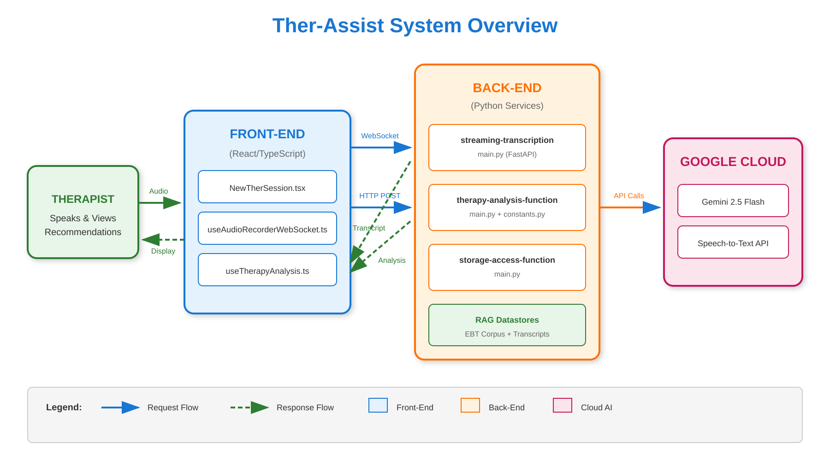
Figure 1: Ther-Assist System Architecture
Key Points: Solid arrows show requests flowing from user to services. Dashed arrows show responses returning. The Front-End talks to Back-End services, which in turn use Google Cloud AI services.

Diagram 2: Real-Time Session Flow
This diagram traces exactly what happens when a therapist speaks during a session, showing the complete journey from spoken word to displayed recommendation:

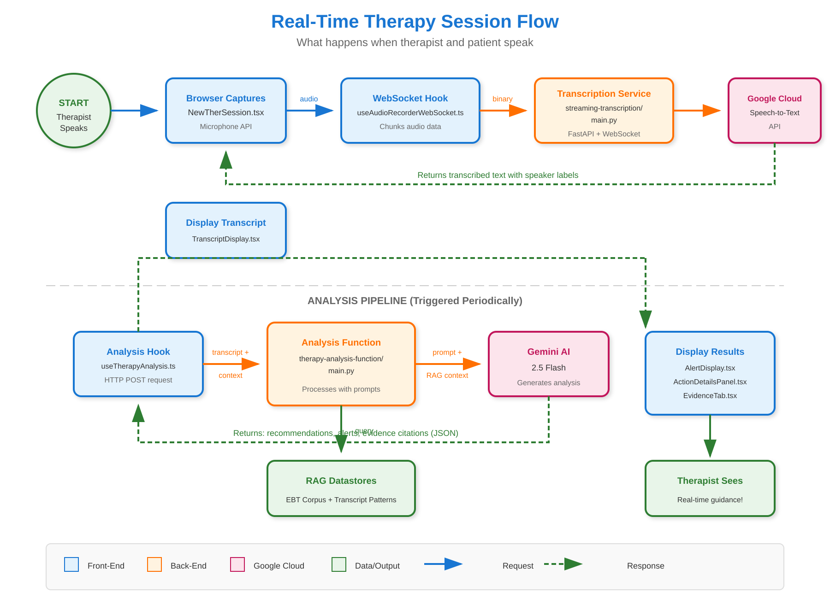
Figure 2: Real-Time Session Data Flow
This diagram has two parts: The top section shows the transcription pipeline (audio to text). The bottom section shows the analysis pipeline (text to recommendations). Both work simultaneously during a session.

Diagram 3: Component Connection Map
This diagram is specifically for developers, showing which files connect to which services and how the Front-End and Back-End communicate:

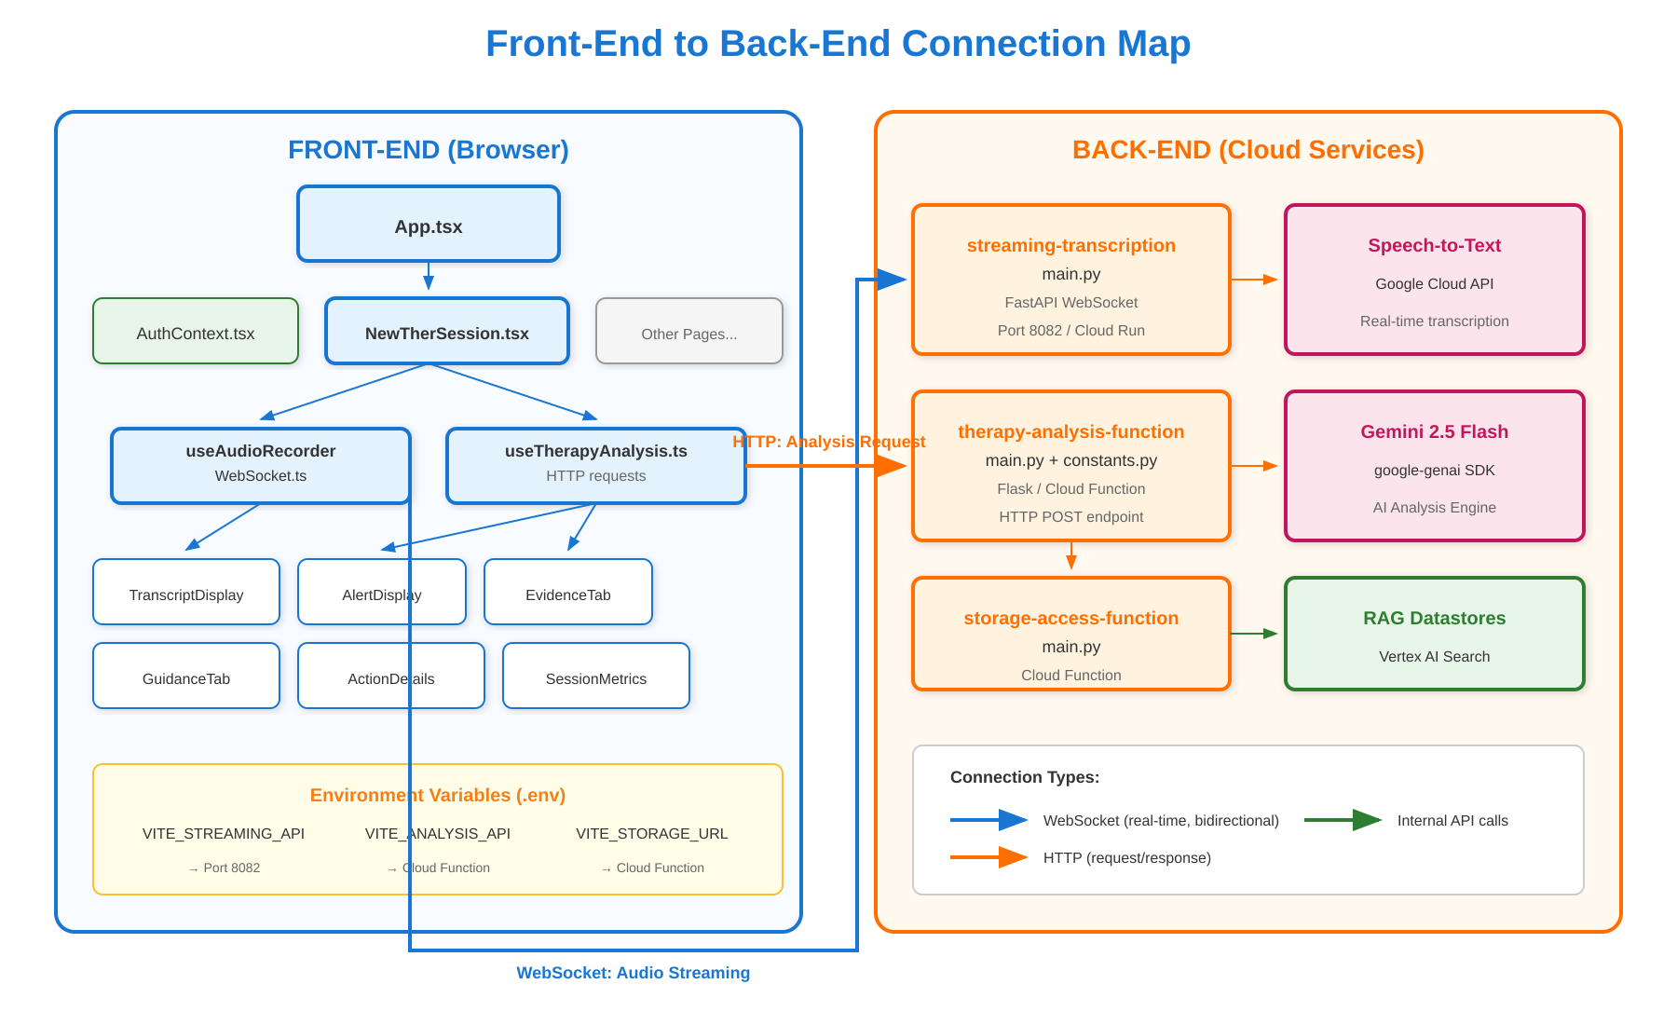
Figure 3: Front-End to Back-End Connection Map
This map shows exactly which Front-End files (hooks and components) connect to which Back-End services, and what type of connection they use (WebSocket vs HTTP).

Part 4: User Journey Walkthrough
Let's follow a therapist named Dr. Sarah through a typical session with Ther-Assist.

Before the Session
- Dr. Sarah opens Ther-Assist in her browser (Front-End loads)
- She logs in with her credentials (AuthContext verifies identity)
- She sees the Landing Page with her options
- She selects a patient and clicks "New Session"

During the Session
What Dr. Sarah Does | What Happens Behind the Scenes | What She Sees
Starts speaking with patient | Audio captured by browser, sent via WebSocket | Transcript appearing live
Continues conversation | Back-End transcribes, Gemini analyzes | Recommendations panel updates
Patient mentions anxiety | AI detects topic, queries RAG for CBT techniques | Alert: "Consider CBT breathing exercise"
Clicks on recommendation | Front-End displays details from AI response | Evidence citations, step-by-step guidance

After the Session
- Dr. Sarah clicks "End Session"
- Back-End generates comprehensive summary using Gemini
- Summary displayed in SessionSummaryModal
- Dr. Sarah can review, save, or export the summary

Part 5: Front-End Developer View
This section is for developers who work primarily with the user interface and want to understand how it connects to the rest of the system.

Technology Stack
Technology | Purpose | Key Files
React 18 | UI Components & State Management | All .tsx files in /components
TypeScript | Type Safety & Better DX | .ts and .tsx files
Vite | Fast Build Tool & Dev Server | vite.config.ts
Material-UI | Pre-built UI Components | Throughout components
Recharts | Data Visualization | SessionLineChart.tsx

How Front-End Talks to Back-End
The front-end communicates with back-end services through two main channels:

1. HTTP Requests (for Analysis): Used when the front-end needs AI analysis of the transcript. The useTherapyAnalysis hook sends POST requests to the therapy-analysis-function.
2. WebSocket (for Transcription): Used for real-time, continuous communication. The useAudioRecorderWebSocket hook maintains a live connection for streaming audio and receiving transcriptions.

Key Components to Know
Component | What It Does | Talks To
App.tsx | Main routing, shows different pages | All page components
NewTherSession.tsx | Active therapy session screen | useTherapyAnalysis, useAudioRecorderWebSocket
TranscriptDisplay.tsx | Shows live transcript | Receives data from NewTherSession
AlertDisplay.tsx | Shows AI recommendations | Receives alerts from analysis
AuthContext.tsx | Manages login state | Firebase (currently mocked)

Data Flow: What Happens When User Records
- User clicks record in NewTherSession.tsx
- useAudioRecorderWebSocket.ts establishes WebSocket connection
- Audio chunks sent to streaming-transcription-service (port 8082)
- Transcription returned via same WebSocket connection
- TranscriptDisplay.tsx updates with new text
- Periodically, transcript sent to therapy-analysis-function via HTTP
- AI recommendations displayed in AlertDisplay.tsx

Part 6: Back-End Developer View
This section is for developers who work with servers, APIs, and data processing, and want to understand how the front-end uses their services.

Technology Stack
Technology | Purpose | Where Used
Python 3.12 | Main programming language | All backend services
FastAPI | Modern async web framework | streaming-transcription-service
Flask | Lightweight web framework | Cloud Functions
google-genai | Gemini AI SDK | therapy-analysis-function
google-cloud-speech | Speech-to-Text API | streaming-transcription-service

The Three Backend Services

1. therapy-analysis-function: Cloud Function that receives transcript segments and returns AI-powered analysis including recommendations, alerts, and evidence citations from the RAG database.
2. streaming-transcription-service: Cloud Run service with WebSocket endpoint that receives audio streams and returns real-time transcription with speaker identification.
3. storage-access-function: Cloud Function for retrieving stored session data, summaries, and historical information.

How Back-End Receives Front-End Requests
Service | Endpoint Type | What Front-End Sends | What Back-End Returns
therapy-analysis | HTTP POST | transcript, session context, action type | recommendations, alerts, evidence
streaming-transcription | WebSocket | binary audio frames | text transcription with speakers
storage-access | HTTP GET | session ID, date range | historical session data

The Gemini Analysis Pipeline
- Receive transcript segment from front-end HTTP request
- Load prompt templates from constants.py
- Query RAG datastores for relevant evidence (EBT corpus + transcript patterns)
- Combine transcript + context + RAG results into Gemini prompt
- Send to Gemini 2.5 Flash API for analysis
- Parse Gemini response into structured JSON
- Return recommendations, alerts, evidence to front-end

What the Front-End Expects
When building or modifying back-end services, keep in mind what the front-end components expect:
Front-End Component | Expects From Back-End | Format
AlertDisplay.tsx | alerts array with priority, message, type | JSON array
ActionDetailsPanel.tsx | recommendations with rationale, evidence | JSON object
TranscriptDisplay.tsx | speaker-labeled text segments | JSON with speaker field
EvidenceTab.tsx | citations with source, page, excerpt | JSON array

Part 7: Complete Technical Flow
This section shows how all pieces work together from start to finish.

The Complete Journey of a Spoken Word
When a therapist or patient speaks, here's exactly what happens:

Step | Location | File/Service | What Happens
1 | Browser | NewTherSession.tsx | Microphone captures audio
2 | Browser | useAudioRecorderWebSocket.ts | Audio converted to binary chunks
3 | Network | WebSocket Connection | Chunks sent to port 8082
4 | Cloud Run | streaming-transcription/main.py | Audio received via FastAPI
5 | Google Cloud | Speech-to-Text API | Audio converted to text
6 | Cloud Run | streaming-transcription/main.py | Speaker diarization applied
7 | Network | WebSocket Connection | Text sent back to browser
8 | Browser | TranscriptDisplay.tsx | Text shown to therapist
9 | Browser | useTherapyAnalysis.ts | Transcript sent for AI analysis
10 | Cloud Function | therapy-analysis/main.py | Transcript received
11 | Vertex AI | RAG Datastores | Relevant evidence retrieved
12 | Google Cloud | Gemini 2.5 Flash API | AI generates recommendations
13 | Cloud Function | therapy-analysis/main.py | Response formatted
14 | Network | HTTP Response | JSON sent to browser
15 | Browser | AlertDisplay.tsx | Recommendations shown

Environment Variables Connection
The front-end and back-end connect through environment variables:
Front-End Variable | Points To | Backend Service
VITE_ANALYSIS_API | Cloud Function URL | therapy-analysis-function
VITE_STREAMING_API | Cloud Run URL | streaming-transcription-service
VITE_STORAGE_ACCESS_URL | Cloud Function URL | storage-access-function

Part 8: Key Files Reference
Quick reference for the most important files in the project.

Front-End Key Files
File | Purpose | When You Need It
App.tsx | Main routing logic | Adding new pages or navigation
AuthContext.tsx | Authentication state | Login/logout functionality
NewTherSession.tsx | Live session screen | Session UI changes
useTherapyAnalysis.ts | Analysis API calls | Changing AI request format
useAudioRecorderWebSocket.ts | Audio streaming | Audio capture changes
.env.development | Local API endpoints | Local development setup

Back-End Key Files
File | Purpose | When You Need It
therapy-analysis-function/main.py | AI analysis logic | Changing recommendations
therapy-analysis-function/constants.py | Prompts & config | Modifying AI prompts
streaming-transcription-service/main.py | Audio transcription | Transcription changes
storage-access-function/main.py | Data retrieval | Historical data access
requirements.txt | Python dependencies | Adding new libraries

Infrastructure Files
File | Purpose | When You Need It
terraform/main.tf | All GCP resources | Infrastructure changes
terraform/variables.tf | Configurable settings | Adding new config options
deploy.sh (each service) | Deployment scripts | Manual deployments
Dockerfile | Container definition | Container changes

Quick Troubleshooting Guide
Problem | Likely Cause | Check This
No transcript appearing | WebSocket connection | streaming-transcription-service logs
No recommendations | Analysis API | therapy-analysis-function logs
Login not working | Auth configuration | AuthContext.tsx, Firebase setup
"Cannot connect" errors | Environment variables | .env files match deployed URLs
Slow analysis | RAG or Gemini | RAG datastore health, Gemini quotas

End of Document

