# Predictive Maintenance for Industrial Equipment using Machine Learning

**Tarek Salameh, AlWaleed Alalami**

**1. Introduction**

In the realm of industrial operations, predictive maintenance stands as a pivotal cornerstone, essential for optimizing performance and minimizing downtime (Kudelina et al., 2023). Our project ventures into this critical domain by leveraging a spectrum of machine learning models, including Random Forest, SVM, Logistic Regression, Deep Learning, Linear Regression, Naive Bayes, and MLP benchmarked with RNN, with the goal of revolutionizing predictive maintenance strategies. This multifaceted approach, encompassing a diverse range of algorithms, aims to significantly enhance the accuracy and efficiency of maintenance practices, representing a substantial advancement over traditional methods.

Our comprehensive analysis compared these varied algorithms to identify the most effective solution for predicting equipment failure. The results from our study indicate remarkable success, especially with the Random Forest model, which demonstrated the highest accuracy, achieving a notable rate of 0.9967. This achievement underscores the potential of our approach to transform predictive maintenance practices in industrial settings, combining the strengths of different machine learning techniques to achieve unparalleled precision and reliability.

**2. Problem Definition and Algorithm  
  
2.1 Task Definition**

Our project is centered on predicting equipment failures in industrial settings, a task of crucial importance for optimizing maintenance schedules and preventing unexpected breakdowns (Nofal et al., 2023). The challenge lies in the multifaceted nature of accurately forecasting these failures, which requires a nuanced and sophisticated approach. Our methodology utilizes a dataset composed of various operational parameters, including sensor readings such as temperature and pressure. The aim is to process this input data to produce a predictive score or classification that indicates the likelihood of equipment failure. The significance of this endeavor stems from its potential to significantly reduce downtime and maintenance costs in industrial environments, thereby enhancing operational efficiency and safety.

**2.2 Algorithm Definition**

In our quest to address the wide spectrum of predictive maintenance scenarios, we carefully selected a range of algorithms for their distinct strengths and capabilities. This includes the robust Random Forest, known for handling diverse data types, the precise SVM for its effectiveness in high-dimensional spaces, the nuanced Logistic Regression, and the advanced MLP for complex pattern recognition. Each algorithm was chosen to ensure a comprehensive and reliable predictive maintenance framework, catering to different aspects of predictive data. Our approach, underlined by a commitment to encompassing a variety of scenarios, led us to rigorously evaluate the efficacy of each model to guarantee the most effective solution for predictive maintenance. (Ehrig et al., 2020)

**Pseudocode for Random Forest:**

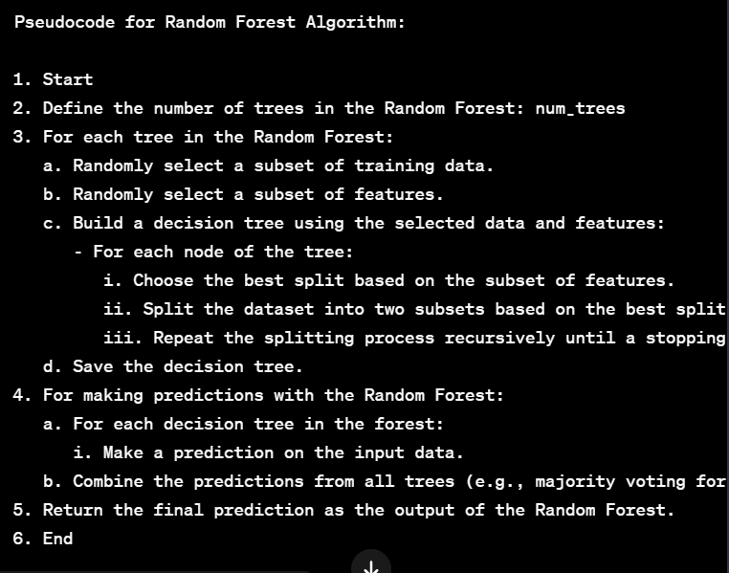

Figure(1): Top 10 Feature Importance’s (RF)

**2.3 Dataset**

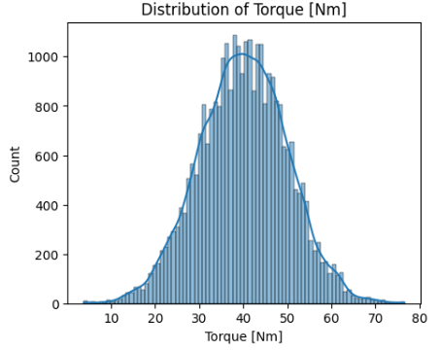The dataset utilized in our analysis consists of 30,000 records of operational data from industrial equipment, encompassing key parameters such as temperatures, rotational speed, torque, and tool wear. A portion of this dataset was generated synthetically to augment the real-world data, ensuring a comprehensive dataset that captures a wide range of operational scenarios. This publicly available and fully labeled dataset proved integral to our study, facilitating our analysis without the need for additional labeling efforts. Furthermore, its structure is such that it does not require special hardware for processing, thus ensuring ease of use and accessibility.

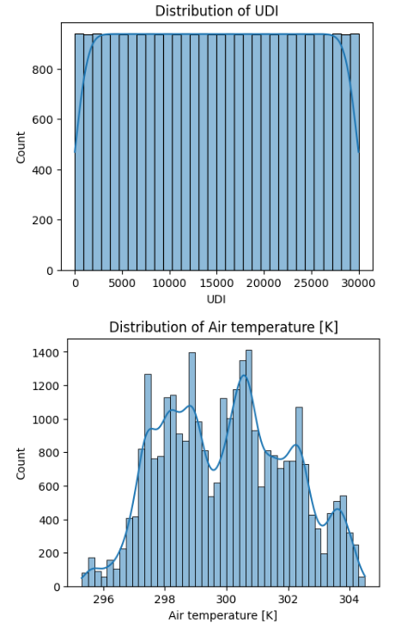

Figure(2): Exploratory Data Analysis (EDA): Visualizing distributions of numeric columns

**3. Experimental Evaluation  
  
3.1 Methodology**

Our methodology involved evaluating a range of machine learning models, including Random Forest, Deep Learning techniques, Support Vector Machine (SVM), Logistic Regression, Linear Regression, Naive Bayes, and a Multi-Layer Perceptron (MLP) benchmarked against a Recurrent Neural Network (RNN). To assess their effectiveness in accurately predicting equipment failures, we focused on key metrics such as accuracy, precision, recall, F1-score, ROC-AUC Score, Mean Squared Error (MSE), and R^2 Score.

The evaluation process included splitting the dataset into training and testing sets to ensure a realistic and robust assessment of each model. The choice and preprocessing of data were meticulously aligned with the specific requirements and characteristics of each model, facilitating an accurate evaluation of their predictive capabilities.

**3.2 Results**

The performance of the models we evaluated showed significant variation, with the Random Forest model standing out as the top performer, achieving an impressive accuracy of 0.9967.

Notably, the Deep Learning model and the MLP, when MLP was benchmarked against the RNN, also exhibited high accuracy, scoring 0.9928 and 0.9907, respectively.

Other models, including SVM, Logistic Regression, Linear Regression, and Naive Bayes, demonstrated strong performances as well. These results highlight the overall effectiveness of advanced machine learning techniques, particularly the Random Forest, Deep Learning, and MLP models, in the realm of predictive maintenance.

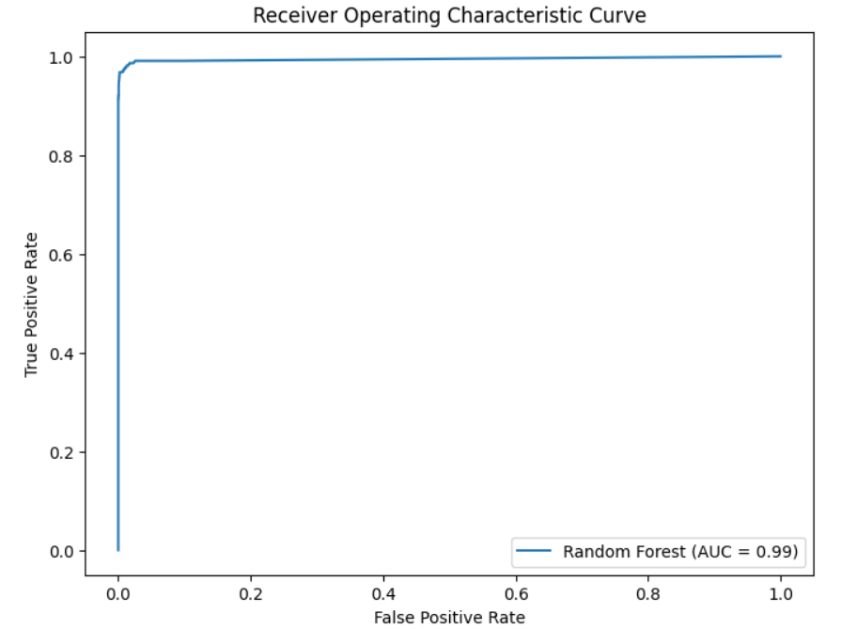

Figure (3): ROC Curve – RF

Figure (4): Machine Learning Accuracies  
  
**3.3 Discussion**

The results from our study robustly support our hypothesis regarding the effectiveness of machine learning in predictive maintenance, as evidenced by the high accuracy and ROC-AUC scores achieved by the models, particularly Random Forest and Deep Learning.

The variance in model performance not only highlights the suitability of different machine learning approaches for this domain but also emphasizes the importance of nuanced feature selection and engineering in influencing model sensitivity and effectiveness.

The superior performance of the Random Forest and advanced models like Deep Learning underlines their robustness in handling complex predictive maintenance data and their applicability in industrial settings. These findings, coupled with plans for integrating more complex models in the future, demonstrate the potential of machine learning to revolutionize predictive maintenance strategies. (Ehrig et al., 2020).

**4. Related Work**

Our project takes a different approach from traditional predictive maintenance methodologies, which often rely on single-model approaches such as the signal processing focus of Kudelina et al. (2023) or the ensemble learning emphasis of Nofal et al. (2023). Instead, we employed a multi-model approach, integrating a diverse spectrum of machine learning models including Random Forest, SVM, Deep Learning, and others. This multifaceted algorithmic strategy enabled a comprehensive analysis of equipment failure data, distinguishing our work in several key aspects:

1. **Enhanced Accuracy:** By evaluating and comparing multiple models, we were able to identify the most effective solution, achieving higher predictive accuracy than traditional single-model methods.
2. **Robust Analysis:** The variety of models employed allowed for a more thorough and robust analysis. Each model contributed its unique strengths in interpreting various aspects of the data, leading to a more nuanced understanding of equipment failures.
3. **Methodological Innovation:** Our approach represents a significant methodological innovation in the field of predictive maintenance. By combining different machine learning techniques, we not only addressed gaps in existing methodologies but also proposed a versatile and potentially more accurate solution for predicting equipment failures.

Overall, our project underscores the value of embracing a multi-model approach in predictive maintenance. This strategy not only improves predictive accuracy but also provides a comprehensive understanding of the factors leading to equipment failures, contributing novel insights and practical strategies to the field.

**5. Code**  
  
The project's code and the merged dataset are shared on GITHUB(LINK), providing clear instructions for reproducing our results. This ensures transparency and facilitates further research and development in this area.

**6. Conclusion**  
  
This project has demonstrated the transformative potential of machine learning in the realm of predictive maintenance, establishing a new benchmark in the field. Through our innovative use of a variety of algorithms, including the standout performance of Random Forest, we have not only enhanced predictive accuracy but also opened new avenues for cost savings and risk mitigation in industrial settings. The efficacy of our multi-model approach, particularly the prominence of Random Forest as the most promising model, underscores the value of machine learning in evolving maintenance strategies.

These findings contribute significantly to the field, illustrating how advanced data analysis can lead to more efficient and effective maintenance strategies. By showcasing the practical applications and benefits of diverse machine learning models, our project sets a precedent for future research and application, highlighting the importance of tailored, data-driven solutions in industrial maintenance. This work, therefore, not only advances the current understanding of predictive maintenance but also provides a solid foundation for further innovations and improvements in this crucial area.

**Bibliography**

* Kudelina, K., et al. (2023). Signal Processing and Machine Learning Techniques for Predictive Maintenance of Rotor Bars in Induction Machines.
* Nofal, Z. A., et al. (2023). Ensemble Learning for Predictive Maintenance on Wafer Stick Machine Using IoT Sensor Data.
* Ehrig, L., et al. (2020). Customizable Asymmetric Loss Functions for Machine Learning-based Predictive Maintenance.