HAKIM
Intelligent Clinic Management System

Technical Implementation, Architecture & Challenges

Graduation Project — Computer Engineering Department

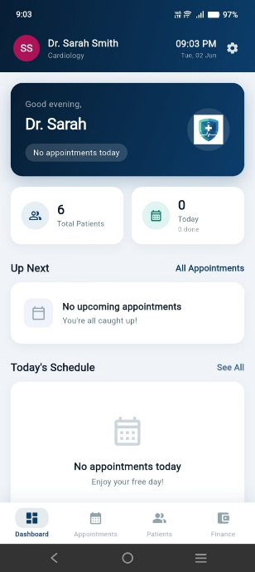
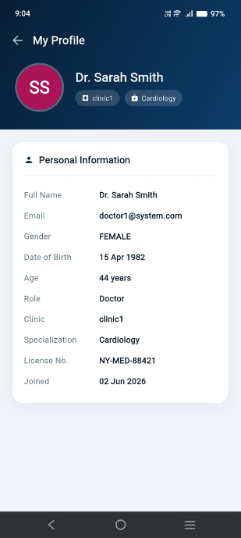
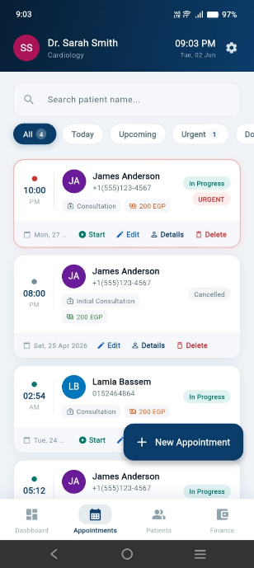
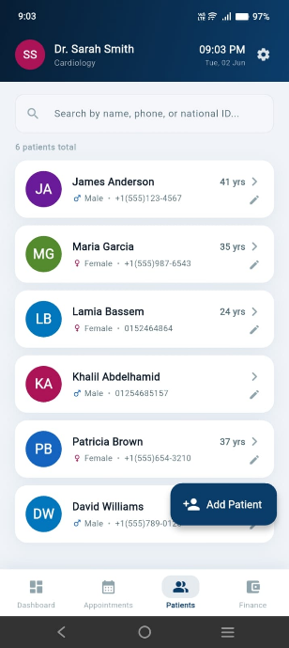
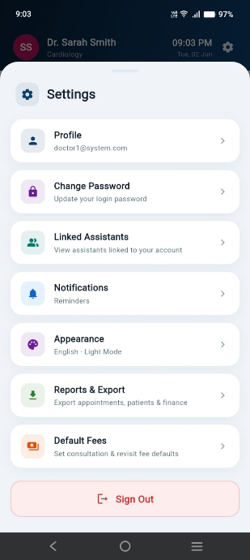
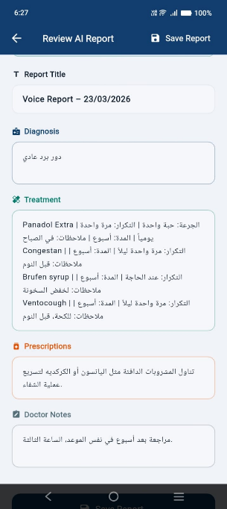
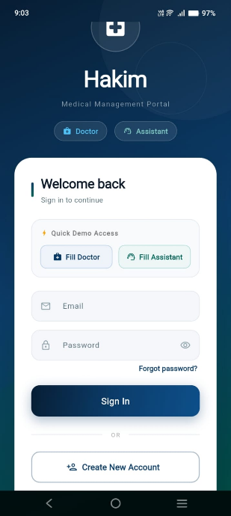
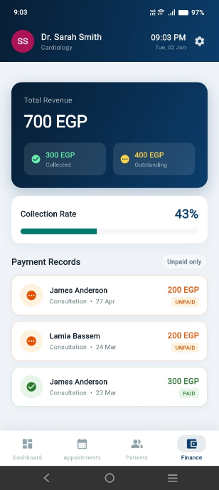

1. Project Overview
Hakim is a cross-platform mobile clinic management system built with Flutter. It is designed to streamline the daily operations of medical clinics by providing separate, role-based interfaces for doctors and their clinic assistants. The system integrates a RESTful backend, a dedicated AI micro-service for medical voice transcription and image analysis, and a secure session management layer — all orchestrated through a clean MVVM architecture powered by Flutter Riverpod.

The application targets two distinct user roles:
- Doctor Interface
- Assistant Interface

1.1 Technology Stack

Layer | Technology | Purpose
Frontend | Flutter (Dart) | Cross-platform UI — Android & iOS from a single codebase
State Management | Flutter Riverpod | Reactive, provider-based state with no autoDispose to preserve session state
HTTP Client | Dio | Interceptor-based HTTP with automatic token injection and error normalisation
Secure Storage | flutter_secure_storage | Encrypted persistence of JWT, user role, and profile data on-device
Backend API | FastAPI (Python) | RESTful API at https://backend.hakim-app.cloud — clinic data, auth, reports
AI Micro-service | Custom AI API | Voice transcription (Whisper + Medical NLP) and medical image analysis at https://ai-api.hakim-app.cloud
Authentication | JWT (Bearer Token) | Stateless token auth — token stored securely, attached to every request via interceptor
Architecture | MVVM | Model / View / ViewModel — clean separation of UI, business logic, and data layer

2. Application Architecture
The application follows the Model-View-ViewModel (MVVM) pattern, which provides a clear boundary between the UI layer and the business logic, making the codebase testable, maintainable, and scalable. The architecture is divided into five layers:

2.1 Layer Breakdown
- Model Layer (lib/model/)
- Service Layer (lib/services/)
- ViewModel Layer (lib/viewmodels/)
- Provider Layer (lib/providers/)
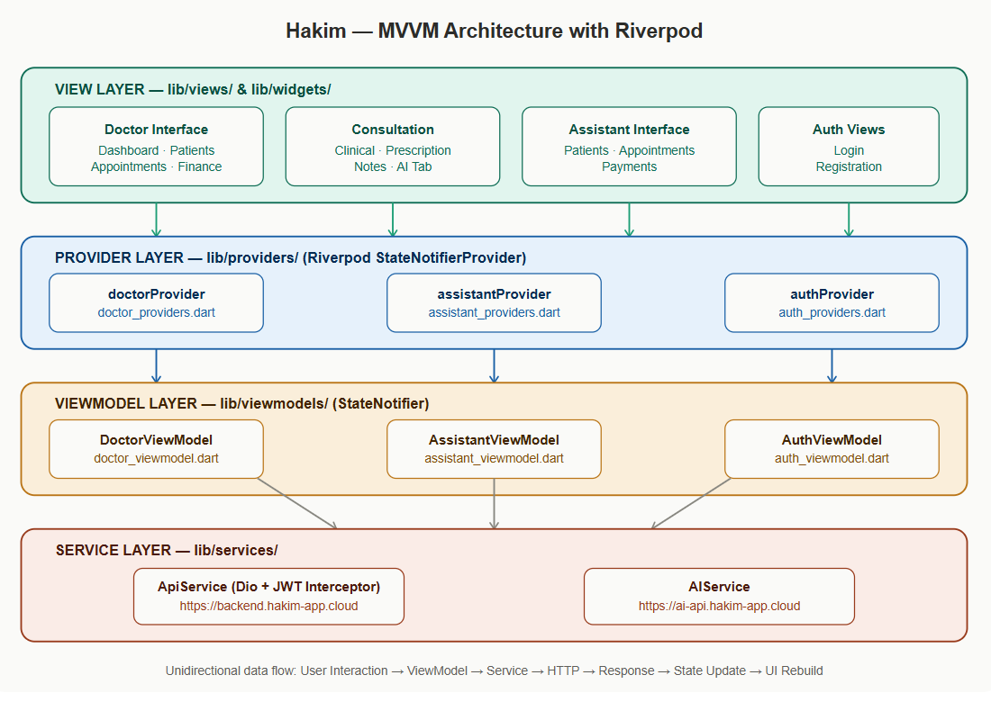
- View Layer (lib/views/ and lib/widgets/)

2.2 Data Flow
User interactions trigger ViewModel methods → ViewModels call Service methods → Services execute HTTP requests through the Dio interceptor → Responses are parsed and stored in immutable state objects → Riverpod notifies all listening widgets to rebuild. This unidirectional flow ensures a single source of truth for every piece of application state.

3. Core Features & Modules

3.1 Authentication & Session Management
The authentication module manages the full user lifecycle including registration, login, session restoration on app restart, and automatic logout on token expiry. It supports two account types — Doctor and Assistant — each with a distinct registration flow and backend endpoint.

- Login
- Registration
- Session Restoration
- Automatic Logout on 401

3.2 Doctor Module
The doctor interface provides a comprehensive clinical management suite with the following capabilities:
- Patient Management
- Appointment Management
- Consultation Session
- Voice Transcription
- Medical Image Analysis
- Financial Module

3.3 Assistant Module
The assistant operates within the scope of a single linked doctor. All data queries are automatically scoped to that doctor's clinic by passing the doctor's primary key as a query parameter to every backend endpoint. The assistant can manage patients, book and manage appointments, and track payments — but cannot access the consultation or AI features.

3.4 AI Integration
The AI capabilities are exposed through a dedicated AIService class that communicates with a custom-hosted AI micro-service running at https://ai-api.hakim-app.cloud. Two endpoints are integrated:

- /transcribe-report
- /analyze-medical-image

Both endpoints require the X-API-KEY header for authentication. Responses are parsed and displayed to the doctor for review and manual correction before being saved as part of the permanent medical record.
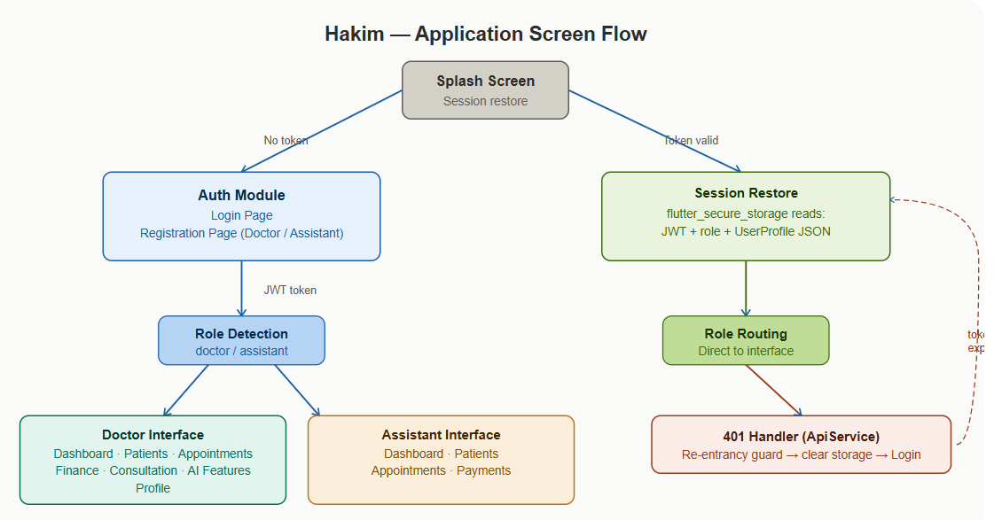

4. Technical Challenges & Solutions
The development of Hakim presented a series of non-trivial engineering problems. Each challenge required careful root-cause analysis and a targeted architectural solution. The following sections document every significant problem encountered and the precise solution implemented.

Challenge 1 — Infinite Redirect Loop on Token Expiry

Problem Description
When the application launched with an expired or missing JWT, the loadAll() method fired three parallel HTTP requests (fetchPatients, fetchAppointments, fetchAppointmentTypes). All three returned HTTP 401 simultaneously. Each 401 independently triggered the logout callback which called Navigator.pushAndRemoveUntil(LoginPage). Executing multiple Navigator operations on a widget tree that is already being torn down caused the UI to freeze on the doctor or assistant interface screen — the user was stuck with no token and no way to log in again without force-closing the app.

Root Cause
The logout handler was registered as a simple callback with no guard against concurrent execution. When parallel requests all failed with 401 at the same time, the handler was invoked three or more times in rapid succession, each attempting to navigate to LoginPage on an already-transitioning navigator stack.

Solution
A boolean re-entrancy guard (_handlingUnauthorized) was introduced inside ApiService. The first 401 to arrive sets the flag to true, clears all persisted credentials, and invokes the navigation callback. All subsequent concurrent 401 responses check the flag and return immediately without re-executing the logout sequence. The guard is reset to false only after a successful login via ApiService.resetUnauthorizedGuard(), ensuring that a future token expiry (days or weeks later) will correctly trigger logout again.

File | lib/services/API_Service.dart → _handleUnauthorized(), resetUnauthorizedGuard()
Pattern | Re-entrancy guard (boolean flag) protecting a non-idempotent side-effecting callback

Challenge 2 — Stale Authentication State Causing Immediate Re-Redirect

Problem Description
After the 401 guard was implemented, a second related bug emerged. When the navigator redirected to LoginPage, the Riverpod authProvider still held state with isAuthenticated = true. The LoginPage's ref.listen watched this value and, upon seeing it was true, immediately navigated back to the DoctorInterface. This caused an infinite navigation loop between LoginPage and DoctorInterface.

Root Cause
The 401 handler (registered in main.dart) had direct access to the navigator via the global NavigatorKey, but had no way to reach the live Riverpod AuthViewModel instance to reset its state. The authProvider had no autoDispose, so the stale state persisted across navigation events.

Solution
AuthViewModel registers itself as a static instance (_instance) in its constructor. A static method resetCurrentInstance() directly sets the ViewModel's state back to the default AuthState (isAuthenticated = false). The 401 handler in main.dart calls this method before executing the navigator push, ensuring the auth state is already clean by the time LoginPage's listener evaluates it.

File | lib/viewmodels/auth_viewmodel.dart → AuthViewModel._instance, resetCurrentInstance()
Pattern | Static instance reference for out-of-tree state mutation

Challenge 3 — Session Not Restored on App Restart

Problem Description
After a user logged in and closed the app, relaunching it always showed the LoginPage — even though the JWT was still valid. Users had to log in every single time they opened the application, which was unacceptable for a clinical tool used many times per day.

Root Cause
Only the JWT was being persisted to secure storage. The SplashScreen had no way to determine which interface to navigate to (doctor or assistant) without the role, and it could not reconstruct a UserProfile without the profile data. Both pieces of information existed only in transient in-memory Riverpod state that was lost on app termination.

Solution
Two additional pieces of data were persisted to FlutterSecureStorage upon every successful login: (1) the user's role string ("doctor" or "assistant") and (2) the full UserProfile serialised as a JSON map. SplashScreen reads all three values on launch. If all are present and the token exists, it reconstructs the UserProfile object and navigates directly to the appropriate interface. If any value is missing, it falls back to LoginPage. Corresponding clear methods are called during logout to ensure no stale session data persists.

Files | lib/services/API_Service.dart → saveRole(), getRole(), saveUserProfile(), getUserProfile()
File | lib/splash/splash_screen.dart → _resolveStartScreen()

Challenge 4 — Assistant Registration Producing an Empty Clinic Scope

Problem Description
After registering an assistant account and logging in, the assistant's patient list, appointment list, and all clinic data were completely empty — even though the linked doctor had patients and appointments. The assistant appeared to have a valid session but could see no data.

Root Cause
The backend creates an assistant account and scopes its JWT to a specific doctor's clinic using the doctor_email field provided at registration. The registration form captured the linked doctor's email but the API call in _createAssistant() was not including it in the request body. The backend therefore created an assistant with no doctor linkage, so the JWT had no clinic scope and all clinic endpoints returned empty results.

Solution
The doctor_email field was added as a required parameter to the RegistrationData model with a client-side validation check that prevents form submission if the field is empty when the user type is Assistant. It is then included in the request body sent to POST /api/v1/users/assistants. A corresponding UI field was added to the registration form to collect this value.

File | lib/viewmodels/auth_viewmodel.dart → _createAssistant(), RegistrationData.doctorEmail

Challenge 5 — Wrong Doctor ID Causing Empty Appointment Lists for Doctors

Problem Description
After logging in as a doctor, the appointments list was consistently empty despite the backend containing appointment records for that doctor. No error was shown; the list simply displayed "No appointments found."

Root Cause
The backend's appointments table stores a doctor_id foreign key that references the doctors table primary key (doctors.id). The login flow was setting the profile's id field to u['user_id'] — the foreign key in the users table — instead of u['id'] — the primary key in the doctors table. The two integer values are different. DoctorViewModel's setDoctorId() stored the wrong key, so all appointment queries sent the wrong doctor_id filter and received no matching records.

Solution
The _buildProfile() method was corrected to prefer u['id'] (the doctors/assistants table primary key) over u['user_id'] (the users table foreign key). The corrected priority is: u['id'] → u['user_id'] → JWT sub claim. This ensures that profile.id always holds the value that other tables reference.

File | lib/viewmodels/auth_viewmodel.dart → _buildProfile()
Lesson | When a backend has separate users and doctors tables, always map to the domain table's PK, not the users table FK

Challenge 6 — Visit ID Management in the Consultation Module

Problem Description
The consultation features (voice transcription, image upload, saving reports) all require a visit_id. A visit might already exist for the appointment (if the doctor started it earlier), or it might need to be created. Calling the creation endpoint when a visit already existed returned an error. Calling it with the wrong appointment status also failed.

Root Cause
There was no centralised mechanism to resolve "does a visit exist for this appointment?". Each action that needed a visit_id was independently trying to create one, leading to duplicate creation attempts and race conditions.

Solution
A lazy-initialisation method ensureVisitExists() was implemented in DoctorViewModel with the following algorithm: (1) Check an in-memory cache — if a visit ID was already resolved in this session, return it immediately. (2) Fetch all visits and search for a match by appointment_id, then by patient_id as a fallback. (3) If no existing visit is found, update the appointment status to CONFIRMED (required by the backend), create a new visit via POST /api/v1/clinic/visits, then advance the status to IN_PROGRESS. (4) Cache the resolved visit ID so all subsequent calls within the consultation session are instant. Status update failures are non-fatal and logged as warnings.

File | lib/viewmodels/doctor_viewmodel.dart → ensureVisitExists()
Pattern | Lazy initialisation with in-memory cache and multi-source fallback resolution

Challenge 7 — Inconsistent AI Response Field Names

Problem Description
The AI transcription endpoint returned JSON with field names that changed across API versions and request contexts. In some responses the diagnosis was in "diagnosis", in others it was "ai_diagnosis" or "impression". Prescriptions appeared as "prescriptions", "medications", "medication_list", or "rx". The application would silently display blank sections for any field it did not recognise.

Root Cause
The AI micro-service evolved independently of the Flutter client, and field naming conventions were not strictly versioned. Different model versions and different audio inputs produced subtly different response schemas.

Solution
A comprehensive field-mapping dictionary (_buildStructuredReport) was built into DoctorViewModel. Each of the four displayed report sections (Diagnosis, Treatment, Prescriptions, Doctor Notes) maps to a prioritised list of all known API key names for that concept. The method iterates through the candidates in order and uses the first non-empty value it finds. A separate _formatApiValue helper handles all possible value types: plain strings, arrays of strings, and arrays of structured medication objects (with dose, frequency, and duration sub-fields). Arabic placeholder strings ("غير مذكور", "غير محدد") are detected and treated as empty to avoid displaying meaningless filler text.

File | lib/viewmodels/doctor_viewmodel.dart → _buildStructuredReport(), _formatApiValue()

Challenge 8 — Inconsistent API Response Envelope Shapes

Problem Description
Different backend endpoints returned list data wrapped in different JSON envelopes. Some returned a bare array, others returned { "items": [...] }, others { "data": [...] }, and some used domain-specific keys like { "patients": [...] }. Code that expected a specific shape would silently return an empty list when the shape changed.

Root Cause
The FastAPI backend was developed by a separate team, and different endpoints were written at different stages of the project with inconsistent response schema conventions.

Solution
A unified normalisation helper _asList() was implemented in ApiService. It attempts to handle every observed response shape: (1) If the response is already a bare List, return it directly. (2) If it is a Map, check a prioritised list of known wrapper keys (items, data, results, appointments, patients, visits, records, reports, list, types, appointment_types). (3) If none of the known keys match, scan all map values and return the first List found, logging a warning with the key names to aid debugging. (4) Return an empty list as a safe fallback.

File | lib/services/API_Service.dart → _asList()

Challenge 9 — Assistant Doctor Scope Resolution on Session Restore

Problem Description
When an assistant's session was restored from secure storage (via SplashScreen), the AssistantViewModel could not determine which doctor's data to load. The doctorId was sometimes null in the restored profile, causing all patient and appointment queries to return empty results.

Root Cause
The doctor_id was present in the original login API response but was not being persisted as part of the saved UserProfile JSON in secure storage. On session restore, the field was absent, and the ViewModel had no fallback.

Solution
Three independent resolution sources were implemented in AssistantViewModel.initForAssistant(), tried in priority order: (1) profile.doctorId — the doctor's primary key stored directly on the assistant record by the backend, persisted to secure storage at login. (2) profile.doctorEmail — the linked doctor's email, used to look up the doctor in the /api/v1/users/doctors list and retrieve their primary key. (3) Clinic name matching — compare the assistant's clinicName against all doctors' clinicName fields as a last resort. The first source that yields a valid integer ID terminates the resolution chain. Both doctor_id and doctor_email are now explicitly persisted to secure storage in the saveUserProfile call.

File | lib/viewmodels/assistant_viewmodel.dart → initForAssistant()
Pattern | Cascading fallback resolution with re-entrancy guard

Challenge 10 — DateTime Timezone Comparison Bug

Problem Description
The "Today's Appointments" filter on the doctor dashboard was not showing appointments that clearly existed for the current date. Appointments that had just been created would sometimes not appear under the "Today" filter tab.

Root Cause
The original filter used Dart's DateTime == operator to compare dates. DateTime's equality check considers the isUtc flag: a DateTime representing 2025-06-01 in UTC and a DateTime representing the same instant in local time are NOT equal under ==, even though they fall on the same calendar day. Appointment timestamps from the backend were UTC ISO 8601 strings, and the device's local DateTime.now() was in the local timezone. Comparing them with == produced incorrect results.

Solution
All date comparisons that need to identify the same calendar day were replaced with explicit year, month, and day field comparisons after converting both sides to local time using .toLocal(). The pattern used throughout the codebase is: dt.year == now.year && dt.month == now.month && dt.day == now.day. The parseDate() utility method was also updated to always call .toLocal() on the parsed DateTime before returning it.

File | lib/viewmodels/doctor_viewmodel.dart → filteredAppointments(), todayAppointments
Pattern | Always convert API timestamps to local time before calendar-day comparisons

Challenge 11 — JWT Role Claim Absent in Token Payload

Problem Description
On some backend deployments, the JWT payload did not contain a "role" field at the expected key. The login flow would fail to determine whether to route the user to the Doctor or Assistant interface, and would fall back to an error state saying "Unknown role. Contact support."

Root Cause
The backend team changed the role claim key name between versions (from "role" to "user_role" to "type"). The client was only checking one specific key name.

Solution
The JWT decoding step in AuthViewModel.login() was updated to check multiple candidate keys in priority order: payload['role'] → payload['user_role'] → payload['type']. If none of these yield a recognisable role string, a secondary resolution method _resolveRoleByEmail() performs an API-based lookup: it fetches both the doctors list and the assistants list and searches for an entry matching the logged-in email address. This approach is robust against any future changes to the JWT schema.

File | lib/viewmodels/auth_viewmodel.dart → login(), _resolveRoleByEmail()

5. Challenges Summary
The following table provides a consolidated reference of all technical challenges encountered during the development of Hakim and the solutions implemented to resolve them.

Challenge / Problem | Root Cause | Solution Implemented
401 Infinite Navigation Loop | Parallel requests all failed with 401 simultaneously, causing multiple navigator pushes | Re-entrancy guard (_handlingUnauthorized) ensures only first 401 triggers logout
Stale Auth State After 401 | authProvider held isAuthenticated=true, causing LoginPage to immediately re-navigate back | Static AuthViewModel instance allows out-of-tree state reset before navigation
Session Not Restored on Restart | Only JWT was persisted; role and UserProfile were lost on app termination | Persist role + full UserProfile JSON to FlutterSecureStorage; restore in SplashScreen
Assistant Empty Clinic Scope | doctor_email was missing from assistant registration request body | Added doctor_email as required field in RegistrationData and API call
Wrong Doctor ID in Queries | profile.id was set from users.user_id (FK) instead of doctors.id (PK) | _buildProfile() now prefers u['id'] (domain table PK) over u['user_id']
Visit ID Management | No mechanism to resolve or lazily create visit records before AI operations | ensureVisitExists() with in-memory cache and three-step creation fallback
Inconsistent AI Field Names | AI micro-service returned different key names across versions and inputs | _buildStructuredReport() maps all known key names per section; _formatApiValue() handles all types
Variable API Response Envelopes | Different endpoints wrapped lists in different JSON keys | _asList() normalisation helper tries all known wrapper keys with a fallback scan
Assistant Doctor Scope on Restore | doctor_id absent in restored profile; ViewModel could not determine which doctor to query for | Three-source cascading resolution: doctorId → doctorEmail lookup → clinic name matching
DateTime Timezone Comparison Bug | DateTime == checks isUtc flag; UTC vs. local comparison produced wrong "today" filter results | Explicit year/month/day field comparison after .toLocal() conversion
JWT Role Claim Key Changed | Backend renamed the role claim key across versions | Check three candidate keys; fallback to API-based email lookup via _resolveRoleByEmail()

6. Backend API Endpoints
All API communication goes through the central ApiService class. The following table lists every backend endpoint integrated into the application.

Method | Endpoint | Purpose
POST | /api/v1/auth/login | User authentication — returns JWT access token
POST | /api/v1/auth/logout | Invalidates server-side session
POST | /api/v1/auth/change-password | Updates authenticated user password
GET | /api/v1/users/doctors | Fetch all doctor accounts (used for role resolution and assistant linking)
GET | /api/v1/users/doctors/:id | Fetch a single doctor by primary key
GET | /api/v1/users/assistants | Fetch all assistant accounts
POST | /api/v1/users/doctors | Create a new doctor account (requires admin token)
POST | /api/v1/users/assistants | Create a new assistant account linked to a doctor (requires admin token)
GET | /api/v1/clinic/patients | Fetch patient list — filterable by doctor_id and search string
POST | /api/v1/clinic/patients | Create a new patient record
PATCH | /api/v1/clinic/patients/:id | Update patient data
DELETE | /api/v1/clinic/patients/:id | Delete patient record
POST | /api/v1/clinic/patients/:id/conditions | Assign a condition from the catalog to a patient
DELETE | /api/v1/clinic/patients/:id/conditions/:conditionId | Remove a condition assignment from a patient
GET | /api/v1/clinic/conditions | Fetch the conditions catalog — searchable
POST | /api/v1/clinic/conditions | Create a new condition entry in the catalog
GET | /api/v1/clinic/appointments | Fetch appointments — filterable by doctor_id, patient_id, status
POST | /api/v1/clinic/appointments | Create a new appointment
PATCH | /api/v1/clinic/appointments/:id | Update appointment details
PATCH | /api/v1/clinic/appointments/:id/status | Update appointment status only
DELETE | /api/v1/clinic/appointments/:id | Delete appointment
GET | /api/v1/clinic/appointment-types | Fetch available appointment type categories
POST | /api/v1/clinic/visits | Start (create) a visit record for an appointment
GET | /api/v1/clinic/visits | Fetch visit records — filterable by doctor_id, patient_id, status
PATCH | /api/v1/clinic/visits/:id/status | Update visit status (CONFIRMED → IN_PROGRESS → COMPLETED)
GET | /api/v1/reports/medical-reports | Fetch medical reports — filterable by patient_id, doctor_id, visit_id
POST | /api/v1/reports/medical-reports | Create a medical report (requires visit_id)
PATCH | /api/v1/reports/medical-reports/:id | Update report fields (doctor edits to AI draft)
PATCH | /api/v1/reports/medical-reports/:id/status | Update report status (DRAFT → FINAL)
POST | /api/v1/reports/transcribe | AI: transcribe audio + create DRAFT report in one step (multipart)
POST | /api/v1/reports/medical-images | Upload a medical image associated with a visit (multipart)
GET | /api/v1/reports/visits/:visitId/medical-images | Fetch all images for a given visit
POST | /api/v1/reports/lab-reports | Upload a PDF lab report associated with a visit (multipart)

7. Key Design Decisions

7.1 No autoDispose on Riverpod Providers
All three core providers (authProvider, doctorProvider, assistantProvider) are declared without autoDispose. In Flutter Riverpod, autoDispose destroys a provider's state when no widget is currently listening to it. During navigation transitions — such as pushing a settings page over the main interface — the main interface briefly has no listening widgets. With autoDispose enabled, this would destroy the ViewModel and lose all loaded patient and appointment data, requiring a full reload on back-navigation. Disabling autoDispose ensures that data persisted in memory survives navigation events.

7.2 Global Navigator Key
A GlobalKey<NavigatorState> is instantiated in main.dart and passed to the MaterialApp. This allows code outside the widget tree — specifically the ApiService 401 callback — to perform navigation without a BuildContext. This pattern is necessary because network callbacks execute asynchronously and may fire at a point where no BuildContext is reliably available on the call stack.

7.3 Admin Token for User Registration
The backend does not provide a public endpoint for self-registration. Creating a user account requires an admin-level JWT. Rather than exposing an admin panel or requiring a backend change, the mobile client obtains a short-lived admin token in-memory during the registration flow by authenticating with an admin credential. This token is used solely for the account creation API call and is never stored or reused.

7.4 Centralised Error Extraction
FastAPI validation errors are returned as structured JSON arrays: { "detail": [ { "loc": [...], "msg": "..." }, ... ] }. A static extractError() method in ApiService parses both this format and simple string detail messages, producing a single human-readable error string. This is the only place in the codebase that parses API errors, ensuring consistent error display across all ViewModels and views.

7.5 Immutable State with copyWith
All state classes (AuthState, DoctorState, AssistantState) are immutable Dart classes with copyWith methods. State updates always produce a new instance rather than mutating the existing one. This is a requirement of Riverpod's StateNotifier, which only triggers widget rebuilds when the state object reference changes. Immutability also prevents accidental shared-state mutations across different parts of the UI.

8. Conclusion
The Hakim clinic management system represents a complete, production-ready mobile application that successfully addresses the real-world complexity of clinical workflows. Beyond implementing the core features, the development process demanded rigorous solutions to a range of challenging engineering problems — from concurrent HTTP race conditions and stateful navigation management to AI response schema variability and multi-source data resolution.

Each challenge documented in this chapter reflects a genuine problem encountered during development, diagnosed through systematic debugging, and resolved through a principled architectural solution. The patterns applied — re-entrancy guards, lazy initialisation with caching, cascading fallback resolution, and defensive data normalisation — are transferable to any production mobile application that integrates a backend API with stateful client-side logic.

The result is an application that is robust against network instability, resilient to backend schema evolution, and capable of recovering gracefully from authentication failures — qualities that are essential for a system used in a clinical environment where reliability and data integrity are paramount.

