Predicting the Remaining Useful Life (RUL) of a Turbofan Jet Engine

Tareq Alaa Alsahaf
Maintenance and Reliability, Industrial Systems Engineering
King Fahd University of Petroleum and Minerals
Dhahran - Saudi Arabia
g202036800@kfupm.edu.sa

Abstract
Predicting the Remaining Useful Life (RUL) of turbofan engines is critical for effective maintenance planning and ensuring operational safety in aviation. This study utilizes the NASA C-MAPSS dataset, which contains multivariate time-series sensor data from multiple engines under varying operating conditions. A machine learning approach is applied to model engine degradation and estimate RUL, enabling timely maintenance decisions. The proposed methodology includes data preprocessing, feature extraction, and regression-based prediction models. Results demonstrate the model’s ability to accurately forecast RUL, potentially reducing unplanned downtime and maintenance costs. This work provides a framework for implementing predictive maintenance strategies in aerospace applications.
Introduction
The data set under study consists of operational and sensor measurements from turbofan jet engines, collected to support predictive maintenance and reliability analysis. Performing data-driven analysis on such equipment is critical because early detection of anomalies and remaining useful life (RUL) estimation can significantly improve operational efficiency and reduce unexpected failures. Asset Performance Management (APM) plays a crucial role in the industry by leveraging this data to monitor, maintain, and optimize the performance of critical assets. Implementing APM strategies helps minimize downtime, avoid costly operational disruptions, extend equipment lifespan, and reduce maintenance expenses, while also enhancing safety by identifying potential failure risks before they become critical. Overall, analyzing these datasets provides actionable insights that enable industries to maximize operational time, improve decision-making, and maintain high standards of reliability and safety in complex machinery like jet engines.

Problem Characterization

Define the Problem and Summarize Its Importance
This graph illustrates the projected growth of Saudi Arabia’s predictive maintenance market, highlighting the importance of accurately predicting the Remaining Useful Life (RUL) of industrial assets such as turbofan jet engines. Effective RUL estimation enables predictive maintenance, a core component of Asset Performance Management (APM), which maximizes operational time, reduces maintenance costs, extends asset lifespan, and enhances safety.

Challenging Aspects
Accurate RUL prediction is challenging due to nonlinear and time-dependent degradation of components, variations in operational conditions, and sensor noise. Additionally, initial wear and manufacturing variations between engines are ignored, adding further uncertainty to model predictions.

Relevant Statistics to Illustrate the Scope and Impact
Ineffective maintenance strategies can reduce an asset’s productive capacity by 5% to 20%, while unplanned downtime costs industries roughly $50 billion annually (Deloitte, 2017). The graph bellow illustrates the growing investment in predictive maintenance in Saudi Arabia as a response to these industrial losses, underscoring the critical need for accurate RUL estimation.
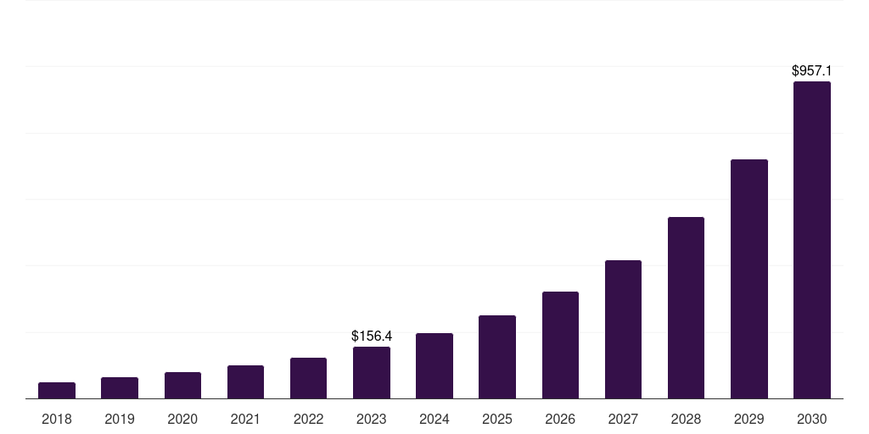
Figure 1: Saudi Arabia predictive maintenance market, 2018-2030 (US$M)

Problem Formulation & Modeling

Mathematical Model
The problem can be mathematically represented as a regression problem as follows:
$$X(t)=[x_{1}(t),x_{2}(t),...,x_{n_{s}}(t)]$$
$X(t)$: Vector of sensor measurements at time $t$.
$$C(t)=\left[c_{1}(t),c_{2}(t),c_{3}(t)\right]$$
$C(t)$: Vector of operational settings (control factors) at time $t$.
$N(t)$: Noise or unmodeled variations.
$RUL(t)$: Remaining Useful Life (RUL), output.
Then the system can be represented as:
$$RUL(t)=f( X\left(t\right) ,C\left(t\right) ,N\left(t\right) )$$
Where $f$is an unknown function that maps sensor data and operating conditions to RUL. The goal is to train a model to learn $f$ in order to predict RUL for unseen future values.

Parameter Diagram (P-Diagram)
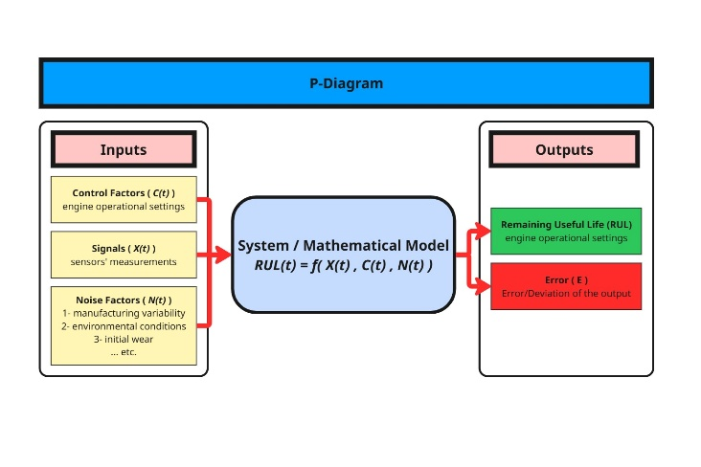
Figure 2: P-Diagram according to NASA Turbofan Jet Engine Data Set
References
- B². (2018, October 2). NASA Turbofan Jet Engine Data Set [Data set]. Kaggle. https://www.kaggle.com/datasets/behrad3d/nasa-cmaps/data
- The P-Diagram for the system was developed using the Miro online whiteboard (https://miro.com).
- Deloitte. (2017). Predictive maintenance and the smart factory. Retrieved from https://www.deloitte.com/us/en/services/consulting/services/predictive-maintenance-and-the-smart-factory.html.
- Grand View Research. (2025). Saudi Arabia Predictive Maintenance Market Size & Outlook. Retrieved from https://www.grandviewresearch.com/horizon/outlook/predictive-maintenance-market/saudi-arabia.

