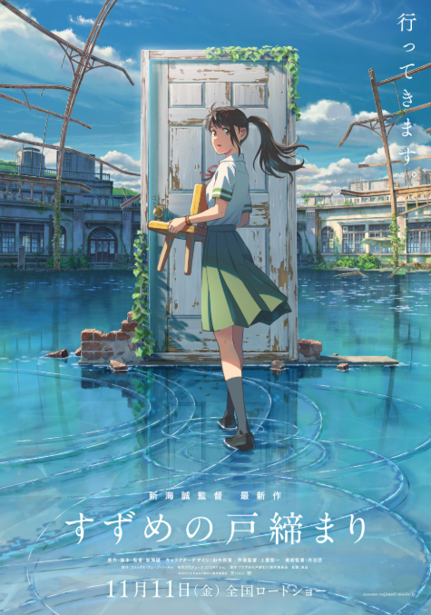  Movie Review Suzume (2022)  Directed by: Makoto Shinkai  Genre: Fantasy / Adventure / Drama | Abstract  This review examines Suzume (2022), Makoto Shinkai’s visually striking animated fantasy film. Blending adventure, emotional storytelling, and symbolic exploration of memory and natural disaster, the film follows a teenager’s cross-country journey to close supernatural doors that threaten Japan. The review summarizes the plot without revealing key twists, evaluates the characters, directing, cinematography, and soundtrack, and discusses the themes that give the film its emotional depth. Ultimately, the analysis highlights why Suzume stands out as one of Shinkai’s most compelling works and offers a strong recommendation for viewers seeking a powerful and immersive cinematic experience.  Farouk Mohammed – Tareq Khalil – Muhammad Waleed – Abdelrahman Azzam – Kareem Fathy – Ans Wael
Table of Contents
Introduction 1
Summary of the Plot (without spoilers) 1
Evaluation of the Plot, Characters, and Themes 1
Plot and Pacing 1
Characters 2
Direction and Cinematography 2
Music and Sound 2
Symbolism and Emotional Impact 2
Conclusion and Recommendation 2

Introduction
Suzume, also known as Suzume’s Door-Locking, is one of the most visually captivating and emotionally resonant animated films of recent years. Directed by the renowned Japanese filmmaker Makoto Shinkai, who is known for Your Name and Weathering With You, the film blends magical realism, natural disaster imagery, and intimate character drama. Set across modern-day Japan, Suzume grabs the viewer’s attention from its opening scenes, weaving together a story that is both deeply personal and symbolically rich. It is not merely a fantasy adventure; it is a coming-of-age film that reflects on grief, responsibility, memory, and healing. If you only watch one animated film this year, Suzume is definitely worth your time.

Summary of the Plot (without spoilers)
The story follows Suzume Iwato, a 17-year-old girl living in a quiet town in Kyushu. Her ordinary life changes the moment she meets a mysterious traveler named Souta Munakata, who is searching for abandoned places across Japan—ruined schools, empty resorts, forgotten villages—each containing a strange, magical door. These doors are portals connected to the afterworld, and if left open, they can unleash massive supernatural forces that cause real earthquakes in Japan.
Suzume discovers one of these doors and, driven by curiosity, accidentally unleashes a catastrophic threat. When she tries to fix her mistake, she becomes linked to Souta’s mission of “door locking,” a sacred duty passed down through his family. The plot evolves into a cross-country journey in which Suzume must face not only supernatural dangers, but also the unspoken trauma of her own past.
The film is fast-moving, action-packed, and full of unexpected twists, balancing intense supernatural moments with emotional character-driven storytelling.

Evaluation of the Plot, Characters, and Themes

Plot and Pacing
The plot of Suzume is exciting, beautifully structured, and full of symbolic moments. While the story begins with a fairly predictable “hero meets mysterious stranger” setup, it quickly develops into something more complex. Shinkai combines realistic depictions of Japan’s geography with magical elements—giant worm-like spirits, glowing red skies, and ancient doors that appear frozen in time. The narrative never feels slow; instead, it operates with a sense of urgency that parallels Suzume’s emotional growth. The plot’s unexpected twist, which reveals the true nature of Suzume’s past, is both surprising and heartbreaking.

Characters
Suzume is a compelling and sensitive protagonist. At first, she appears typical—cheerful, polite, somewhat naive—but as the story unfolds, her emotional depth becomes clear. She is brave, selfless, understanding, and empathetic, yet she carries unresolved grief. Her journey is not just physical but emotional; she learns to confront her memories and find her own strength.
Souta serves as both a mentor and moral counterpart to Suzume. Although he is transformed early in the film (avoiding spoilers), his character remains optimistic, thoughtful, and dedicated. Other characters, such as Suzume’s strict yet caring aunt Tamaki and the mischievous supernatural cat Daijin, add humor, tension, and emotional complexity. The cast is excellent as a whole, and the voice acting is convincing and full of emotion.

Direction and Cinematography
Makoto Shinkai’s direction is visually stunning. Every scene is meticulously crafted—sunsets, abandoned towns, reflections on water, and sweeping landscapes are brought to life with vibrant color and intricate detail. The cinematography captures both the beauty of Japan and the terror of natural disasters. Lighting plays an essential role: bright scenes emphasize hope and curiosity, while darker, red-lit sequences create suspense and danger. The film’s transitions between the real world and supernatural spaces are smooth and artistically imaginative. Shinkai’s style is unmistakable—his directing elevates the story beyond typical animation.

Music and Sound
The soundtrack, composed by the Japanese band RADWIMPS in collaboration with Kazuma Jinnouchi, is one of the film’s strongest elements. The music ranges from soft piano melodies during emotional scenes to powerful orchestral themes during action sequences. The score enhances the mood and gives weight to both quiet and intense moments. The opening theme, infused with a sense of adventure, sets the tone for the entire film. Sound effects, especially during earthquake sequences, are realistic and immersive.

Symbolism and Emotional Impact
One of the most remarkable aspects of Suzume is its use of symbolism. The doors represent trauma, memory, and unresolved emotions. The “worm” symbolizes the uncontrollable forces of nature—and perhaps the emotional burdens people carry silently. Suzume’s journey can be interpreted as Japan’s process of healing from real natural disasters. The conclusion of the film, without revealing details, is emotionally satisfying, dramatic, and full of hope.

Conclusion and Recommendation
Suzume stands out as one of Makoto Shinkai’s most mature and cohesive films. It successfully blends fantasy adventure with heartfelt drama, offering both thrilling supernatural sequences and quiet, deeply emotional moments. The characters are memorable, the animation is breathtaking, and the soundtrack enriches every scene.
I highly recommend Suzume to anyone who enjoys animation, fantasy, or character-driven stories. It is well worth watching, and its emotional depth ensures that it will stay in your mind long after the credits roll. For its visuals, story, and artistic direction, I would give Suzume 4.5 out of 5 stars.

