***School Database System***

Dr.Rafat Amarneh

**Created By: Tareq Ali ,Qusay Nasser ,Amir Subaih , Mohanad abd-alrazzaq.**

**Description**:

This project is a school and consists of a teacher and the teacher gives more than one subject and the subject is given by more than one teacher and the teacher teaches more than one class, and the class gives him more than one teacher, the class contains students and each student is in one class and the students take Exams and exams are taken by more than one student and the student can take a book and the book can be taken by more than one student and the student has a family

There 7 tables Are: family, student, books, teacher, class, course, exam. **And we have a relation between one teacher and many teacher(supervisor)**

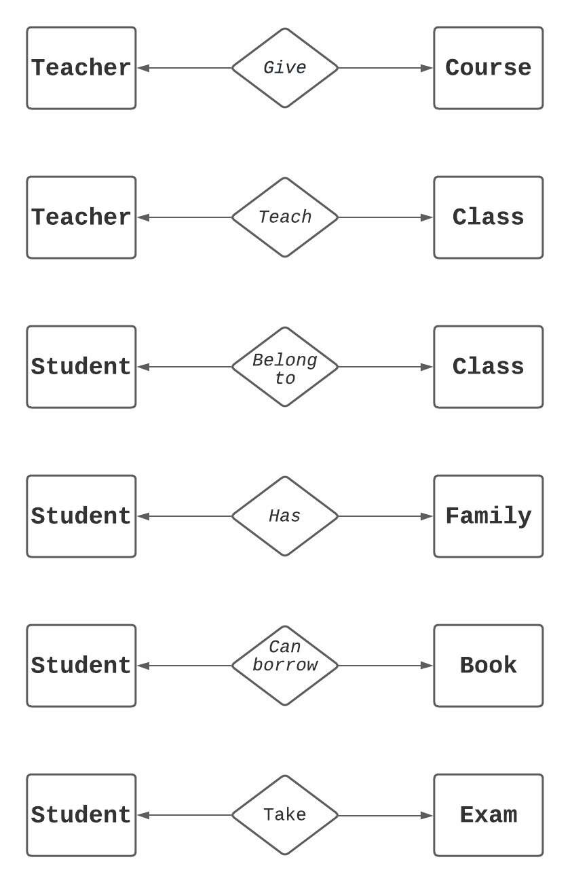

**ERD**

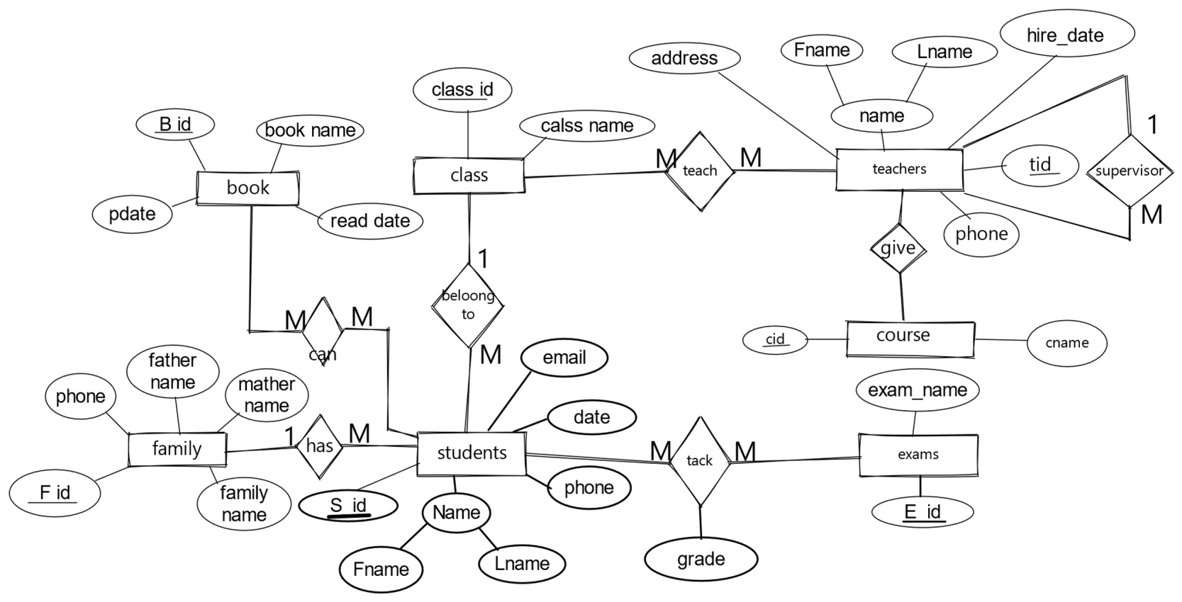

**Mapping**

