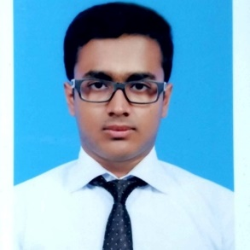

355/1 East Kazipara

Mirpur, Dhaka - 1216

Contact No: +8801795876026

tareqimam800@gmail.com

https://www.linkedin.com/in/md-imam-hossain-9425aa22b/

Md Imam Hossain

|  |  |
| --- | --- |
| Career Objective | To secure a position in a well-established organization with a stable environment that will lead to a lasting relationship in the field of Software Developer. |
| Career Summary | Results-oriented Computer Science and Engineering major currently attending IUBAT. Aiming to leverage a proven knowledge of computer-aided engineering, backend developing, and desktop technology skills to successfully fill the developer role at your company. Frequently praised as focused by my peers, I can be relied upon to help your company achieve its goals. |
| Education | **B.Sc. in Computer Science and Engineering - IUBAT**  **HSC – Adamjee Cantonment College**  **SSC – Muslim Modern Academy** |
| Work Experience | **English & Math Teacher** Independent  March 2019 – September 2021  **Trainee**  at Kodeeo Limited.  January 2022 – April 2022  **Intern**  at Ahosania  May 2022 – August 2022 |
| Projects | * Job Portal(PHP, Laravel, MySQL) * Leader Board website(HTML, CSS) * A Sequential Model approach using Machine Learning for detecting driver drowsiness(Python) |
| Skills on Tools | * Problem solving using C programming. * Object oriented programming using C++. * Frontend design using HTML, CSS, Bootstrap & JavaScript (basic). * Backend using PHP, Laravel. * Database using MySQL. * Graphics design using Adobe Photoshop and Illustrator. |
| OTHER Tools | • Codeblocks • Visual Studio Code • Xampp • Git & Github |
| Portfolio | * <https://github.com/TareqImam> |
| Personal Attributes | * Keen Observer * Quick in adopting new tech * Comfortable working independently or as part of a team |
| Reference | * Prof. Dr. Utpal Kanti Das   Professor & Chairman  Department of CSE, IUBAT  Phone: 01819199419  E-mail: ukd@iubat.edu   * Tahmid Faiyaz Utshaw   CEO, Course Platoon  Phone: 0 1676-719783  Email: [Utshawjdg@gmail.com](mailto:Utshawjdg@gmail.com) |

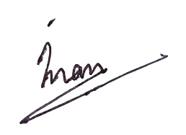

----------------------

Md Imam Hossain