
HCI Course Project
Phase 1
Improving the Interface and User Experience of an Ambualnce Dispatch System

Ayah Sa’afin 1160063
Tareq Kirresh 1142828
Mohannad Jamal 1140643

1. Description of the problem
We have a web application that is an ambulance management and dispatch system. It is supposed to track vehicles in real time, manage cases,
and help the dispatcher go about their tasks. However, this application, in its current state, is unusable. Our goal throughout this project is to make the application more friendly to the dispatchers using it.

The Application was based on the log-sheet system of the Red Cross Society, and thus, reflects their operating practices.

2. Analysis of the problem
The problem with the current state of the application(aside from not being functionally complete), is that it is not well organized, and the design of the UI is illogical and uncomfortable. The application has many issues.
The colors are not matching, and there are too many of them on the screen. The location of the widgets makes no sense, and screen real-estate is wasted
on forms rather than data. This can be clearly seen in the images below :

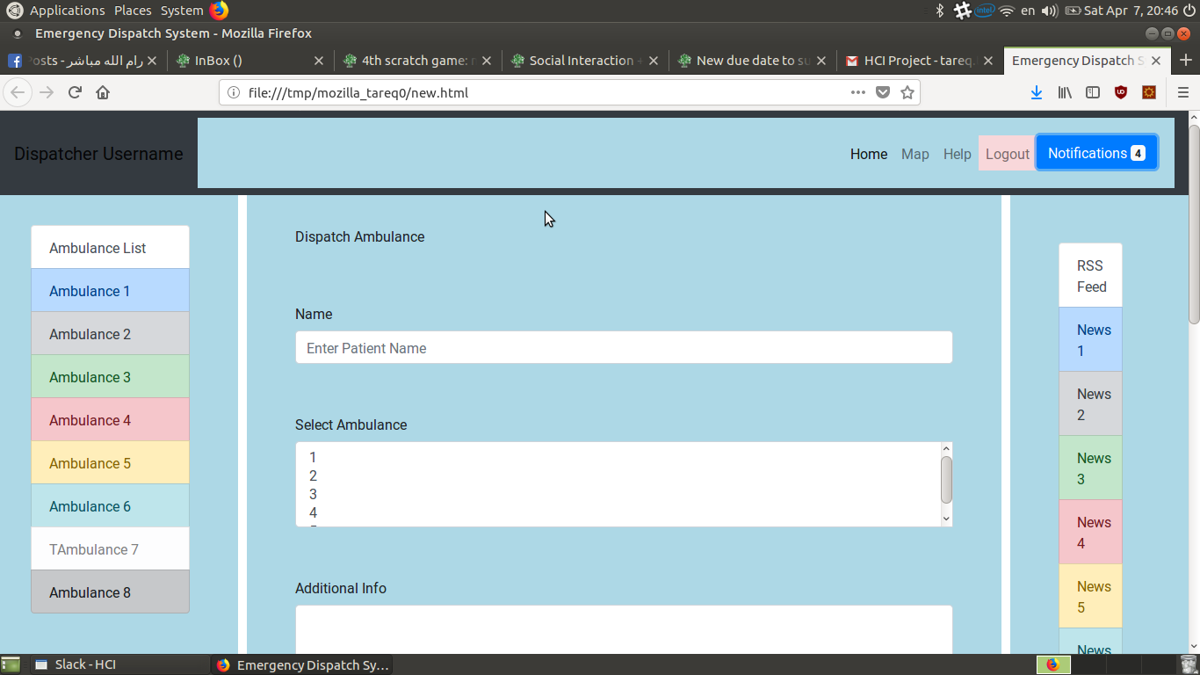

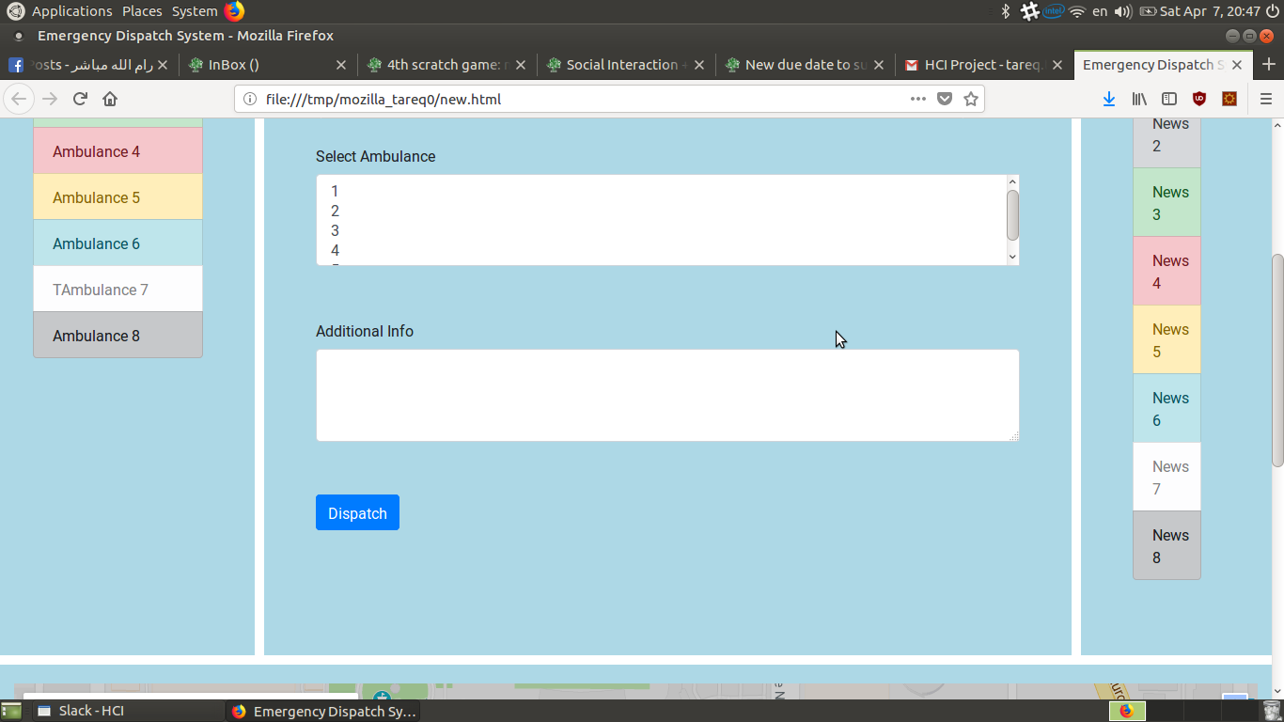
As is clear from the pictures above, the main center widget is a poorly designed form, that is sitting in place of more necessary data(the map with the ambulances on it). The RSS feed to the right is taking up a portion of the screen, but is not clear enough to read because of the small size of the portion it is taking and how close the items are.

The Ambulance list to the right of the screen is taking up too much space, and the information on it is unclear because there is no mapping of any sort between the colors of the background and the status of the ambulance. Furthermore, the most important source of information, the map with the ambulances on it, is actually at the bottom of the screen away from all the action, as shown in the figure below

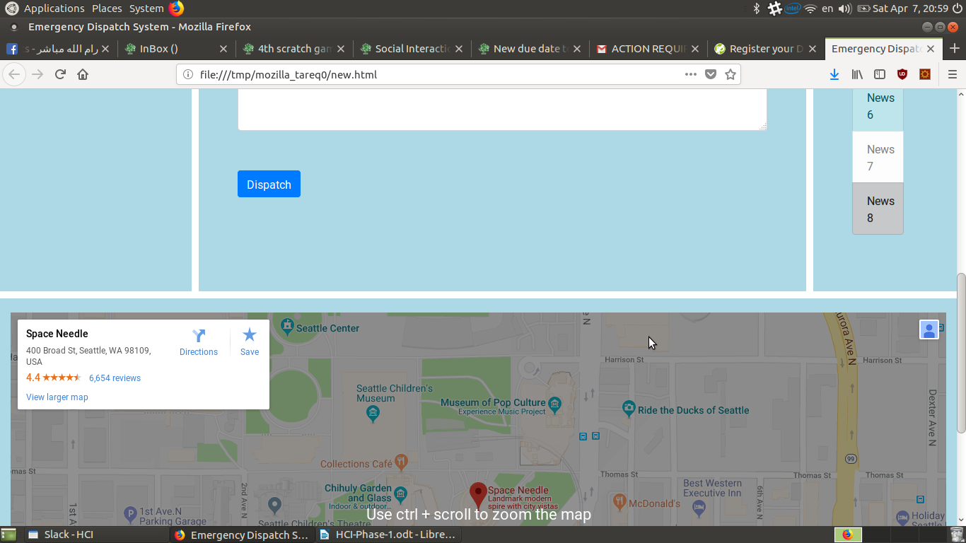
Another core issue with the application is that there is a lack of a clear way to retrieve historical data.

Finally, the application is in english, despite being designed to be used by arab users with minimal computer skills.

3. Persona of the user
