
HCI Assignment 1
Tareq Kirresh 1142828

1. A Good Product : Rice Cooker
This is a rice cooker that clrealy indicates what it can and cant do (quick rice, white rice, brown rice, etc), and all you have to do is throw in rice and water into it from the top.

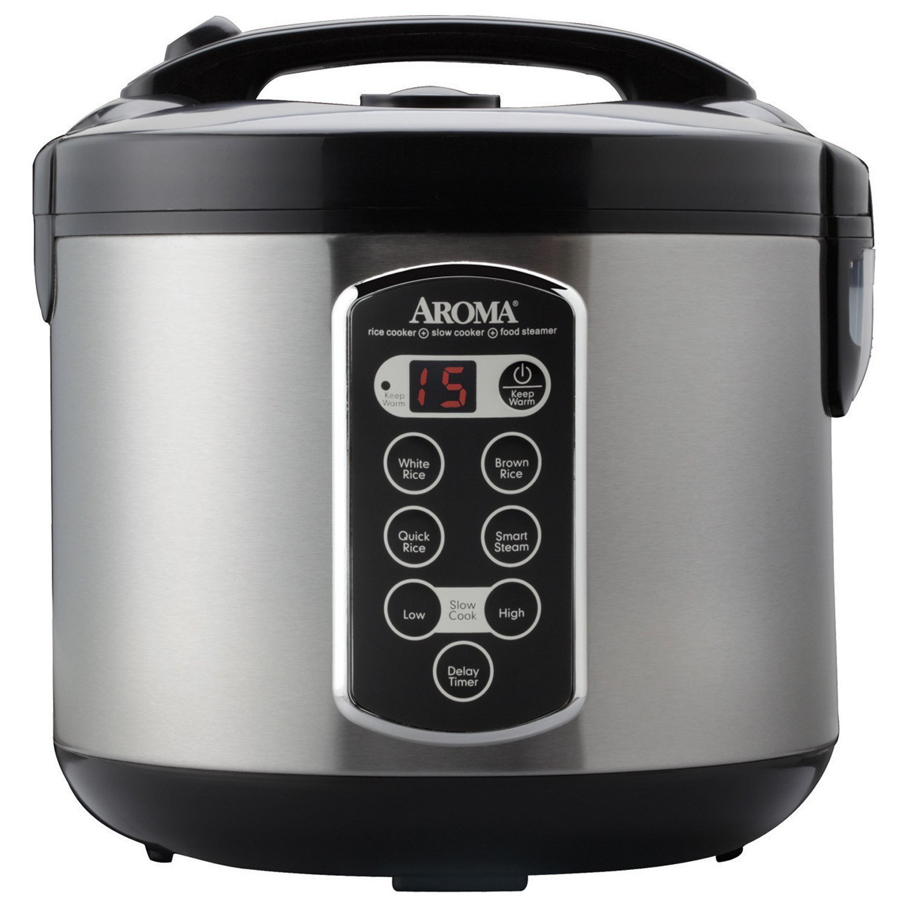

Affordances : Cook various types of rice.
Signifires : Display means that it is a timed process, the button on top means that there is a chamber.
Mappings : Each button is tied to a type of rice.
Feedback : Display tells us how much time is remaining.

2. A Good Product : Pizza Sicssors
This product is a sicssor and spatula that allows us to cut a pizza and serve it.

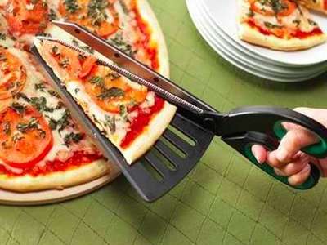

Affordances : Allows us to cut pizza.
Signifires : Sicssors means that it cuts stuff, triangular base means it cuts triangles.
Mappings : None.
Feedback : None.

3. A Bad Product : Knife/Peeler combo
This is a product I found while browsing a home supply store. It is a combination of a peeler and knife. Just looking at it, it looks very unsafe to use and disfunctional. It also looks very uncomfortable to hold due to the unnatural handle shape.

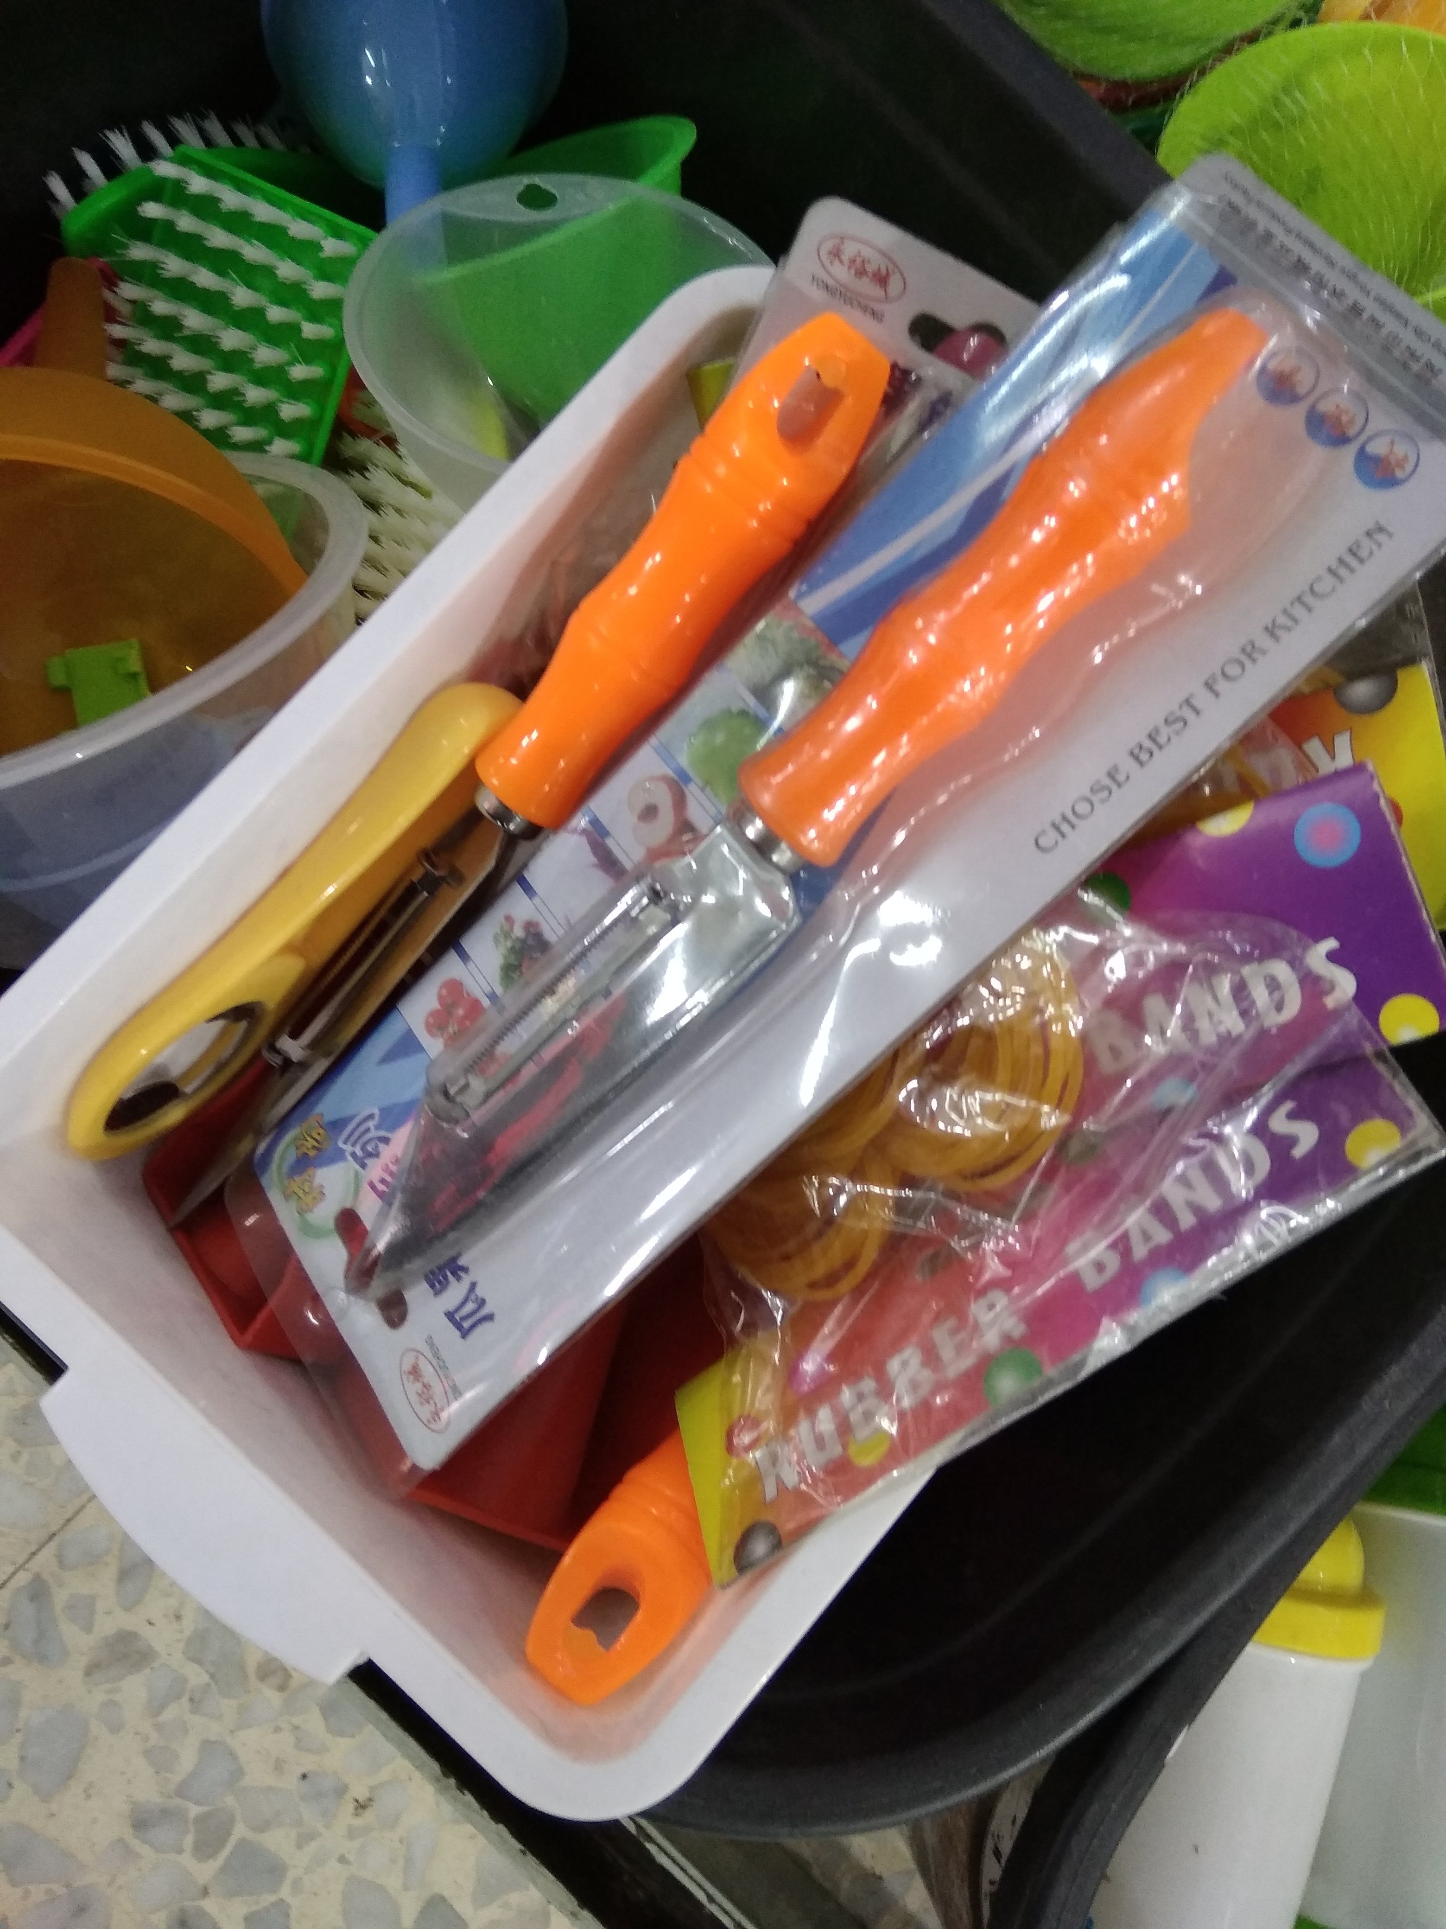

Affordances : Cutting and peeling.
Signifires : Knife blade and peeler.
Mappings : Knife is for cutting, peeler is for peeling.
Feedback : none.

4. A Bad Product : Hammer multitool
This is a product I own. At first glance, it might seem like it is a good idea, however, the pliers are clumsy to use, the hammer head is too small, and using the smaller tools is a nightmare. Though not pictured here, the top of the hammer also has a slot milled into it to install screwdriver bits, but has no retentention mechanism and is very clumsy. Overall, the materials, shape, and mechanisms of this design make it unusable.

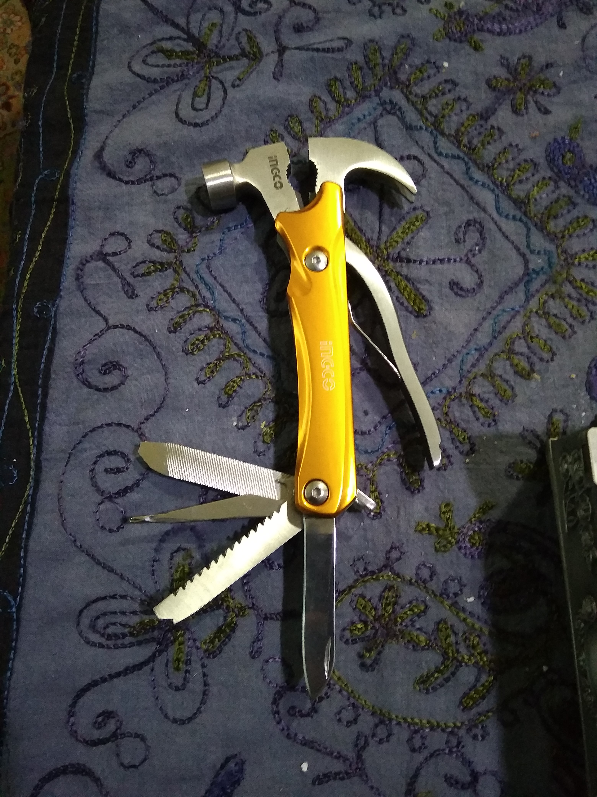

Afforances : Hammering, grabbing, cutting, sawing, screwing, tightening.
Signifires : Hammer, pliers, wire cutter, knife, saw, screw, wrench.
Mappings : Each tool is mapped to its respective function.
Feedback : None.

