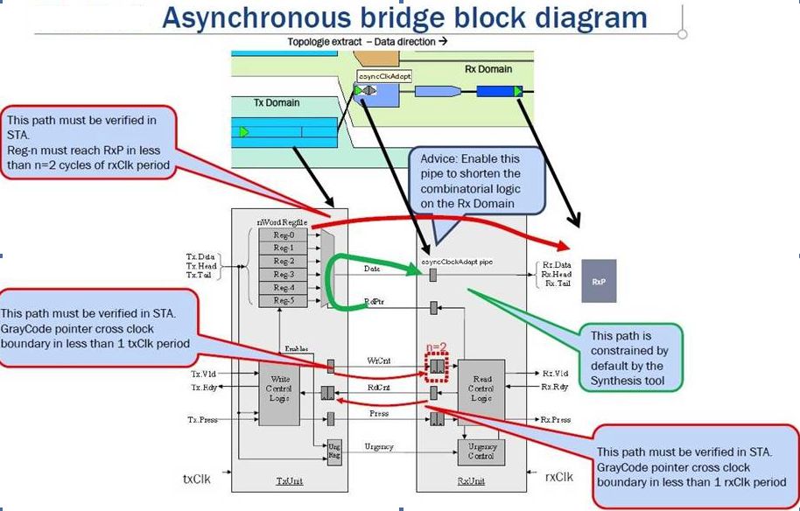

**Two Special Timing Checks**

**Async FIFO data/control race check**

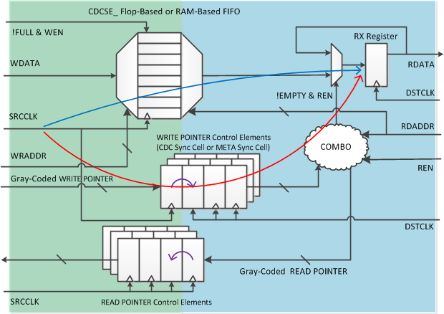

**Async FIFO gray-coded pointer bus skew check**

