Table 5 Association between 非钙化 plaque burden with cardiovascular and cerebrovascular risk factors

Variables | 冠脉 |  |  |  | 头颈
 | β | OR | 95%CI | p value | β | OR | 95%CI | p value
Model 1*
FG
TG
TC
Model 2#
FG
TG
TC
HDL-C
LDL-C
SBP
DBP
Model 3^
FG
TG,mmol/L
TC,mmol/L
HDL-C,mmol/L
LDL-C,mmol/L
SBP，mmHg
Uric acid,umol
Creatinine,umol/L
DBP,mmHg
*crude model
#adjusted for age, gender, BMI, Uric acid and creatinine
^further adjusted for other cardiovascular and cerebrovascular risk factors.
Abbreviations: FG = fasting glucose; BMI = body mass index;TC = total cholesterol; HDL-C = high-density lipoprotein cholesterol; LDL-C = low-density lipoprotein cholesterol; DBP =
非钙化

Model 1
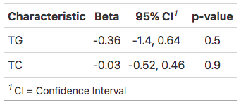
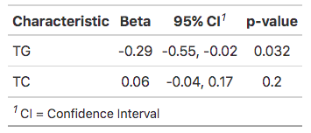
Model 2
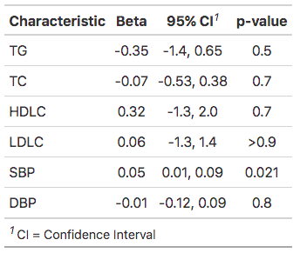
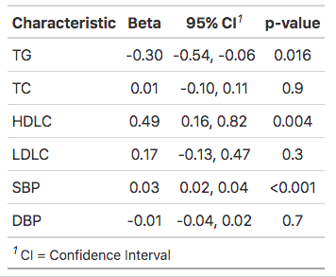
Model 3
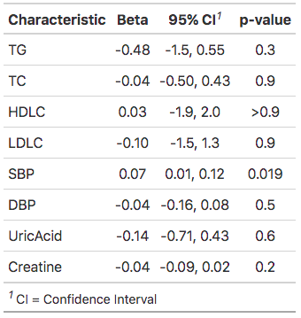
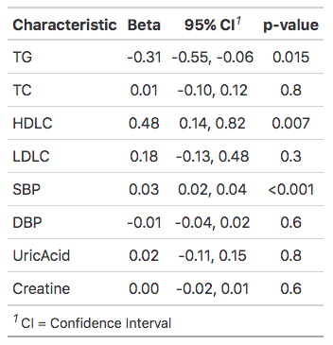

diastolic blood pressure

Table 5 Association between 钙化 plaque burden with cardiovascular and cerebrovascular risk factors

Variables | Coronary |  |  |  | carotid-cerebrovascular
 | β | OR | 95%CI | p value | β | OR | 95%CI | p value
Model 1*
FG
TG
TC
Model 2#
FG
TG
TC
HDL-C
LDL-C
SBP
DBP
Model 3^
FG
TG,mmol/L
TC,mmol/L
HDL-C,mmol/L
LDL-C,mmol/L
SBP，mmHg
Uric acid,umol
Creatinine,umol/L
DBP,mmHg
*crude model
#adjusted for age, gender, BMI, Uric acid and creatinine
^further adjusted for other cardiovascular and cerebrovascular risk factors.
Abbreviations: FG = fasting glucose; BMI = body mass index;TC = total cholesterol; HDL-C = high-density lipoprotein cholesterol; LDL-C = low-density lipoprotein cholesterol; DBP = diastolic blood pressure

钙化
Model 1
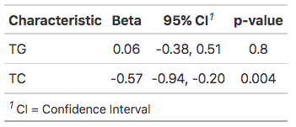
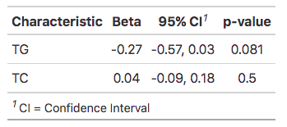
Model 2
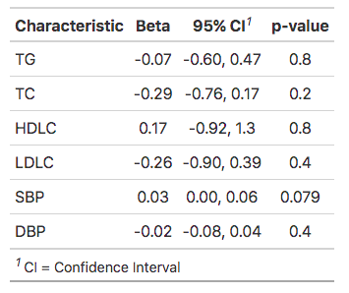
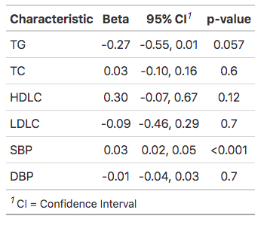
Model 3

