Neural Network

1-hidden layer ANN with 1 neuron

set.seed(12321)

ann_NN1 <- neuralnet(Rs ~ lai + lon + soc + MAT + MAP + ele + type, data = ann_Train)

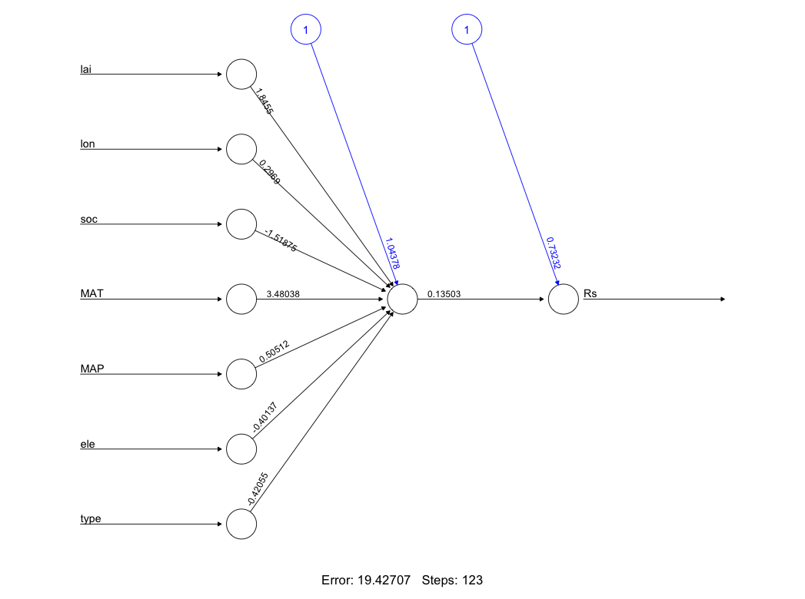

2-hidden layers, layer-1 4neurons, layer-2, 1-neuron, logistic activation function

ann_NN2 <- neuralnet(Rs ~ lai + lon + soc + MAT + MAP + ele + type,

data = ann_Train,

hidden = c(4,1),

act.fct = "logistic",

linear.output = TRUE)

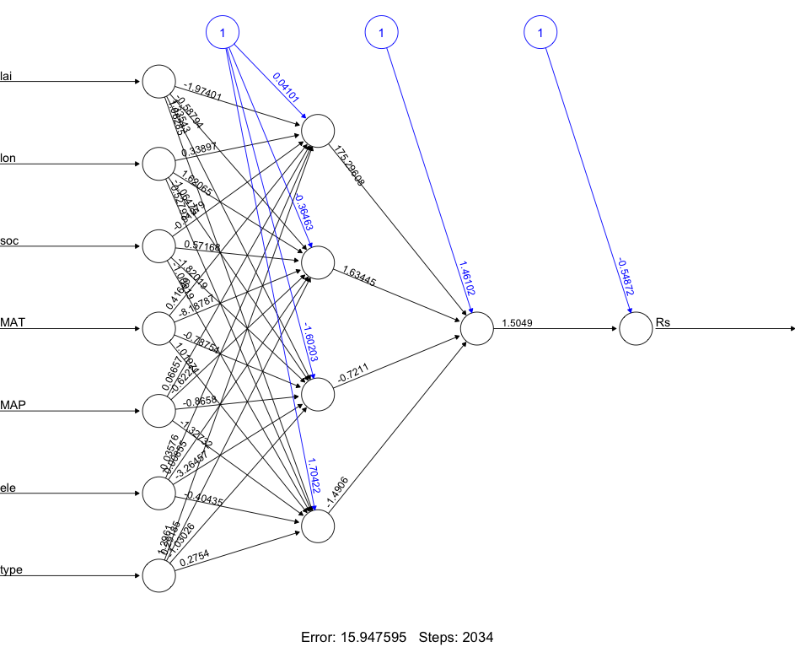

print(MSE_NN2)

[1] 0.08391077

> print(RMSE_NN2)

[1] 0.2806271

# 2-hidden layers, layer-1 5neurons, layer-3, 1-neuron, logistic activation function

ann_NN3 <- neuralnet(Rs ~ lai + lon + soc + MAT + MAP + ele + type,

data = ann_Train,

hidden = c(5,3),

act.fct = "logistic",

linear.output = TRUE)

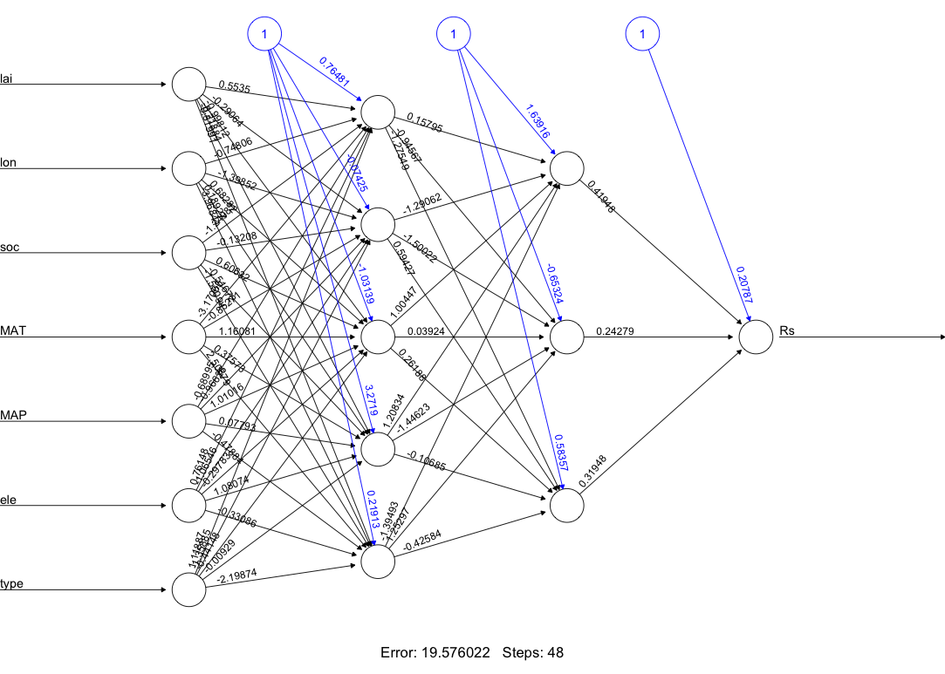

> print(MSE_NN3)

[1] 0.06817191

> print(RMSE_NN3)

[1] 0.2610975

# Fitting Random Forest to train dataset

set.seed(120)

RF <- randomForest(Rs~.,

data = ann_Test,

ntree = 500,

mtry =3,

importance = TRUE,

proximity = TRUE)

> print(RF)

Call:

randomForest(formula = Rs ~ ., data = ann_Test, ntree = 500, mtry = 3, importance = TRUE, proximity = TRUE)

Type of random forest: regression

Number of trees: 500

No. of variables tried at each split: 3

Mean of squared residuals: 0.04059603

% Var explained: 51.38(可以理解为R-squared = 0.5138)

> which.min(RF$mse)

[1] 415

> # MSE of this optimal random forest

> RF$mse[which.min(RF$mse)]

[1] 0.04048048

最小MSE值发生在415棵树时，为0.04048048

# check the importance of variable of randomForest model

RF$importance

> RF$importance

%IncMSE IncNodePurity(数值越大越重要)

lai 0.030869704 2.0619102

lon 0.019184256 1.9784822

soc 0.007042075 0.8978223

ele 0.014493855 1.8486584

MAT 0.028296583 2.1526604

MAP 0.012613637 1.3503342

type 0.050693411 3.5643718

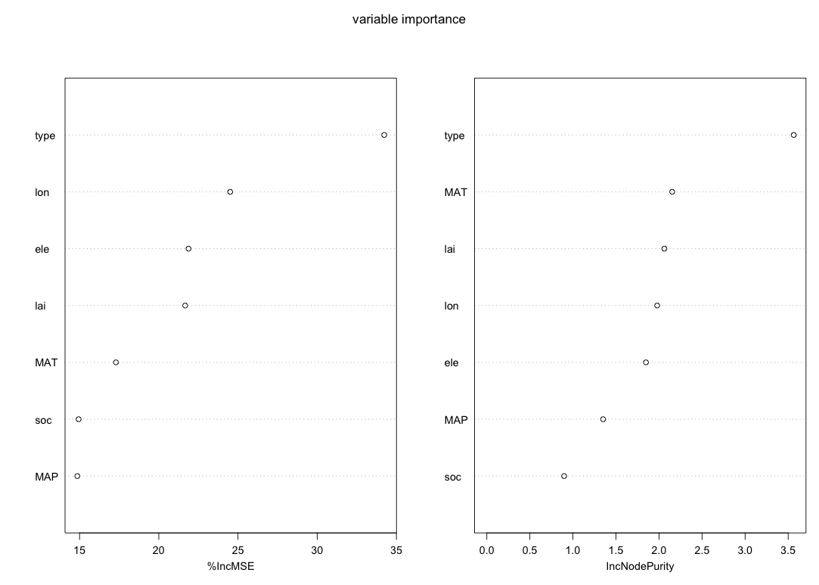

set.seed(120)

RF_2 <- randomForest(soc~.,

data = Rester_rf,

ntree = 500,

mtry =3,

importance = TRUE,

proximity = TRUE)