1. To study the advertising effects on sales, 10 samples of advertising expenses and sales of a company were collected as follows:

|  |  |  |  |
| --- | --- | --- | --- |
| Obs | Sales | Radio | Newspaper |
| 1 | 973 | 0 | 40 |
| 2 | 1119 | 0 | 40 |
| 3 | 875 | 25 | 25 |
| 4 | 625 | 25 | 25 |
| 5 | 910 | 30 | 30 |
| 6 | 971 | 30 | 30 |
| 7 | 931 | 35 | 35 |
| 8 | 1177 | 35 | 35 |
| 9 | 882 | 40 | 25 |
| 10 | 982 | 40 | 25 |

1. Produce scatter plots for 1)Sales against Radio expense and 2)Sales against Newspaper expense. Add appropriate main title and axis titles for the graphs.

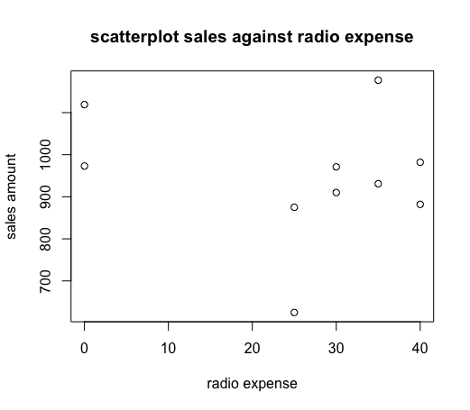

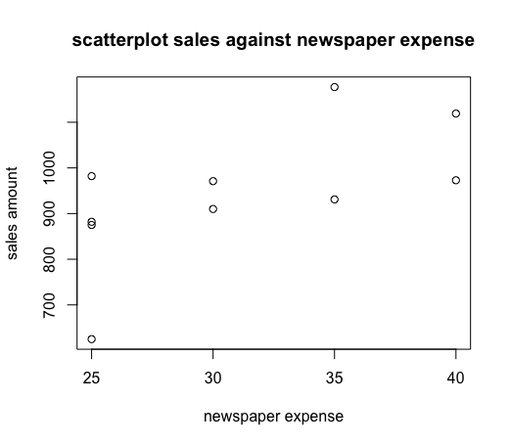

1. Do you find any relationships between advertising expenses and sales from the graphs?

* Sales against radio expense: no relationship between two variables are observed
* Sales against newspaper expense: possible positive relationship between sales and newspaper expense are observed. Future analysis is required to determine specific coefficient.

**Appendix**

sales <- c(973,1119,875,625,910,971,931,1177,882,982)

> radio <- c(0,0,25,25,30,30,35,35,40,40)

> newspaper <- c(40,40,25,25,30,30,35,35,25,25)

> plot(radio~sales)

> plot(radio~sales, main ="scatterplot sales against radio expense", xlab = "sales", ylab ="radio expense")

> plot(newspaper~sales)

> plot(newspaper~sales, main = "scatterplot sales against newspaper expense", xlab ="sales", ylab = "newspaper expense")

> plot(sales~radio)

> plot(sales~radio, main ="scatterplot sales against radio expense", xlab = "radio expense", ylab ="sales amount")

> plot(sales~newspaper, main = "scatterplot sales against newspaper expense", xlab ="newspaper expense", ylab = "sales amount")

plot(y ~ x) = plot(x, y)