其实很简单，就做一个曝光部位占当年的百分比随时间变化的柱状图即可

X轴为时间，Y轴为曝光部位的比例

> year <- OnSetBodyPart$year

> exposed <- OnSetBodyPart$percent1

> year

[1] 1952 1953 1954 1955 1956 1957 1958 1959 1960 1961 1962 1963 1964 1965 1966 1967 1968 1969

[19] 1970 1971 1972 1973 1974 1975 1976 1977 1978 1979 1980 1981 1982 1983 1984 1985 1986 1987

[37] 1988 1989 1990 1991 1992 1993 1994 1995 1996 1997 1998 1999 2000 2001 2002 2003 2004 2005

[55] 2006 2007 2008 2009 2010 2011 2012 2013 2014 2015 2016 2017 2018 2019 2020

> exposed

[1] 1.0000 0.0000 0.0000 0.0000 0.0000 0.0000 0.0000 0.0000 0.0000 0.0000 0.0000 0.0000 0.0000

[14] 0.0000 0.0000 0.0000 0.0000 0.0000 1.0000 0.0000 0.0000 0.0000 0.0000 0.0000 0.0000 0.0000

[27] 0.0000 0.0000 0.2500 0.0000 0.5000 0.0000 0.5000 0.6667 0.5556 0.6667 0.2000 0.2000 0.5000

[40] 0.0000 0.4286 0.2222 0.3333 0.1667 0.2381 0.4000 0.2381 0.5000 0.3556 0.4000 0.6000 0.4828

[53] 0.5000 0.4082 0.4200 0.5417 0.3474 0.5281 0.4932 0.4420 0.4174 0.4752 0.4952 0.5214 0.4169

[66] 0.4657 0.4790 0.4196 0.5401

> unexposed <-OnSetBodyPart$percent2

> unexposed

[1] 0.0000 1.0000 0.0000 0.0000 0.0000 0.0000 0.0000 0.0000 0.0000 0.0000 0.0000 0.0000 0.0000

[14] 0.0000 0.0000 0.0000 0.0000 0.0000 0.0000 0.0000 0.0000 1.0000 0.0000 1.0000 0.0000 0.0000

[27] 0.0000 1.0000 0.7500 1.0000 0.5000 1.0000 0.5000 0.3333 0.4444 0.3333 0.8000 0.8000 0.5000

[40] 1.0000 0.5714 0.7778 0.6667 0.8333 0.2857 0.6000 0.7619 0.5000 0.6444 0.6000 0.4000 0.5172

[53] 0.5000 0.5918 0.5800 0.4583 0.6526 0.4719 0.5068 0.5580 0.5826 0.5248 0.5048 0.4786 0.5831

[66] 0.5343 0.5210 0.5804 0.4599

> barplot(exposed ~ year, col = "green", density = 30, angel = 45)

**身体曝光部分发病占比（会另传一份单独图片文件）：**

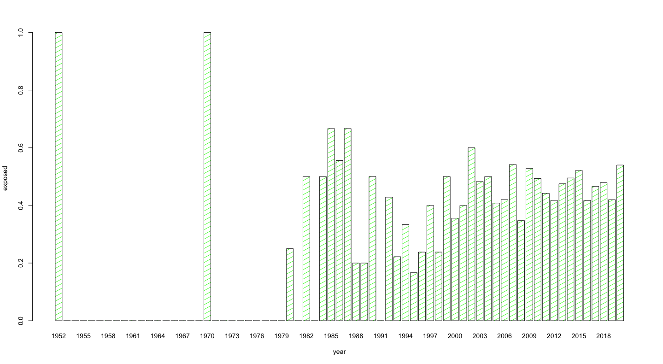

其实很简单，就做一个1型占当年的百分比随时间变化的柱状图即可

X轴为时间，Y轴为1型的比例

> barplot(typeone_percentage ~ year_type, col = "blue", density = 30, angel = -45, width = 2)

> View(OnSetType)

> year_type <- OnSetType$year

> typeone_percentage <- OnSetType$type1

> year_type

[1] 1952 1953 1954 1955 1956 1957 1958 1959 1960 1961 1962 1963 1964 1965 1966 1967 1968 1969

[19] 1970 1971 1972 1973 1974 1975 1976 1977 1978 1979 1980 1981 1982 1983 1984 1985 1986 1987

[37] 1988 1989 1990 1991 1992 1993 1994 1995 1996 1997 1998 1999 2000 2001 2002 2003 2004 2005

[55] 2006 2007 2008 2009 2010 2011 2012 2013 2014 2015 2016 2017 2018 2019 2020

> typeone_percentage

[1] 0.0000 0.0000 0.0000 0.0000 0.0000 0.0000 0.0000 0.0000 0.0000 0.0000 0.0000 0.0000 0.0000

[14] 0.0000 0.0000 0.0000 0.0000 0.0000 0.0000 0.0000 0.0000 0.0000 0.0000 0.0000 0.0000 0.0000

[27] 0.0000 0.0000 0.3300 0.0000 0.0000 0.0000 0.0000 1.0000 0.0000 0.6700 0.0000 0.2500 0.3846

[40] 0.0000 0.1667 0.0000 0.4000 0.2857 0.1000 0.1786 0.0769 0.0000 0.2750 0.1111 0.3077 0.3200

[53] 0.1176 0.1429 0.1905 0.1563 0.2706 0.2133 0.2400 0.1622 0.2346 0.1767 0.2556 0.2061 0.1931

[66] 0.1944 0.1960 0.2110 0.2540

> barplot(year_type ~ typeone_percentage)

**类型1部分占比（会另传一份单独图片文件）：**

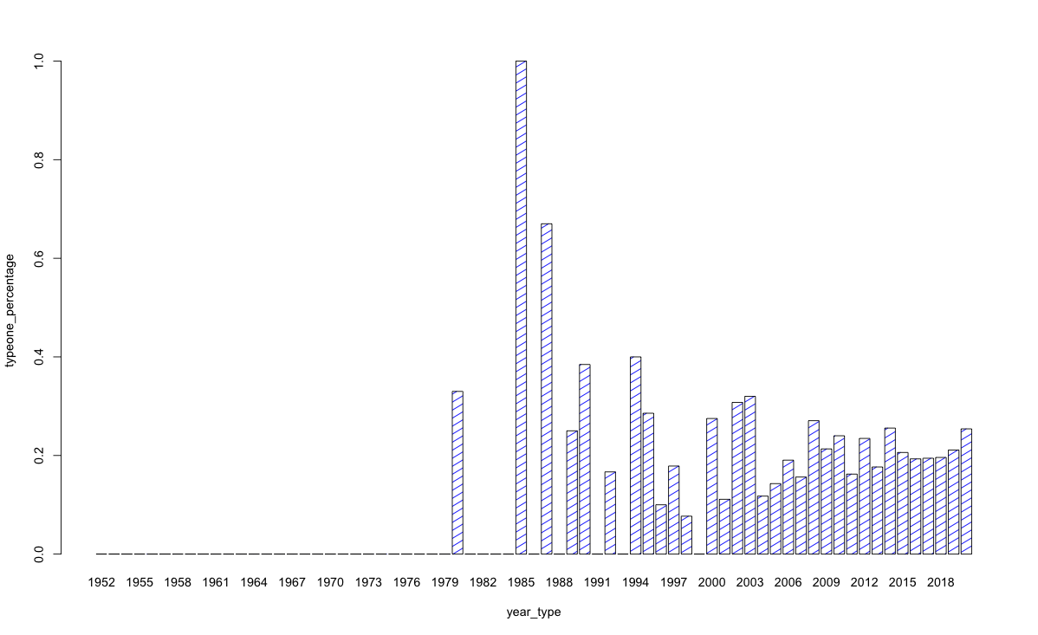

那就请帮我把有意义的年份的95%CI算一下吧，谢谢！