其实很简单，就做一个曝光部位占当年的百分比随时间变化的柱状图即可

X轴为时间，Y轴为曝光部位的比例

> year <- OnSetBodyPart$year

> exposed <- OnSetBodyPart$percent1

> year

[1] 1952 1953 1954 1955 1956 1957 1958 1959 1960 1961 1962 1963 1964 1965 1966 1967 1968 1969

[19] 1970 1971 1972 1973 1974 1975 1976 1977 1978 1979 1980 1981 1982 1983 1984 1985 1986 1987

[37] 1988 1989 1990 1991 1992 1993 1994 1995 1996 1997 1998 1999 2000 2001 2002 2003 2004 2005

[55] 2006 2007 2008 2009 2010 2011 2012 2013 2014 2015 2016 2017 2018 2019 2020

> exposed

[1] 1.0000 0.0000 0.0000 0.0000 0.0000 0.0000 0.0000 0.0000 0.0000 0.0000 0.0000 0.0000 0.0000

[14] 0.0000 0.0000 0.0000 0.0000 0.0000 1.0000 0.0000 0.0000 0.0000 0.0000 0.0000 0.0000 0.0000

[27] 0.0000 0.0000 0.2500 0.0000 0.5000 0.0000 0.5000 0.6667 0.5556 0.6667 0.2000 0.2000 0.5000

[40] 0.0000 0.4286 0.2222 0.3333 0.1667 0.2381 0.4000 0.2381 0.5000 0.3556 0.4000 0.6000 0.4828

[53] 0.5000 0.4082 0.4200 0.5417 0.3474 0.5281 0.4932 0.4420 0.4174 0.4752 0.4952 0.5214 0.4169

[66] 0.4657 0.4790 0.4196 0.5401

> unexposed <-OnSetBodyPart$percent2

> unexposed

[1] 0.0000 1.0000 0.0000 0.0000 0.0000 0.0000 0.0000 0.0000 0.0000 0.0000 0.0000 0.0000 0.0000

[14] 0.0000 0.0000 0.0000 0.0000 0.0000 0.0000 0.0000 0.0000 1.0000 0.0000 1.0000 0.0000 0.0000

[27] 0.0000 1.0000 0.7500 1.0000 0.5000 1.0000 0.5000 0.3333 0.4444 0.3333 0.8000 0.8000 0.5000

[40] 1.0000 0.5714 0.7778 0.6667 0.8333 0.2857 0.6000 0.7619 0.5000 0.6444 0.6000 0.4000 0.5172

[53] 0.5000 0.5918 0.5800 0.4583 0.6526 0.4719 0.5068 0.5580 0.5826 0.5248 0.5048 0.4786 0.5831

[66] 0.5343 0.5210 0.5804 0.4599

> barplot(exposed ~ year, col = "green", density = 30, angel = 45)

**身体曝光部分发病占比（会另传一份单独图片文件）：**

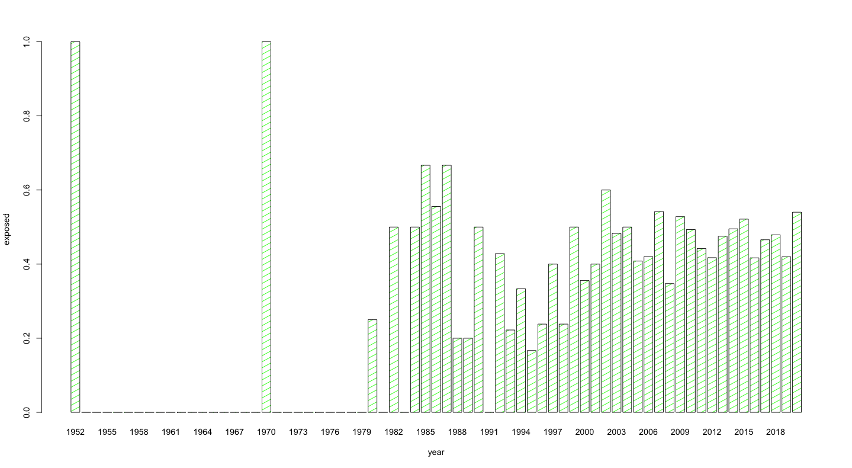

其实很简单，就做一个1型占当年的百分比随时间变化的柱状图即可

X轴为时间，Y轴为1型的比例

> barplot(typeone_percentage ~ year_type, col = "blue", density = 30, angel = -45, width = 2)

> View(OnSetType)

> year_type <- OnSetType$year

> typeone_percentage <- OnSetType$type1

> year_type

[1] 1952 1953 1954 1955 1956 1957 1958 1959 1960 1961 1962 1963 1964 1965 1966 1967 1968 1969

[19] 1970 1971 1972 1973 1974 1975 1976 1977 1978 1979 1980 1981 1982 1983 1984 1985 1986 1987

[37] 1988 1989 1990 1991 1992 1993 1994 1995 1996 1997 1998 1999 2000 2001 2002 2003 2004 2005

[55] 2006 2007 2008 2009 2010 2011 2012 2013 2014 2015 2016 2017 2018 2019 2020

> typeone_percentage

[1] 0.0000 0.0000 0.0000 0.0000 0.0000 0.0000 0.0000 0.0000 0.0000 0.0000 0.0000 0.0000 0.0000

[14] 0.0000 0.0000 0.0000 0.0000 0.0000 0.0000 0.0000 0.0000 0.0000 0.0000 0.0000 0.0000 0.0000

[27] 0.0000 0.0000 0.3300 0.0000 0.0000 0.0000 0.0000 1.0000 0.0000 0.6700 0.0000 0.2500 0.3846

[40] 0.0000 0.1667 0.0000 0.4000 0.2857 0.1000 0.1786 0.0769 0.0000 0.2750 0.1111 0.3077 0.3200

[53] 0.1176 0.1429 0.1905 0.1563 0.2706 0.2133 0.2400 0.1622 0.2346 0.1767 0.2556 0.2061 0.1931

[66] 0.1944 0.1960 0.2110 0.2540

> barplot(year_type ~ typeone_percentage)

**类型1部分占比（会另传一份单独图片文件）：**

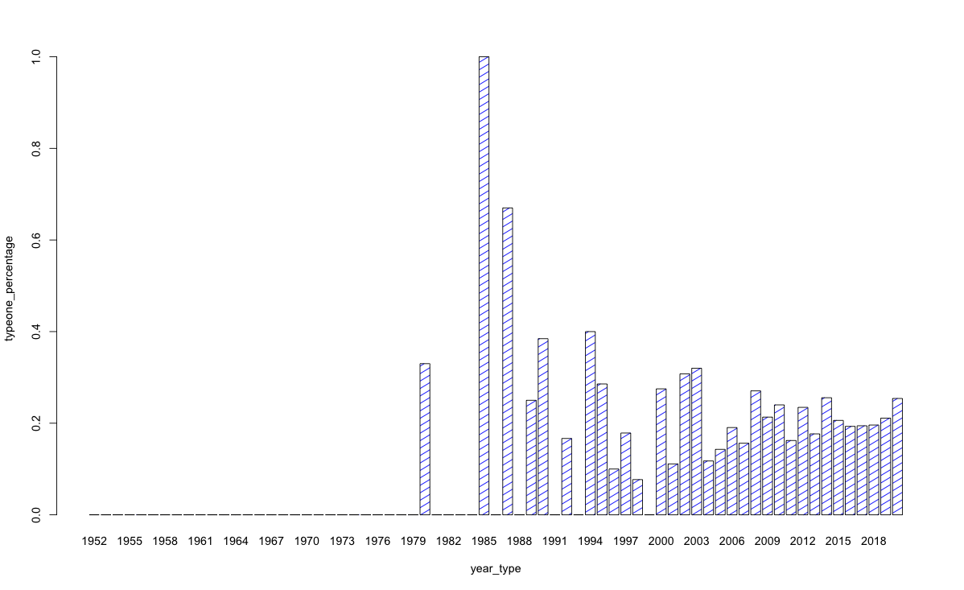

那就请帮我把有意义的年份的95%CI算一下吧，谢谢！

95% Confidence Interval

根据这份数据分析的结果和报告，如果我们想调查和抽取在year 年份的白癜风发病年龄，这个发病年龄会有95%的可能性落在 Lower end 和 Upper end 之间。

|  |  |  |
| --- | --- | --- |
| year | Lower end | Upper end |
| 1980 | 5.492538 | 16.00746 |
| 1986 | 7.024972 | 21.22503 |
| 1988 | 5.805747 | 16.19425 |
| 1989 | 4.586143 | 27.41386 |
| 1990 | 13.53081 | 23.32633 |
| 1992 | 12.69939 | 37.01489 |
| 1993 | 14.53572 | 27.01984 |
| 1994 | 11.7341 | 28.59924 |
| 1995 | 15.70843 | 25.95824 |
| 1996 | 16.46284 | 25.63239 |
| 1997 | 20.08327 | 28.81328 |
| 1998 | 13.58214 | 26.32263 |
| 1999 | 16.44414 | 30.88919 |
| 2000 | 16.63746 | 24.25143 |
| 2001 | 9.059485 | 27.74051 |
| 2002 | 13.7685 | 30.80293 |
| 2003 | 15.21072 | 24.65135 |
| 2004 | 19.03869 | 28.84703 |
| 2005 | 21.00663 | 29.0767 |
| 2006 | 21.71982 | 29.48018 |
| 2007 | 23.4975 | 30.85544 |
| 2008 | 24.63162 | 30.67273 |
| 2009 | 24.06593 | 30.15879 |
| 2010 | 26.75022 | 32.2359 |
| 2011 | 25.1754 | 30.44504 |
| 2012 | 24.21429 | 28.5392 |
| 2013 | 25.29645 | 29.20978 |
| 2014 | 23.97008 | 27.76694 |
| 2015 | 26.08674 | 29.34637 |
| 2016 | 25.61516 | 29.19638 |
| 2017 | 27.09777 | 30.56577 |
| 2018 | 25.48747 | 29.15119 |
| 2019 | 26.09201 | 29.75573 |
| 2020 | 27.74754 | 31.64711 |

> summary(data_1980)

Min. 1st Qu. Median Mean 3rd Qu. Max.

7.00 9.25 10.50 10.75 12.00 15.00

> length(data_1980)

[1] 4

> mean(data_1980)

[1] 10.75

> sd(data_1980)

[1] 3.304038

> error1980 <- qt(0.975, df=length(data_1980)-1)*sd(data_1980)/sqrt(length(data_1980))

> error1980

[1] 5.257462

> left1980 <- mean(data_1980)-error1980

> right1980 <- mean(data_1980)+error1980

> left1980

[1] 5.492538

> right1980

[1] 16.00746

> summary(data_1986)

Min. 1st Qu. Median Mean 3rd Qu. Max.

4.00 9.00 11.00 14.12 21.00 27.00

> length(data_1986)

[1] 8

> mean(data_1986)

[1] 14.125

> sd(data_1986)

[1] 8.492644

> error1986 <- qt(0.975, df =length(data_1986)-1)*sd(data_1986)/sqrt(length(data_1986))

> error1986

[1] 7.100028

> left1986 <- mean(data_1986)-error1986

> right1986 <- mean(data_1986)+error1986

> left1986

[1] 7.024972

> right1986

[1] 21.22503

> data_1988 <- na.omit(MeanAgeOnSet_by_Year$data1988)

> summary(data_1988)

Min. 1st Qu. Median Mean 3rd Qu. Max.

7 8 9 11 15 16

> length(data_1988)

[1] 5

> mean(data_1988)

[1] 11

> sd(data_1988)

[1] 4.1833

> error1988 <- qt(0.975, df =length(data_1988)-1)*sd(data_1988)/sqrt(length(data_1988))

> error1988

[1] 5.194253

> left1988 <- mean(data_1988)-error1988

> right1988 <- mean(data_1988)+error1988

> left1988

[1] 5.805747

> right1988

[1] 16.19425

>

> data_1989 <- na.omit(MeanAgeOnSet_by_Year$data1989)

> summary(data_1989)

Min. 1st Qu. Median Mean 3rd Qu. Max.

4 9 19 16 22 26

> length(data_1989)

[1] 5

> mean(data_1989)

[1] 16

> sd(data_1989)

[1] 9.192388

> error1989 <- qt(0.975, df =length(data_1989)-1)*sd(data_1989)/sqrt(length(data_1989))

> error1989

[1] 11.41386

> left1989 <- mean(data_1989)-error1989

> right1989 <- mean(data_1989)+error1989

> left1989

[1] 4.586143

> right1989

[1] 27.41386

> data_1990 <- na.omit(MeanAgeOnSet_by_Year$data1990)

> summary(data_1990)

Min. 1st Qu. Median Mean 3rd Qu. Max.

0.00 16.25 20.50 18.43 23.50 32.00

> length(data_1990)

[1] 14

> mean(data_1990)

[1] 18.42857

> sd(data_1990)

[1] 8.482691

> error1990 <- qt(0.975, df =length(data_1990)-1)*sd(data_1990)/sqrt(length(data_1990))

> left1990 <- mean(data_1990)-error1990

> right1990 <- mean(data_1990)+error1990

> left1990

[1] 13.53081

> right1990

[1] 23.32633

> data_1992 <- na.omit(MeanAgeOnSet_by_Year$data1992)

> summary(data_1992)

Min. 1st Qu. Median Mean 3rd Qu. Max.

6.00 16.50 27.00 24.86 33.00 42.00

> length(data_1992)

[1] 7

> mean(data_1992)

[1] 24.85714

> sd(data_1992)

[1] 13.1457

> error1992 <- qt(0.975, df =length(data_1992)-1)*sd(data_1992)/sqrt(length(data_1992))

> left1992 <- mean(data_1992)-error1992

> right1992 <- mean(data_1992)+error1992

> left1992

[1] 12.69939

> right1992

[1] 37.01489

> data_1993 <- na.omit(MeanAgeOnSet_by_Year$data1993)

> summary(data_1993)

Min. 1st Qu. Median Mean 3rd Qu. Max.

7.00 21.00 22.00 20.78 25.00 30.00

> length(data_1993)

[1] 9

> mean(data_1993)

[1] 20.77778

> sd(data_1993)

[1] 8.120618

> error1993 <- qt(0.975, df =length(data_1993)-1)*sd(data_1993)/sqrt(length(data_1993))

> left1993 <- mean(data_1993)-error1993

> right1993 <- mean(data_1993)+error1993

> left1993

[1] 14.53572

> right1993

[1] 27.01984

> data_1994 <- na.omit(MeanAgeOnSet_by_Year$data1994)

> summary(data_1994)

Min. 1st Qu. Median Mean 3rd Qu. Max.

7.00 18.00 19.50 20.17 26.25 29.00

> length(data_1994)

[1] 6

> mean(data_1994)

[1] 20.16667

> sd(data_1994)

[1] 8.035339

> error1994 <- qt(0.975, df =length(data_1994)-1)*sd(data_1994)/sqrt(length(data_1994))

> left1994 <- mean(data_1994)-error1994

> right1994 <- mean(data_1994)+error1994

> left1994

[1] 11.7341

> right1994

[1] 28.59924

> data_1995 <- na.omit(MeanAgeOnSet_by_Year$data1995)

> summary(data_1995)

Min. 1st Qu. Median Mean 3rd Qu. Max.

8.00 15.00 23.00 20.83 26.25 32.00

> length(data_1995)

[1] 12

> mean(data_1995)

[1] 20.83333

> sd(data_1995)

[1] 8.066016

> left1995 <- qt(0.975, df =length(data_1995)-1)*sd(data_1995)/sqrt(length(data_1995))

> error1995 <- qt(0.975, df =length(data_1995)-1)*sd(data_1995)/sqrt(length(data_1995))

> left1995 <- mean(data_1995)-error1995

> right1995 <- mean(data_1995)+error1995

> left1995

[1] 15.70843

> right1995

[1] 25.95824

>

> data_1996 <- na.omit(MeanAgeOnSet_by_Year$data1996)

> summary(data_1996)

Min. 1st Qu. Median Mean 3rd Qu. Max.

5.00 15.00 19.00 21.05 28.00 39.00

> length(data_1996)

[1] 21

> mean(data_1996)

[1] 21.04762

> sd(data_1996)

[1] 10.07212

> error1995 <- qt(0.975, df =length(data_1996)-1)*sd(data_1996)/sqrt(length(data_1996))

> left1995 <- mean(data_1996)-error1996

错误: 找不到对象'error1996'

> error1996 <- qt(0.975, df =length(data_1996)-1)*sd(data_1996)/sqrt(length(data_1996))

> left1996 <- mean(data_1996)-error1996

> right1996 <- mean(data_1996)+error1996

> left1996

[1] 16.46284

> right1996

[1] 25.63239

>

> data_1997 <- na.omit(MeanAgeOnSet_by_Year$data1997)

> summary(data_1997)

Min. 1st Qu. Median Mean 3rd Qu. Max.

7.00 15.00 24.00 24.45 34.00 44.00

> length(data_1997)

[1] 29

> mean(data_1997)

[1] 24.44828

> sd(data_1997)

[1] 11.4754

> error1997 <- qt(0.975, df =length(data_1997)-1)*sd(data_1997)/sqrt(length(data_1997))

> left1997 <- mean(data_1997)-error1997

> right1997 <- mean(data_1997)+error1997

> left1997

[1] 20.08327

> right1997

[1] 28.81328

> data1998 <- na.omit(MeanAgeOnSet_by_Year$data1998)

> summary(data1998)

Min. 1st Qu. Median Mean 3rd Qu. Max.

2.00 11.00 17.00 19.95 27.00 55.00

> length(data1998)

[1] 21

> mean(data1998)

[1] 19.95238

> sd(data1998)

[1] 13.99456

> error1998 <- qt(0.975, df =length(data1998)-1)*sd(data1998)/sqrt(length(data1998))

> left1998 <- mean(data1998)-error1998

> right1998 <- mean(data1998)+error1998

> left1998

[1] 13.58214

> right1998

[1] 26.32263

>

> data1999 <- na.omit(MeanAgeOnSet_by_Year$data1999)

> summary(data1999)

Min. 1st Qu. Median Mean 3rd Qu. Max.

4.00 12.00 22.00 23.67 33.00 50.00

> length(data1999)

[1] 18

> mean(data1999)

[1] 23.66667

> sd(data1999)

[1] 14.52381

> error1999 <- qt(0.975, df =length(data1999)-1)*sd(data1999)/sqrt(length(data1999))

> left1999 <- mean(data1999)-error1999

> right1999 <- mean(data1999)+error1999

> left1999

[1] 16.44414

> right1999

[1] 30.88919

> data2000 <- na.omit(MeanAgeOnSet_by_Year$data2000)

> summary(data2000)

Min. 1st Qu. Median Mean 3rd Qu. Max.

5.00 11.00 17.00 20.44 26.00 51.00

> length(data2000)

[1] 45

>

> mean(data2000)

[1] 20.44444

> sd(data2000)

[1] 12.67165

> error2000 <- qt(0.975, df =length(data2000)-1)*sd(data2000)/sqrt(length(data2000))

> left2000 <- mean(data2000)-error2000

> right2000 <- mean(data2000)+error2000

> left2000

[1] 16.63746

> right2000

[1] 24.25143

> data2001 <- na.omit(MeanAgeOnSet_by_Year$data2001)

> summary(data2001)

Min. 1st Qu. Median Mean 3rd Qu. Max.

3.00 10.00 15.00 18.40 27.25 45.00

> length(data2001)

[1] 10

> mean(data2001)

[1] 18.4

> sd(data2001)

[1] 13.05714

> error2001 <- qt(0.975, df =length(data2001)-1)*sd(data2001)/sqrt(length(data2001))

> left2001 <- mean(data2001)-error2001

> right2001 <- mean(data2001)+error2001

> left2001

[1] 9.059485

> right2001

[1] 27.74051

data2002 <- na.omit(MeanAgeOnSet_by_Year$data2002)

> summary(data2002)

Min. 1st Qu. Median Mean 3rd Qu. Max.

0.00 13.25 22.00 22.29 32.50 50.00

> length(data2002)

[1] 14

> mean(data2002)

[1] 22.28571

> sd(data2002)

[1] 14.75142

> error2002 <- qt(0.975, df =length(data2002)-1)*sd(data2002)/sqrt(length(data2002))

> left2002 <- mean(data2002)-error2002

> right2002 <- mean(data2002)+error2002

> left2002

[1] 13.7685

> right2002

[1] 30.80293

data2003 <- na.omit(MeanAgeOnSet_by_Year$data2003)

> summary(data2003)

Min. 1st Qu. Median Mean 3rd Qu. Max.

0.00 10.00 19.00 19.93 28.00 50.00

> length(data2003)

[1] 29

> summary(data2003)

Min. 1st Qu. Median Mean 3rd Qu. Max.

0.00 10.00 19.00 19.93 28.00 50.00

> mean(data2003)

[1] 19.93103

> sd(data2003)

[1] 12.40948

> error2003 <- qt(0.975, df =length(data2003)-1)*sd(data2003)/sqrt(length(data2003))

> left2003 <- mean(data2003)-error2003

> right2003 <- mean(data2003)+error2003

> left2003

[1] 15.21072

> right2003

[1] 24.65135

>

> data2004 <- na.omit(MeanAgeOnSet_by_Year$data2004)

> summary(data2004)

Min. 1st Qu. Median Mean 3rd Qu. Max.

0.00 13.00 19.00 23.94 36.50 54.00

> length(data2004)

[1] 35

> mean(data2004)

[1] 23.94286

> sd(data2004)

[1] 14.27656

> error2004 <- qt(0.975, df =length(data2004)-1)*sd(data2004)/sqrt(length(data2004))

> left2004 <- mean(data2004)-error2004

> right2004 <- mean(data2004)+error2004

> left2004

[1] 19.03869

> right2004

[1] 28.84703

>

data2005 <- na.omit(MeanAgeOnSet_by_Year$data2005)

> summary(data2005)

Min. 1st Qu. Median Mean 3rd Qu. Max.

2.00 15.00 24.50 25.04 34.25 64.00

> length(data2005)

[1] 48

> mean(data2005)

[1] 25.04167

> sd(data2005)

[1] 13.89621

> error2005 <- qt(0.975, df =length(data2005)-1)*sd(data2005)/sqrt(length(data2005))

> left2005 <- mean(data2005)-error2005

> right2005 <- mean(data2005)+error2005

> left2005

[1] 21.00663

> right2005

[1] 29.0767

>

data2006 <- na.omit(MeanAgeOnSet_by_Year$data2006)

> summary(data2006)

Min. 1st Qu. Median Mean 3rd Qu. Max.

1.00 13.25 29.00 25.60 36.75 53.00

> length(data2006)

[1] 50

> mean(data2006)

[1] 25.6

> sd(data2006)

[1] 13.65314

> error2006 <- qt(0.975, df =length(data2006)-1)*sd(data2006)/sqrt(length(data2006)

+

> error2006

错误: 找不到对象'error2006'

> error2006 <- qt(0.975, df =length(data2006)-1)*sd(data2006)/sqrt(length(data2006))

> left2006 <- mean(data2006)-error2006

> right2006 <- mean(data2006)+error2006

> left2006

[1] 21.71982

> right2006

[1] 29.48018

>

> data2007 <- na.omit(MeanAgeOnSet_by_Year$data2007)

> summary(data2007)

Min. 1st Qu. Median Mean 3rd Qu. Max.

1.00 14.75 25.00 27.18 38.50 60.00

> length(data2007)

[1] 68

> mean(data2007)

[1] 27.17647

> sd(data2007)

[1] 15.19912

> error2007 <- qt(0.975, df =length(data2007)-1)*sd(data2007)/sqrt(length(data2007))

> left2007 <- mean(data2007)-error2007

> right2007 <- mean(data2007)+error2007

> left2007

[1] 23.4975

> right2007

[1] 30.85544

> data2008 <- na.omit(MeanAgeOnSet_by_Year$data2008)

> summary(data2008)

Min. 1st Qu. Median Mean 3rd Qu. Max.

2.00 16.75 25.00 27.65 36.25 65.00

> length(data2008)

[1] 92

> mean(data2008)

[1] 27.65217

> sd(data2008)

[1] 14.58543

> error2007 <- qt(0.975, df =length(data2008)-1)*sd(data2008)/sqrt(length(data2008))

> error2008 <- qt(0.975, df =length(data2008)-1)*sd(data2008)/sqrt(length(data2008))

> left2008 <- mean(data2008)-error2008

> right2008 <- mean(data2008)-error2008

> right2008 <- mean(data2008)+error2008

> left2008

[1] 24.63162

> right2008

[1] 30.67273

>

> data2009 <- na.omit(MeanAgeOnSet_by_Year$data2009)

> summary(data2009)

Min. 1st Qu. Median Mean 3rd Qu. Max.

6.00 15.00 25.00 27.11 38.00 67.00

> length(data2009)

[1] 89

> mean(data2009)

[1] 27.11236

> sd(data2009)

[1] 14.46189

> error2009 <- qt(0.975, df =length(data2009)-1)*sd(data2009)/sqrt(length(data2009))

> left2009 <- mean(data2009)-error2009

> right2009 <- mean(data2009)+error2009

> left2009

[1] 24.06593

> right2009

[1] 30.15879

data2010 <- na.omit(MeanAgeOnSet_by_Year$data2010)

> summary(data2010)

Min. 1st Qu. Median Mean 3rd Qu. Max.

0.00 16.00 26.00 29.49 44.00 71.00

> length(data2010)

[1] 144

> mean(data2010)

[1] 29.49306

> sd(data2010)

[1] 16.65109

> error2010 <- qt(0.975, df =length(data2010)-1)*sd(data2010)/sqrt(length(data2010))

> left2010 <- mean(data2010)-error2010

> right2010 <- mean(data2010)+error2010

> left2010

[1] 26.75022

> right2010

[1] 32.2359

data2011 <- na.omit(MeanAgeOnSet_by_Year$data2011)

> summary(data2011)

Min. 1st Qu. Median Mean 3rd Qu. Max.

0.00 15.00 25.00 27.81 39.00 72.00

> length(data2011)

[1] 137

> mean(data2011)

[1] 27.81022

> sd(data2011)

[1] 15.59484

> error2011 <- qt(0.975, df =length(data2011)-1)*sd(data2011)/sqrt(length(data2011))

> left2011 <- mean(data2011)-error2011

> right2011 <- mean(data2011)+error2011

> left2011

[1] 25.1754

> right2011

[1] 30.44504

>

> data2012 <- na.omit(MeanAgeOnSet_by_Year$data2012)

> summary(data2012)

Min. 1st Qu. Median Mean 3rd Qu. Max.

0.00 13.00 25.00 26.38 39.00 65.00

> length(2012)

[1] 1

> length(data2012)

[1] 215

> mean(data2012)

[1] 26.37674

> sd(data2012)

[1] 16.08629

> error2012 <- qt(0.975, df =length(data2012)-1)*sd(data2012)/sqrt(length(data2012))

> left2012 <- mean(data2012)-error2012

> right2012 <- mean(data2012)+error2012

> left2012

[1] 24.21429

> right2012

[1] 28.5392

> data2013 <- na.omit(MeanAgeOnSet_by_Year$data2013)

> summary(data2012)

Min. 1st Qu. Median Mean 3rd Qu. Max.

0.00 13.00 25.00 26.38 39.00 65.00

> summary(data2013)

Min. 1st Qu. Median Mean 3rd Qu. Max.

0.00 15.00 25.00 27.25 39.00 67.00

> length(data2013)

[1] 241

> mean(data2013)

[1] 27.25311

> sd(data2013)

[1] 15.4199

> error2013 <- qt(0.975, df =length(data2013)-1)*sd(data2013)/sqrt(length(data2013))

> left2013 <- mean(data2013)-error2013

> right2013 <- mean(data2013)+error2013

> left2013

[1] 25.29645

> right2013

[1] 29.20978

> data2014 <- na.omit(MeanAgeOnSet_by_Year$data2014)

> summary(data2014)

Min. 1st Qu. Median Mean 3rd Qu. Max.

0.00 11.00 24.00 25.87 40.00 76.00

> length(data2014)

[1] 308

> mean(data2014)

[1] 25.86851

> sd(data2014)

[1] 16.93193

> error2014 <- qt(0.975, df =length(data2014)-1)*sd(data2014)/sqrt(length(data2014))

> left2014 <- mean(data2014)-error2014

> right2014 <- mean(data2014)+error2014

> left2014

[1] 23.97008

> right2014

[1] 27.76694

data2015 <- na.omit(MeanAgeOnSet_by_Year$data2015)

> summary(data2015)

Min. 1st Qu. Median Mean 3rd Qu. Max.

0.00 13.00 26.00 27.72 41.00 81.00

> length(data2015)

[1] 441

> mean(data2015)

[1] 27.71655

> sd(data2015)

[1] 17.41457

> error2015 <- qt(0.975, df =length(data2015)-1)*sd(data2015)/sqrt(length(data2015))

> left2015 <- mean(data2015)-error2015

> right2015 <- mean8data2015+error2015

错误: 找不到对象'mean8data2015'

> right2015 <- mean(data2015)+error2015

> left2015

[1] 26.08674

> right2015

[1] 29.34637

>

data2016 <- na.omit(MeanAgeOnSet_by_Year$data2016)

> summayr(data2016)

Error in summayr(data2016) : 没有"summayr"这个函数

> summary(data2016)

Min. 1st Qu. Median Mean 3rd Qu. Max.

0.00 12.00 25.50 27.41 41.00 74.00

> length(data2016)

[1] 364

> mean(data2016)

[1] 27.40577

> sd(data2016)

[1] 17.3721

> error2016 <- qt(0.975, df =length(data2016)-1)*sd(data2016)/sqrt(length(data2016))

> left2016 <- mean(data2016)

> left2016 <- mean(data2016)-error2016

> right2016 <- mean(data2016)+error2016

> left2016

[1] 25.61516

> right2016

[1] 29.19638

data2017 <- na.omit(MeanAgeOnSet_by_Year$data2017)

> summary(data2017)

Min. 1st Qu. Median Mean 3rd Qu. Max.

0.00 14.00 28.00 28.83 43.00 74.00

> length(data2017)

[1] 406

> mean(data2017)

[1] 28.83177

> sd(data2017)

[1] 17.77314

> error2017 <- qt(0.975, df =length(data2017)-1)*sd(data2017)/sqrt(length(data2017))

> left2017 <- mean(data2017)-error2017

> right2017 <- mean(data2017)+error2017

> left2017

[1] 27.09777

> right2017

[1] 30.56577

> data2018 <- na.omit(MeanAgeOnSet_by_Year$data2018)

> summary(data2018)

Min. 1st Qu. Median Mean 3rd Qu. Max.

0.00 11.00 27.00 27.32 42.00 75.00

> length(data2018)

[1] 357

> mean(data2018)

[1] 27.31933

> sd(data2018)

[1] 17.59944

> error2018 <- qt(0.975, df =length(data2018)-1)*sd(data2018)/sqrt(length(data2018))

> left2018 <- mean(data2018)-error2018

> right2018 <- mean(data2018)+error2018

> left2018

[1] 25.48747

> right2018

[1] 29.15119

data2019 <- na.omit(MeanAgeOnSet_by_Year$data2019)

> summary(data2019)

Min. 1st Qu. Median Mean 3rd Qu. Max.

0.00 13.00 25.50 27.92 41.75 76.00

> length(data2019)

[1] 398

> mean(data2019)

[1] 27.92387

> sd(data2019)

[1] 17.92034

> error2019 <- qt(0.975, df =length(data2018)-1)*sd(data2018)/sqrt(length(data2018))

> left2019 <- mean(data2019)-error2019

>

> right2019 <- mean(data2019)+error2019

> left2019

[1] 26.09201

> right2019

[1] 29.75573

>

data2020 <- na.omit(MeanAgeOnSet_by_Year$data2020)

> summary(data2020)

Min. 1st Qu. Median Mean 3rd Qu. Max.

1.0 14.0 28.0 29.7 44.0 82.0

> length(data2020)

[1] 337

> mean(data2020)

[1] 29.69733

> sd(data2020)

[1] 18.19644

> error2020 <- qt(0.975, df =length(data2020)-1)*sd(data2020)/sqrt(length(data2020))

> left2020 <- meand(data2020) - error2020

Error in meand(data2020) : 没有"meand"这个函数

> left2020 <- mean(data2020) - error2020

> right2020 <- mean(data2020) + error2020

> left2020

[1] 27.74754

> right2020

[1] 31.64711

>