I

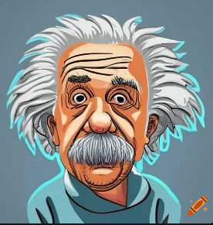t is the third time that European Championship matches are played on German territory and the second time in [reunified Germany](https://en.wikipedia.org/wiki/German_reunification), as [West Germany](https://en.wikipedia.org/wiki/West_Germany) hosted the tournament's [1988](https://en.wikipedia.org/wiki/UEFA_Euro_1988) edition, and four matches of the multi-national [Euro 2020](https://en.wikipedia.org/wiki/UEFA_Euro_2020) were played in [Munich](https://en.wikipedia.org/wiki/Munich). It is the first time the competition is held in what was formerly [East Germany](https://en.wikipedia.org/wiki/East_Germany), with [Leipzig](https://en.wikipedia.org/wiki/Leipzig) as a host city, as well as the first major tournament since the [2006 FIFA World Cup](https://en.wikipedia.org/wiki/2006_FIFA_World_Cup) that Germany serves as a solo host nation.[[1]](https://en.wikipedia.org/wiki/UEFA_Euro_2024#cite_note-1)[[2]](https://en.wikipedia.org/wiki/UEFA_Euro_2024#cite_note-2) The tournament returned to its usual four-year cycle after the 2020 edition was postponed to 2021 due to the [COVID-19 pandemic](https://en.wikipedia.org/wiki/COVID-19_pandemic_in_Europe).

Subscript: H2O, CO2

Superscript: H2O, CO2

|  |  |  |  |
| --- | --- | --- | --- |
|  |  |  |  |
|  |  |  |  |
|  |  |  |  |
|  |  |  |  |
|  |  |  |  |
|  |  |  |  |
|  |  |  |  |
|  |  |  |  |
|  |  |  |  |
|  |  |  |  |
|  |  |  |  |
|  |  |  |  |
|  |  |  |  |
|  |  |  |  |
|  |  |  |  |